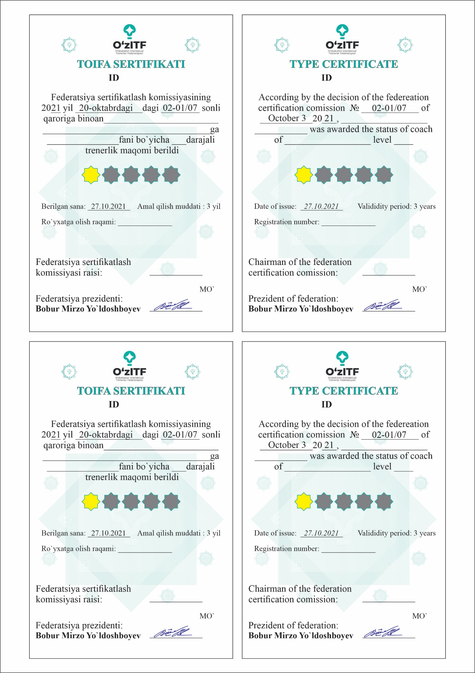

|  |
| --- |
| **${certificate_id}** |

|  |
| --- |
| **${certificate_id}** |

|  |
| --- |
| ${full_name_english} |

|  |
| --- |
| ${full_name} |

|  |
| --- |
| ${subject_english} |

|  |
| --- |
| 5 |

|  |
| --- |
| ${subject} |

|  |
| --- |
| 5 |

|  |
| --- |
| ${registered_number} |

|  |
| --- |
| ${registered_number} |

|  |
| --- |
| **${certificate_id2}** |

|  |
| --- |
| **${certificate_id2}** |

|  |
| --- |
| ${full_name2} |

|  |  |
| --- | --- |
| |  | | --- | | 5 |   ${full_name_english2} |

|  |
| --- |
| ${subject_english2} |

|  |
| --- |
| ${subject2} |

|  |
| --- |
| ${registered_number2} |

|  |
| --- |
| ${registered_number2} |

|  |
| --- |
| 5 |