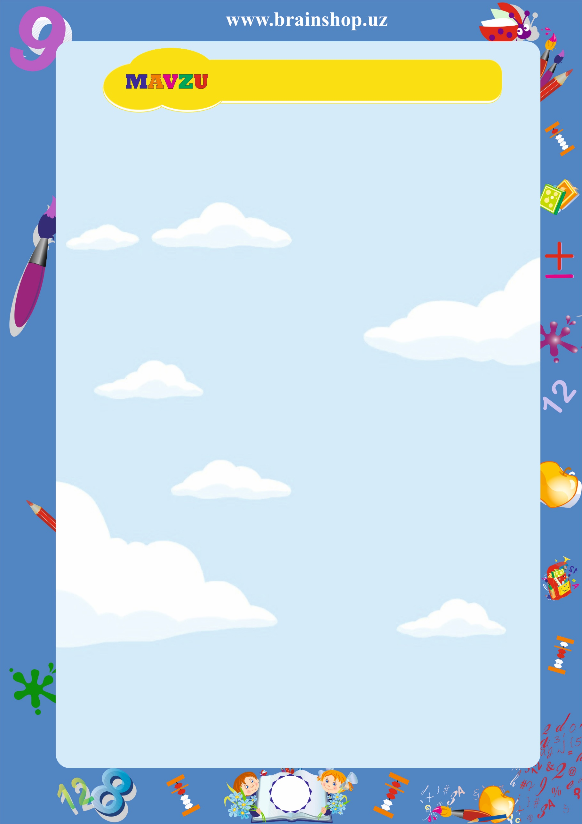

|  |
| --- |
| **${theme}** |

${block_name}

| **№** | **${tn1}** | **${tn2}** | **${tn3}** | **${tn4}** | **${tn5}** | **${tn6}** | **${tn7}** | **${tn8}** | **${tn9}** | **${tn10}** |
| --- | --- | --- | --- | --- | --- | --- | --- | --- | --- | --- |
| **Misol:** | ${task1} | ${task2} | ${task3} | ${task4} | ${task5} | ${task6} | ${task7} | ${task8} | ${task9} | ${task10} |
| **Javob:** |  |  |  |  |  |  |  |  |  |  |
| **Natija:** |  |  |  |  |  |  |  |  |  |  |

${/block_name}

**${theme} – javoblar varaqasi**

${answer_block}

| **№** | **${tn1}** | **${tn2}** | **${tn3}** | **${tn4}** | **${tn5}** | **${tn6}** | **${tn7}** | **${tn8}** | **${tn9}** | **${tn10}** |
| --- | --- | --- | --- | --- | --- | --- | --- | --- | --- | --- |
| **Misol:** | ${task1} | ${task2} | ${task3} | ${task4} | ${task5} | ${task6} | ${task7} | ${task8} | ${task9} | ${task10} |
| **Javob:** | ${ans1} | ${ans2} | ${ans3} | ${ans4} | ${ans5} | ${ans6} | ${ans7} | ${ans8} | ${ans9} | ${ans10} |
| **Natija:** |  |  |  |  |  |  |  |  |  |  |

${/answer_block}