|  |  |
| --- | --- |
| 変更前 | 変更後 |
| 1: *//fireworks - born of insomnia*  2: Firework**[]** fs = **new** Firework**[**10**];**  3: **boolean** once**;**  4: **void** setup**(){**  5: size**(**400**,**400**);**  6: smooth**();**  7: **for** **(int** i = 0**;** i < fs**.**length**;** i++**){**  8: fs**[**i**]** = **new** Firework**();**  9: **}**  10: **}**  11: **void** draw**(){**  12: noStroke**();**  13: fill**(**50**,**0**,**40**,**20**);**  14: rect**(**0**,**0**,**width**,**height**);**  15: **for** **(int** i = 0**;** i < fs**.**length**;** i++**){**  16: fs**[**i**].**draw**();**  17: **}**  18: **}**  19: **void** mouseReleased**(){**  20: once = false**;**  21: **for** **(int** i = 0**;** i < fs**.**length**;** i++**){**  22: **if((**fs**[**i**].**hidden**)**&&**(**!once**)){**  23: fs**[**i**].**launch**();**  24: once = true**;**  25: **}**  26: **}**  27: **}**  28: **class** Firework**{**  29: **float** x**,** y**,** oldX**,**oldY**,** ySpeed**,** targetX**,** targetY**,** explodeTimer**,** flareWeight**,** flareAngle**;**  30: **int** flareAmount**,** duration**;**  31: **boolean** launched**,**exploded**,**hidden**;**  32: color flare**;**  33: Firework**(){**  34: launched = false**;**  35: exploded = false**;**  36: hidden = true**;**  37: **}**  38: **void** draw**(){**  39: **if((**launched**)**&&**(**!exploded**)**&&**(**!hidden**)){**  40: launchMaths**();**  41: strokeWeight**(**1**);**  42: stroke**(**255**);**  43: line**(**x**,**y**,**oldX**,**oldY**);**  44: **}**  45: **if((**!launched**)**&&**(**exploded**)**&&**(**!hidden**)){**  46: explodeMaths**();**  47: noStroke**();**  48: strokeWeight**(**flareWeight**);**  49: stroke**(**flare**);**  50: **for(int** i = 0**;** i < flareAmount + 1**;** i++**){**  51: pushMatrix**();**  52: translate**(**x**,**y**);**  53: point**(**sin**(**radians**(**i*flareAngle**))**\*explodeTimer**,**cos**(**radians**(**i*flareAngle**))**\*explodeTimer**);**  54: popMatrix**();**  55: **}**  56: **}**  57: **if((**!launched**)**&&**(**!exploded**)**&&**(**hidden**)){**  58: *//do nothing*  59: **}**  60: **}**  61: **void** launch**(){**  62: x = oldX = mouseX + **((**random**(**5**)**\*10**)** - 25**);**  63: y = oldY = height**;**  64: targetX = mouseX**;**  65: targetY = mouseY**;**  66: ySpeed = random**(**3**)** + 2**;**  67: flare = color**(**random**(**3**)**\*50 + 105**,**random**(**3**)**\*50 + 105**,**random**(**3**)**\*50 + 105**);**  68: flareAmount = ceil**(**random**(**30**))** + 20**;**  69: flareWeight = ceil**(**random**(**3**));**  70: duration = ceil**(**random**(**4**))**\*20 + 30**;**  71: flareAngle = 360/flareAmount**;**  72: launched = true**;**  73: exploded = false**;**  74: hidden = false**;**  75: **}**  76: **void** launchMaths**(){**  77: oldX = x**;**  78: oldY = y**;**  79: **if(**dist**(**x**,**y**,**targetX**,**targetY**)** > 6**){**  80: x += **(**targetX - x**)**/2**;**  81: y += -ySpeed**;**  82: **}else{**  83: explode**();**  84: **}**  85: **}**  86: **void** explode**(){**  87: explodeTimer = 0**;**  88: launched = false**;**  89: exploded = true**;**  90: hidden = false**;**  91: **}**  92: **void** explodeMaths**(){**  93: **if(**explodeTimer < duration**){**  94: explodeTimer+= 0.4**;**  95: **}else{**  96: hide**();**  97: **}**  98: **}**  99: **void** hide**(){**  100: launched = false**;**  101: exploded = false**;**  102: hidden = true**;**  103: **}**  104: **}** | Firework**[]** fs = **new** Firework**[**100**];**  2: **boolean** once**;**  3: **void** setup**(){**  4: size**(**2000**,**1000**);**  5: smooth**();**  6: **for** **(int** i = 0**;** i < fs**.**length**;** i++**){**  7: fs**[**i**]** = **new** Firework**();**  8: **}**  9: **}**  10: **void** draw**(){**  11: noStroke**();**  12: fill**(**50**,**0**,**40**,**20**);**  13: rect**(**0**,**0**,**width**,**height**);**  14: **for** **(int** i = 0**;** i < fs**.**length**;** i++**){**  15: fs**[**i**].**draw**();**  16: **}**  17: **}**  18: **void** mouseReleased**(){**  19: once = false**;**  20: **for** **(int** i = 0**;** i < fs**.**length**;** i++**){**  21: **if((**fs**[**i**].**hidden**)**&&**(**!once**)){**  22: fs**[**i**].**launch**();**  23: once = true**;**  24: **}**  25: **}**  26: **}**  27: **class** Firework**{**  28: **float** x**,** y**,** oldX**,**oldY**,** ySpeed**,** targetX**,** targetY**,** explodeTimer**,** flareWeight**,** flareAngle**;**  29: **int** flareAmount**,** duration**;**  30: **boolean** launched**,**exploded**,**hidden**;**  31: color flare**;**  32: Firework**(){**  33: launched = false**;**  34: exploded = false**;**  35: hidden = true**;**  36: **}**  37: **void** draw**(){**  38: **if((**launched**)**&&**(**!exploded**)**&&**(**!hidden**)){**  39: launchMaths**();**  40: strokeWeight**(**5**);**  41: stroke**(**255**);**  42: line**(**x**,**y**,**oldX**,**oldY**);**  43: **}**  44: **if((**!launched**)**&&**(**exploded**)**&&**(**!hidden**)){**  45: explodeMaths**();**  46: noStroke**();**  47: strokeWeight**(**flareWeight**);**  48: stroke**(**flare**);**  49: **for(int** i = 0**;** i < flareAmount + 1**;** i++**){**  50: pushMatrix**();**  51: translate**(**x**,**y**);**  52: point**(**sin**(**radians**(**i*flareAngle**))**\*explodeTimer**,**cos**(**radians**(**i*flareAngle**))**\*explodeTimer**);**  53: popMatrix**();**  54: **}**  55: **}**  56: **if((**!launched**)**&&**(**!exploded**)**&&**(**hidden**)){**  57: *//do nothing*  58: **}**  59: **}**  60: **void** launch**(){**  61: x = oldX = mouseX + **((**random**(**5**)**\*10**)** - 25**);**  62: y = oldY = height**;**  63: targetX = mouseX**;**  64: targetY = mouseY**;**  65: ySpeed = random**(**3**)** + 2**;**  66: flare = color**(**random**(**3**)**\*50 + 105**,**random**(**3**)**\*50 + 105**,**random**(**3**)**\*50 + 105**);**  67: flareAmount = ceil**(**random**(**30**))** + 20**;**  68: flareWeight = ceil**(**random**(**3**));**  69: duration = ceil**(**random**(**4**))**\*20 + 3**;**  70: flareAngle = 3600/flareAmount**;**  71: launched = true**;**  72: exploded = false**;**  73: hidden = false**;**  74: **}**  75: **void** launchMaths**(){**  76: oldX = x**;**  77: oldY = y**;**  78: **if(**dist**(**x**,**y**,**targetX**,**targetY**)** > 6**){**  79: x += **(**targetX - x**)**/2**;**  80: y += -ySpeed**;**  81: **}else{**  82: explode**();**  83: **}**  84: **}**  85: **void** explode**(){**  86: explodeTimer = 0**;**  87: launched = false**;**  88: exploded = true**;**  89: hidden = false**;**  90: **}**  91: **void** explodeMaths**(){**  92: **if(**explodeTimer < duration**){**  93: explodeTimer+= 0.6**;**  94: **}else{**  95: hide**();**  96: **}**  97: **}**  98: **void** hide**(){**  99: launched = false**;**  100: exploded = false**;**  101: hidden = true**;**  102: **}**  103: **}** |

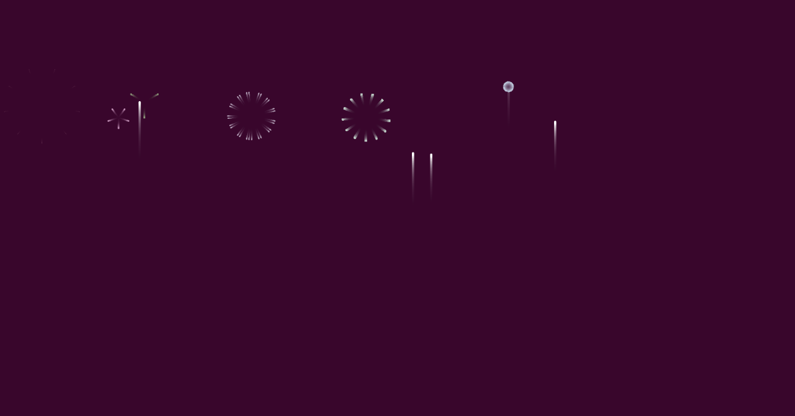

↑変更後

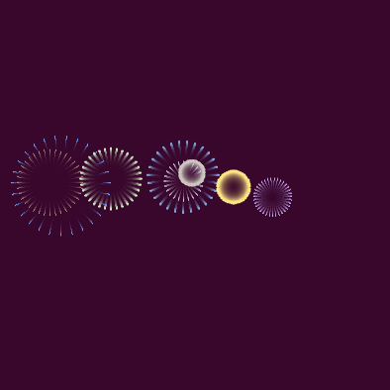

↑変更前

サイズを大きくして、かつ花火の数を増やしました。