|  |  |
| --- | --- |
| コピー後 | コピー前 |
| 1: **void** setup**()** **{**  2: size**(**600**,**400**);**  3: **}**  4:  5: **float** ballX = 200**;**  6: **float** ballY = 100**;**  7: **float** speedX = 10**;**  8: **float** speedY = 0**;**  9: **int** hit = 0**;**  10: **int** miss = 0**;**  11:  12:  13: **void** draw**()** **{**  14:  15: **if(**mousePressed**){** hit =0**;** miss=0**;}**  16: **float** paddle = 1000/**(**hit+10**);**  17: **if(**ballX < 0 || ballX > width**)** speedX = -speedX**;**  18: **if(**ballY > height**){**  19: speedY = -speedY**;**  20: **float** distance = abs**(**mouseX - ballX**);**  21: **if(**distance < paddle**)** hit +=1**;**  22: **else** miss +=1**;**  23: **}** **else** speedY +=1**;**  24:  25: ballX += speedX**;**  26: ballY += speedY**;**  27:  28: background**(**100**,**200**,**50**);**  29: fill**(**200**,**150**,**200**);**  30: ellipse**(**ballX**,** ballY**,**50**,**50**);**  31: fill**(**255**,**255**,**50**);**  32: rect**(**mouseX - paddle**,** height - 10**,** 2*paddle**,** 10**);**  33:  34: fill**(**0**);**  35: text**(**"OK;" + hit**,**10**,**10**);**  36: text**(**"miss;" + miss**,**10**,**40**);**  37: **}** | void **setup**() {    size(600,400);  }    float ballX = 200;  float ballY = 100;  float speedX = 10;  float speedY = 0;  int hit = 0;  int miss = 0;  void **draw**() {      if(mousePressed){ hit =0; miss=0;}    float paddle = 1000    if(ballX < 0 || ballX > width) speedX = -speedX;    if(ballY > height){    speedY = -speedY;    float distance = abs(mouseX - ballX);    if(distance < paddle) hit +=1;    else miss +=1;   } else speedY +=1;      ballX += speedX;    ballY += speedY;      background(100,200,50);    fill(100,120,255);    ellipse(ballX, ballY,50,50);    fill(255,255,50);    rect(mouseX - paddle, height - 10, 2*paddle, 10);      fill(0);    text("hit;" + hit,10,10);    text("miss;" + miss,10,40);  } |

変更点：だんだん小さくなるようにしました。色を変えました。textを変えました。

変更後

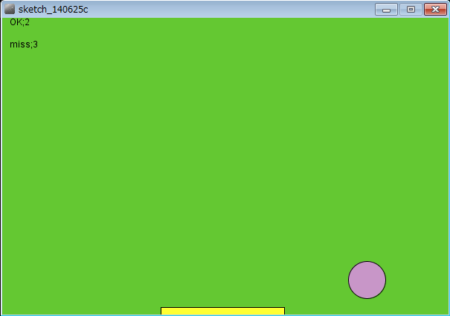

コピー後

