A Synopsis
On

GRAMEEN QUEST - AI-ENABLED GAMIFIED RURAL LEARNING PLATFORM
Submitted by
Kanchan Dadhale 22356030048
Sakshi Chaudhary 22356030046
Dhiraj Chaudhary 22356030047

Under the Guidance of
Mrs. Sarika panwal


DEPARTMENT OF BACHELOR OF COMPUTER APPLICATION
SCHOOL OF COMPUTATIONAL SCIENCES
FACULTY OF SCIENCE AND TECHNOLOGY
JSPM UNIVERSITY PUNE
ACADEMIC YEAR 2025-26

Staff Use only:
Selected / Rejected | Name of the Guide | Name of the Project coordinator
 |  | Dr. Anita Pisote

1. Project Topic / Title:
Tentative: Grameen Quest: A Gamified Offline Learning Platform for Rural Students Using Progressive Web App Technology
Finalized (Guide will write):

2. Details of Group Member:
Roll. No. | Class | Division | Name of Student | Mobile Number | Email Id
38 | BCA | A | Kanchan Dadhale | 93073 65587 | dadhale.kanchan987@gmail.com
37 | BCA | A | Dhiraj Chaudhari | 76206 88903 | dc170373@gmail.com
36 | BCA | A | Sakshi Chaudhari | 90223 36317 | chaudharisakshi197@gmail.com

Name & Signature of the Project Guide:

Name & Signature of the Project Coordinator:

Name & Signature of the Program Coordinator:

Abstract
Grameen Quest is a web-based gamified rural learning platform designed for students from Class 1 to Class 10. The system addresses major learning barriers in rural and low-bandwidth areas by offering lightweight practice quizzes, class-wise subjects, multilingual support in English, Hindi, and Marathi, and offline accessibility through Progressive Web App features. Students earn XP, coins, levels, badges, and streak rewards to increase motivation and consistency. The platform also includes daily missions, weekly challenge rounds, and a parent-teacher snapshot module for progress tracking. The project aims to strengthen foundational learning, encourage regular study habits, and provide a scalable digital learning model suitable for village schools and community learning centers.

Introduction
Rural students frequently experience difficulty in accessing continuous digital education because of poor internet connectivity, limited device capabilities, and reduced personalized support. Many existing ed-tech products are built for urban users and are not optimized for low-resource environments. Grameen Quest is proposed as an inclusive and practical learning platform that combines education with gamification to keep students engaged. With an offline-first approach and simple interface design, the platform enables regular practice, tracks progress, and improves teacher and parent involvement.

- State of the Art
Current educational platforms such as Khan Academy, Byju's, and similar quiz-based systems provide rich content and tracking features, but many require stable internet connectivity, stronger devices, or paid access. Gamification has been widely accepted as an effective method to improve participation and motivation, yet implementation in rural learning ecosystems remains limited. Recent systems have improved adaptive quizzes, multilingual interfaces, and progress analytics, but low-bandwidth-first, village-focused platforms with integrated daily mission and weekly challenge mechanics are still uncommon. Grameen Quest is designed to fill this gap through lightweight architecture, offline capability, and local-context usability.

- Need of the Work
There is a strong need for a digital learning system that works reliably in rural conditions where internet connectivity is unstable and infrastructure is limited. Students require an engaging environment that encourages daily practice and long-term consistency. Teachers and parents need simple and accessible visibility into student performance and learning behavior. Schools and community centers need affordable, easy-to-deploy technology without heavy setup requirements. Local language support is also essential for inclusion and better understanding among learners.

Problem Statement
Build a gamified digital platform to enhance learning outcomes for students in rural schools (grades 6- 12), focusing on STEM subjects. The platform should use interactive games, multilingual content, and offline access to engage students with limited internet connectivity.

Objectives of Project Work
- To design and develop a gamified web platform for rural students (Class 1-10).
- To provide class-wise and subject-wise quiz practice modules.
- To implement reward mechanisms (XP, coins, badges, streaks) for motivation.
- To support multilingual interaction (English, Hindi, Marathi).
- To implement daily missions and weekly challenge rounds.
- To provide a parent/teacher progress snapshot and activity export.
- To enable offline usability using PWA and local caching.

Existing System
Existing systems provide digital quizzes and video lessons but often lack complete support for rural constraints such as low internet speed, intermittent connectivity, and simplified interfaces. Most available solutions focus on generic content delivery rather than village-level student engagement loops and lightweight tracking. Also, many platforms have limited offline support and are less personalized for grade-level quick practice.
- Literature Review

This section summarizes the previous studies related to proposed system in below table including their title, authors, objectives, methods and limitations.

S. No. | Title, Author(s), Year & Publisher | Objectives | Methods/Tools | Outcome/Results/  Observations | Limitations/Suggested Future Work
1 | From Game Design Elements to Gamefulness (Deterding et al.; 2011) | To explain gamification principles. | Conceptual framework | Game elements improve engagement. | Not specifically tested in rural school settings.
2 | Does Gamification Work? (Hamari, Koivisto, Sarsa; 2014) | To review gamification effectiveness. | Literature review | Positive effect on motivation and participation. | Mixed long-term learning impact.
3 | Reports on digital learning inclusion (UNESCO; 2023) | To improve equitable access to education technology. | Policy and implementation studies | Offline and low-cost tools recommended. | Broad policy focus, limited product-level design details.
4 | Mobile learning in low-resource contexts (Traxler; 2018) | To study mobile-first learning adoption. | Case analyses | Mobile/offline models are practical in underserved regions. | Does not deeply address gamified progress analytics.
5 | Evaluating Progressive Web Apps for Offline Learning in Low-Bandwidth Environments" (Patel & Sharma; 2022) | To assess the technical feasibility and user retention of offline-first educational PWAs in rural schools. | Quasi-experimental design, field deployment, caching analytics | PWA architectures significantly reduced load times and maintained 85% functionality without active internet. | Device storage constraints limited the amount of cached multimedia content.
6 | Impact of Micro-Rewards and Streaks on Student Engagement in Digital Literacy Programs" (Okafor et al.; 2021) | To investigate how gamified micro-rewards (coins, streaks) affect daily practice habits of K-8 students. | Longitudinal study, quantitative usage logs, user surveys | Streak mechanics increased daily return rates by 42% compared to non-gamified control groups. | Novelty effect observed; engagement metrics slightly declined after the first three months.

Proposed Solutions/System
The proposed system is a browser-based platform where students create a basic profile and select their class level. The platform provides subject-wise quizzes with instant feedback and awards points for correct responses. A gamification engine tracks XP, levels, streaks, badges, and coins. Daily missions and weekly challenge rounds encourage regular practice. A separate parent/teacher dashboard summarizes activity, learning trends, and recent attempts. The system supports multiple languages and can run offline after first load through service worker caching.

Methodology
- Architecture:
- Client-side web application (HTML, CSS, JavaScript)
- Local storage for user progress and state
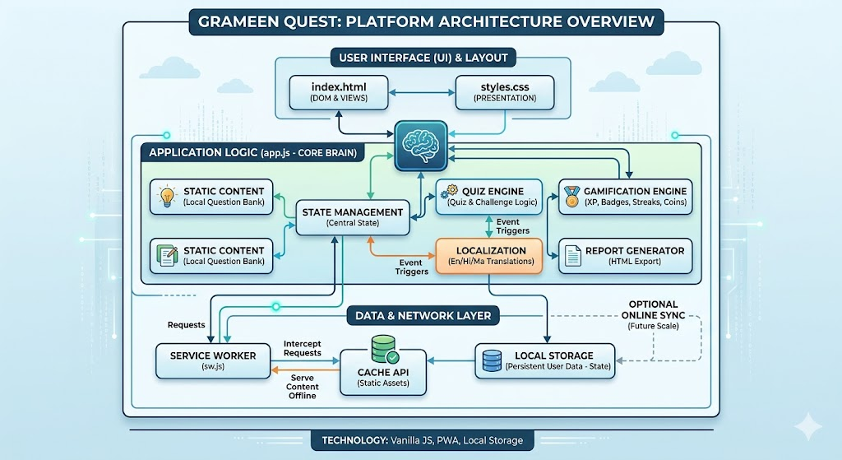
- Service Worker for offline cache and PWA behavior

- Core Modules:
- Student Profile Module (name, class, village/school)
- Learning Tracks & Quiz Module
- Gamification Module (XP, levels, streaks, badges, coins)
- Missions & Weekly Challenge Module
- Parent/Teacher Snapshot Module
- Reporting Module (progress export)
- Language Support Module (English/Hindi/Marathi)

- Algorithms/Logic:
- Rule-based scoring (correct answer reward)
- Progress aggregation per subject
- Streak tracking by day-based login/activity
- Milestone-based badge awarding

- Tools & Technologies:
- Frontend: HTML5, CSS3, JavaScript (Vanilla)
- Storage: Browser LocalStorage
- PWA: Manifest + Service Worker
- Deployment: Netlify/Vercel (optional)

10. Resources Required and other Equipment
- Hardware:
- Laptop/Desktop (minimum 8 GB RAM recommended)
- Android smartphone for user testing (optional)

Software:
- VS Code
- Modern browser (Chrome/Edge/Firefox)
- Git/GitHub (optional for version control)

- Platform/Environment:
- Static hosting service (Netlify or Vercel)
- Internet only for initial load; later usable offline for cached assets

Expected Outcomes
- Functional rural learning web app for Classes 1 to 10.
- Improved student engagement through gamified mechanics.
- Basic measurable progress tracking across subjects.
- Better teacher/parent visibility into learner activity.
- Offline-capable educational interface for low-bandwidth regions.

Applications
- Village schools and community learning centers.
- NGO-led digital literacy and remedial learning programs.
- Home practice for students in low-connectivity areas.
- Supplemental classroom learning with progress monitoring.

Work Plan & Timeline

Phase | Duration | Month and Year | Deliverable
Requirement Analysis | 2 weeks |  | Requirement specification and feature list
Literature Review | 2 weeks |  | Comparative study and finalized problem scope
System Design | 2 weeks |  | UI flow, module design, architecture diagram
Development - Core Features | 4 weeks |  | Quiz + profile + gamification modules
Development - Advanced Features | 2 weeks |  | Missions, challenge round, teacher snapshot
Testing and debugging | 2 weeks |  | Test cases and bug-fix report
Deployment and Documentation | 2 weeks |  | Hosted prototype + final project report

13. Conclusion
Grameen Quest is a practical and scalable digital education solution tailored for rural learners. By combining offline-first architecture, multilingual accessibility, and gamification-based motivation, the platform can improve study regularity, learner participation, and measurable progress. The project demonstrates how lightweight and affordable web technologies can support inclusive education in underserved communities.

References (should be as per IEEE reference format.
[1] S. Deterding, D. Dixon, R. Khaled, and L. Nacke, "From game design elements to gamefulness: Defining gamification," in Proc. 15th Int. Academic MindTrek Conf., Tampere, Finland, 2011, pp. 9-15.
[2] J. Hamari, J. Koivisto, and H. Sarsa, "Does Gamification Work? A Literature Review of Empirical Studies," in Proc. 47th Hawaii Int. Conf. Syst. Sci. (HICSS), Waikoloa, HI, USA, 2014, pp. 3025-3034.
[3] UNESCO, Global Education Monitoring Report. Paris, France: UNESCO Publishing, 2023.
[4] J. Traxler, "Learning with Mobiles in Developing Contexts," Int. J. Mobile Blended Learn., 2018.

