***React js,Node js and Mysql***

Q1: To create a dynamic Tree structure control with below functionality.

1. Create Category: Click Add Category, request to enter Category Name (it can be popup)
2. Create subcategory for the parent category: Request to enter subcategory name as shown in image.
3. Possible to add any no of Subcategory.
4. Adding of subcategory should be dynamic.

Refer below Image:

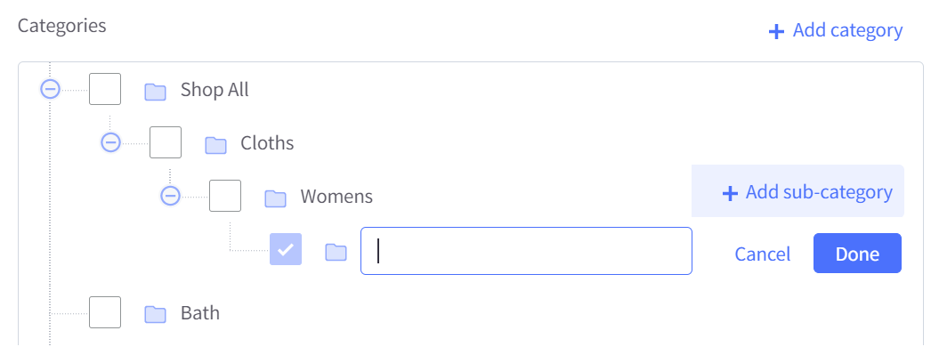

Q1: Create Post call using Node js and connect to Mysql and save the details.