Board 2 Report
ECEN 3730: PCB Design and Manufacture
Daniel Diaz Reyes
3/12/2026

Project Overview

Plan of Record (POR)
For Board 2, the board is expected to showcase how nearly identical circuits exhibit different responses based on whether good design rules were followed, and if a return plane is present or if circuits use a common return trace. The 555-timer circuit from Board 1 will be reused as an input signal for two Texas Instruments (TI) 74AHC14. The hex inverters will be provided power by a 3.3 V LDO. One of the TI inverters will follow good design rules (e.g. decoupling capacitors close to the IC VCC pin) and have a return plane. The other will not follow good design rules and no return plane, just a common return trace.

Board Bring-up Process

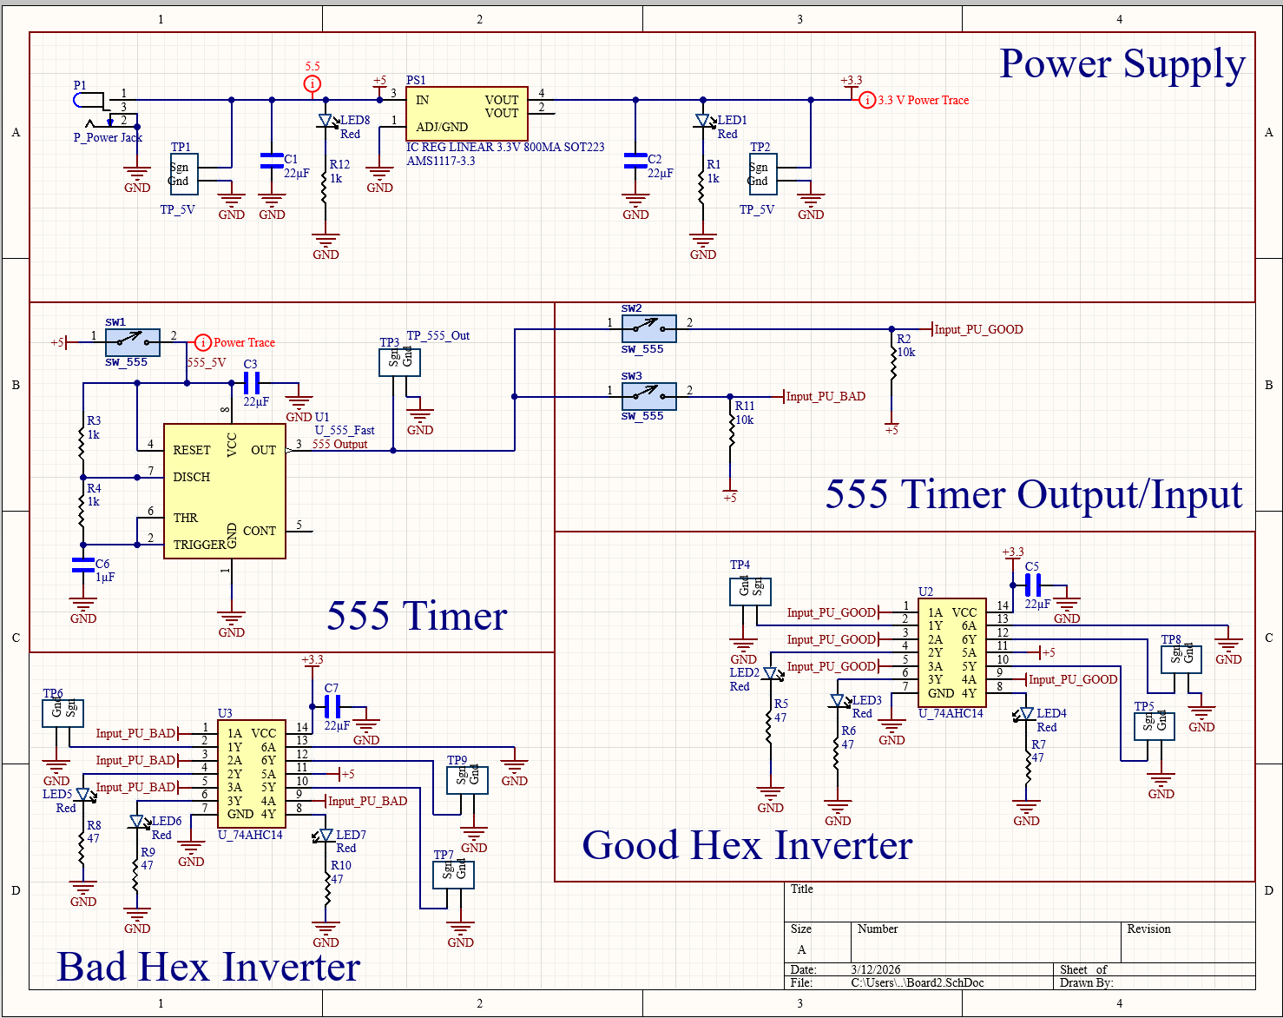
Figure 1. Schematic of the board developed in Altium, identical hex circuits

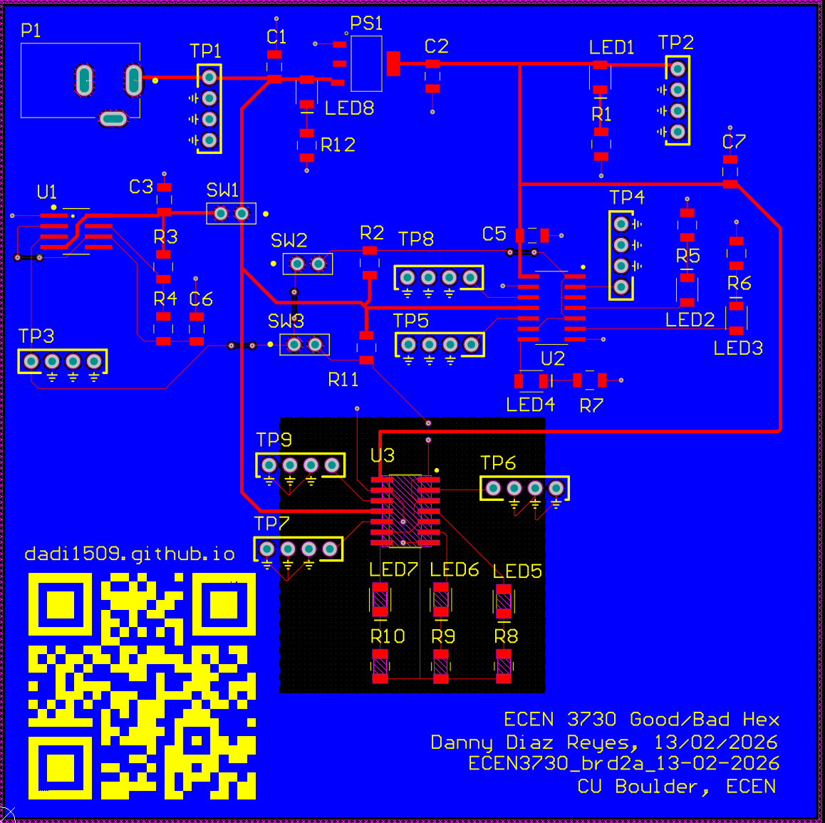
Figure 2. Final PCB Board Layout, black box represents area without return plane, decoupling capacitor placed far away from the IC for that circuit.
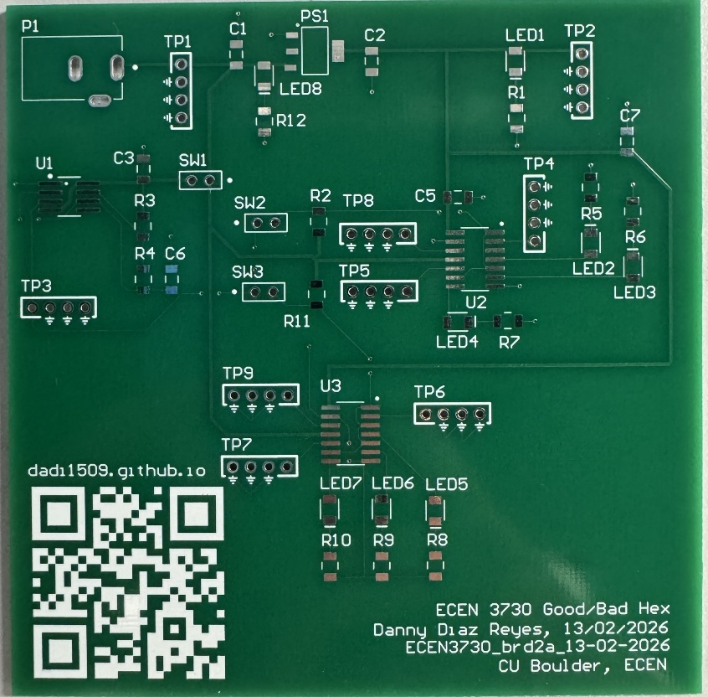
Figure 3. Picture of PCB manufactured by JLC PCB

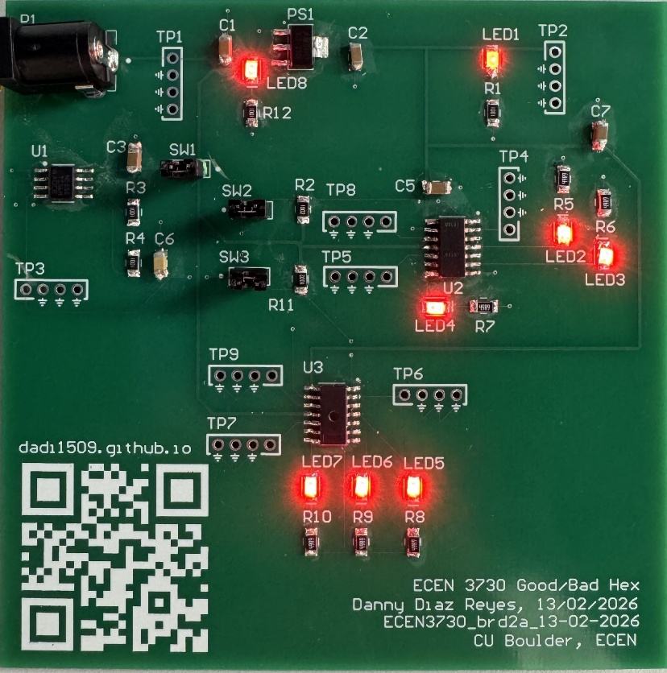
Figure 4. Fully assembled PCB board showing power distributed to all of the ICs

What Worked

Oscilloscope Screenshots and Analysis
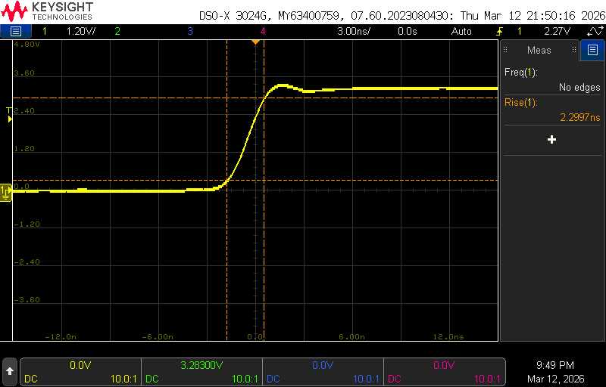
Figure 5. Rise time for the properly designed hex, approximately 2.3 ns and faster than the improperly designed hex
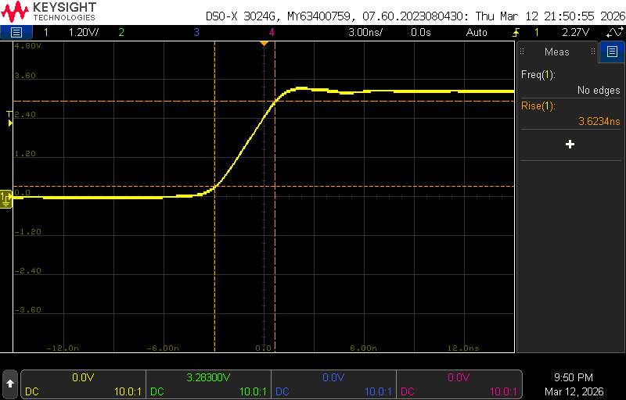
Figure 6. Rise time of improperly designed hex, it is approximately 1.5 ns slower than the properly good hex. This is mostly due to this circuit having a further away decoupling capacitor, meaning that the circuit sees a higher inductance thus when it sees a voltage change from the 555 timer it has less effective power delivery. Subsequently, the circuit sees a voltage droop leading to an inconsistent supply voltage thus a longer rise time.
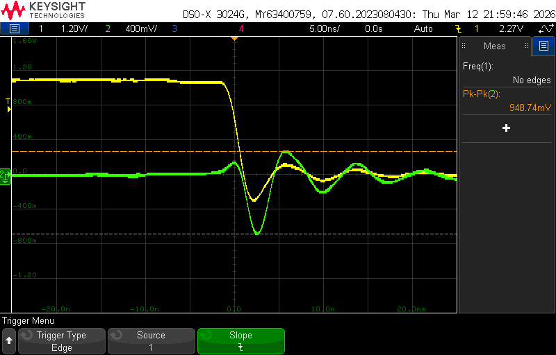
Figure 7. Ground bounce shown by the improperly designed hex, nearly 1 V. Since there is no return plane in the improperly designed hex, when the circuit hits a falling edge, there is a much higher change in current (increase in di/dt) in the shared return trace as opposed to a continuous return plane, leading to a higher inductance and impedance. This higher change in current leads to an increase in noise thus a higher ground bounce. This is not ideal since many applications require high system stability or low signal noise.
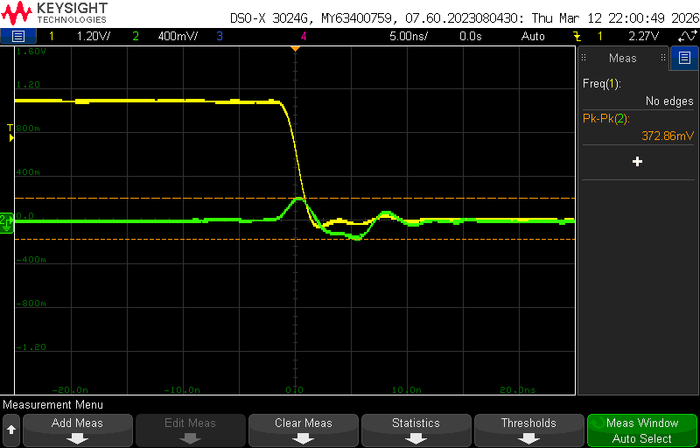
Figure 8. Ground bounce in the properly designed hex, about 0.3 V, much better than the improperly designed hex showing the benefits of having a return plane in the PCB.
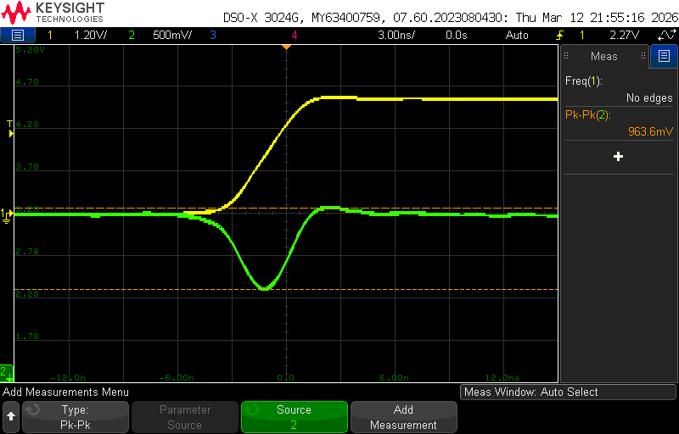
Figure 9. Switching noise at the high line output of the improperly designed hex-inverter shows that our 3.3 V line is seen as high as a 1 V loss when hitting a rising edge. Not ideal and this is likely what is causing our slower rise time. Mostly caused by the decoupling capacitor being far away.
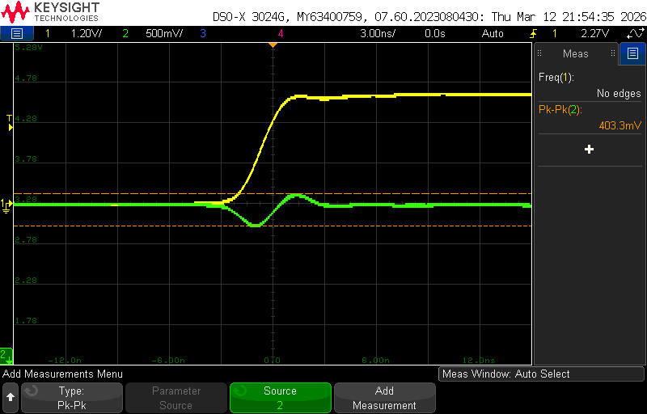
Figure 10. Switching noise of the high line output of properly designed hex, about 0.4 V, over half that of the improperly designed hex. Shows the benefit of having a decoupling capacitor close.
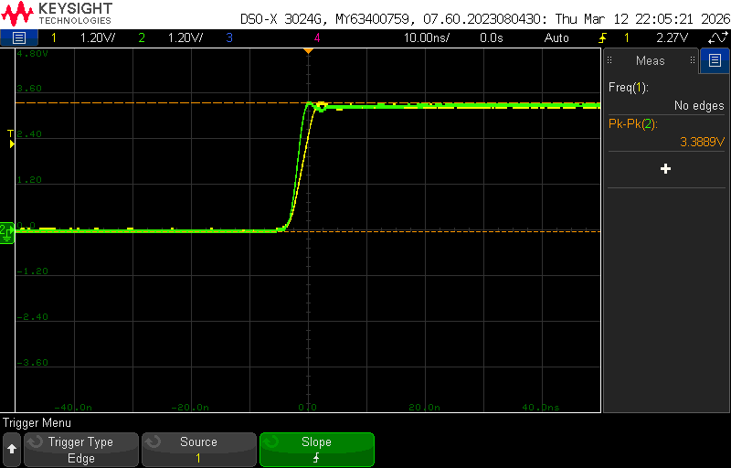
Figure 11. Rise edge of the hex-inverters shown side by side, clearer to see the faster rise time of the properly designed hex.
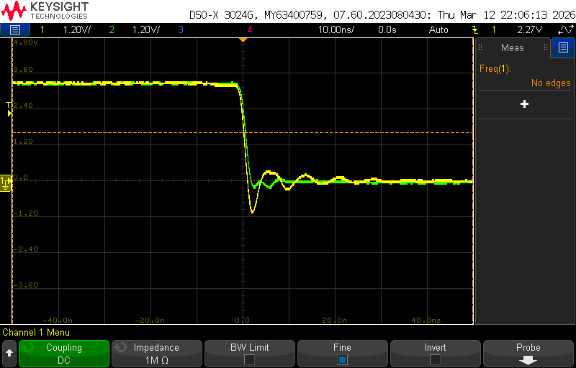
Figure 12. Falling edge of the hex-inverters shows clearer the effects the ground bounce is having on the circuit and the benefits of having a return plane in the circuit.

Conclusions and Project Analysis
What Worked and Went Well
Overall, the board successfully showed that identical circuit schematics can behave completely differently if the PCB is not designed properly. Moving forward, some of the best design features that should be included are:
- Placing decoupling capacitors as close as possible to the input voltage of our ICs. This will help minimize switching noise on our voltage lines by reducing the inductance seen by the IC and can elongate the life of the IC by keeping the IC operating within its designed operating voltage.
- Having a consistent return plane in the board rather than a common return trace amongst multiple components. The more components that share a return trace, the higher ground bounce we will see since the components increase our current loops. This is not good for many ICs and in many applications could lead to false logical signals (e.g. false resets, false high/low). Leading to our circuit not behaving as desired.
- There are other good practices that this board didn’t necessarily cover but are good overall (e.g. cross-under traces being as short as possible)

Soft Errors
While there were no hard errors that prevented the board from behaving as desired according to the POR, there was one soft error that led to delays in the assembly of the board. When designing the board in Altium, I flipped the footprint of the hex inverter across the y-axis. While footprints can be flipped across the x-axis without major repercussions, flipping the footprint across the y-axis meant that I could not solder the hex normally as this would lead to the incorrect connections. Without enough time to reorder the board, I had to very carefully bend the pins on the IC backwards and solder the IC in a “dead bug” orientation.
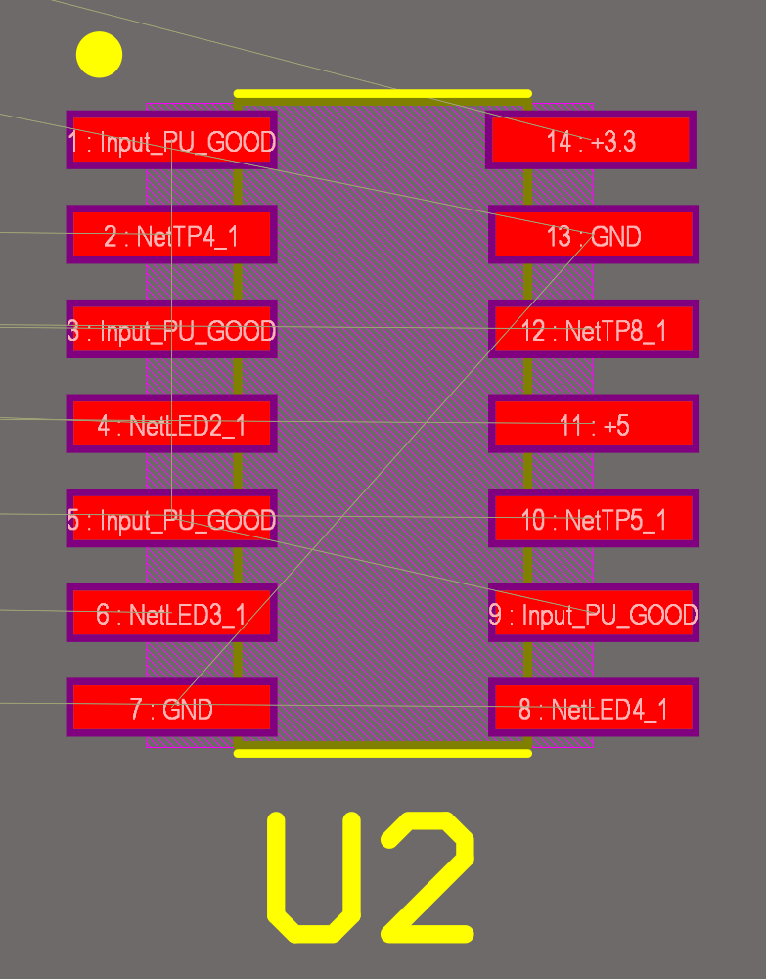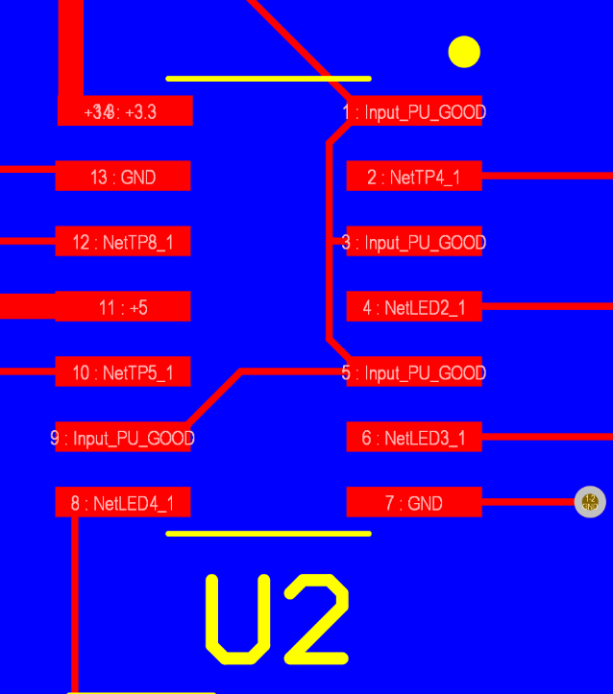
Figure 13. Comparison of proper (left) orientation of the hex inverter footprint versus what was implemented in the final design (right) which is incorrect
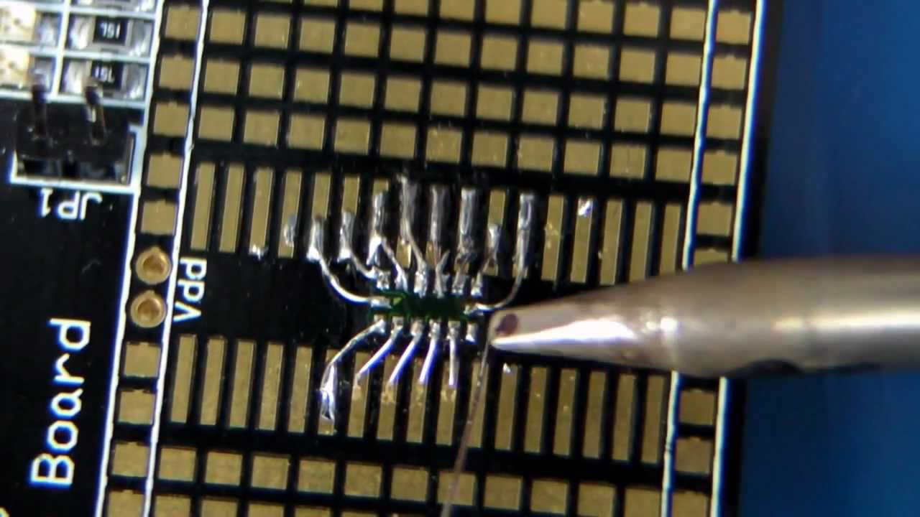
Figure 14. Example of what “dead bug” orientation looks like, instead of wires I instead bent the pins the backwards.

Lessons and Improvements Moving Forward
Moving forward, I will make sure to be more careful as to how I modify the footprints of any component within Altium. While rotations and mirroring can be helpful for tracing placement, incorrect mirroring and rotations can lead to manufacturing errors and in a real-world scenario, cost tons of money in circuits that will not behave as intended. Finally, the good practices that were discovered through this board will be implemented in future boards.

