Board 3 Report
ECEN 3730: PCB Design and Manufacture
Daniel Diaz Reyes
3/31/2026

Project Overview

Plan of Record (POR)
For Board 3, the board is expected to showcase the full PCB design process through the design of an ATMega328p-based microcontroller board that uses a USB Mini connection to interface with the Arduino IDE. This board should follow all good PCB design principles (e.g. decoupling capacitors, keeping cross-under lines as short as possible, keeping all powerlines at the top layer, etc.) and have 6, 8, and 10 pin headers spaced appropriately to where Arduino shields are able to connect with the board. The board will also be designed in such a way that it will be powered by either the USB connection or the 5V power jack, but not both.

Board Bring-up Process
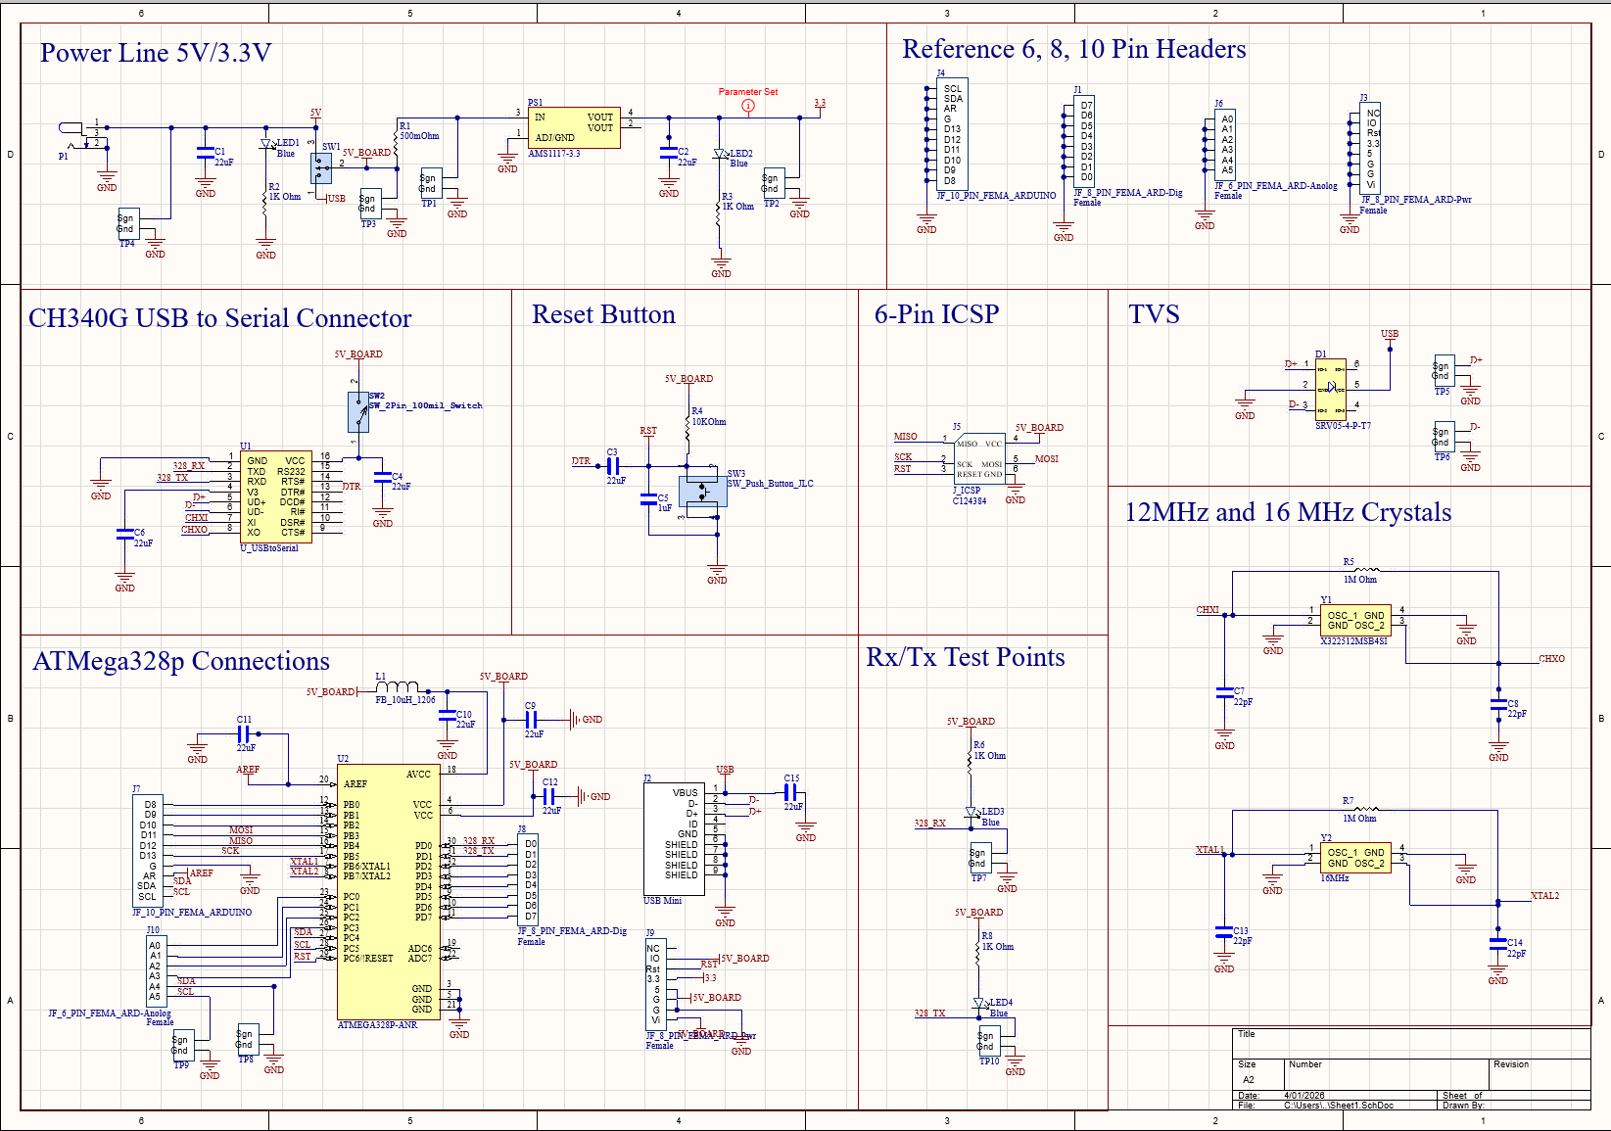
Figure 1. Schematic of the board developed in Altium
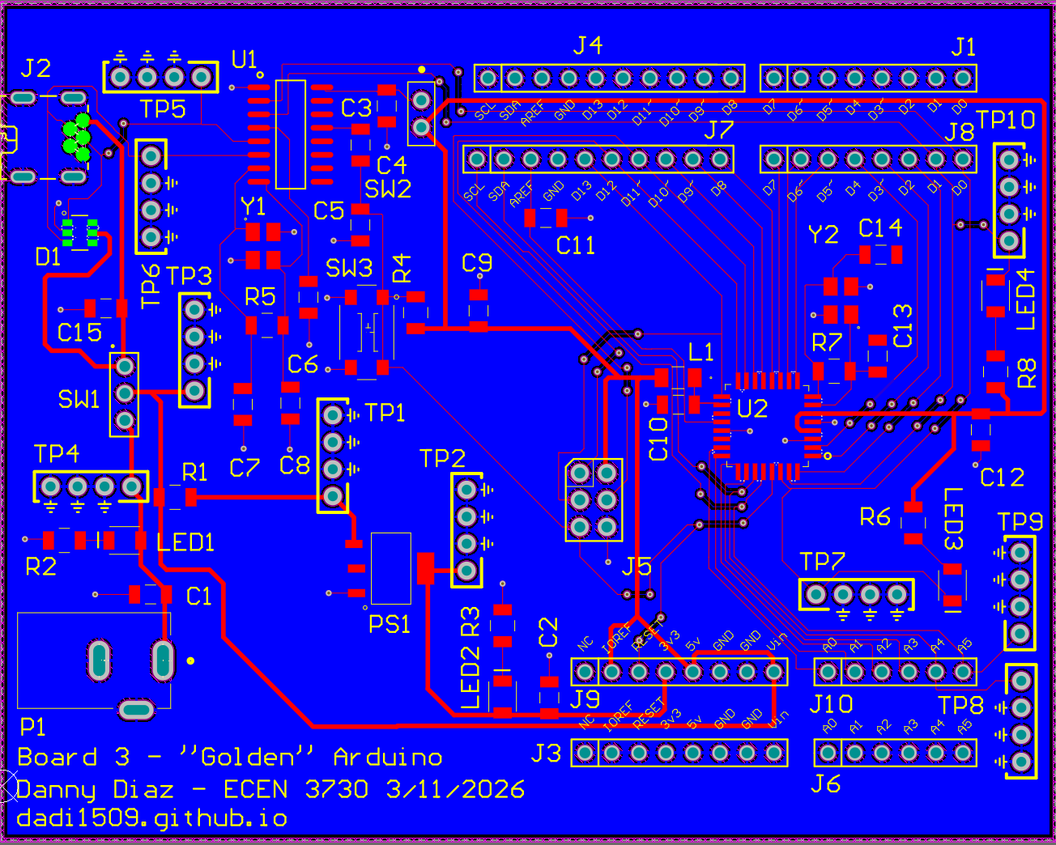
Figure 2. Final PCB Board Layout, test points added to test signals like Rx/Tx communication, power distribution, etc.
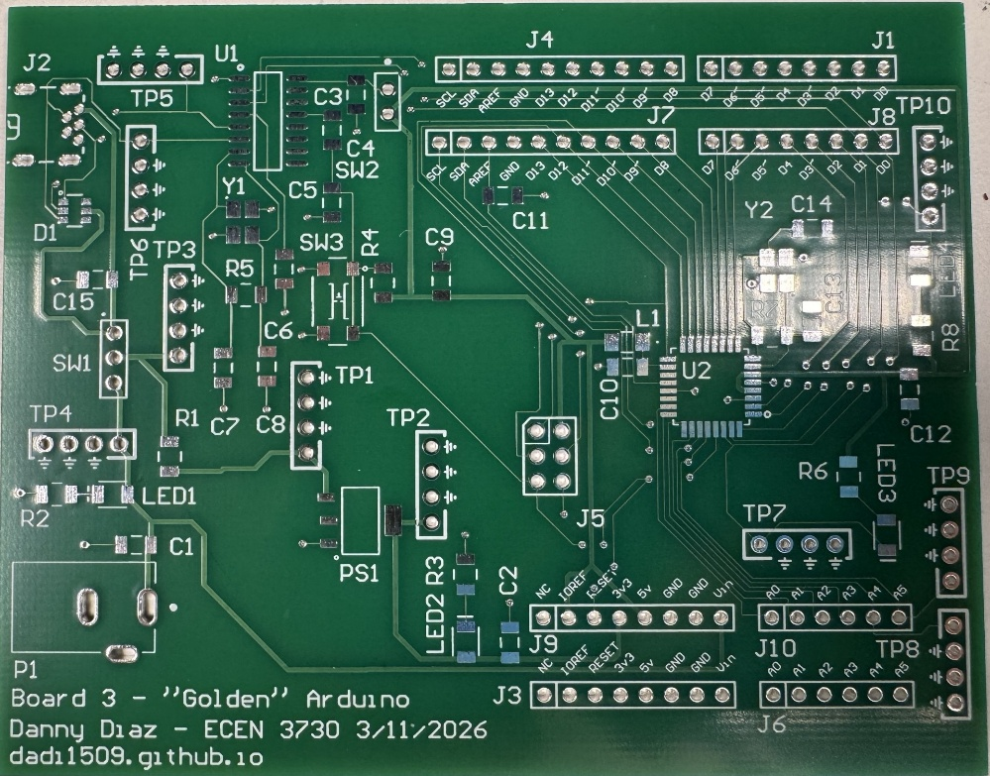
Figure 3. Picture of PCB manufactured by JLC PCB
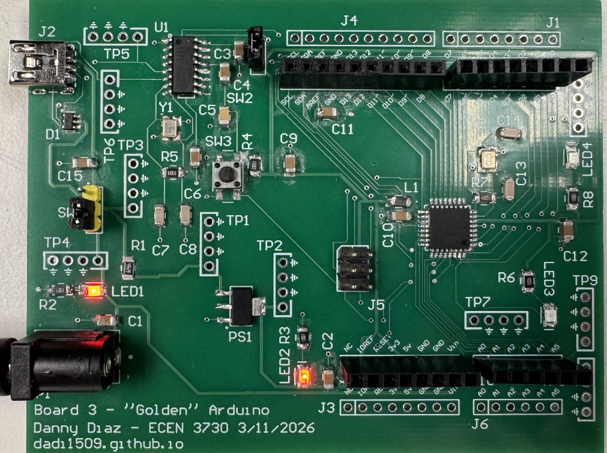
Figure 4. Fully assembled PCB board showing power distributed to all of the ICs

What Worked

What it Means to Work Properly
For it to work properly the board should be able to do the following:
- Bootload and receive code through the USB port, uploaded through the Arduino IDE
- The switching noise of my board should be lower than that of the commercial board due to the commercial board not having a copper pour
- Overall, all noise measurements should be lower than that of the commercial board unless decoupling capacitors were not placed in the correct place or not at all

Oscilloscope Screenshots and Analysis
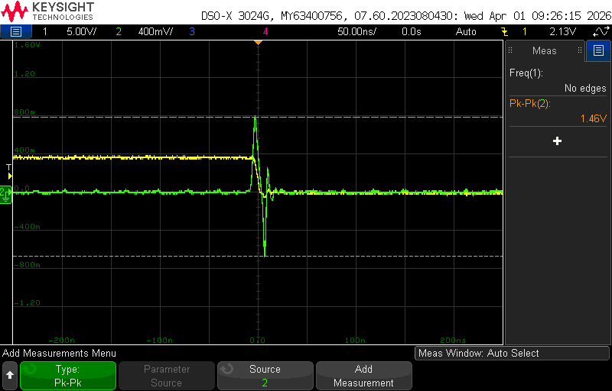
Figure 5. Oscilloscope screenshot of the quiet low (Q_{low}) line, set on digital pin 9, when the ATMega328p on the commercial Arduino board switches I/O state on the falling edge. Approximately 1.46 V, likely explained by the fact that many commercial Arduino boards do not have a copper pour for grounding.
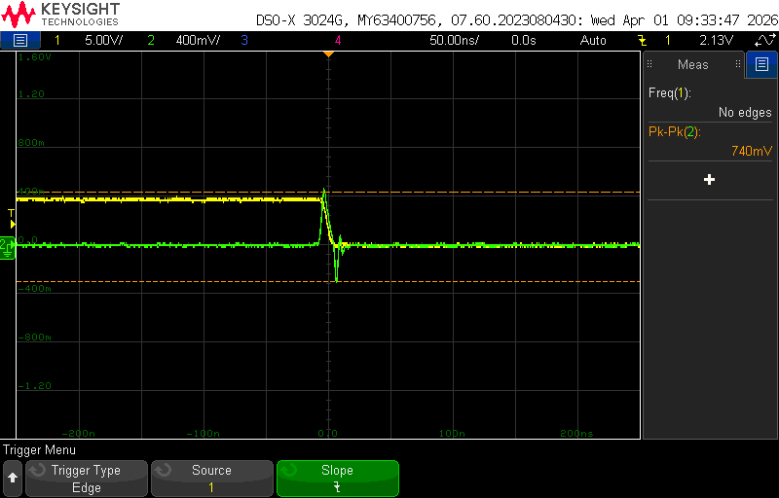
Figure 6. Oscilloscope screenshot of the Q_{low} line when the ATMega328p on the custom-designed Arduino board switches I/O state on the falling edge. The switching noise at the Q_{low} line is approximately 740 mV, supporting the conclusion that the copper pour significantly reduces noise. In this case, the switching noise of the custom-designed board is approximately 0.51x that of the commercial board.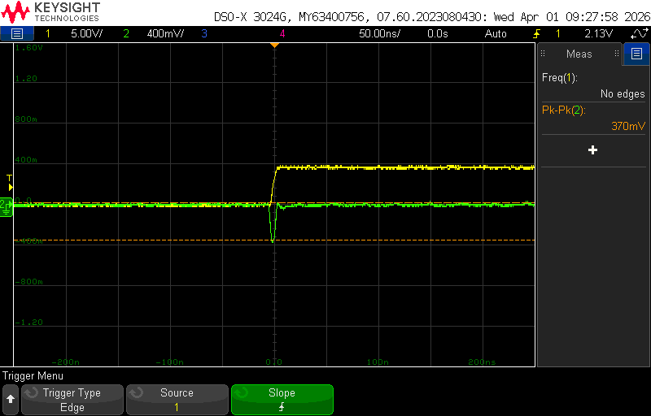
Figure 7. Oscilloscope screenshot of the Q_{low} line when the ATMega328p on the commercial Arduino board switches I/O state on the rising edge. The Q_{low} line of the commercial Arduino on the rising edge is approximately 370 mV.

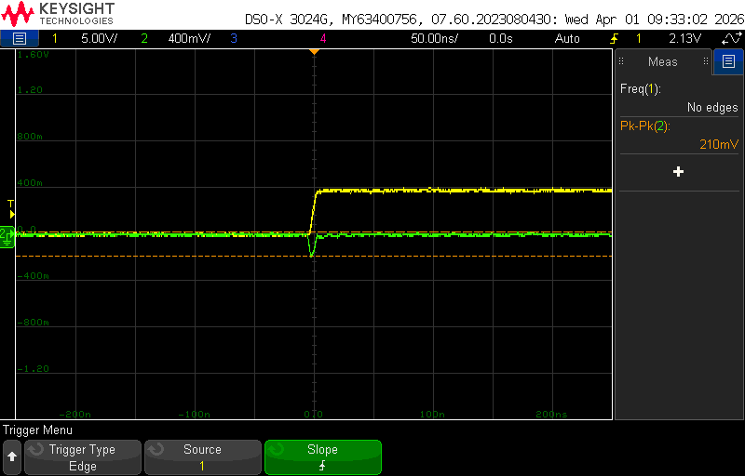
Figure 8. Oscilloscope screenshot of the Q_{low} line when the ATMega328p on the custom-designed Arduino board switches I/O state on the rising edge. The Q_{low} line of the custom-designed Arduino at the rising edge is approximately 210 mV which makes sense due to the copper pour the custom Arduino has. With a switching noise on the rising edge of approximately 0.56x that of the commercial Arduino, this difference while partially can be attributed to decoupling capacitors, it is more likely due to the copper pour.

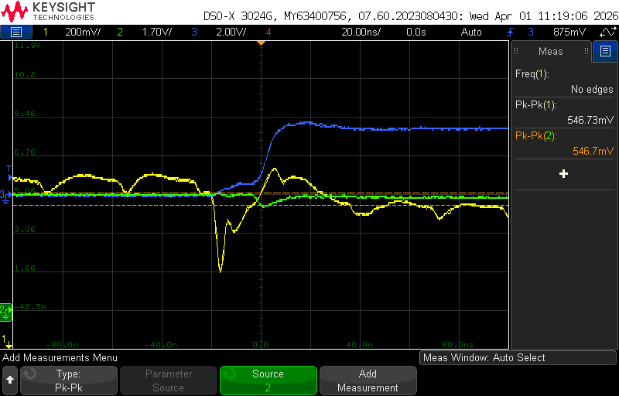
Figure 9. Oscilloscope screenshot of the 5V line and quiet high line (Q_{high}), set on digital pin 8, set on top of each other on the rising edge for the commercial Arduino board. The green line represents the 5 V power rail and the yellow line represents the Q_{high} line and the associated switching noise when the I/O pins switch states. They have approximately the same noise at around 547 mV.
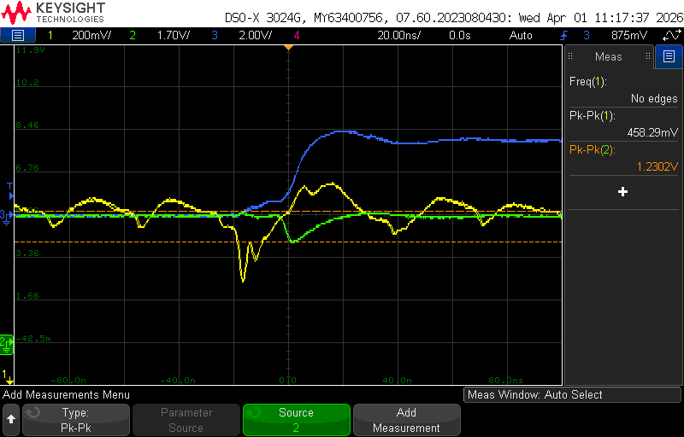
Figure 10. Oscilloscope screenshot of the 5V line and Q_{high}, set on digital pin 8, set on top of each other on the rising edge for the custom-designed Arduino board. This is the first measurement where the values are not consistent with the expected trend. The Q_{high} line has a smaller switching noise at approximately 458 mV compared to the commercial board, 547 mV. However, the 5 V line has a switching noise of approximately 1.2 V, which is higher than that of the commercial board. This is likely caused by the long power trace from the custom Arduino PCB to the header pins, along with the lack of a nearby decoupling capacitor where the shield connects to the custom board. This leads to a higher inductance on the 5 V rail creating a voltage droop. In summary, the most likely cause for why the 5 V rail and the Q_{high} lines do not exhibit the same switching noise, is due to the 5 V rail having a higher effective inductance than the Q_{high} line.
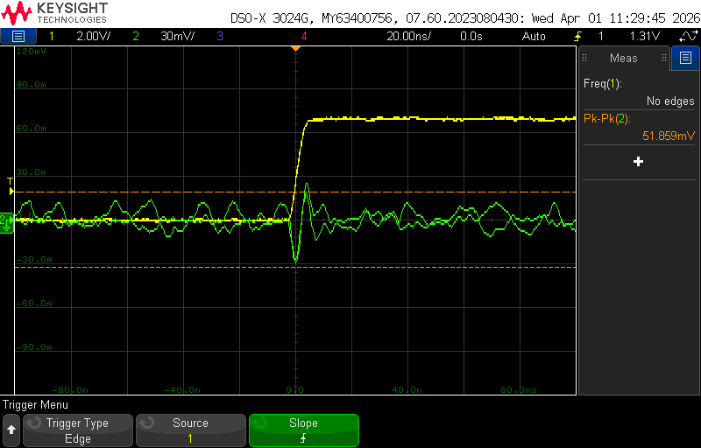
Figure 11. Picture of the EMI seen on the commercial board directly underneath the board’s digital pin 13 that is causing the trigger of the oscilloscope (i.e. where the greatest noise is seen). The green line shows the noise seen by a loop, at the rising edge of the commercial Arduino, approximately 52 mV.
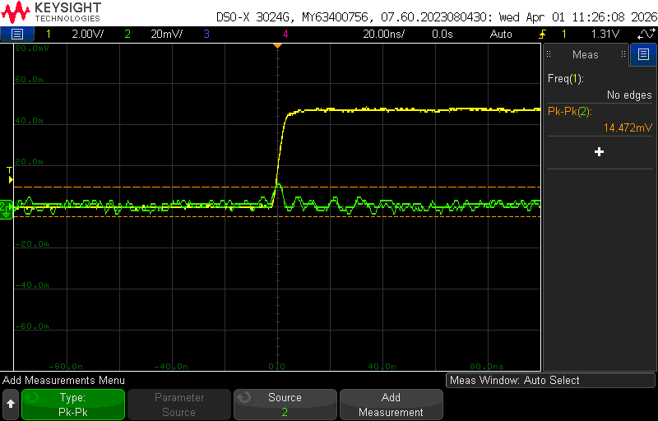
Figure 12. Picture of the EMI at the bottom of the custom-designed board directly underneath digital pin 13 of the board. The green line shows the EMI noise, and this further proves the benefit of not only placing decoupling capacitors at the correct places but also having a copper pour layer. The EMI noise seen in the custom Arduino is approximately that of 15 mV, which compared to the 52 mV of the commercial board, is about 0.29x that of the commercial board.
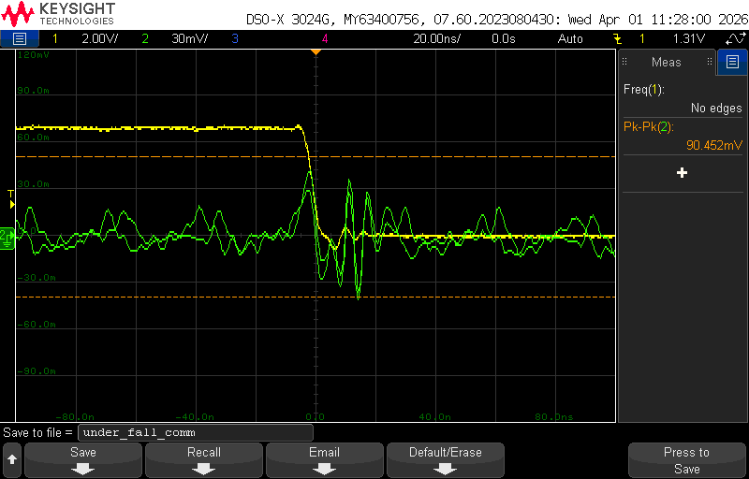
Figure 13. Picture of the EMI seen at the bottom of the board. The green line shows the noise seen by a loop directly underneath digital pin 13 of the commercial board at the falling edge.
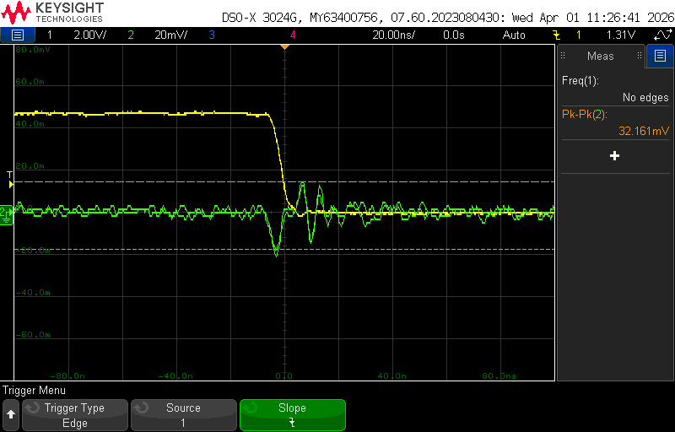
Figure 14. Picture of the EMI seen at the bottom of the board, victim loop is placed directly underneath digital pin 13 that is being used as our scope trigger and is toggling at a constant rate. On the falling edge, it can be seen that the EMI is approximately 32 mV, which is approximately 0.36x the amount of the commercial board 90 mV.
Measurement Type | Q_{low} Switching Noise (Falling Edge) | Q_{low} Switching Noise (Rising Edge) | 5V Rail (ATMega328p) | Q_{high} (ATMega328p) | EMI (Rising Edge) | EMI (Falling Edge) | Avg.
Commercial Board Value (V) | 1.46 | 0.37 | 0.547 | 0.547 | 0.052 | 0.09
My Board Value (V) | 0.74 | 0.21 | 1.23 | 0.458 | 0.014 | 0.032
% of Commercial Board Value | 50.68 | 56.75 | 224.86 | 83.72 | 26.9 | 35.55 | 79.7
Table 1. Recorded noise values to characterize both commercial and custom-designed Arduino board
Based on the measurements in Table 1, on average, my custom board had approximately 80% of the noise of the commercial board. However, this average is skewed by the 5V rail measurement when the ATMega328p switches. When excluding that outlier, the average reduces to approximately 50%, representing a significant improvement in noise reduction and is consistent with the expected results of having a copper pour layer and proper decoupling capacitor placement.

Conclusions and Project Analysis
What Worked and Went Well
Overall, despite the board not undergoing the CDR, the board performed largely as expected. After debugging the board and getting it to power properly, it was able to receive code and run an Arduino IDE program that helped identify many of the differences between the commercial board and the board I designed, as well as areas for future improvement.

Debugging
There were two major debugging steps that had to be taken to debug the board properly.
- At first the USB CH340G IC connection was not recognized by laptops. Using a microscope and a magnifying glass it was confirmed that all solders and traces seemed correct and intact. This was then further confirmed using a DMM to test for continuity, in which all connections passed. Because of this, the original CH340G IC was changed for a new one and that fixed the problem.
- The ATMega328p bootloaded but wasn’t loading any code, after inspecting the ATMega328p under the microscope it was seen that the RST pin and the TX pins of the ATMega328p had a solder bridge connecting the two. This meant that whenever code was trying to be uploaded the RST pin would receive a false reset, inhibiting any code from being uploaded. This was a simple fix and just removed the extra solder, afterwards the Arduino was able to interact with the Arduino IDE as expected.

Hard Errors
There was only one hard error that, while it didn’t prevent the ATMega328p and CH340G chip from interacting and uploading code properly, it did not meet the specification of the POR. The POR requested for the board to be designed in such a way that the Arduino would be powered by either the 5 V Power Jack connector or the USB connector. However, because of a mistake not caught in the schematic and the final PCB Design (due to not having a finished product for the CDR), the ATMega328p can only be fully powered by the power jack connector and not the USB without using a flywire, which leaves the 3.3 V line without power when trying to power the board with a USB. Because of this, the only way to program the Arduino is by having both the power jack and USB connector connected at the same time. Since then, the Schematic and Final PCB layout has been changed to reflect proper power trace distribution [Fig. 1 and Fig. 2].
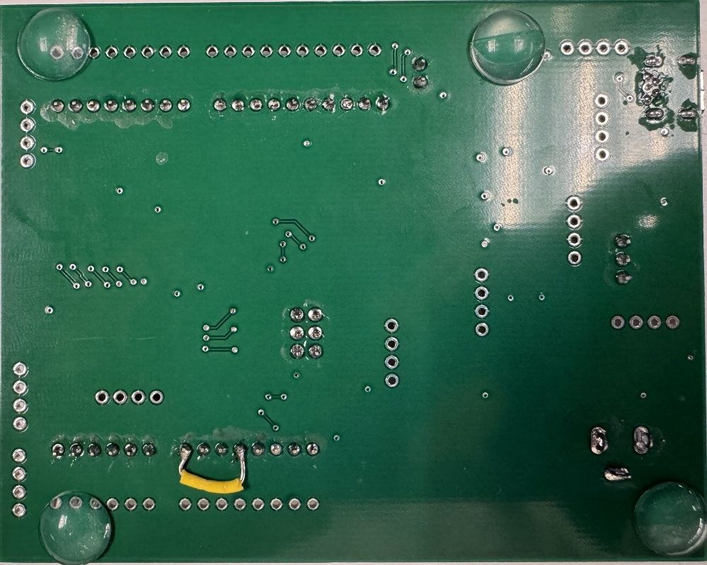
Figure 15. Picture of wire soldered across V_{in} and 5 V pins to properly power the ATMega328p. Quick fix for the hard error, board needs to be powered by the USB and power jack at the same time.

Lessons and Improvements Moving Forward
Moving forward, I think I will need to give myself more breathing room to designing the PCB, especially as components in the PCB and/or layers in it increase. Even with setting aside 50 hours of work for the PCB, it still took longer than expected leading to not having a finished product for the CDR, leading to a hard error that a fresh pair of eyes maybe could’ve caught. Because of this, I want to give myself more breathing room for working on boards than perhaps first estimated in case any hiccups occur (e.g. Altium crashing, work not saving, original PCB layout not optimal, familiarizing myself with new tools, etc.)

