**SQL Assignment**

LeCab Clone

# **Overview**

LeCab is a ride-sharing platform, for assignment you were given 4 tables:

Trips: Trips information

Riders: user data

Riders2: user data

Cars : cars information

**👉 Kindly click on the** [**file**](https://drive.google.com/drive/folders/1zGt6hVgrTUiCX35FV_46b8mU76IX806M?usp=share_link) **to check and download**

Above link contains the .txt file which has CREATEand INSERT sql code of the database. You have to copy the code and paste it in a blank sql workbench sheet. Press ctrl+A then run the entire code by clicking on the left lightning symbol.

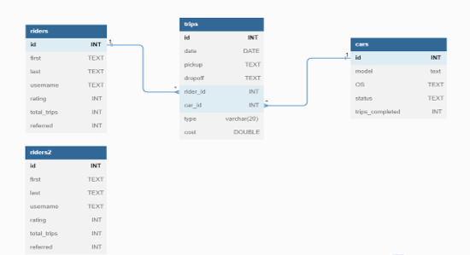

You can also view the ER diagram in you mysql workbench:

**Database tab > reverse Engineer… > Next > enter password > Next > chose database(lecab) > Next> Execute > Next > Finish**

# **Task Questions**

1. First examine all the tables, trips, riders, cars.

2. check the pk and fk of the tables.

3. Do cross join in riders and cars tables.

4. using left join combine trips and riders

5. use INNER join to combine trips and cars.

6. Do union on riders and riders2 table.

7. What is the average cost of a trip? round it in 2 decimals.

8. find all the riders who have used lecab less than 500 times.

9. Write a query that finds two cars that have the highest trips_completed