CUSTOMER SEGMENTATION ANALYSIS USING K-MEANS CLUSTERING
Data Analytics Internship Project Report
Submitted By
Name: Dadi Srinivas
Internship Domain: Data Analytics
Organization: Navodita Infotech
Submission Date: June 2026

ABSTRACT
Customer segmentation is an important technique used by businesses to understand customer behavior and improve marketing strategies. This project analyzes customer data using the K-Means Clustering algorithm to identify different groups of customers based on their annual income and spending score.
The objective of this project is to divide customers into meaningful segments so that businesses can target them with personalized marketing campaigns and improve customer satisfaction.

1. INTRODUCTION
In today's competitive business environment, understanding customer behavior is essential for maximizing sales and customer retention.
Customer Segmentation is the process of dividing customers into groups based on similar characteristics such as:
- Age
- Income
- Spending habits
- Purchase behavior
Machine Learning algorithms such as K-Means Clustering help businesses automatically identify customer groups and generate valuable business insights.

2. OBJECTIVE
The main objectives of this project are:
- Analyze customer data.
- Understand customer spending patterns.
- Apply K-Means Clustering.
- Group customers into meaningful segments.
- Generate business recommendations based on customer behavior.

3. DATASET DESCRIPTION
The dataset used in this project is the Mall Customers Dataset.
Dataset Features
Feature | Description
CustomerID | Unique customer identifier
Gender | Male or Female
Age | Customer age
Annual Income (k$) | Annual income in thousand dollars
Spending Score (1-100) | Spending behavior score
Dataset Information
- Total Records: 200
- Total Columns: 5
- Missing Values: 0
(Insert Screenshot 1: Dataset Preview)
(Insert Screenshot 2: Dataset Information and Statistical Summary)

4. TOOLS AND TECHNOLOGIES USED
Programming Language
- Python
Libraries Used
- Pandas
- NumPy
- Matplotlib
- Seaborn
- Scikit-Learn
Development Environment
- Jupyter Notebook
- Anaconda

5. METHODOLOGY
The project was completed in the following steps:
Step 1: Data Collection
The Mall Customers dataset was loaded into Python using Pandas.
Step 2: Data Exploration
Basic dataset information was analyzed using:
- df.head()
- df.shape
- df.info()
- df.describe()
Step 3: Data Visualization
Several visualizations were created to understand customer behavior:
- Gender Distribution
- Age Distribution
- Annual Income Distribution
- Spending Score Distribution
- Income vs Spending Scatter Plot
Step 4: Customer Segmentation
K-Means Clustering algorithm was applied on:
- Annual Income
- Spending Score
Step 5: Business Insights
Customer groups were analyzed and interpreted to provide marketing recommendations.

6. PROJECT WORKFLOW
Dataset
↓
Data Exploration
↓
Data Visualization
↓
Feature Selection
↓
K-Means Clustering
↓
Customer Segmentation
↓
Business Insights

7. IMPLEMENTATION
Importing Required Libraries
import pandas as pd
import matplotlib.pyplot as plt
import seaborn as sns
from sklearn.cluster import KMeans

Loading Dataset
df = pd.read_csv("Mall_Customers.csv")
df.head()

Feature Selection
X = df[['Annual Income (k$)',
'Spending Score (1-100)']]

Applying K-Means Clustering
kmeans = KMeans(
n_clusters=5,
random_state=42,
n_init=10
)
y_kmeans = kmeans.fit_predict(X)

Creating Clusters
df['Cluster'] = y_kmeans

Visualizing Customer Segments
plt.scatter(
X.iloc[:,0],
X.iloc[:,1],
c=y_kmeans
)

8. DATA VISUALIZATION RESULTS
Gender Distribution
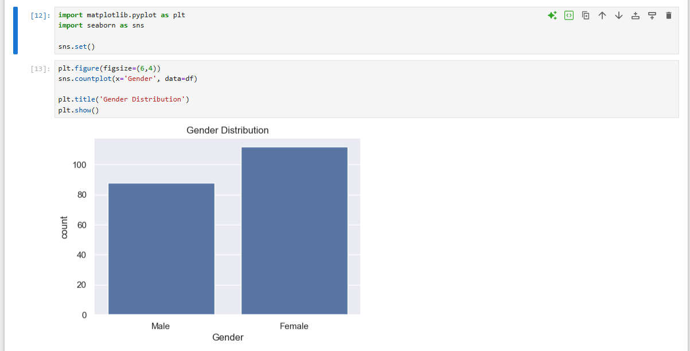
Age Distribution
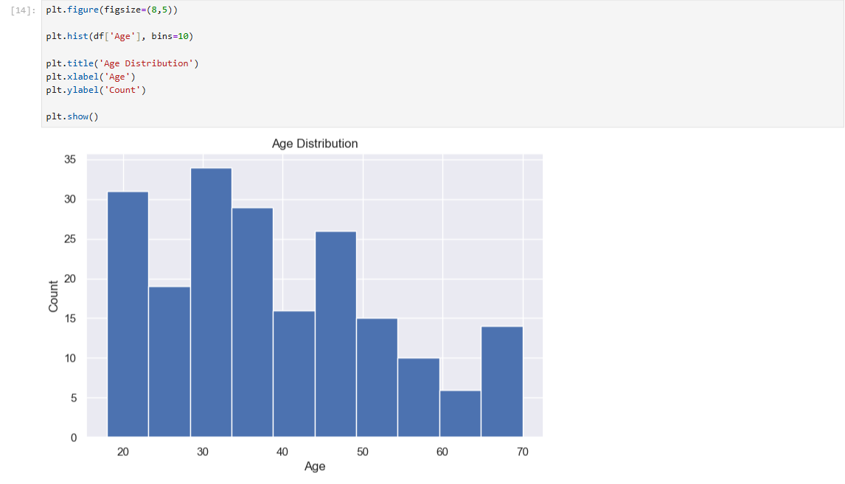

Annual Income Distribution
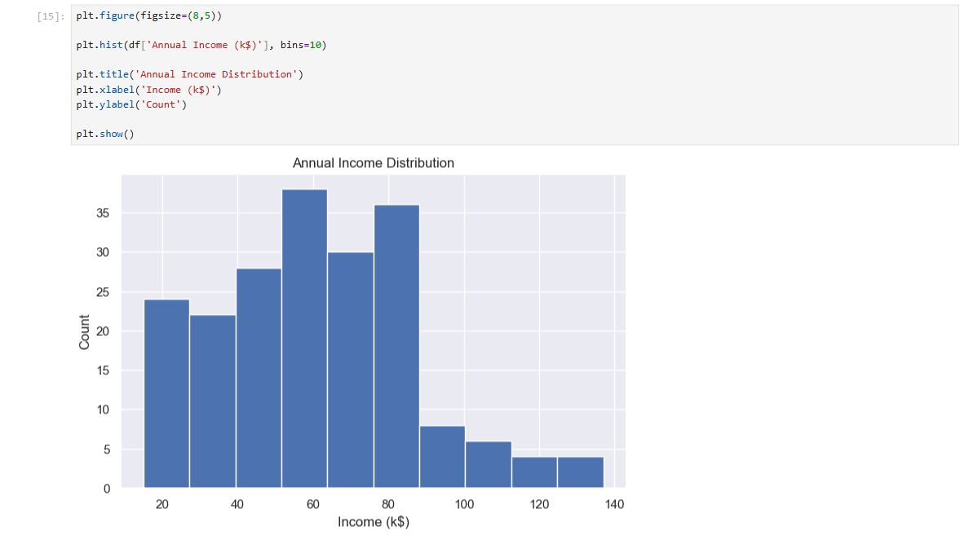

Spending Score Distribution

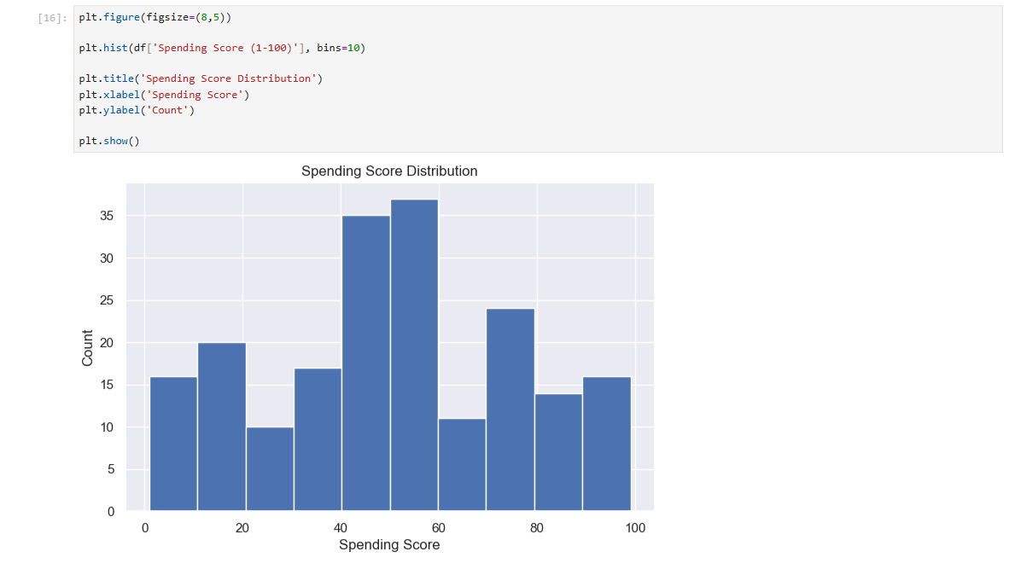 Income vs Spending Score

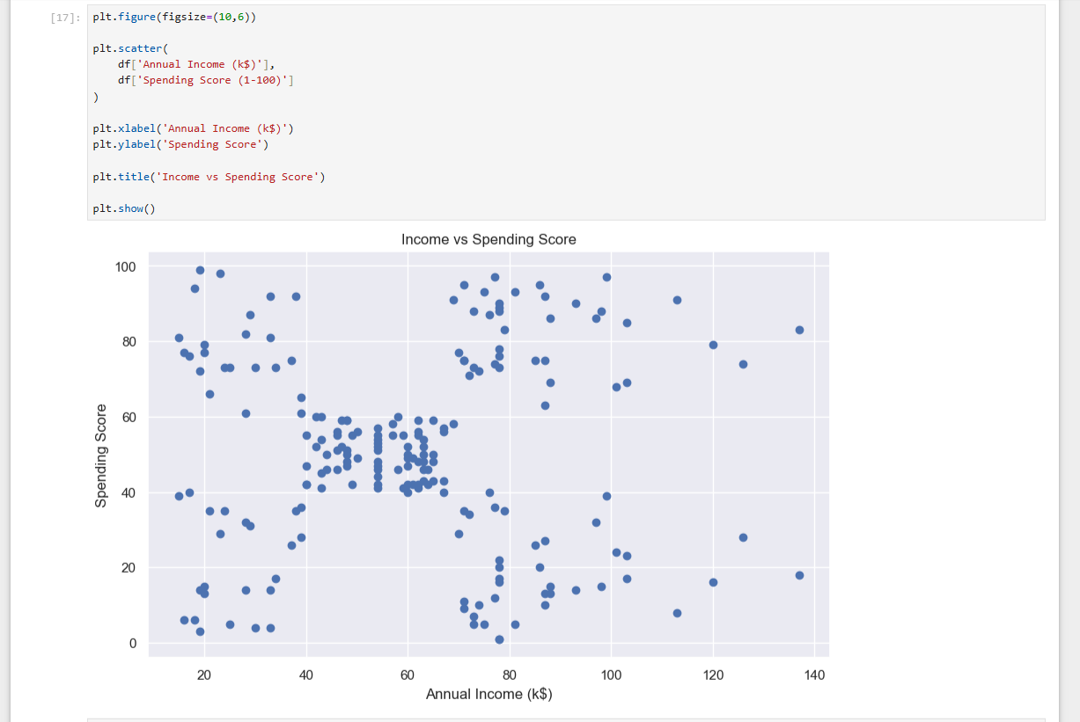

Customer Segmentation Graph
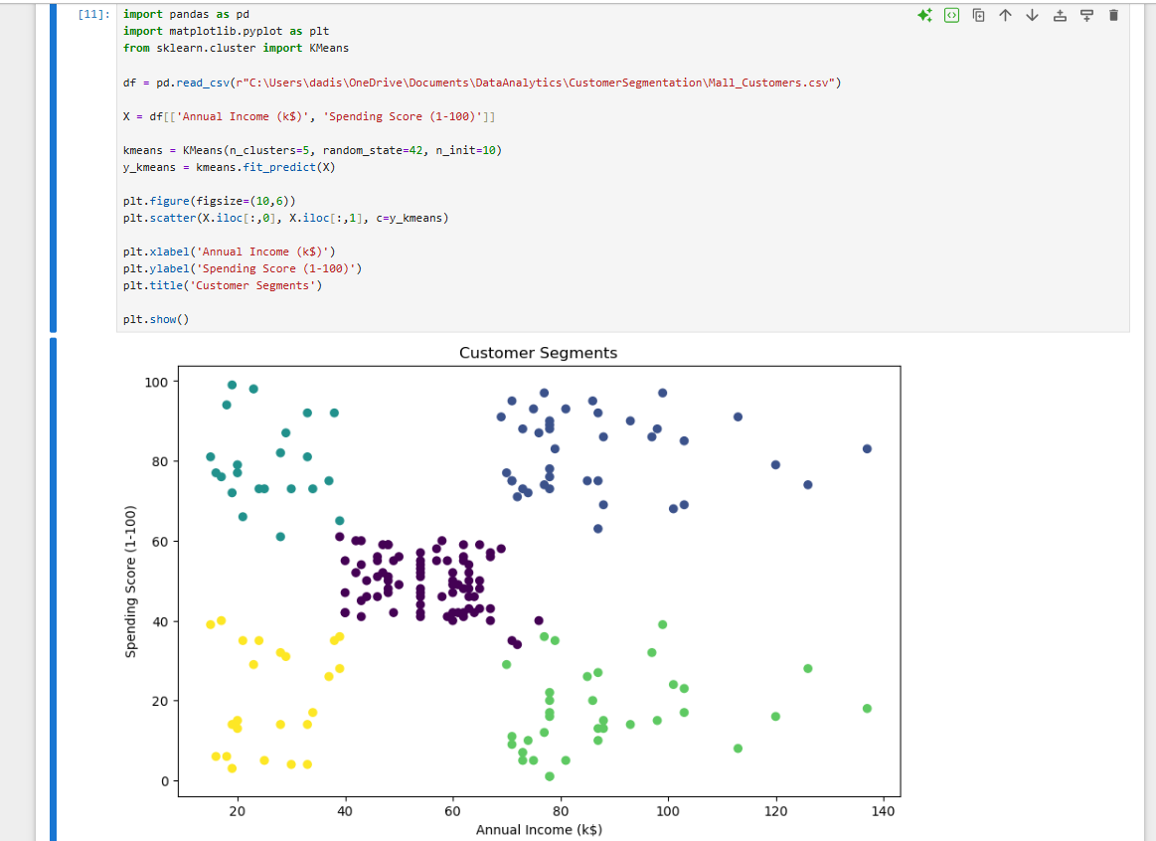
9. CLUSTER ANALYSIS
Customer Distribution
Cluster | Customers
0 | 81
1 | 39
2 | 22
3 | 35
4 | 23

Average Values of Each Cluster
Cluster | Annual Income | Spending Score | Age
0 | 55.30 | 49.52 | 42.72
1 | 86.54 | 82.13 | 32.69
2 | 25.73 | 79.36 | 25.27
3 | 88.20 | 17.11 | 41.11
4 | 26.30 | 20.91 | 45.22
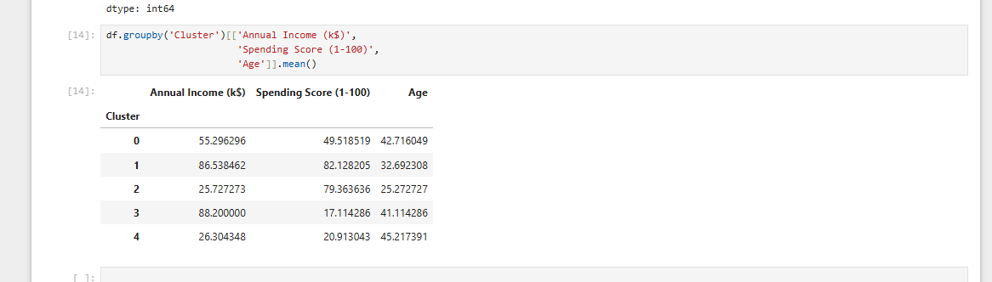
10. BUSINESS INSIGHTS
Cluster 0
Average Income – Average Spending
- Regular customers
- Suitable for loyalty programs

Cluster 1
High Income – High Spending
- Premium customers
- Most valuable customer group
- Target with luxury products and exclusive offers

Cluster 2
Low Income – High Spending
- Young enthusiastic shoppers
- Respond well to discounts and offers

Cluster 3
High Income – Low Spending
- Potential customers
- Can be converted through personalized marketing

Cluster 4
Low Income – Low Spending
- Budget-conscious customers
- Suitable for affordable product campaigns

11. CONCLUSION
Customer Segmentation Analysis was successfully performed using the K-Means Clustering algorithm.
Five distinct customer groups were identified based on Annual Income and Spending Score. The analysis revealed different customer behaviors and spending patterns, enabling businesses to design targeted marketing strategies.
This project demonstrates how Data Analytics and Machine Learning can be used to transform raw customer data into meaningful business insights.

12. FUTURE ENHANCEMENTS
Future improvements can include:
- Using larger real-world datasets.
- Applying advanced clustering algorithms.
- Developing interactive dashboards using Power BI.
- Integrating customer purchase history.
- Real-time customer segmentation systems.

REFERENCES
- Python Documentation
- Scikit-Learn Documentation
- Pandas Documentation
- Matplotlib Documentation
- Mall Customers Dataset (Kaggle)

