How Flux is wired in the Uniphore Platform Lab
Written for: someone learning Flux and GitOps through this lab repo (kind cluster + GitHub).

1. The idea in one paragraph
Git is the source of truth. Nobody runs kubectl apply for app changes. CI only edits files in Git (an image tag). Flux, running inside the cluster, polls Git and makes the cluster match. Rolling back means git revert.

2. Big picture
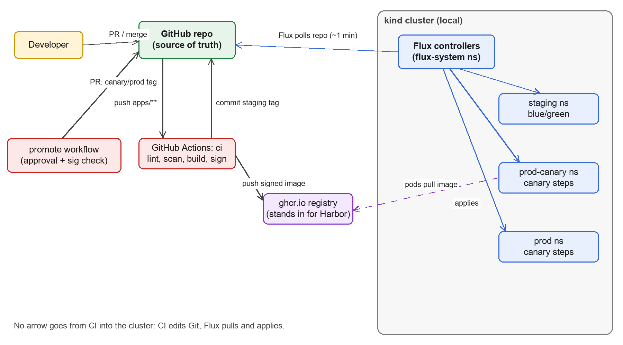
Figure 1: Delivery flow. CI never pushes to the cluster; Flux pulls from Git.

3. Flux components in the cluster
Installed by flux bootstrap into the flux-system namespace.
Controller | Job in this lab
source-controller | Clones the GitHub repo (GitRepository flux-system) and fetches the Argo Helm chart (HelmRepository).
kustomize-controller | Builds and applies the Kustomizations (infra and the apps) and waits for health.
helm-controller | Installs the Argo Rollouts HelmRelease.
notification-controller | Events and alerts. Unused in the lab; ready for Slack and similar.

4. The chain of Kustomizations
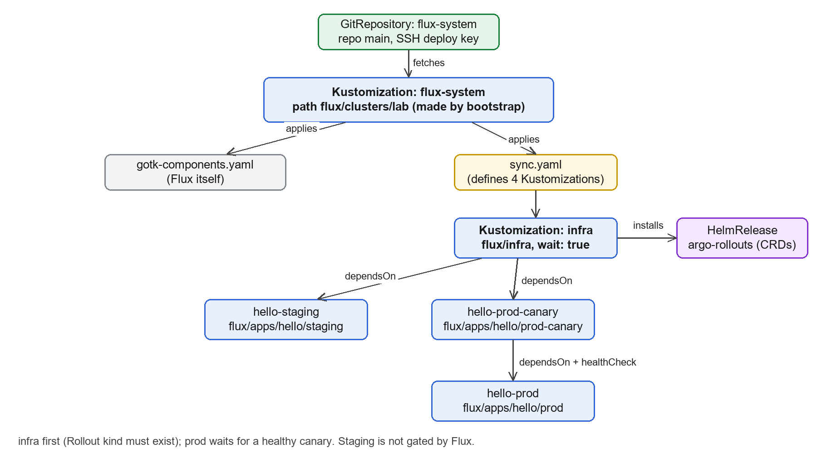
Figure 2: How bootstrap leads to infra, staging, canary and prod.
- Self-managing bootstrap. The flux-system Kustomization watches the folder holding Flux's own manifests and sync.yaml. Adding a file there makes Flux create more Kustomizations.
- infra first. The apps use kind: Rollout, which does not exist until Argo Rollouts' CRDs are installed. dependsOn: infra avoids "no matches for kind Rollout" errors.
- Prod waits for canary. hello-prod dependsOn hello-prod-canary, which has a healthCheck on its Rollout. A bad canary keeps prod from reconciling.
- Note. hello-prod-canary dependsOn infra, not hello-staging. Staging-before-canary is enforced by the promote workflow (it copies the staging tag), not by Flux.

5. Repo layout
flux/
clusters/lab/
sync.yaml defines infra + 3 app Kustomizations
flux-system/ generated by bootstrap (components, git sync)
infra/
argo-rollouts.yaml Namespace + HelmRepository + HelmRelease
apps/hello/
base/ Rollout, Services, PDB, NetworkPolicy (shared)
staging/ overlay: namespace, image tag, blue/green patch
prod-canary/ overlay: namespace, image tag
prod/ overlay: namespace, image tag, 6 replicas

Kustomize pattern: base is the shared definition. Each overlay sets namespace, images (name + tag) and small patches. Promotion means changing one line, newTag, in an overlay.

6. Life of a change
# | Actor | What happens
1 | Developer | Merges a change under apps/.
2 | GitHub Actions (ci) | Lints, scans, builds, signs, pushes the image; commits newTag=sha-xxxx to the staging overlay.
3 | Flux | Polls Git (about every minute) and applies the staging overlay.
4 | Argo Rollouts | Runs a blue/green rollout in staging, then switches traffic.
5 | Developer | Runs the promote workflow for prod-canary; approves; merges the PR.
6 | Flux + Argo Rollouts | Apply the canary overlay; canary steps 25%, 50%, 100%.
7 | Flux | Canary healthy, so hello-prod is unblocked.
8 | Developer | Runs promote for prod; merges the PR; Flux applies the prod overlay.

7. Flux vs Argo Rollouts
Two layers that are easy to mix up.
- Flux decides what version is declared. It reads Git and applies manifests. It is the GitOps engine.
- Argo Rollouts decides how a new version is rolled out inside one namespace (blue/green or canary steps). Flux only applies a Rollout object; the Rollouts controller does the rest.

8. Commands to see it working
flux get sources git # is the repo being fetched?
flux get kustomizations # status of infra / staging / canary / prod
flux get helmreleases -A # Argo Rollouts install
flux reconcile kustomization hello-staging --with-source # skip the wait
flux logs --level=error # controller errors
kubectl get rollout -A # Rollouts per namespace
flux tree kustomization flux-system # everything Flux owns

9. Failure modes worth practising
Symptom | Likely cause
staging pods ImagePullBackOff | Tag is still 'bootstrap', ci has not pushed the image yet, or the ghcr package is private.
Kustomization False: no matches for kind Rollout | infra has not finished; check flux get helmreleases -A.
hello-prod never reconciles | Canary Rollout not healthy (by design).
Manual kubectl edit is reverted | Flux drift correction at the next reconcile. That is GitOps working.
Need to roll back | git revert the tag-bump commit; Flux restores the old version.

10. Differences from Uniphore's real setup
Real: Flux per cluster (staging cluster, prod canary cluster us0, prod clusters), repos on GitHub, images from Harbor, secrets via Secrets Manager. Lab: one cluster, namespaces stand in for clusters, ghcr.io stands in for Harbor.
Never run flux install or flux bootstrap against real clusters. Here it only touched the local kind cluster.

