|  |  |
| --- | --- |
| Name: |  |
| Athena user name: |  |
| Recitation Section: |  |

|  |  |
| --- | --- |
| Question 1. (10 pts)  Question 2. (15 pts)  Question 3. (20 pts)  Question 4. (25 pts)  Question 5. (25 pts)  Question 6 (5 pts) | ….......______________  ….......______________  ….......______________  ….......______________  ….......______________  ….......______________ |

## Question 1. (15 pts)

Identify the complexity of each of the codes shown below

|  |  |
| --- | --- |
| a)  def **sort1(L):**  doMore = True  while(doMore):  doMore = False  for i in xrange(0, len(L)-1):  if(L[i] > L[i+1]):  swap(L, i, i+1)  doMore = True  return L | b, c)  def **sort2(L):**  if(len(L) <= 1):  return L  mid = len(L) / 2  L1 = sort2(L[0:mid])  L2 = sort2(L[mid:])  return combine(L1, L2)  def **combine(L1, L2):**  result = []  p1 = 0  p2 = 0  for i in xrange(0, len(L1) + len(L2)):  if(decide(L1, L2, p1, p2)):  result.append(L1[p1])  p1 += 1  else:  result.append(L2[p2])  p2 += 1  return result  def **decide(L1, L3, p1, p2):**  ‘‘‘decide whether to read from L1 or L2’’’ |
| a) Complexity of sort1: | b) Complexity of combine:  c) Complexity of sort2: |

## Question 2. (15 pts)

Object-oriented programming. We want to implement classes to store information about different items in a store. We give you a class Good that is used to store the name and price of regular item. Your task is to complete a derived class GoodOnSale that stores, in addition to the regular price already stored by Good, a percentage off.

class Good:

def __init__(price, name):

self.price=price

self.name=name

def getCurrentPrice():

return price

class GoodOnSale(Good):

def __init__(price, name, percentageRebate):

#Your code here

def getCurrentPrice():

#Your code here

## Question 3. (20 pts)

More object-oriented programming. We give you the following class for complex numbers (which is different from the one in lecture).

class ComplexNumber:

def __init__(re, im):

self.re=re

self.im=im

def mutateAdd(cplx2):

self.re=self.re+cplx2.re

self.im=self.im+cplx2.im

def __str__():

return str(self.re) + '+' + str(self.im) + 'i'

a) What does the following code print?

c1=ComplexNumber(0.0, 1.0)

c2=ComplexNumber(1.0, 0.0)

c3=ComplexNumber(0.0, 1.0)

c4=c1

c1.add(c2)

print c1

print c3

print c4

Answer:

b) What is wrong with the following code?

c1=ComplexNumber(0.0, 1.0)

c1.re=1.0

Answer:

## 

## Question 4. (25 pts)

For this exercise, we are going to use the Monte Carlo method to compute the natural logarithm of a value c > 1; i.e. ln(c). We know from basic calculus that the natural logarithm ln(c) equals the area under the curve 1/x between 1 and c (if you did not know that, you know it now!). We are going to compute the area under this curve by taking a random sample of the points in the rectangle between (1,0) and (c,1)---which has a known area (c-1)---and computing the fraction that fall below the 1/x curve as shown in the figure below.

**Your code should raise a ValueError if C is not greater than 1.**

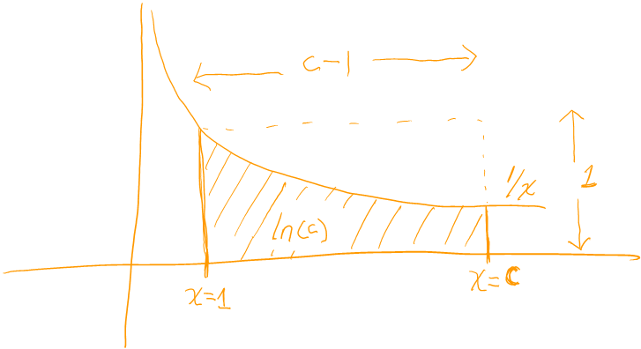

def monteCarloLn(c, N):

'''return a monte carlo approximation of ln(c) using N samples.

raises a ValueError if c<=1 '''

## 

## Question 5. (25 pts)

In the game of Jenga, players take turn moving wooden blocks in an assembly until one of the players makes a move that causes the whole structure to collapse, in which case he or she loses. Write a Monte Carlo simulation that computes the average duration of a game of two players given the probability p1 and p2 that each of them loses at a given step. You should assume that the probabilities of losing are independent and remain constant as the game progresses.

def monteCarloJenga(p1, p2, N):

‘‘‘run N trials of simulation to estimate the average duration of the game

assuming that on every turn, player 1 has a probability p1 of losing and

player 2 has a probability p2 of losing.’’’

## 

## Question 6. (5 pts)

Link each of the concepts on the left with a concept on the right.

|  |  |
| --- | --- |
|  | abstraction barrier |
| memoryless property |  |
|  | Gaussian Distribution |
| overriding parent class methods |  |
|  | Exponential Distribution |
| getter and setter methods |  |
|  | polymorphism |
| package data and computation |  |
|  | Objects |