Prediction of biological environment from MRI scans, by reverse engineering methods

By David Cohen - 204150718

Advisor: Professor Aviv Mezer

Background:

Conventional Magnetic Resonance Imaging (MRI) techniques are used in the clinical routine to diagnose and monitor neurological diseases. However, clinical routine MRI of the brain primarily visualizes macroscopic lesions. In contrast, it is difficult to assess subtle changes with MRI, and obtain a quantitative index of the scaned tissue.

In contrast, quantitative MRI (qMRI) techniques measure actual physical parameters.

The respective parameter maps provide quantitative parameter values that can be used to detect subtle changes in tissue composition in neurological diseases such as Parkinson[1], or abnormal biological processes such as aging[2].

This project will be focused on five qMRI parameters:

T1 - The time constant which determines the time at which excited protons return to equilibrium.

T2 - The time constant which determines the time at which excited protons reach equilibrium or go out of phase with each other.

R2* - relaxation refers to decay of transverse magnetization caused by a combination of spin-spin relaxation and magnetic field inhomogeneity, highly correlated with R2[3].

MTV - macromolecular tissue volume

MT - Magnetization Transfer is the physical process by which macromolecules and their closely associated water molecules (the "bound" pool) cross-relax with protons in the free water pool.

The human brain is comprised mainly of water (70–80%), proteins (8–11%) and lipids (5 15%)[4] The distribution of these four molecules varies between brain regions, across lifespan, and in different pathological states. Lipids are known to strongly affect the contrast of brain qMRI maps4.

Iron is an important metal involved in various physiological processes, such as ATP generation and DNA replication (Chang, 2019; Mills et al., 2010; Qian & Ke, 2019).

Particularly, iron is essential for a variety of neurological processes (McCarthy & Kosman, 2015; Rouault, 2013). Iron transport in the brain is effectuated by several pathways; namely, transferrin-dependent iron transport, non-transferrin bound iron (NTBI) mobilization, uptake and export by and from neurons, oligodendrocytes, astrocytes, and microglia (Hohnholt & Dringen, 2013; Roy Sarkar & Dutta, 2019). Furthermore, Ferritin is the main iron storage protein, conformed by two types of subunits, H type (heavy) and L type (light), which co-assemble into a supramolecular spherical-shaped protein (Chang, 2019). The iron content and water fraction (WF) of cellular compartments are thought to influence qMRI parameters (Stüber et al., 2014).

# There have been a few quantitative attempts to find a relationship between lipid content and qMRI results(Disentangling molecular alterations from water-content changes in the aging human brain using quantitative MRI), Fig. 1 contains   a diagrammatic summary of the MRI methods that have been used to probe biological substrates.

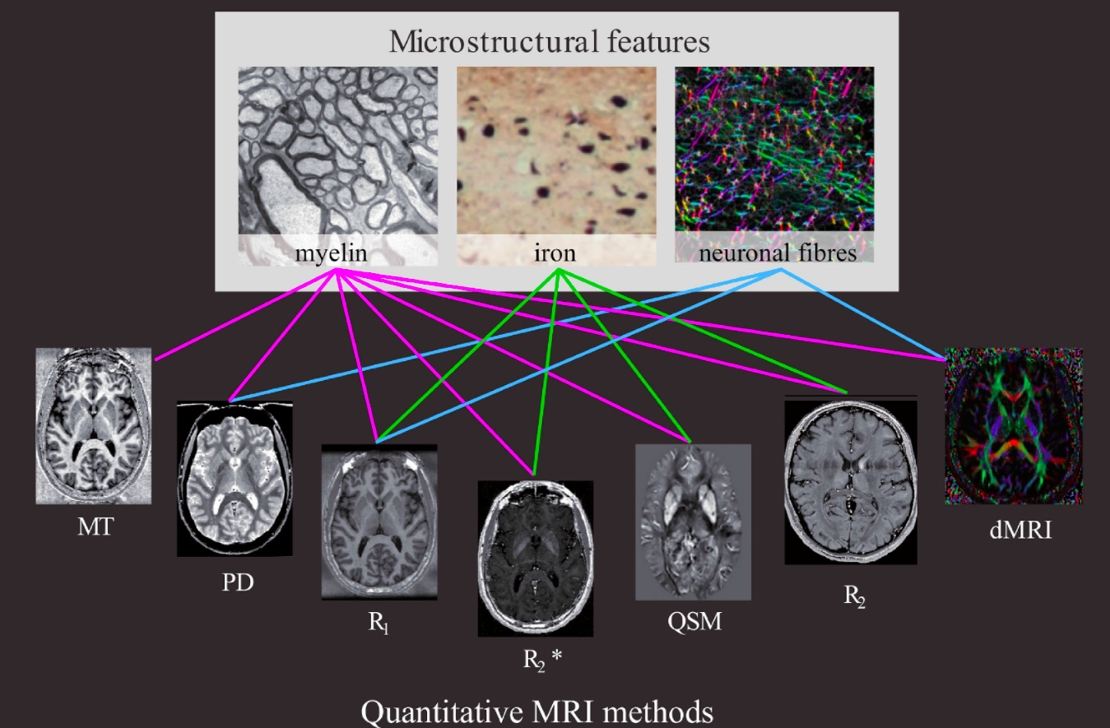

Fig. 1. Schematic representation of connections between MRI methods and the neocortical microstructural. A coloured line between a method and a microstructural feature implies that this method has been used to probe this feature in the reviewed papers in Sections [Myelin mapping: myeloarchitecture in vivo](https://www.sciencedirect.com/science/article/pii/S1053811918301629" \l "sec3.3) - [Iron mapping: from glial cells to senile plaques](https://www.sciencedirect.com/science/article/pii/S1053811918301629" \l "sec3.5).

Research goals:

In this study, I will try to find a way to predict the biological environment of tissue in terms of lipids and iron content by analyzing qMRI results only, using methods of reverse engineering and machine learning.

Data

The data I will use during the study based on about 500 samples of water solutions, in the presence of different lipids and iron content (free ions, and protein-bounded) in different types and varying amounts.

These samples were scanned in a 3T MRI machine, and 5 parameters of qMRI were established (R1 = 1/T1, R2 = 1/T2, R2*, MT and MTV).

Work plan

1) Preliminary background: Reading articles on qMRI and the impact of the biological environment on its parameters. Understanding the methods techniques developed, in this lab, specifically for in-vitro samples.

2) Analysis of the data: analyze the data on which the study is based on, detecting outliers, study the different models suggested previously to correlate the qMRI parameters to the lipid and iron compositions. Asses if additional experiments are necessary to achieve this goal.

3) Creating a unified and cohesive model for determining the biological environment of arbitrary sampling.

4) Check the results of the model and correct it if necessary

Computational Tools:

At this research Simple *Linear Regression* Models were created to examine the ability to predict iron and lipid concentrations by five parameters of qMRI values. Linear regression is a linear approach for modelling the relationship between a scalar response and one or more explanatory variables (Freedman, 2009).

In addition,I use *leave one out cross-validation* technique. the available learning set is partitioned into n disjoin. The model is trained using n − 1 subsets, which, together, represent the training set. Then, the model is applied to the remaining subset, which is denoted as the validation set, and the performance is measured. This procedure is repeated until each of the n subsets has served as validation set. The average of the n performance measurements on the n validation sets is the cross-validated performance.

References:

1. Nürnberger L, Gracien RM, Hok P, et al. Longitudinal changes of cortical microstructure in Parkinson’s disease assessed with T1 relaxometry. *NeuroImage: Clinical*. 2017;13:405-414. doi:10.1016/J.NICL.2016.12.025

1. 1. Nürnberger L, Gracien RM, Hok P, et al. Longitudinal changes of cortical microstructure in Parkinson’s disease assessed with T1 relaxometry. *NeuroImage: Clinical*. 2017;13:405-414. doi:10.1016/J.NICL.2016.12.025

  
2. Filo, Shir, et al. "Disentangling molecular alterations from water-content changes in the aging human brain using quantitative MRI." *Nature communications* 10.1 (2019): 1-16.‏
3. Craft, Melissa L., et al. "R2 and R2* MRI assessment of liver iron content in an undifferentiated diagnostic population with hyperferritinaemia, and impact on clinical decision making." *European Journal of Radiology* 135 (2021): 109473.‏
4. Shtangel, Oshrat, and Aviv A. Mezer. "A phantom system for assessing the effects of membrane lipids on water proton relaxation." *NMR in Biomedicine* 33.4 (2020): e4209.‏