Climate Modelling

Pietro Monticone & Davide Orsenigo

2019-08-26 | Turin University

# Introduction

### Packages

library(tidyverse)  
library(plotly)  
library(scales)  
library(gganimate)  
library(knitr)  
library(DT)  
library(colorRamps)  
library(webshot)

### Input Parameters

S <- 1370  
A <- 204  
B <- 2.17  
K <- 3.86  
ai <- 0.62  
ab <- 0.25  
aW <- 0.75  
aB <- 0.25  
gamma <- 2.2  
delta <- 10/gamma  
c <- 7  
k <- 0.003265*0.75  
T0 <- 20  
D <- 0.3 # Death Rate  
w0 <- 0.5  
b0 <- 0.2  
u0 <- 1-w0-b0

### Fit from Textbook Spreadsheet

zones <- c(85,75,65,55,45,35,25,15,6)  
coszones <- cospi(zones/180)  
sunWt <- c(0.5,0.531,0.624,0.77,0.892,1.021,1.12,1.189,1.219)  
df <- data.frame(zones,sunWt)  
f <- function(zones,d,n,k){  
 d*cos(n*zones)^2+k } #cos or cos^2 ??  
  
Fit <- nls(sunWt ~ f(zones,d,n,k),data= df, start=list(d=1,n=0.015,k=0.3))  
ggplot(df, aes(zones,sunWt))+geom_point()+geom_smooth(aes(y=f(zones,0.7768699,0.0164348,0.4617747)))+xlab("Latitude")+ylab("Solar Weight Factor")

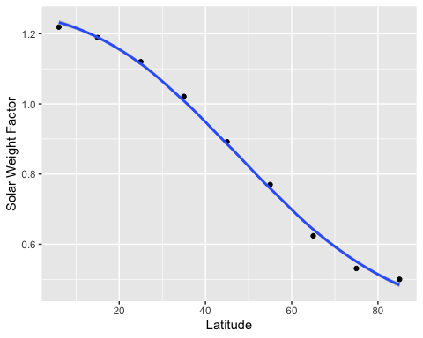

### Functional Forms

gauss <- function(x,m,sd,b){  
 ((24+b)/(0.00798*sqrt(2*pi*sd^2)))*exp(-(x-m)^2/(2*sd^2))-b  
}  
  
#SOLAR LUMINOSITY (Latitude)  
Func <- function(x){ 0.7768699*cos(0.0164348*x)^2+0.4617747 }  
# SOLAR LUMINOSITY (Time)  
Sun1 <- function(x,a){a*x/100}   
Sun2 <- function(x){1370*(sinpi((x+90)/180))^2}  
Sun3 <- function(x){1370-(((1370)/(sqrt(2*pi*1^2)))*exp(-(x-50)^2/(2*1^2)))}  
Sun4 <- function(x){ifelse(x==50,1370/3,1370)}  
Sun5 <- function(x){(1/100) * (abs(x-150)+25)}  
Sun6 <- function(x){1370*(1+0.1*cospi(x/180))}  
Incident <- function(x,y){x*y/4}  
  
# ALBEDO  
Step <- function(x,c){ifelse(x<c, 0.6, 0.3)}  
alb <- function(x,a,b,c,d){ (exp(c*(x+d)) / (exp(c*(x+d))+1)) * (b-a) + a }  
  
# EBM  
ebm01 <- function(cycles,A,B,K,ai,ab,gamma,delta) {  
 Incident <- function(x,y){ x*y/4 }  
 Func <- function(x){ 0.7768699*cos(0.0164348*x)^2+0.4617747 }  
   
 Zones <- seq(-89, 89, by = 2)  
 cosZones <- abs(cospi(Zones/180))  
 t <- c(1:cycles)  
 Temperature <- rep(0,cycles)  
 Ti <- gauss(Zones,0,50,31.6)  
 SunWt <- Func(Zones)  
 Rin <- Incident(S,SunWt)  
 T <- Ti  
 a <- alb(T,ai,ab,gamma,delta)  
   
 for(i in t) { Tcos <- cosZones*T  
 Tm <- sum(Tcos)/sum(cosZones)  
 T <- (Rin*(1-a)+K*Tm-A) / (B+K)  
 a <- alb(T,ai,ab,gamma,delta)  
 Temperature[i] <- Tm }  
   
 return( data.frame(Zones,T,a,Ti)) }   
ebm02 <- function(cycles,A,B,K,ai,ab,gamma,delta) {  
 Incident <- function(x,y){ x*y/4 }  
 Func <- function(x){ 0.7768699*cos(0.0164348*x)^2+0.4617747 }  
 Zones <- seq(-89, 89, by = 2)  
 cosZones <- abs(cospi(Zones/180))  
 t <- c(1:cycles)  
 Temperature <- rep(0,cycles)  
 Ti <- gauss(Zones,0,50,31.6)  
 SunWt <- Func(Zones)  
 Rin <- Incident(S,SunWt)  
 T <- Ti  
 a <- alb(T,ai,ab,gamma,delta)  
 for(i in t)   
 {Tcos <- cosZones*T  
 Tm <- sum(Tcos)/sum(cosZones)  
 T <- (Rin*(1-a)+K*Tm-A) / (B+K)  
 a <- alb(T,ai,ab,gamma,delta)  
 Temperature[i] <- Tm }  
 return( data.frame(t,Temperature) ) }   
  
ebm11 <- function(cycles1,cycles2,A,B,K,ai,ab,gamma,delta) {  
 Incident <- function(x,y){ x*y/4 }  
 Func <- function(x){ 0.7768699*cos(0.0164348*x)^2+0.4617747 }  
 Sun1 <- function(x,a){a*x/100}   
   
 Zones <- seq(-89, 89, by = 2)  
 cosZones <- abs(cospi(Zones/180))  
 J <- rep(0,cycles1)  
 TEMP1 <- matrix(NA, nrow=90, ncol=cycles1)  
 Temp <- rep(0,cycles1)  
 Sun1 <- function(x,a){a*x/100}   
 SunWt <- Func(Zones)  
   
 for(j in c(1:cycles1)){  
 T <- gauss(Zones,0,50,31.6)  
 a <- alb(T,ai,ab,gamma,delta)  
 S <- Sun1(1370,j)  
 Rin <- Incident(S,SunWt)  
   
 for(i in c(1:cycles2))  
 {Tcos <- cosZones*T  
 Tm <- sum(Tcos)/sum(cosZones)  
 T <- (Rin*(1-a)+K*Tm-A) / (B+K)  
 a <- alb(T,ai,ab,gamma,delta)  
 TEMP1[,j] <- T  
 J[j] <- j  
 Temp[j] <- Tm } }   
   
 return( data.frame(J,Temp) ) }   
ebm12 <- function(cycles1,cycles2,A,B,K,ai,ab,gamma,delta) {  
 Incident <- function(x,y){ x*y/4 }  
 Func <- function(x){ 0.7768699*cos(0.0164348*x)^2+0.4617747 }  
 Sun1 <- function(x,a){a*x/100}   
   
 Zones <- seq(-89, 89, by = 2)  
 cosZones <- abs(cospi(Zones/180))  
 SunWt <- Func(Zones)  
 J <- rep(0,cycles1)  
 TEMP1 <- matrix(NA, nrow=90, ncol=cycles1)  
 Temp <- rep(0,cycles1)  
   
   
 for(j in c(1:cycles1)){  
 T <- gauss(Zones,0,50,31.6)  
 a <- alb(T,ai,ab,gamma,delta)  
 S <- Sun1(1370,j)  
 Rin <- Incident(S,SunWt)  
   
 for(i in c(1:cycles2))  
 {Tcos <- cosZones*T  
 Tm <- sum(Tcos)/sum(cosZones)  
 T <- (Rin*(1-a)+K*Tm-A) / (B+K)  
 a <- alb(T,ai,ab,gamma,delta)  
 TEMP1[,j] <- T  
 J[j] <- j  
 Temp[j] <- Tm } }   
   
 return( TEMP1 ) }  
  
ebm21 <- function(cycles1,cycles2,A,B,K,ai,ab,gamma,delta ) {  
 Incident <- function(x,y){ x*y/4 }  
 Func <- function(x){ 0.7768699*cos(0.0164348*x)^2+0.4617747 }  
 Sun2 <- function(x){1370*(sinpi((x+90)/180))^2}  
   
 Zones <- seq(-89, 89, by = 2)  
 cosZones <- abs(cospi(Zones/180))  
 SunWt <- Func(Zones)  
 J <- rep(0,cycles1)  
 Temp2 <- rep(0,cycles1)  
 T2 <- gauss(Zones,0,50,31.6)  
 TEMP2 <- matrix(NA, nrow=90, ncol=cycles1)  
 a <- alb(T2,ai,ab,gamma,delta)  
 Sarr <- rep(0,cycles1)   
   
for(j in c(1:cycles1)){  
 S <- Sun2(j)  
 Rin <- Incident(S,SunWt)  
 for(i in c(1:cycles2))  
 {Tcos <- cosZones*T2  
 Tm <- sum(Tcos)/sum(cosZones)  
 T2 <- (Rin*(1-a)+K*Tm-A) / (B+K)  
 a <- alb(T2,ai,ab,gamma,delta)  
 }  
 Sarr[j] <- Sun2(j)  
 TEMP2[,j] <- T2  
 J[j] <- j  
 Temp2[j] <- Tm }   
   
 return( data.frame(J,Temp2) ) }  
ebm22 <- function(cycles1,cycles2,A,B,K,ai,ab,gamma,delta ) {  
 Incident <- function(x,y){ x*y/4 }  
 Func <- function(x){ 0.7768699*cos(0.0164348*x)^2+0.4617747 }  
 Sun2 <- function(x){1370*(sinpi((x+90)/180))^2}  
   
 Zones <- seq(-89, 89, by = 2)  
 cosZones <- abs(cospi(Zones/180))  
 J <- rep(0,cycles1)  
 Temp2 <- rep(0,cycles1)  
 T2 <- gauss(Zones,0,50,31.6)  
 TEMP2 <- matrix(NA, nrow=90, ncol=cycles1)  
 a <- alb(T2,ai,ab,gamma,delta)  
 Sarr <- rep(0,cycles1)   
 SunWt <- Func(Zones)  
   
for(j in c(1:cycles1)){  
 S <- Sun2(j)  
 Rin <- Incident(S,SunWt)  
 for(i in c(1:cycles2))  
 {Tcos <- cosZones*T2  
 Tm <- sum(Tcos)/sum(cosZones)  
 T2 <- (Rin*(1-a)+K*Tm-A) / (B+K)  
 a <- alb(T2,ai,ab,gamma,delta)  
 }  
 Sarr[j] <- Sun2(j)  
 TEMP2[,j] <- T2  
 J[j] <- j  
 Temp2[j] <- Tm }   
   
 return( TEMP2 ) }  
ebm23 <- function(cycles1,cycles2,A,B,K,ai,ab,gamma,delta ) {  
 Incident <- function(x,y){ x*y/4 }  
 Func <- function(x){ 0.7768699*cos(0.0164348*x)^2+0.4617747 }  
 Sun2 <- function(x){1370*(sinpi((x+90)/180))^2}  
   
 Zones <- seq(-89, 89, by = 2)  
 cosZones <- abs(cospi(Zones/180))  
 J <- rep(0,cycles1)  
 Temp2 <- rep(0,cycles1)  
 T2 <- gauss(Zones,0,50,31.6)  
 TEMP2 <- matrix(NA, nrow=90, ncol=cycles1)  
 a <- alb(T2,ai,ab,gamma,delta)  
 Sarr <- rep(0,cycles1)   
 SunWt <- Func(Zones)  
   
for(j in c(1:cycles1)){  
 S <- Sun2(j)  
 Rin <- Incident(S,SunWt)  
 for(i in c(1:cycles2))  
 {Tcos <- cosZones*T2  
 Tm <- sum(Tcos)/sum(cosZones)  
 T2 <- (Rin*(1-a)+K*Tm-A) / (B+K)  
 a <- alb(T2,ai,ab,gamma,delta)  
 }  
 Sarr[j] <- Sun2(j)  
 TEMP2[,j] <- T2  
 J[j] <- j  
 Temp2[j] <- Tm }   
   
 return( data.frame(Sarr,Temp2) ) }  
  
ebm31 <- function(cycles1,cycles2,A,B,K,ai,ab,gamma,delta ) {  
 Incident <- function(x,y){ x*y/4 }  
 Func <- function(x){ 0.7768699*cos(0.0164348*x)^2+0.4617747 }  
 Sun3 <- function(x){1370-(((1370)/(sqrt(2*pi*1^2)))*exp(-(x-50)^2/(2*1^2)))}  
   
 Zones <- seq(-89, 89, by = 2)  
 cosZones <- abs(cospi(Zones/180))  
 SunWt <- Func(Zones)  
 J <- rep(0,cycles1)  
 TEMP3 <- matrix(NA, nrow=90, ncol=cycles1)  
 Temp <- rep(0,cycles1)  
 T3 <- gauss(Zones,0,50,31.6)  
 a <- alb(T3,ai,ab,gamma,delta)  
   
for(j in c(1:cycles1)){  
 S <- Sun3(j)  
 Rin <- Incident(S,SunWt)  
 for(i in c(1:cycles2))  
 {Tcos <- cosZones*T3  
 Tm <- sum(Tcos)/sum(cosZones)  
 T3 <- (Rin*(1-a)+K*Tm-A) / (B+K)  
 a <- alb(T3,ai,ab,gamma,delta)  
 }  
 TEMP3[,j] <- T3  
 J[j] <- j  
 Temp[j] <- Tm  
}  
   
 return( data.frame(J,Temp) ) }  
ebm32 <- function(cycles1,cycles2,A,B,K,ai,ab,gamma,delta ) {  
 Incident <- function(x,y){ x*y/4 }  
 Func <- function(x){ 0.7768699*cos(0.0164348*x)^2+0.4617747 }  
 Sun3 <- function(x){1370-(((1370)/(sqrt(2*pi*1^2)))*exp(-(x-50)^2/(2*1^2)))}  
   
 Zones <- seq(-89, 89, by = 2)  
 cosZones <- abs(cospi(Zones/180))  
 SunWt <- Func(Zones)  
 J <- rep(0,cycles1)  
 TEMP3 <- matrix(NA, nrow=90, ncol=cycles1)  
 Temp <- rep(0,cycles1)  
 T3 <- gauss(Zones,0,50,31.6)  
 a <- alb(T3,ai,ab,gamma,delta)  
   
for(j in c(1:cycles1)){  
 S <- Sun3(j)  
 Rin <- Incident(S,SunWt)  
 for(i in c(1:cycles2))  
 {Tcos <- cosZones*T3  
 Tm <- sum(Tcos)/sum(cosZones)  
 T3 <- (Rin*(1-a)+K*Tm-A) / (B+K)  
 a <- alb(T3,ai,ab,gamma,delta)  
 }  
 TEMP3[,j] <- T3  
 J[j] <- j  
 Temp[j] <- Tm  
}  
   
 return( TEMP3 ) }  
  
ebm41 <- function(cycles1,cycles2,A,B,K,ai,ab,gamma,delta ) {  
 Incident <- function(x,y){ x*y/4 }  
 Func <- function(x){ 0.7768699*cos(0.0164348*x)^2+0.4617747 }  
 Sun4 <- function(x){ifelse(x==50,1370/3,1370)}  
   
 Zones <- seq(-89, 89, by = 2)  
 cosZones <- abs(cospi(Zones/180))  
 SunWt <- Func(Zones)  
 J <- rep(0,cycles1)  
 Temp <- rep(0,cycles1)  
 T4 <- gauss(Zones,0,50,31.6)  
 TEMP4 <- matrix(NA, nrow=90, ncol=cycles1)  
 a <- alb(T4,ai,ab,gamma,delta)  
   
for(j in c(1:cycles1)){  
 S <- Sun4(j)  
 Rin <- Incident(S,SunWt)  
 for(i in c(1:cycles2))  
 {Tcos <- cosZones*T4  
 Tm <- sum(Tcos)/sum(cosZones)  
 T4 <- (Rin*(1-a)+K*Tm-A) / (B+K)  
 a <- alb(T4,ai,ab,gamma,delta)  
 }  
 TEMP4[,j] <- T4  
 J[j] <- j  
 Temp[j] <- Tm  
}  
   
 return( data.frame(J,Temp) ) }  
ebm42 <- function(cycles1,cycles2,A,B,K,ai,ab,gamma,delta ) {  
 Incident <- function(x,y){ x*y/4 }  
 Func <- function(x){ 0.7768699*cos(0.0164348*x)^2+0.4617747 }  
 Sun4 <- function(x){ifelse(x==50,1370/3,1370)}  
   
 Zones <- seq(-89, 89, by = 2)  
 cosZones <- abs(cospi(Zones/180))  
 SunWt <- Func(Zones)  
 J <- rep(0,cycles1)  
 Temp <- rep(0,cycles1)  
 T4 <- gauss(Zones,0,50,31.6)  
 TEMP4 <- matrix(NA, nrow=90, ncol=cycles1)  
 a <- alb(T4,ai,ab,gamma,delta)  
  
for(j in c(1:cycles1)){  
 S <- Sun4(j)  
 Rin <- Incident(S,SunWt)  
 for(i in c(1:cycles2))  
 {Tcos <- cosZones*T4  
 Tm <- sum(Tcos)/sum(cosZones)  
 T4 <- (Rin*(1-a)+K*Tm-A) / (B+K)  
 a <- alb(T4,ai,ab,gamma,delta)  
 }  
 TEMP4[,j] <- T4  
 J[j] <- j  
 Temp[j] <- Tm  
}  
 return( TEMP4 ) }  
  
ebm51 <- function(cycles1,cycles2,A,B,K,ai,ab,gamma,delta ) {  
 Incident <- function(x,y){ x*y/4 }  
 Func <- function(x){ 0.7768699*cos(0.0164348*x)^2+0.4617747 }  
 Sun5 <- function(x){(1/100) * (abs(x-150)+25)}  
   
 Zones <- seq(-89, 89, by = 2)  
 cosZones <- abs(cospi(Zones/180))  
 SunWt <- Func(Zones)  
 J <- rep(0,cycles1)  
 Temp5 <- rep(0,cycles1)  
 T5 <- gauss(Zones,0,50,31.6)  
 TEMP5 <- matrix(NA, nrow=90, ncol=cycles1)  
 a <- alb(T5,ai,ab,gamma,delta)  
 Sarr <- rep(0,cycles1)   
   
 for(j in c(0:cycles1)){  
 S <- Sun5(j)  
 Rin <- 1370*Incident(S,SunWt)  
 for(i in c(1:cycles2))  
 {Tcos <- cosZones*T5  
 Tm <- sum(Tcos)/sum(cosZones)  
 T5 <- (Rin*(1-a)+K*Tm-A) / (B+K)  
 a <- alb(T5,ai,ab,gamma,delta)  
 }  
 Sarr[j] <- Sun5(j)  
 J[j] <- j  
 Temp5[j] <- Tm  
 }  
 return( data.frame(Sarr,Temp5) ) }  
  
ebm_ND1 <- function(cycles,w0,b0,A,B,K,ai,ab,aW,aB,gamma,delta){  
Incident <- function(x,y){ x*y/4 }  
Func <- function(x){ 0.7768699*cos(0.0164348*x)^2+0.4617747 }  
Sun6 <- function(x){1370*(1+0.1*cospi(x/180))}  
  
Zones <- seq(-89, 89, by = 2)  
cosZones <- abs(cospi(Zones/180))  
SunWt <- Func(Zones)  
Rin <- Incident(S,SunWt)  
Sun6 <- function(x){1370*(1+0.1*cospi(x/180))}  
T <- gauss(Zones,0,50,31.6)-6  
  
w <- rep(w0,length(Zones)) #0.5  
b <- rep(b0,length(Zones)) #0.2  
u <- rep(1-w0-b0,length(Zones))  
  
a <- w*aW+b*aB+u*alb(T,ai,ab,gamma,delta)  
  
Barr <- rep(0,cycles)  
Warr <- rep(0,cycles)  
Uarr <- rep(0,cycles)  
Tarr <- rep(0,cycles)  
I <- rep(0,cycles)  
  
TEMP <- matrix(NA, nrow=90, ncol=cycles)  
  
for(i in c(1:cycles)) {  
 S <- Sun6(i) # oppure costante S <- 1370  
 Rin <- Incident(S,SunWt)  
 Tcos <- cosZones*T  
 Tm <- sum(Tcos)/sum(cosZones)  
 T <- (Rin*(1-a)+K*Tm-A) / (B+K)  
 TEMP[,i] <- T  
 a <- alb(T,ai,ab,gamma,delta)  
 I[i] <- i  
 Tarr[i] <- T[45]  
}   
  
return( data.frame(Zones,w,b,u,T) )}  
ebm_ND2 <- function(cycles,w0,b0,A,B,K,ai,ab,aW,aB,gamma,delta){  
Incident <- function(x,y){ x*y/4 }  
Func <- function(x){ 0.7768699*cos(0.0164348*x)^2+0.4617747 }  
Sun6 <- function(x){1370*(1+0.1*cospi(x/180))}  
  
Zones <- seq(-89, 89, by = 2)  
cosZones <- abs(cospi(Zones/180))  
SunWt <- Func(Zones)  
Rin <- Incident(S,SunWt)  
Sun6 <- function(x){1370*(1+0.1*cospi(x/180))}  
T <- gauss(Zones,0,50,31.6)-6  
  
w <- rep(w0,length(Zones)) #0.5  
b <- rep(b0,length(Zones)) #0.2  
u <- rep(1-w0-b0,length(Zones))  
  
a <- w*aW+b*aB+u*alb(T,ai,ab,gamma,delta)  
  
Barr <- rep(0,cycles)  
Warr <- rep(0,cycles)  
Uarr <- rep(0,cycles)  
Tarr <- rep(0,cycles)  
I <- rep(0,cycles)  
  
TEMP <- matrix(NA, nrow=90, ncol=cycles)  
  
for(i in c(1:cycles)) {  
 S <- Sun6(i) # oppure costante S <- 1370  
 Rin <- Incident(S,SunWt)  
 Tcos <- cosZones*T  
 Tm <- sum(Tcos)/sum(cosZones)  
 T <- (Rin*(1-a)+K*Tm-A) / (B+K)  
 TEMP[,i] <- T  
 a <- alb(T,ai,ab,gamma,delta)  
 I[i] <- i  
 Tarr[i] <- T[45]  
}   
 return( data.frame(I,Barr,Warr,Uarr,Tarr) )}  
ebm_ND3 <- function(cycles,w0,b0,A,B,K,ai,ab,aW,aB,gamma,delta){  
Incident <- function(x,y){ x*y/4 }  
Func <- function(x){ 0.7768699*cos(0.0164348*x)^2+0.4617747 }  
Sun6 <- function(x){1370*(1+0.1*cospi(x/180))}  
  
Zones <- seq(-89, 89, by = 2)  
cosZones <- abs(cospi(Zones/180))  
SunWt <- Func(Zones)  
Rin <- Incident(S,SunWt)  
Sun6 <- function(x){1370*(1+0.1*cospi(x/180))}  
T <- gauss(Zones,0,50,31.6)-6  
  
w <- rep(w0,length(Zones)) #0.5  
b <- rep(b0,length(Zones)) #0.2  
u <- rep(1-w0-b0,length(Zones))  
  
a <- w*aW+b*aB+u*alb(T,ai,ab,gamma,delta)  
  
Barr <- rep(0,cycles)  
Warr <- rep(0,cycles)  
Uarr <- rep(0,cycles)  
Tarr <- rep(0,cycles)  
I <- rep(0,cycles)  
  
TEMP <- matrix(NA, nrow=90, ncol=cycles)  
  
for(i in c(1:cycles)) {  
 S <- Sun6(i) # oppure costante S <- 1370  
 Rin <- Incident(S,SunWt)  
 Tcos <- cosZones*T  
 Tm <- sum(Tcos)/sum(cosZones)  
 T <- (Rin*(1-a)+K*Tm-A) / (B+K)  
 TEMP[,i] <- T  
 a <- alb(T,ai,ab,gamma,delta)  
 I[i] <- i  
 Tarr[i] <- T[45]  
}   
 return( TEMP )}  
ebm_ND4 <- function(cycles,s,A,B,K,ai,ab,gamma,delta){  
Incident <- function(x,y){ x*y/4 }  
Func <- function(x){ 0.7768699*cos(0.0164348*x)^2+0.4617747 }  
Sun7 <- function(x,y){x*y}  
  
Zones <- seq(-89, 89, by = 2)  
cosZones <- abs(cospi(Zones/180))  
SunWt <- Func(Zones)  
Rin <- Incident(S,SunWt)  
Sarr1 <- rep(0,length(Zones)+30)  
#Sarr[1] <- Sun7(S,s)  
Tarr1 <- rep(0,length(Sarr1))  
  
for(h in c(1:length(Sarr1))) {  
S <- 920+(h-1)*10  
Sarr1[h] <- S  
T <- gauss(Zones,0,50,31.6)-6  
  
a <- alb(T,ai,ab,gamma,delta)  
  
for(i in c(1:cycles)) {  
Rin <- Incident(S,SunWt)  
Tcos <- cosZones*T  
TM <- sum(T)/length(Zones)  
Tm <- sum(Tcos)/sum(cosZones)  
T <- (Rin*(1-a)+K*Tm-A) / (B+K)  
a <- alb(T,ai,ab,gamma,delta)  
}  
  
Tarr1[h] <- Tm  
}   
return (data.frame(Tarr1,Sarr1))  
  
}  
  
ebm_D1 <- function(cycles,w0,b0,c,k,D,A,B,K,ai,ab,aW,aB,gamma,delta){  
Incident <- function(x,y){ x*y/4 }  
Func <- function(x){ 0.7768699*cos(0.0164348*x)^2+0.4617747 }  
Sun6 <- function(x){1370*(1+0.1*cospi(x/180))}  
  
Zones <- seq(-89, 89, by = 2)  
cosZones <- abs(cospi(Zones/180))  
SunWt <- Func(Zones)  
Rin <- Incident(S,SunWt)  
T <- gauss(Zones,0,50,31.6)-6  
  
w <- rep(w0,length(Zones)) #0.5  
b <- rep(b0,length(Zones)) #0.2  
u <- rep(1-w0-b0,length(Zones))  
  
a <- w*aW+b*aB+u*alb(T,ai,ab,gamma,delta)  
  
Barr <- rep(0,cycles)  
Warr <- rep(0,cycles)  
Uarr <- rep(0,cycles)  
Tarr <- rep(0,cycles)  
I <- rep(0,cycles)  
  
TEMP <- matrix(NA, nrow=length(Zones), ncol=cycles)  
  
for(i in c(1:cycles)) {  
S <- Sun6(i) # oppure costante S <- 1370  
Rin <- Incident(S,SunWt)  
Tcos <- cosZones*T  
Tm <- sum(Tcos)/sum(cosZones)  
T <- (Rin*(1-a)+K*Tm-A) / (B+K)  
TEMP[,i] <- T  
Tw <- T+c*(a-aW)  
Tb <- T+c*(a-aB)  
Fw <- 1-k*(T0-Tw)^2  
Fb <- 1-k*(T0-Tb)^2  
for(j in c(1:length(Zones))){  
 if(Fw[j]<0){Fw[j]=0}  
 if(Fb[j]<0){Fb[j]=0} }  
w <- w+w*(u*Fw-D)  
b <- b+b*(u*Fb-D)  
for(j in c(1:length(Zones))){  
if(w[j]<0.001){w[j]=0.001}  
if(b[j]<0.001){b[j]=0.001} }  
u <- 1-w-b  
a <- w*aW+b*aB+u*alb(T,ai,ab,gamma,delta)  
Barr[i] <- b[45]  
Warr[i] <- w[45]  
Uarr[i] <- u[45]  
I[i] <- i  
Tarr[i] <- T[45]  
}   
return ( data.frame(Zones,w,b,u,T) )  
}  
ebm_D2 <- function(cycles,w0,b0,c,k,D,A,B,K,ai,ab,aW,aB,gamma,delta){  
Incident <- function(x,y){ x*y/4 }  
Func <- function(x){ 0.7768699*cos(0.0164348*x)^2+0.4617747 }  
Sun6 <- function(x){1370*(1+0.1*cospi(x/180))}  
  
Zones <- seq(-89, 89, by = 2)  
cosZones <- abs(cospi(Zones/180))  
SunWt <- Func(Zones)  
Rin <- Incident(S,SunWt)  
Sun6 <- function(x){1370*(1+0.1*cospi(x/180))}  
T <- gauss(Zones,0,50,31.6)-6  
  
w <- rep(w0,length(Zones)) #0.5  
b <- rep(b0,length(Zones)) #0.2  
u <- rep(1-w0-b0,length(Zones))  
  
a <- w*aW+b*aB+u*alb(T,ai,ab,gamma,delta)  
  
Barr <- rep(0,cycles)  
Warr <- rep(0,cycles)  
Uarr <- rep(0,cycles)  
Tarr <- rep(0,cycles)  
I <- rep(0,cycles)  
  
TEMP <- matrix(NA, nrow=90, ncol=cycles)  
  
for(i in c(1:cycles)) {  
S <- Sun6(i) # oppure costante S <- 1370  
Rin <- Incident(S,SunWt)  
Tcos <- cosZones*T  
Tm <- sum(Tcos)/sum(cosZones)  
T <- (Rin*(1-a)+K*Tm-A) / (B+K)  
TEMP[,i] <- T  
Tw <- T+c*(a-aW)  
Tb <- T+c*(a-aB)  
Fw <- 1-k*(T0-Tw)^2  
Fb <- 1-k*(T0-Tb)^2  
for(j in c(1:length(Zones))){  
 if(Fw[j]<0){Fw[j]=0}  
 if(Fb[j]<0){Fb[j]=0} }  
w <- w+w*(u*Fw-D)  
b <- b+b*(u*Fb-D)  
for(j in c(1:length(Zones))){  
if(w[j]<0.001){w[j]=0.001}  
if(b[j]<0.001){b[j]=0.001} }  
u <- 1-w-b  
a <- w*aW+b*aB+u*alb(T,ai,ab,gamma,delta)  
Barr[i] <- b[45]  
Warr[i] <- w[45]  
Uarr[i] <- u[45]  
I[i] <- i  
Tarr[i] <- T[45]  
}   
return ( data.frame(I,Barr,Warr,Uarr,Tarr) )  
}  
ebm_D3 <- function(cycles,w0,b0,c,k,D,A,B,K,ai,ab,aW,aB,gamma,delta){  
Incident <- function(x,y){ x*y/4 }  
Func <- function(x){ 0.7768699*cos(0.0164348*x)^2+0.4617747 }   
Sun6 <- function(x){1370*(1+0.1*cospi(x/180))}  
  
Zones <- seq(-89, 89, by = 2)  
cosZones <- abs(cospi(Zones/180))  
SunWt <- Func(Zones)  
Rin <- Incident(S,SunWt)  
Sun6 <- function(x){1370*(1+0.1*cospi(x/180))}  
T <- gauss(Zones,0,50,31.6)-6  
  
w <- rep(w0,length(Zones)) #0.5  
b <- rep(b0,length(Zones)) #0.2  
u <- rep(1-w0-b0,length(Zones))  
  
a <- w*aW+b*aB+u*alb(T,ai,ab,gamma,delta)  
  
Barr <- rep(0,cycles)  
Warr <- rep(0,cycles)  
Uarr <- rep(0,cycles)  
Tarr <- rep(0,cycles)  
I <- rep(0,cycles)  
  
TEMP <- matrix(NA, nrow=length(Zones), ncol=cycles)  
  
for(i in c(1:cycles)) {  
S <- Sun6(i) # oppure costante S <- 1370  
Rin <- Incident(S,SunWt)  
Tcos <- cosZones*T  
Tm <- sum(Tcos)/sum(cosZones)  
T <- (Rin*(1-a)+K*Tm-A) / (B+K)  
TEMP[,i] <- T  
Tw <- T+c*(a-aW)  
Tb <- T+c*(a-aB)  
Fw <- 1-k*(T0-Tw)^2  
Fb <- 1-k*(T0-Tb)^2  
for(j in c(1:length(Zones))){  
 if(Fw[j]<0){Fw[j]=0}  
 if(Fb[j]<0){Fb[j]=0} }  
w <- w+w*(u*Fw-D)  
b <- b+b*(u*Fb-D)  
for(j in c(1:length(Zones))){  
if(w[j]<0.001){w[j]=0.001}  
if(b[j]<0.001){b[j]=0.001} }  
u <- 1-w-b  
a <- w*aW+b*aB+u*alb(T,ai,ab,gamma,delta)  
Barr[i] <- b[45]  
Warr[i] <- w[45]  
Uarr[i] <- u[45]  
I[i] <- i  
Tarr[i] <- T[45]  
}   
return ( TEMP )  
}  
ebm_Db1 <- function(cycles,s,w0,b0,c,k,D,A,B,K,ai,ab,aW,aB,gamma,delta){  
Incident <- function(x,y){ x*y/4 }  
Func <- function(x){ 0.7768699*cos(0.0164348*x)^2+0.4617747 }  
Sun7 <- function(x,y){x*y}  
  
Zones <- seq(-89, 89, by = 2)  
cosZones <- abs(cospi(Zones/180))  
SunWt <- Func(Zones)  
Rin <- Incident(S,SunWt)  
Sarr <- rep(0,length(Zones))  
#Sarr[1] <- Sun7(S,s)  
  
BLACK <- matrix(NA, nrow=length(Zones), ncol=length(Zones))  
WHITE <- matrix(NA, nrow=length(Zones), ncol=length(Zones))  
  
for(h in c(1:length(Zones))) {  
S <- 920+(h-1)*10  
Sarr[h] <- S  
T <- gauss(Zones,0,50,31.6)-6  
w <- rep(w0,length(Zones)) #0.5  
b <- rep(b0,length(Zones)) #0.2  
u <- rep(1-w0-b0,length(Zones))  
a <- w*aW+b*aB+u*alb(T,ai,ab,gamma,delta)  
for(i in c(1:cycles)) {  
Rin <- Incident(S,SunWt)  
Tcos <- cosZones*T  
Tm <- sum(Tcos)/sum(cosZones)  
T <- (Rin*(1-a)+K*Tm-A) / (B+K)  
Tw <- T+c*(a-aW)  
Tb <- T+c*(a-aB)  
Fw <- 1-k*(T0-Tw)^2  
Fb <- 1-k*(T0-Tb)^2  
for(j in c(1:length(Zones))){  
 if(Fw[j]<0){Fw[j]=0}  
 if(Fb[j]<0){Fb[j]=0} }  
w <- w+w*(u*Fw-D)  
b <- b+b*(u*Fb-D)  
for(j in c(1:length(Zones))){  
if(w[j]<0.001){w[j]=0.001}  
if(b[j]<0.001){b[j]=0.001} }  
u <- 1-w-b  
a <- w*aW+b*aB+u*alb(T,ai,ab,gamma,delta)  
}  
  
BLACK[h,] <- b  
WHITE[h,] <- w  
}   
  
return ( plot_ly( x=Zones, y=Sarr, z=~BLACK ,colors = colorRamp(c("white", "black")), type = "heatmap") )  
   
   
}  
ebm_Db2 <- function(cycles,w0,b0,c,k,D,A,B,K,ai,ab,aW,aB,gamma,delta){  
 Incident <- function(x,y){ x*y/4 }  
 Func <- function(x){ 0.7768699*cos(0.0164348*x)^2+0.4617747 }   
 Sun6 <- function(x){1370*(1+0.1*cospi(x/180))}  
   
 Zones <- seq(-89, 89, by = 2)  
 cosZones <- abs(cospi(Zones/180))  
 SunWt <- Func(Zones)  
 Rin <- Incident(S,SunWt)  
 Sun6 <- function(x){1370*(1+0.1*cospi(x/180))}  
 T <- gauss(Zones,0,50,31.6)-6  
   
 w <- rep(w0,length(Zones)) #0.5  
 b <- rep(b0,length(Zones)) #0.2  
 u <- rep(1-w0-b0,length(Zones))  
   
 a <- w*aW+b*aB+u*alb(T,ai,ab,gamma,delta)  
   
 Barr <- rep(0,cycles)  
 Warr <- rep(0,cycles)  
 Uarr <- rep(0,cycles)  
 Tarr <- rep(0,cycles)  
 I <- rep(0,cycles)  
   
 TEMP <- matrix(NA, nrow=length(Zones), ncol=cycles)  
 BLACK <- matrix(NA, nrow=length(Zones), ncol=cycles)  
 WHITE <- matrix(NA, nrow=length(Zones), ncol=cycles)  
   
   
 for(i in c(1:cycles)) {  
 S <- Sun6(i) # oppure costante S <- 1370  
 Rin <- Incident(S,SunWt)  
 Tcos <- cosZones*T  
 Tm <- sum(Tcos)/sum(cosZones)  
 T <- (Rin*(1-a)+K*Tm-A) / (B+K)  
 Tw <- T+c*(a-aW)  
 Tb <- T+c*(a-aB)  
 Fw <- 1-k*(T0-Tw)^2  
 Fb <- 1-k*(T0-Tb)^2  
 for(j in c(1:length(Zones))){  
 if(Fw[j]<0){Fw[j]=0}  
 if(Fb[j]<0){Fb[j]=0} }  
 w <- w+w*(u*Fw-D)  
 b <- b+b*(u*Fb-D)  
 for(j in c(1:length(Zones))){  
 if(w[j]<0.001){w[j]=0.001}  
 if(b[j]<0.001){b[j]=0.001} }  
 u <- 1-w-b  
 a <- w*aW+b*aB+u*alb(T,ai,ab,gamma,delta)  
 Barr[i] <- b[45]  
 Warr[i] <- w[45]  
 Uarr[i] <- u[45]  
 I[i] <- i  
 Tarr[i] <- T[45]  
 TEMP[,i] <- T  
 BLACK[,i] <- b  
 WHITE[,i] <- w  
   
 }   
 return ( BLACK )  
}  
ebm_Dw1 <- function(cycles,s,w0,b0,c,k,D,A,B,K,ai,ab,aW,aB,gamma,delta){  
Incident <- function(x,y){ x*y/4 }  
Func <- function(x){ 0.7768699*cos(0.0164348*x)^2+0.4617747 }  
Sun7 <- function(x,y){x*y}  
  
Zones <- seq(-89, 89, by = 2)  
cosZones <- abs(cospi(Zones/180))  
SunWt <- Func(Zones)  
Rin <- Incident(S,SunWt)  
Sarr <- rep(0,length(Zones))  
#Sarr[1] <- Sun7(S,s)  
  
BLACK <- matrix(NA, nrow=length(Zones), ncol=length(Zones))  
WHITE <- matrix(NA, nrow=length(Zones), ncol=length(Zones))  
  
for(h in c(1:length(Zones))) {  
S <- 920+(h-1)*10  
Sarr[h] <- S  
T <- gauss(Zones,0,50,31.6)-6  
w <- rep(w0,length(Zones)) #0.5  
b <- rep(b0,length(Zones)) #0.2  
u <- rep(1-w0-b0,length(Zones))  
a <- w*aW+b*aB+u*alb(T,ai,ab,gamma,delta)  
for(i in c(1:cycles)) {  
Rin <- Incident(S,SunWt)  
Tcos <- cosZones*T  
Tm <- sum(Tcos)/sum(cosZones)  
T <- (Rin*(1-a)+K*Tm-A) / (B+K)  
Tw <- T+c*(a-aW)  
Tb <- T+c*(a-aB)  
Fw <- 1-k*(T0-Tw)^2  
Fb <- 1-k*(T0-Tb)^2  
for(j in c(1:length(Zones))){  
 if(Fw[j]<0){Fw[j]=0}  
 if(Fb[j]<0){Fb[j]=0} }  
w <- w+w*(u*Fw-D)  
b <- b+b*(u*Fb-D)  
for(j in c(1:length(Zones))){  
if(w[j]<0.001){w[j]=0.001}  
if(b[j]<0.001){b[j]=0.001} }  
u <- 1-w-b  
a <- w*aW+b*aB+u*alb(T,ai,ab,gamma,delta)  
}  
  
BLACK[h,] <- b  
WHITE[h,] <- w  
}   
  
return ( plot_ly( x=Zones, y=Sarr, z=~WHITE ,colors = colorRamp(c("white", "black")), type = "heatmap") )  
   
   
}  
ebm_Dw2 <- function(cycles,w0,b0,c,k,D,A,B,K,ai,ab,aW,aB,gamma,delta){  
 Incident <- function(x,y){ x*y/4 }  
 Func <- function(x){ 0.7768699*cos(0.0164348*x)^2+0.4617747 }   
 Sun6 <- function(x){1370*(1+0.1*cospi(x/180))}  
   
 Zones <- seq(-89, 89, by = 2)  
 cosZones <- abs(cospi(Zones/180))  
 SunWt <- Func(Zones)  
 Rin <- Incident(S,SunWt)  
 Sun6 <- function(x){1370*(1+0.1*cospi(x/180))}  
 T <- gauss(Zones,0,50,31.6)-6  
   
 w <- rep(w0,length(Zones)) #0.5  
 b <- rep(b0,length(Zones)) #0.2  
 u <- rep(1-w0-b0,length(Zones))  
   
 a <- w*aW+b*aB+u*alb(T,ai,ab,gamma,delta)  
   
 Barr <- rep(0,cycles)  
 Warr <- rep(0,cycles)  
 Uarr <- rep(0,cycles)  
 Tarr <- rep(0,cycles)  
 I <- rep(0,cycles)  
   
 TEMP <- matrix(NA, nrow=length(Zones), ncol=cycles)  
 BLACK <- matrix(NA, nrow=length(Zones), ncol=cycles)  
 WHITE <- matrix(NA, nrow=length(Zones), ncol=cycles)  
   
   
 for(i in c(1:cycles)) {  
 S <- Sun6(i) # oppure costante S <- 1370  
 Rin <- Incident(S,SunWt)  
 Tcos <- cosZones*T  
 Tm <- sum(Tcos)/sum(cosZones)  
 T <- (Rin*(1-a)+K*Tm-A) / (B+K)  
 Tw <- T+c*(a-aW)  
 Tb <- T+c*(a-aB)  
 Fw <- 1-k*(T0-Tw)^2  
 Fb <- 1-k*(T0-Tb)^2  
 for(j in c(1:length(Zones))){  
 if(Fw[j]<0){Fw[j]=0}  
 if(Fb[j]<0){Fb[j]=0} }  
 w <- w+w*(u*Fw-D)  
 b <- b+b*(u*Fb-D)  
 for(j in c(1:length(Zones))){  
 if(w[j]<0.001){w[j]=0.001}  
 if(b[j]<0.001){b[j]=0.001} }  
 u <- 1-w-b  
 a <- w*aW+b*aB+u*alb(T,ai,ab,gamma,delta)  
 Barr[i] <- b[45]  
 Warr[i] <- w[45]  
 Uarr[i] <- u[45]  
 I[i] <- i  
 Tarr[i] <- T[45]  
 TEMP[,i] <- T  
 BLACK[,i] <- b  
 WHITE[,i] <- w  
   
 }   
 return ( WHITE )  
}  
ebm_D4 <- function(p,cycles,s,w0,b0,c,k,D,A,B,K,ai,ab,aW,aB,gamma,delta){  
Incident <- function(x,y){ x*y/4 }  
Func <- function(x){ 0.7768699*cos(0.0164348*x)^2+0.4617747 }  
Sun7 <- function(x,y){x*y}  
  
Zones <- seq(-89, 89, by = 2)  
cosZones <- abs(cospi(Zones/180))  
SunWt <- Func(Zones)  
Rin <- Incident(S,SunWt)  
Sarr <- rep(0,length(Zones)+30)  
#Sarr[1] <- Sun7(S,s)  
  
BLACK <- matrix(NA, nrow=length(Sarr), ncol=cycles)  
WHITE <- matrix(NA, nrow=length(Sarr), ncol=cycles)  
Tarr <- rep(0,length(Sarr))  
  
for(h in c(1:length(Sarr))) {  
S <- 920+(h-1)*10  
Sarr[h] <- S  
T <- gauss(Zones,0,50,31.6)-6  
  
w <- rep(w0,length(Zones)) #0.5  
b <- rep(b0,length(Zones)) #0.2  
u <- rep(1-w0-b0,length(Zones))  
  
a <- w*aW+b*aB+u*alb(T,ai,ab,gamma,delta)  
  
Barr <- rep(0,cycles)  
Warr <- rep(0,cycles)  
  
for(i in c(1:cycles)) {  
Rin <- Incident(S,SunWt)  
Tcos <- cosZones*T  
TM <- sum(T)/length(Zones)  
Tm <- sum(Tcos)/sum(cosZones)  
T <- (Rin*(1-a)+K*Tm-A) / (B+K)  
Tw <- T+c*(a-aW)  
Tb <- T+c*(a-aB)  
Fw <- 1-k*(T0-Tw)^2  
Fb <- 1-k*(T0-Tb)^2  
for(j in c(1:length(Zones))){  
 if(Fw[j]<0){Fw[j]=0}  
 if(Fb[j]<0){Fb[j]=0} }  
w <- w+w*(u*Fw-D)  
b <- b+b*(u*Fb-D)  
for(j in c(1:length(Zones))){  
if(w[j]<0.001){w[j]=0.001}  
if(b[j]<0.001){b[j]=0.001} }  
u <- 1-w-b  
a <- w*aW+b*aB+u*alb(T,ai,ab,gamma,delta)  
Warr[i] <- w[45]  
Barr[i] <- b[45]  
  
}  
  
WHITE[h,] <- Warr  
BLACK[h,] <- Barr  
Tarr[h] <- Tm  
}   
if(p==0){return (WHITE)}  
if(p==1){return (BLACK)}  
if(p==2){return (data.frame(Tarr,Sarr))}  
}

##### Solar Luminosity

$$S_{1}(t)=\frac{S}{100}t$$

$$S_{2}(t)=S(\sin^{2}(t+90))$$

$$S_{3}(t)=S(1−\frac{1}{\sqrt{2π}}e^{−(t−50)^{2}/2})$$

$$S_{4}(t)=S(1−\frac{1}{3}δ(t−50))$$

$$S_{5}(t)=\frac{1}{100}(|t−150|+25)$$

$$S_{6}(t)=S(1+\frac{1}{10}cos(t))$$

##### Albedo

$$a(T)=\frac{e^{γ(T+δ)}}{e^{γ(T+δ)}+1}(β−α)+α$$

##### EBM

$$T=\frac{R_{in}(1−a(T))+KT_{m}−A}{B+K}$$

##### Daisyworld

$$a(T)=wa_{w}+ba_{b}+u(\frac{e^{γ(T+δ)}}{e^{γ(T+δ)}+1}(β−α)+α)$$

$$T_{w}=T+c(a−a_{w})$$

$$T_{b}=T+c(a−a_{b})$$

$$F_{w}=1−k(T_{0}−T_{w})^{2}$$

$$F_{b}=1−k(T_{0}−T_{b})^{2}$$

$$w′=w+w(uF_{w}−D)$$

$$b′=b+b(uF_{b}−D)$$

plot_albedo <- ggplot(data.frame(x= seq(-15,15, by=0.1),y=alb(seq(-15,15, by=0.1),ai,ab,gamma,delta)))+geom_line(aes(x,y),colour="blue")+xlab("Temperature")+ylab("Albedo")  
plot_albedo

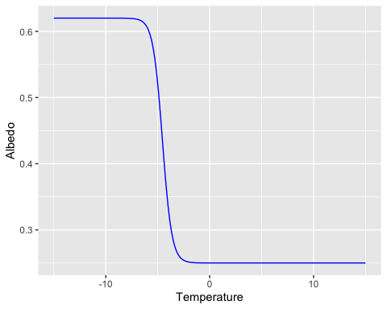

# Run 0

data01 <- ebm01(150,A,B,K,ai,ab,gamma,delta) #from 300  
data02 <-ebm02(150,A,B,K,ai,ab,gamma,delta) #from 300  
  
plot01 <- ggplot(data01,aes(Zones)) +  
 geom_line(aes(y=T, colour = "Temperature",linetype="Temperature")) +  
 geom_line(aes(y=a*25, colour = "Albedo",linetype="Albedo"))+  
 geom_line(aes(y=Ti, colour = "Initial Temperature",linetype="Initial Temperature"))+xlab("Latitude")+ylab("Temperature")+scale_colour_manual(name="Legend",values=c("blue","red","red"))+scale_linetype_manual(name="Legend",values=c("Temperature"=1, "Albedo"=1, "Initial Temperature"=2))  
  
plot02 <- ggplot(data02) +  
 geom_line(aes(t, Temperature),colour = 'green')+xlab("Time")+ylab("Mean Temperature")  
  
plot01

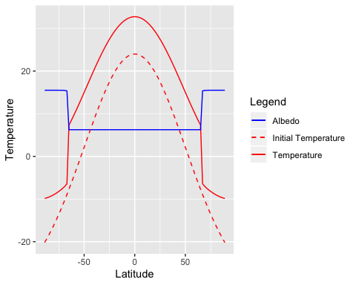

plot02

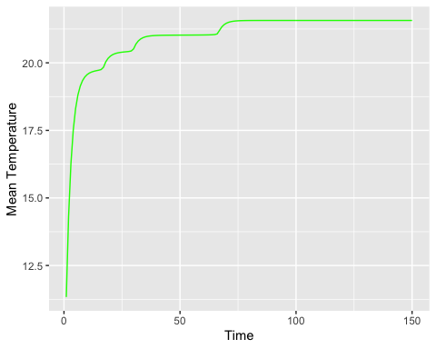

# Run 1

data11 <- ebm11(100,300,A,B,K,ai,ab,gamma,delta)  
plot11 <- ggplot(data11,aes(J,Temp))+geom_line(aes(J, Temp),colour = 'red')+xlab("Time")+ylab("Mean Temperature")+ggtitle("Non Dynamic Mean Temperature (T(t) independent from T(t-1))")  
  
plot11

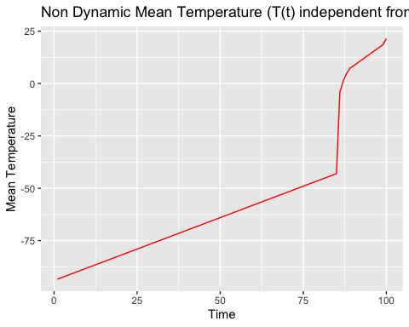

TEMP1 <- ebm12(100,300,A,B,K,ai,ab,gamma,delta)  
  
plot_ly(z=~TEMP1)%>% add_surface() %>% layout(  
 title = "With Initialization", scene = list(  
 xaxis = list(title = "S/100"),  
 yaxis = list(title = "Latitude"),  
 zaxis = list(title = "T") ))

# Run 2

data21 <- ebm21(180,300,A,B,K,ai,ab,gamma,delta )  
  
plot21 <- ggplot(data21,aes(J,Temp2))+geom_line(aes(J, Temp2),colour = 'red')+xlab("Time")+ylab("Mean Temperature")+ggtitle("Sinusoidal Perturbation")  
  
plot21

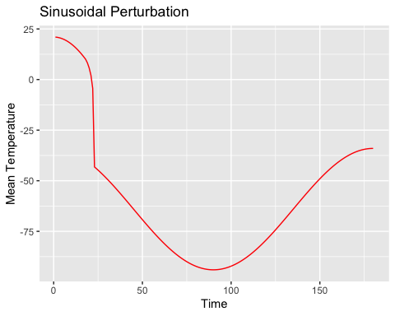

TEMP2 <- ebm22(180,300,A,B,K,ai,ab,gamma,delta )  
plot_ly(z=~TEMP2) %>% add_surface() %>% layout(  
 title = "Without Initialization",scene = list(  
 xaxis = list(title = "S/100"),  
 yaxis = list(title = "Latitude"),  
 zaxis = list(title = "T") ))

# Run 3 & 4

data31 <- ebm31(200,300,A,B,K,ai,ab,gamma,delta )  
data41 <- ebm41(200,300,A,B,K,ai,ab,gamma,delta )  
  
plot31 <- ggplot(data31,aes(J,Temp))+geom_line(aes(J, Temp),colour = 'red')+xlab("Time")+ylab("Mean Temperature")+ggtitle("Gaussian Perturbation")  
plot41 <- ggplot(data41,aes(J,Temp))+geom_line(aes(J, Temp),colour = 'red')+xlab("Time")+ylab("Mean Temperature")+ggtitle("Delta Perturbation")  
  
plot31

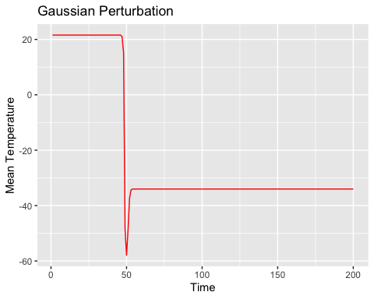

plot41

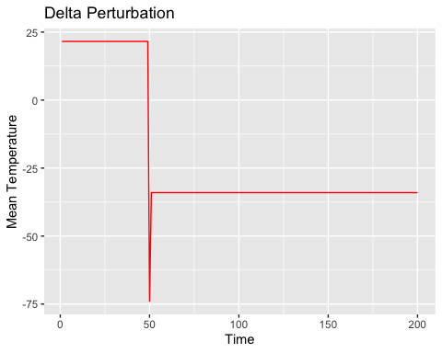

TEMP3 <- ebm32(200,300,A,B,K,ai,ab,gamma,delta )  
TEMP4 <- ebm42(200,300,A,B,K,ai,ab,gamma,delta)  
  
plot_ly(z=~TEMP3) %>% add_surface()%>% layout(  
 title = "Without Initialization", scene = list(  
 xaxis = list(title = "S/100"),  
 yaxis = list(title = "Latitude"),  
 zaxis = list(title = "T") ))

plot_ly(z=~TEMP4) %>% add_surface()%>% layout(  
 title = "Without Initialization",scene = list(  
 xaxis = list(title = "S/100"),  
 yaxis = list(title = "Latitude"),  
 zaxis = list(title = "T") ))

### Hysteresis Cycles

data23 <- ebm23(180,300,A,B,K,ai,ab,gamma,delta )  
  
plot23 <- ggplot(data23,aes(Sarr,Temp2))+geom_point(aes(Sarr, Temp2),colour = 'yellow')+ylab("Mean Temperature")+xlab("S_2(t)")+ggtitle("Mean temperature vs. Sinusoidally Fluctuating Incoming Radiation")  
plot23

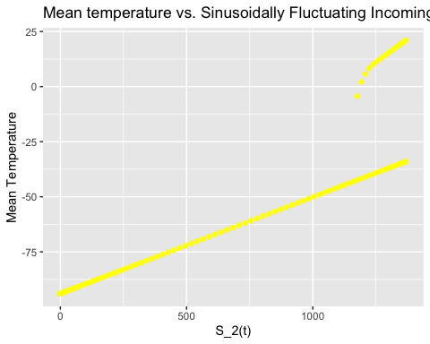

data51 <- ebm51(300,60,A,B,K,ai,ab,gamma,delta )  
  
plot51 <- ggplot(data51,aes(Sarr,Temp5,group=1))+geom_point(aes(Sarr, Temp5),colour = 'yellow')+geom_segment(aes(x = Sarr[89], y = Temp5[89], xend = Sarr[90], yend = Temp5[90]),colour = 'yellow')+geom_segment(aes(x = Sarr[258], y = Temp5[258], xend = Sarr[259], yend = Temp5[259]),colour = 'yellow')+ylab("Mean Temperature")+xlab("S_5(t)")+ggtitle("Mean temperature vs. Linearly Fluctuating Incoming Radiation")  
plot51

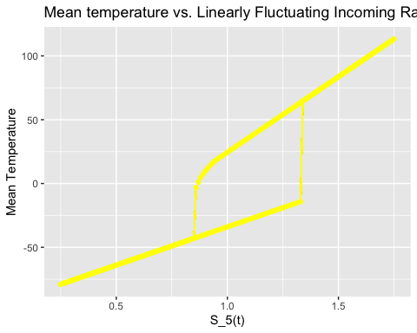

# Embedding Daisies in EBM

# WITHOUT DAISIES  
data_ND1 <- ebm_ND1(500,w0,b0,A,B,K,ai,ab,aW,aB,gamma,delta) #from 500  
data_ND2 <- ebm_ND2(500,w0,b0,A,B,K,ai,ab,aW,aB,gamma,delta)  
data_ND4 <- ebm_ND4(300,1370/920,A,B,K,ai,ab,gamma,delta) #from 300  
TEMP <- ebm_ND3(500,w0,b0,A,B,K,ai,ab,aW,aB,gamma,delta)  
  
plot_ND1 <- ggplot(data_ND1,aes(Zones))+geom_line(aes(y=w, colour = "% White"))+geom_line(aes(y=b, colour = "% Black"))+geom_line(aes(y=u, colour="% Bare Ground"))+geom_line(aes(y=T/5, colour="Temperature"))+ylab("Temperature & Albedo")+xlab("Latitude")+ggtitle("Without Daisies | Time Steps : 100")+scale_colour_manual(name="Legend",values=c("brown","black","white", "red"))  
  
plot_ND2 <- ggplot(data_ND2,aes(I))+geom_line(aes(y=Barr,colour="% Black"))+ geom_line(aes(y=Warr,colour="% White"))+ geom_line(aes(y=Uarr, colour="% Bare Ground"))+geom_line(aes(y=Tarr/25,colour="Temperature"))+ylab("Temperature & Albedo")+xlab("Time")+ggtitle("Without Daisies | Time Steps : 100")+scale_colour_manual(name="Legend",values=c("brown","black","white", "red"))  
  
plot_ND1

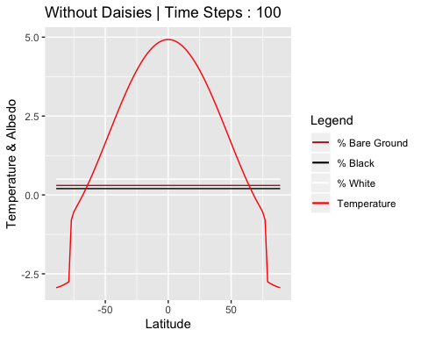

plot_ND2

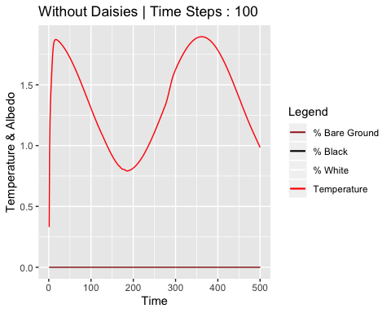

plot_ly(z=~TEMP)%>% add_surface() %>% layout( title="Temperature Without Daisies",  
 scene = list(  
 xaxis = list(title = "Time"),  
 yaxis = list(title = "Latitude"),  
 zaxis = list(title = "T") ))

#WITH DAISIES  
data_D1 <- ebm_D1(500,w0,b0,c,k,D,A,B,K,ai,ab,aW,aB,gamma,delta)  
data_D2 <- ebm_D2(500,w0,b0,c,k,D,A,B,K,ai,ab,aW,aB,gamma,delta)  
data_D4 <- ebm_D4(2,300,1370/920,w0,b0,c,k,D,A,B,K,ai,ab,aW,aB,gamma,delta) #from 300  
TEMP <- ebm_D3(500,w0,b0,c,k,D,A,B,K,ai,ab,aW,aB,gamma,delta)  
BLACK <- ebm_Db2(500,w0,b0,c,k,D,A,B,K,ai,ab,aW,aB,gamma,delta)  
WHITE <- ebm_Dw2(500,w0,b0,c,k,D,A,B,K,ai,ab,aW,aB,gamma,delta)  
  
  
plot_D1 <- ggplot(data_D1 ,aes(Zones))+geom_line(aes(y=w, colour = "% White"))+geom_line(aes(y=b, colour = "% Black"))+geom_line(aes(y=u, colour="% Bare Ground"))+geom_line(aes(y=T/5, colour="Temperature"))+ylab("Temperature & Albedo")+xlab("Latitude")+ggtitle("With Daisies")+scale_colour_manual(name="Legend",values=c("brown","black","white", "red"))  
plot_D2 <- ggplot(data_D2,aes(I))+geom_line(aes(y=Barr,colour="% Black"))+ geom_line(aes(y=Warr,colour="% White"))+ geom_line(aes(y=Uarr, colour="% Bare Ground"))+geom_line(aes(y=Tarr/25,colour="Temperature"))+ylab("Temperature & Albedo")+xlab("Time")+ggtitle("With Daisies")+scale_colour_manual(name="Legend",values=c("brown","black","white", "red"))  
plot_D4 <- ggplot(data_D4,aes(Sarr,Tarr))+ylab("Temperature")+xlab("Solar Luminosity")+ggtitle("Solar Luminosity vs. Temperature")+geom_line()  
  
plot_D1

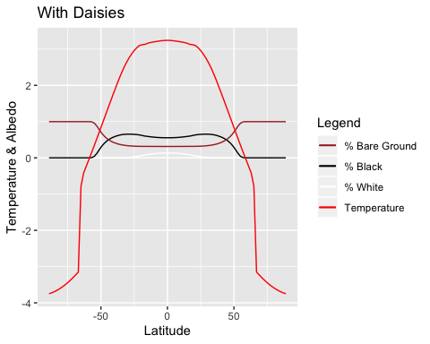

plot_D2

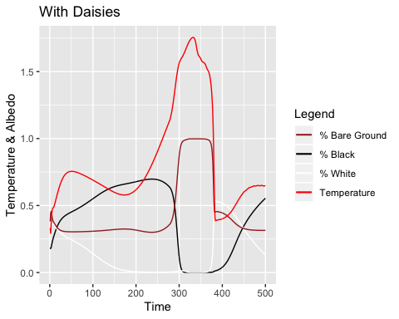

plot_ly(z=~TEMP)%>% add_surface() %>% layout(title="Temperature With Daisies",  
 scene = list(  
 xaxis = list(title = "Time"),  
 yaxis = list(title = "Latitude"),  
 zaxis = list(title = "T") ))

plot_ly(z=~BLACK)%>% add_surface() %>% layout(title="Distribution of Black Daisies",  
 scene = list(  
 xaxis = list(title = "Time"),  
 yaxis = list(title = "Latitude"),  
 zaxis = list(title = "Black") ))

plot_ly(z=~WHITE)%>% add_surface() %>% layout(title="Distribution of White Daisies",  
 scene = list(  
 xaxis = list(title = "Time"),  
 yaxis = list(title = "Latitude"),  
 zaxis = list(title = "White") ))

ebm_Db1(150,1370/920,w0,b0,c,k,D,A,B,K,ai,ab,aW,aB,gamma,delta)%>% layout(title="Distribution of Black Daisies",  
 xaxis = list(title = "Latitude"),  
 yaxis = list(title = "Solar Luminosity") )

ebm_Dw1(150,1370/920,w0,b0,c,k,D,A,B,K,ai,ab,aW,aB,gamma,delta) %>% layout(title="Distribution of White Daisies",  
 xaxis = list(title = "Latitude"),  
 yaxis = list(title = "Solar Luminosity") )

WHITE <- ebm_D4(0,300,1370/920,w0,b0,c,k,D,A,B,K,ai,ab,aW,aB,gamma,delta)  
BLACK <- ebm_D4(1,300,1370/920,w0,b0,c,k,D,A,B,K,ai,ab,aW,aB,gamma,delta)  
  
  
plot_ly(z=~BLACK)%>% add_surface() %>% layout(title="Distribution of Black Daisies",  
 scene = list(  
 xaxis = list(title = "Time"),  
 yaxis = list(title = "Solar Luminosity"),  
 zaxis = list(title = "Black") ))

plot_ly(z=~WHITE)%>% add_surface() %>% layout(title="Distribution of White Daisies",  
 scene = list(  
 xaxis = list(title = "Time"),  
 yaxis = list(title = "Solar Luminosity"),  
 zaxis = list(title = "White") ))

data_ND4_D4 <- data.frame(data_ND4,data_D4)  
plot_ND4_D4 <- ggplot(data_ND4_D4,aes(Sarr))+ylab("Temperature")+xlab("Solar Luminosity")+ggtitle("Solar Luminosity vs. Temperature")+geom_line(aes(y=Tarr, colour = "With Daisies"))+geom_line(aes(y=Tarr1, colour = "Without Daisies"))+scale_colour_manual(name="Legend",values=c("green","brown"))  
plot_ND4_D4

