Does the Economy Impact Generosity?
An Empirical Analysis of Altruism and Economic Trends
Anjali Mehta, Annie Xie, Jianing Cai, Marijke van der Geer, Nakshatra
Yalagach, Prashanth Wagle, Sara Shallenberger, Steve Zhou, and Trinity Chamblin

This empirical study investigates whether the economy affects altruism, by examining the potential impact of economic and demographic trends on generous behaviors, particularly towards healthcare non-profits using publicly available datasets. Biokind Analytics is an organization with a mission to provide data analytic services to healthcare non-profits. Biokind reached out to the 2023 Data Science for the Public Good Cohort (a group of dedicated undergraduate and graduate students from across the country) to seek our assistance in advancing their mission. As passionate advocates for the public good, we embraced the opportunity to contribute our skills and knowledge towards investigating the relationships between economic indicators and altruism toward healthcare non-profits. These ideas lead us to our research question:

What is the effect of the economy on donations from households to health care non-profits, and what are the factors that influence households to donate?

This question helps to uncover valuable insights that can aid both research in this area and Biokind Analytics in supporting the advancement of healthcare philanthropy and the vital services provided by these organizations.

The following three publicly available data sources were explored to discover the variables that could be observed in relation to altruism and the economy. These details regarding the sources and their attributes are explained further below.

- Bureau of Labor Statistics (BLS)
- Panel Study of Income Dynamics (PSID)
- National Center for Charitable Statistics (NCCS).

One of the main challenges faced in the data discovery phase was the inconsistency of the time increments within the data sources. For example, monthly level data were available for the sources relating to economic observations while a data source observed for our donation trends, NCCS, only recorded information on a yearly basis. This is because most donation trend data sources are based on data from the IRS (Internal Revenue Service).

To perform an economic analysis, we needed to determine specific indicators that we assessed to be representative of the economy as a whole and ones that could have an impact on altruism. The selected attributes were the consumer sentiment index, Dow Jones industrial average, and unemployment rate. The consumer sentiment index gauges public perceptions of economic optimism and future conditions, affecting individuals' likelihood to support charitable causes. The Dow Jones index signifies overall economic performance and stock market performance, influencing people's ability to contribute. The unemployment rate reflects individuals' financial stability and the health of the labor market, potentially impacting their willingness to donate. Analyzing these indicators allows us to explore how economic conditions relate to altruistic behavior and donations in the healthcare nonprofit sector.

An analysis of pre-existing literature was conducted to supplement the trends we might discover regarding periods of uncertainty, such as the COVID-19 pandemic. Numerous studies have explored how charitable donation behaviors respond to certain socioeconomic events, such as the 2008 financial crisis. With household characteristics as control variables, it can be concluded that apart from the shocks to income and wealth, the increased uncertainty after the financial crisis also accounted for the decrease in charitable donations. Thus, despite the lack of timely research on the effect of COVID-19 pandemic on charitable donations, we expect that charities receive fewer donations due to decreased income and wealth as well as increased risk and uncertainty in economic recovery.
To observe altruistic trends, we investigated the biennial donation data and demographics from PSID, a biennial survey of American households since 1968. It is a comprehensive survey which includes important attributes such as income, wealth, family compositions, and residence. The philanthropy module was introduced in 2001 and collects data on donations to different types of non-profits. This study focuses on the data between 2001-2019. On average, there is data for 8640 households each year. The dependent variables that this study focuses on are whether the household donated to healthcare organizations and what amount they donated to those organizations is. It is worth noting that the PSID data only recorded donations over $25. Besides, predictors such as income, wealth, and self-reported health are considered in this study as well.
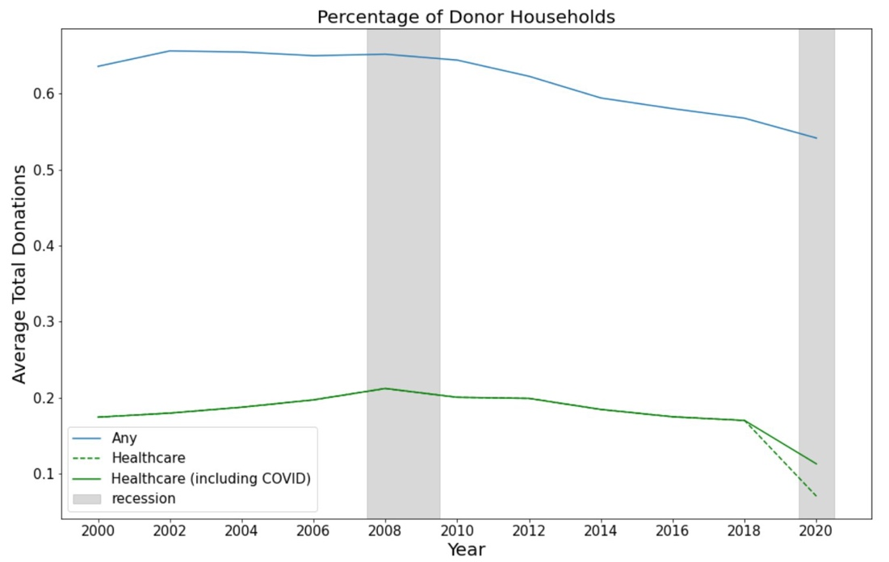
Figure 1. Percentage of Donor Households

Figure 1 above reveals the percentage of donor households over the years from 2000 to 2020. The blue line represents the percentage of all causes of donations, while the green lines represent the percentage of donations to healthcare nonprofits only. The difference between the green solid line and the dashed line represents the donations that include specific COVID-19 related items. Tracing the lines through the years, we can see that there is a decreasing trend regarding the percentage of households donating money. The percentage of households who donated dropped from around 61 percent to 58 percent over the years, while the percentage of households who specifically donated to healthcare dropped from around 17 percent to 12 percent over the time.

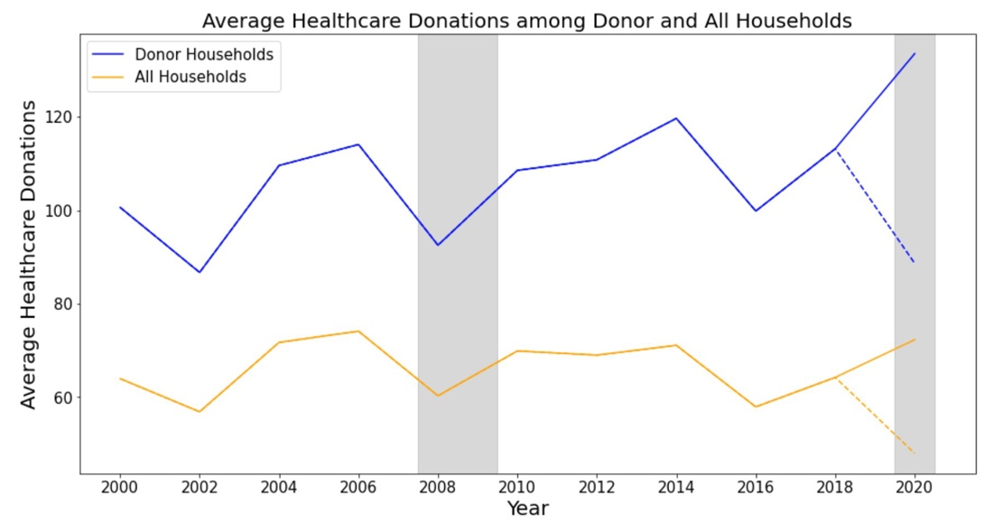

Figure 2: Average Healthcare Donations Among Donors

Figure 2 above demonstrates the trend of the average donations among those donor households over time. The blue line represents specifically donor households, and the yellow line represents all households. It is worth noting that there is an extreme value in the year 2000 (shown as the dash line), and the adjusted version for this extreme value is shown as the solid line. Based on this graph, we can observe that the average amount for both total donations and healthcare donations are increasing throughout the years.

Combining the findings from the two graphs above, it is interesting to point out that although the percentage of households donating is decreasing, the average donation amount is increasing among those households who are donating.

State-wide data from the NCCS was investigated to observe altruistic trends. Specifically, we investigated the NCCS annual core files which compile IRS tax filings from tax-exempt charitable and non-profit organizations and contain extensive metrics such as geolocation, contributions, and revenue for each organization that files. These files were extracted and aggregated for fiscal years 2000 through 2019 and filtered for companies categorized under the health subsector (NTEE Major 5 subsector HE). However, it should be noted that because certain organizations receive filing extensions, not all filings during each fiscal year actually correspond with that fiscal year. Therefore, companies that received extensions for 2018 or 2019 are not represented in those files and the data for these years are incomplete.

Once ingested and filtered, the main focus was on contributions received by healthcare charities in the United States. This measure was inflated to represent 2022 dollars and the outliers in this category were removed. The below images describe the trends in contributions as they relate to various economic indicators over time.

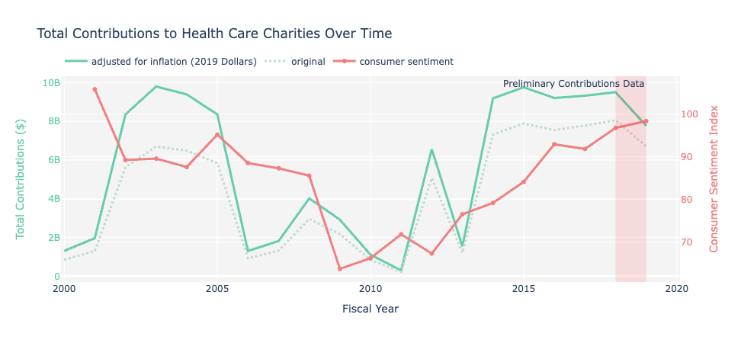
Figure 3: Consumer Sentiment Index and Donations
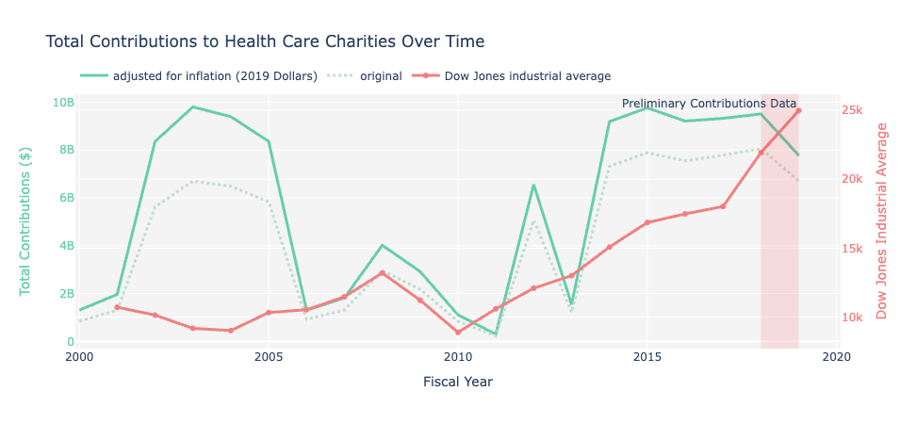
Figure 4: Dow Jones Industrial Average and Donations

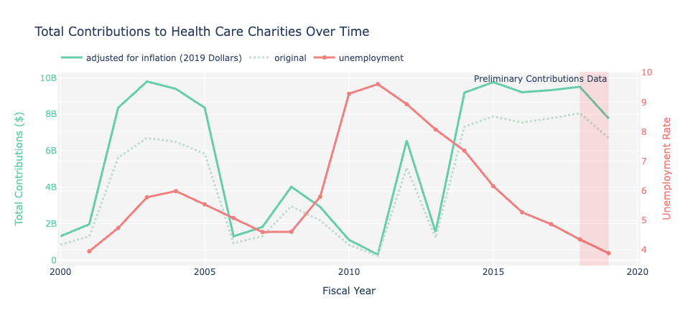
Figure 5: Unemployment and Donations

Figure 3 represents the comparison of contributions to healthcare charities compared against the pre-determined economic indicators. Some similarities are observed in Figure 4, which describes the trends in the Dow Jones industrial average compared with trends in contributions. Likewise, similar trends are observed in Figure 3 when comparing consumer sentiment and contributions. Consumer sentiment measures how consumers are currently feeling about the state of the economy relative to the previous year. It is likely that as positive feelings about the economy increase, people are more inclined to donate. These observations are consistent with previous literature.
On the other hand, when comparing unemployment and contributions (Figure 5) these trends seem to contrast each other. This, again, is consistent with expectations since higher unemployment rates correspond to lower donations and vice versa.
Overall, it seems that with more longitudinal data, these economic indicators could act as predictors for contributions. When considering our results with the previous literature, it is likely that this is true for charities as a whole. However, when looking specifically at healthcare charities our results show that large health crises might more strongly indicate higher contributions. For example, there was a peak in healthcare donations between 2002 and 2005 which does not necessarily match trends in any of the economic indicators. Yet, this period corresponds to the outbreak of SARS pointing to the idea that SARS was a more prominent driver of contributions than economic trends.

By providing public access to this data, we hope that healthcare non-profits and research experts can conduct this analysis for free and ultimately expand the scope of our methods. With an understanding of the intricate patronship between societal well-being and economic conditions, we hope that these findings help shed light on this often-debated relationship, specifically in the context of contributions to health care organizations during periods of economic uncertainty.

Works Cited (APA)

Indiana University Lily Family School of Philanthropy. (2021). The 2021 Bank of America study of philanthropy: Charitable giving by affluent households. Retrieved July 31, 2023, from https://scholarworks.iupui.edu/server/api/core/bitstreams/ff2ebcdc-fe48-41fe-baf9-6437b62f8bfa/content
List, J. A. (2011). The market for charitable giving. Journal of Economic Perspectives, 25(2), 157–180. https://doi.org/10.1257/jep.25.2.157
Meer, J., Miller, D., & Wulfsberg, E. (2016). The Great Recession and charitable giving. https://doi.org/10.3386/w22902
Amin, K., Harris, E. The Effect of Investor Sentiment on Nonprofit Donations. J Bus Ethics 175, 427–450 (2022). https://doi.org/10.1007/s10551-020-04646-7
Baker, Malcolm, and Jeffrey Wurgler. 2007. "Investor Sentiment in the Stock Market." Journal of Economic Perspectives, 21 (2): 129-152.

