Measuring Economic Diversity in Fairfax County Anjali Mehta, Trinity Chamblin, and Prashanth Wagle

The Business Diversity project is a significant part of the Social and Impact Data Commons project. The Data Commons is an open knowledge repository co-locating publicly available datasets alongside administrative records, advanced analytics, and visualization tools. Our project aims to understand the landscape of economic diversity—focusing on minority owned businesses within Fairfax County, Virginia

As defined by the U.S Census Bureau, a minority-owned business is a US-based enterprise predominantly owned (51% or more) by one or more members of a socially and economically disadvantaged minority group based on race.

Our stakeholders, Fairfax County, are interested in this question to develop policies to help minority business owners:

- How are minority-owned businesses distributed across Fairfax County geographically?

It is important to note that in attempting to help Fairfax County answer this question we recognized that the main challenge is the discrepancy across larger publicly available data sets. Thus, throughout our project, we have attempted to mitigate this challenge as we reach our goal. Data enables the study of minority business activities at small geography levels, so it is vital that data remains accurate on developing policies at the county level and supporting our local communities. While there are many sources that have business data, we are interested in the Mergent Intellect, an extensive database containing business information such as a business's industry, its founding year, the executives’ names, and its location.

However, a case study conducted in Fairfax County revealed that the Annual Business Survey(ABS) conducted by the US Census Bureau reported approximately 38% of minority-owned businesses in 2017, and during that same period, Mergent Intellect reported 7%. This leads us to believe that Mergent Intellect underrepresents businesses. Although we do not have Mergent Intellect’s methodology for identifying minority-owned businesses, our preliminary findings suggest that Mergent Intellect includes solely registered minority-owned owned businesses, therefore undercounting those not registered.

To help Fairfax answer this question, our goal is to create a binary classification model that can reduce the underrepresentation in Mergent Intellect’s data. Our classification model consists of three inputs:

- The Business Owner’s Name
- The Company’s Name
- The Company’s Location

For ethical purposes, our model employs the binary classification of minority owned or non-minority owned among businesses. Business owners’ racial identifiers are not disclosed to maintain this research’s intended application. We look at business owners’ names as our first predictor, existing research on name analysis suggests that names with distinct cultural or ethnic backgrounds are often associated with minority individuals. As our second predictor, we chose to evaluate the language that a company’s name is written in as another helpful indicator of the company owner’s minority status. Lastly, our third predictor is the population demographics at the business’ locations.

We began our research by exploring data sources that tracked minority business ownership to build training and testing data for our classifier model. We web scrapped and accessed databases that tracked minority business ownership in Fairfax County. We found business data from the minority-focused Chamber of Commerce websites (Black, Latin, Asian, and Native American), Yelp.com, Small Business Supply Directory (SBSD), and the Axle database. This data holds information such as the business owner's name, company name and address.
The businesses tagged as minority owned from Mergent were then labelled within our training set as “Listed.” The term “Listed’ and “Not Listed” is used as a proxy for minority-owned and non-minority owned respectively to eliminate bias which could exist because although we have high confidence that `Listed’ businesses are minority-owned, we do not have confidence that businesses “Listed’ are not minority-owned. To obtain a dataset of non-minority owned businesses, we compiled a list of businesses founded before 1964. This is because the Civil Rights Act was implemented in 1964; businesses established before this date are more likely to be non-minority owned. According to Census Data, the population of non-minorities in Fairfax County in 1964 was approximately 90%, as opposed to around 50% in 2017. After finding the unique businesses labelled as ‘Listed,’ we extracted the same number of businesses classified as ‘Not Listed.’ As a result, we had an equally balanced data set to train and test our model as shown in Figure 1 below.

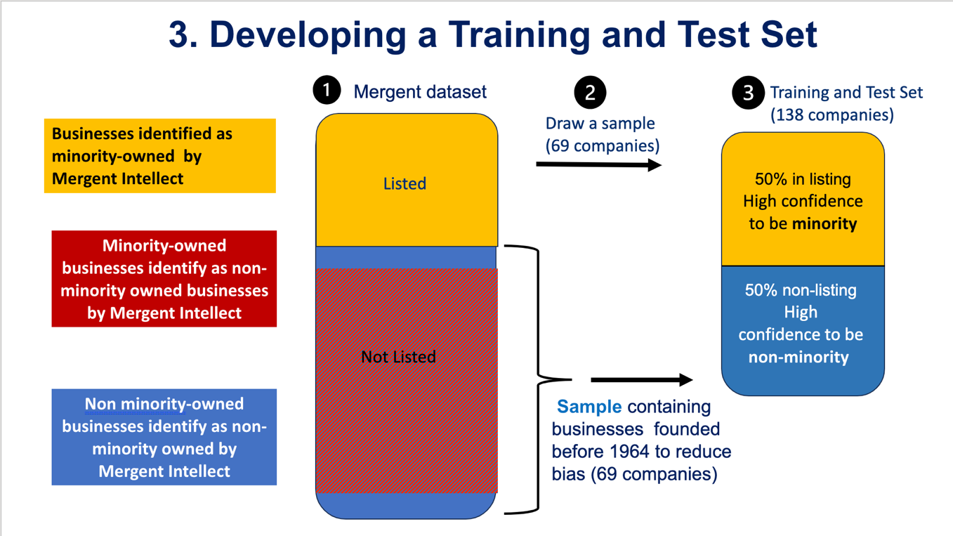
Figure 1: Developing our Testing and Training Set

The business owners' names included in our training set were evaluated using natural language processing (NLP) methods. These methods evaluated the owner’s name and produced a probability representing the likelihood of the name belonging to a minority. After computing these probabilities, we computed the percent accuracy for each NLP tool and selected the best one. Our second predictor was a binary minority indicator based on the company’s name. We assessed the languages of the company names using natural language processing to predict the probability that a name in English phonetically resembles a different language. The last predictor in our model comprises population demographics from the US census data, specifically focusing on the census tract where the business is located. We have input the proportion of minority individuals in that census tract.

We created the classification model to identify Mergent Intellect’s underrepresentation of minority-owned businesses. This underrepresentation is identified as an ‘error’ and represents the proportion of businesses that were falsely classified as non-minority owned. We trained and evaluated several linear and non-linear models by randomly drawing samples and applying them to the model to get the performance. We repeated this process 10,000 times to make sure that our results were not by chance, and we found out the model, using the outside data we found was on average 78% accurate.

The rate of misclassified businesses by Mergent was approximately 39%, and the number of businesses classified as minority-owned was around 7%. We applied it to the totality of the Mergent Intellect dataset and determined if the reported error value decreased. As our focus is identifying misclassified businesses, we only applied the model to those that were not already flagged as minority owned by Mergent. We proceeded by applying the model to the non-flagged businesses and then included the businesses that were correctly listed as minority owned. By doing this, we calculated the new percentage of minority-owned businesses, which turned out to be 37.77%. Remarkably, this figure closely aligned with the 38% reported by the ABS census, which was our target percentage. Next, we assessed the error of this updated model and found it to be 26.315%, significantly lower than the initial error rate. This result indicates that our model is performing well and reducing the error in tracking minority business ownership.

The percentages represented above are depicted in Figure 2 for clarity.

 | % Minority Businesses in dataset | % Error
Mergent Intellect | 7% | 39.47 %
After Model is applied | 41.75 % | 22.34 %
Figure 2

We then created a geographical distribution of companies across Fairfax County using geolocation methods. Figure 3 represents the smaller portion of companies with executive names reported, about 18,000 businesses.
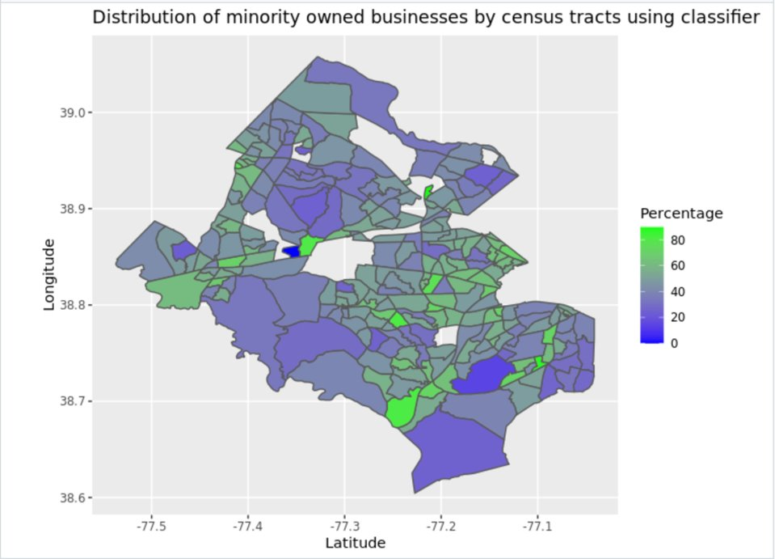
Figure 3
Throughout our research, we experienced several limitations and challenges. One challenge was our inability to produce an extensive list of businesses despite web scraping from various sites. This resulted in a smaller list of businesses compared to our main sources. To mitigate this challenge, we carefully balanced the training set, ensuring it comprised 50% of businesses included in the listings and 50% not included. This allowed for a balanced training set, but it is still smaller than it should be. A future application of this project would be to continue searching for more businesses to add to our listing so that the model’s training set can be improved. Additionally, we acknowledge a potential limitation in our approach, wherein census demographic information is based on the number of people living in a particular area. By using this data to infer information about business owners' locations, we assumed they reside in the same area as their businesses are.
We hope that with this model, community programs and policymakers across the entire National Capital Region can foster healthier and more diverse business climates within their communities by using accurate information to help encourage initiatives for underserved businesses. These improvements would not only help better our economy but promote representation for underserved groups and prioritize inclusion for all.

Works Cited (transform into APA Format):

Decoding State-County Census Tracts versus Tribal Census Tracts: https://www.census.gov/newsroom/blogs/random-samplings/2012/07/decoding-state-county-census-tracts-versus-tribal-census-tracts.html

Yelp Business Review Company:
https://www.yelp.com/

Mergent Intellect (MI) Database:
https://www.mergentintellect.com/index.php/search/index

The Virginia Small Business Supply Directory (SBSD):
https://sbsd.virginia.gov/

Chamber of Commerce:
- Hispanic: https://www.novahispanicchamber.com/
- Black: https://www.northernvirginiabcc.org/
- Asian: https://www.aabac.org/

Fairfax County ACS (American Community Survey) census:
https://www.census.gov/quickfacts/fact/table/fairfaxcountyvirginia/POP010220#POP010220

North Carolina Voter Registration Data (Statewide and County Level data available): https://www.ncsbe.gov/results-data/voter-registration-data

Natural Language Processing Documentation:
RaceBert: https://pypi.org/project/racebert/
Rethnicity: https://www.sciencedirect.com/science/article/pii/S2352711021001874
Ethnicolr: https://ethnicolr.readthedocs.io/ethnicolr.html#install

SpaceY: https://spacy.io/
LangDetect: https://pypi.org/project/langdetect/

1964 Information: https://storymaps.arcgis.com/stories/f74a8fbad837435b8e901cc9c04aa345
1964 information: https://www.richmondfed.org/-/media/richmondfedorg/publications/research/econ_focus/2004/winter/pdf/economic_history.pdf

