Profile DSS Customers By Year

library(inspectdf)  
library(dplyr)

##   
## Attaching package: 'dplyr'

## The following objects are masked from 'package:stats':  
##   
## filter, lag

## The following objects are masked from 'package:base':  
##   
## intersect, setdiff, setequal, union

library(data.table)

##   
## Attaching package: 'data.table'

## The following objects are masked from 'package:dplyr':  
##   
## between, first, last

library(here)

## here() starts at /home/ads7fg/git/vecf_counts

library(maditr)

##   
## Use magrittr pipe '%>%' to chain several operations:  
## mtcars %>%  
## let(mpg_hp = mpg/hp) %>%  
## take(mean(mpg_hp), by = am)  
##

##   
## Attaching package: 'maditr'

## The following objects are masked from 'package:data.table':  
##   
## dcast, melt

## The following objects are masked from 'package:dplyr':  
##   
## between, coalesce, first, last

library(dataplumbr)

## Warning: replacing previous import 'data.table::month' by  
## 'lubridate::month' when loading 'dataplumbr'

## Warning: replacing previous import 'data.table::hour' by 'lubridate::hour'  
## when loading 'dataplumbr'

## Warning: replacing previous import 'data.table::quarter' by  
## 'lubridate::quarter' when loading 'dataplumbr'

## Warning: replacing previous import 'data.table::week' by 'lubridate::week'  
## when loading 'dataplumbr'

## Warning: replacing previous import 'data.table::year' by 'lubridate::year'  
## when loading 'dataplumbr'

## Warning: replacing previous import 'data.table::wday' by 'lubridate::wday'  
## when loading 'dataplumbr'

## Warning: replacing previous import 'data.table::second' by  
## 'lubridate::second' when loading 'dataplumbr'

## Warning: replacing previous import 'data.table::minute' by  
## 'lubridate::minute' when loading 'dataplumbr'

## Warning: replacing previous import 'data.table::mday' by 'lubridate::mday'  
## when loading 'dataplumbr'

## Warning: replacing previous import 'data.table::yday' by 'lubridate::yday'  
## when loading 'dataplumbr'

## Warning: replacing previous import 'data.table::isoweek' by  
## 'lubridate::isoweek' when loading 'dataplumbr'

library(ggplot2)

dt <- fread(here("data/working/DSS/dss_customers_by_year.csv"))

## Value Frequencies

### Categorical variables

cat_chart <-   
 dt %>%   
 dt_select(-1) %>%   
 inspect_cat() %>%   
 show_plot(high_cardinality = 1)

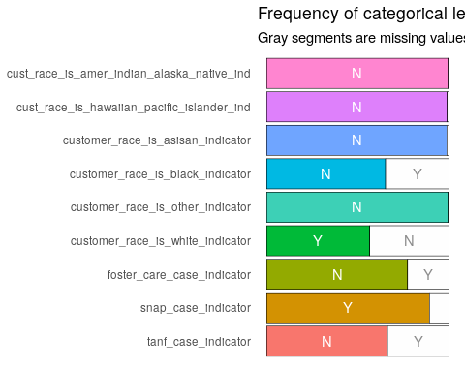

## Completeness

# Number of cell values missing per row  
row_empties <- rowSums(var.is_blank(dt))  
  
# Create better visualization  
row_empties_dt <- as.data.table(row_empties)  
records_with_empties <- row_empties_dt[row_empties > 0, .N]  
records_with_empties

## [1] 0

# Number of cell values missing per column  
col_empties <- colSums(var.is_blank(dt))  
  
# Create better visualization  
  
col_empties_dt <- as.data.table(col_empties, keep.rownames = T)  
#dtt <- setDT(df, keep.rownames=TRUE)  
colnames(col_empties_dt) <- c("item", "empties")  
item_empties <- col_empties_dt[order(-empties)]  
item_empties

## item empties  
## 1: unique_id 0  
## 2: age_class_code 0  
## 3: age_group_code 0  
## 4: age_type_code 0  
## 5: calendar_year_number 0  
## 6: cust_race_is_amer_indian_alaska_native_ind 0  
## 7: cust_race_is_hawaiian_pacific_islander_ind 0  
## 8: customer_race_is_asisan_indicator 0  
## 9: customer_race_is_black_indicator 0  
## 10: customer_race_is_other_indicator 0  
## 11: customer_race_is_white_indicator 0  
## 12: ethnicity_code 0  
## 13: foster_care_case_indicator 0  
## 14: gender_code 0  
## 15: month_of_birth 0  
## 16: snap_case_indicator 0  
## 17: tanf_case_indicator 0  
## 18: year_of_birth 0

## Valid Values

#. gender ----  
invalid_gend <- c("1", "2")  
gender_invalid <- dt[gender_code %in% invalid_gend, .N]  
  
# ethnicity  
invalid_eth <- c("0", "3", "90", "93")  
invalid_ethnicity <- data.table(invalid_ethnicity = dt[ethnicity_code %in% invalid_eth, .N])  
  
# race  
invalid_race_amer_ind <- data.table(invalid_race_amer_ind = dt[!cust_race_is_amer_indian_alaska_native_ind %in% c("Y", "N"), .N])  
invalid_race_asian <- data.table(invalid_race_asian = dt[!customer_race_is_asisan_indicator %in% c("Y", "N"), .N])  
invalid_race_black <- data.table(invalid_race_black = dt[!customer_race_is_black_indicator %in% c("Y", "N"), .N])  
invalid_race_pacific <- data.table(invalid_race_pacific = dt[!cust_race_is_hawaiian_pacific_islander_ind %in% c("Y", "N"), .N])  
invalid_race_other <- data.table(invalid_race_other = dt[!customer_race_is_other_indicator %in% c("Y", "N"), .N])  
invalid_race_white <- data.table(invalid_race_white = dt[!customer_race_is_white_indicator %in% c("Y", "N"), .N])  
  
# year  
invalid_year <- data.table(invalid_year = dt[!as.integer(calendar_year_number) %in% 2013:2016, .N])  
  
# services  
invalid_foster <- data.table(invalid_foster = dt[!foster_care_case_indicator %in% c("Y", "N"), .N])  
invalid_snap <- data.table(invalid_snap = dt[!snap_case_indicator %in% c("Y", "N"), .N])  
invalid_tanf <- data.table(invalid_tanf = dt[!tanf_case_indicator %in% c("Y", "N"), .N])  
  
  
vv_multi <- data.table(invalid_ethnicity,   
 invalid_race_amer_ind,   
 invalid_race_asian,   
 invalid_race_black,   
 invalid_race_pacific,   
 invalid_race_other,   
 invalid_race_white,  
 invalid_foster,  
 invalid_snap,  
 invalid_tanf)  
vv_multi_t <- as.data.table(t(vv_multi), keep.rownames = T)  
  
colnames(vv_multi_t) <- c("item", "count")  
vv_multi_t[, pct := round(100*(count/nrow(dt)), 1)]  
  
g <- ggplot(vv_multi_t, aes(x=item, y=count)) +  
 geom_bar(stat="identity", colour="black", fill="white") +   
 xlab("Race") + ylab("Count") +  
 labs(title = "Count of Individuals with Invalid Values",  
 subtitle = "Dataset: DSS Customers By Year") +  
 theme(axis.text.x = element_text(angle = 45, hjust = 1)) +  
 geom_text(aes(label=count), position=position_dodge(width=0.9), vjust=-0.2)  
g

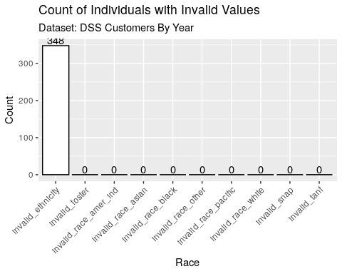

gp <- ggplot(vv_multi_t, aes(x=item, y=pct)) +  
 geom_bar(stat="identity", colour="black", fill="white") +   
 xlab("Race") + ylab("Percent") +  
 labs(title = "Percent of Individuals with Invalid Values",  
 subtitle = "Dataset: DSS Customers By Year") +  
 theme(axis.text.x = element_text(angle = 45, hjust = 1)) +  
 geom_text(aes(label=pct), position=position_dodge(width=0.9), vjust=-0.2)  
gp

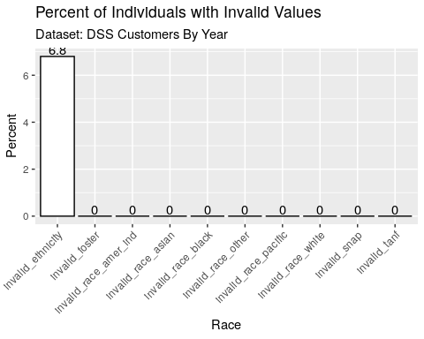

## Longitudinal Consistency

### Does any demographic have multiple values over time?

#final_dt[, .(cnt = length(unique(`Year Built`))), .(`Parcel ID`)][order(-cnt)]  
  
gender_multi <-  
 data.table(gender_multi = dt[!is.na(gender_code), .(cnt = length(unique(gender_code)), dmg = "multi gender"), unique_id][cnt > 1, .N])  
  
birth_year_multi <-  
 data.table(birth_year_multi = dt[!is.na(year_of_birth), .(cnt = length(unique(year_of_birth)), dmg = "multi birth yr"), unique_id][cnt > 1, .N])  
  
birth_month_multi <-  
 data.table(birth_month_multi = dt[!is.na(month_of_birth), .(cnt = length(unique(month_of_birth)), dmg = "multi birth mo"), unique_id][cnt > 1, .N])  
  
ethnicity_multi <-  
 data.table(ethnicity_multi = dt[!is.na(ethnicity_code) & ethnicity_code != 0, .(cnt = length(unique(ethnicity_code)), dmg = "multi ethnicity"), unique_id][cnt > 1, .N])  
  
race_white_multi <-  
 data.table(race_white_multi = dt[!is.na(customer_race_is_white_indicator) &  
 customer_race_is_white_indicator %in% c("Y", "N"), .(cnt = length(unique(customer_race_is_white_indicator)), dmg = "multi race white"), unique_id  
 ][cnt > 1, .N])  
  
race_black_multi <-  
 data.table(race_black_multi = dt[!is.na(customer_race_is_black_indicator) &  
 customer_race_is_black_indicator %in% c("Y", "N"), .(cnt = length(unique(customer_race_is_black_indicator)), dmg = "multi race black"), unique_id  
 ][cnt > 1, .N])  
  
dmg_multi <- data.table(gender_multi, birth_year_multi, birth_month_multi, ethnicity_multi, race_white_multi, race_black_multi)  
dmg_multi_t <- as.data.table(t(dmg_multi), keep.rownames = T)  
colnames(dmg_multi_t) <- c("item", "count")  
dmg_multi_t[, pct := round(100*(count/nrow(dt)), 1)]  
  
g <- ggplot(dmg_multi_t, aes(x=item, y=count)) +  
 geom_bar(stat="identity", colour="black", fill="white") +   
 xlab("Demographic Item") + ylab("Count") +  
 labs(title = "Count of Individuals with Multiple Values per Demographic Item",  
 subtitle = "Dataset: DSS Customers By Year") +  
 theme(axis.text.x = element_text(angle = 45, hjust = 1))  
g

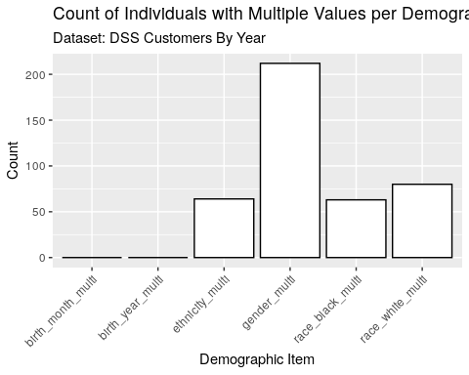

gp <- ggplot(dmg_multi_t, aes(x=item, y=pct)) +  
 geom_bar(stat="identity", colour="black", fill="white") +   
 xlab("Demographic Item") + ylab("Percent") +  
 labs(title = "Percent of Individuals with Multiple Values per Demographic Item",  
 subtitle = "Dataset: DSS Customers By Year") +  
 theme(axis.text.x = element_text(angle = 45, hjust = 1))  
gp

