

**A JSP Project Report On,**

**Online Class Test System**

**For JEC MCA**

**Submitted by:**

**Himansu Bhorali (01/15)**

**Bondita Borah (20/15)**

**For 5th Semester Final Examination of Master of Computer Application**

**Jorhat Engineering College, Jorhat**

**2017**

**Acknowledgement**

We take this opportunity to express our sincere gratitude to all those who helped us in various capacities in undertaking this project and devising the report.

We want to give a heartiest thank to the faculty of the MCA department in providing a helping hand in this project and to also for guiding to make such a project.

We also thank our friends for their constant support and cooperation.

**Himansu Bhorali (01/15) Bondita Borah (20/15)**

**5th semester MCA 5th semester MCA**

**_________________________________________**

**CERTIFICATE**

This is to certify that the project entitled “ONLINE CLASSTEST SYSTEM for JEC MCA”, which has been jointly submitted by Himansu Bhorali and Bondita Borah for the partial fulfillment of 5th Semester of Master of Computer Application course is a bona fide project work carried out by them under my supervision.

I wish them all success in future.

**Mr. Joydeep Sarmah**

H.O.D.

Master of Computer Application

Jorhat Engineering College

**CERTIFICATE**

This is to certify that the project entitled “ONLINE CLASSTEST SYSTEM for JEC MCA”, which has been jointly submitted by Himansu Bhorali and Bondita Borah for the partial fulfillment of 5th Semester of Master of Computer Application course is a bona fide project work carried out by them under my supervision.

I wish them all success in future.

**Mr. Dhurbajyoti Baruah**

Assistant Professor

Master of Computer Application

Jorhat Engineering College

**CERTIFICATE**

This is to certify that the project entitled “ONLINE CLASSTEST SYSTEM for JEC MCA”, which has been jointly submitted by Himansu Bhorali and Bondita Borah for the partial fulfillment of 5th Semester of Master of Computer Application course is a bona fide project work carried out by them under my supervision.

I wish them all success in future.

**Mr. Abinash Borah**

Assistant Professor

Master of Computer Application

Jorhat Engineering College

**Declaration**

We hereby declare that the project report entitled “ONLINE CLASSTEST SYSTEM for JEC MCA” submitted by us is our own and is not submitted by any other university or institute for the award of any degree or for any other purpose.

**Himansu Bhorali (01/15) Bondita Borah (20/15)**

**5th semester MCA 5th semester MCA**

**Index**

1_Introduction

2_Objective

3_Feasibility Study

4_Requirements analysis

5_Diagrams

6_Data Dictionary

7_Screenshots

8_Conclusion

**__________________**

**Introduction**

Today **Online Class test System** has become a fast growing Class test method because of its speed and accuracy. It is also needed less manpower to execute the Class test. Almost all organizations now-a-days, are conducting their objective exams by online Class test system, it saves students time in Class tests. Organizations can also easily check the performance of the student that they give in a Class test. As a result of this, organizations are releasing results in less time.

The **Online class test system is a web application** for students of MCA department to appear for an online test in an effective way and there is no loss of time to check the paper. The chief aim of Online Class Test is to effectively estimate the student completely via a totally automated system which besides preserving time, offers swifter outcomes.

________________________________________________

**Objective**

**The objective of the project “Online Class test System for JEC MCA” is to make evaluation and conduction of Class test simple, and faster. They are as follows:**

* To provide a simple and easy to understand interface through which students of MCA department can appear for Class test online and teachers (admin) can set tests for them.
* System can automatically identify a student and his/her respective semester and the current available test for him/her.
* Objective type questions, each with four options for the answers will be provided to the student(s) from the database as per the active test for that specific student(s).
* Checking of answers, calculation of marks and assigning total marks to students are to be done automatically by the system.
* To provided login id and password facility and credentials should be checked properly at the time of login for both students and admin(s).
* Admin can add and manage - subjects, create tests and assign time and marks to them, add questions to tests and assign marks to each question randomly.
* Admin will also provide login id and password to the students before the test.
* Admin can specifically select and print the results of different tests and result list of a test(s) will contain student names orderly, as per their rank (based on their score).
* ___________________________________________________

**Feasibility Study**

The feasibility study of any system is mainly intended to study and analyze the proposed system and to decide whether the system under consideration will be viable or not after implementation. That is it determines the usability of the project after deployment. To come to result a set of query is answered keeping the efficiency of the software and its impact on the domain for which it was developed. It main emphasis is on the following three questions elucidated below as:

**What** are the user’s requirements and how does a candidate system meet them?

**What** resources are available for the proposed systems? Is it worth solving the problem?

**What** is the likely impact of the proposed system on the organization? I.e. how does the proposed system fit within the organization?

Thus since the feasibility study may lead to commitment of large resources, it becomes necessary that it should be conducted competently and no fundamental errors of judgment are made. Different types of feasibility study and the way we performed on our project “Online Class test System**”**.

**Technical Feasibility:**

In technical feasibility, we study all technical issues regarding the proposed system. It is mainly concerned with the specifications of the equipment and the software, which successfully satisfies the end-user’s requirement. The technical needs of the system may vary accordingly but include:

* The feasibility to produce outputs in a given time.
* Response time under certain conditions.
* Ability to process a certain volume of the transaction at a particular speed.
* Facility to communicate data.

Under this analysis process questions like (i) does the compatible platform exist within our domain or can we procure it? (ii) Does the proposed equipment have the technical capacity to hold the data required using the new system?

Both at the development site and at server where we will be hiring the space for the website, and also the database would it be possible to upgrade the system after it is developed and implemented, if necessary? And would the recommended technology guarantee the reliability, accuracy and data security? This analysis process requires more emphasis on system configuration given more importance rather than the actual hardware specifications.

. The configuration of the existing systems is:

* Processor : Any Dual Core, 1000 MHz (or above)
* Memory : 1024 MB (or above)
* Secondary storage : 20 GB (or above)

For Software there are following alternatives:

Operating System**: Windows** 7/8.1/10

Development tool: NetBeans IDE

Database: MySQL

Documentation tool: MS-Word

**Economical Feasibility:-**

Meaning: Are there sufficient benefits in creating the system to make the acceptable? Or are the costs of not creating the system so great that it is advisable to undertaken the project.

This will include three major costs as described below:

* Cost of Hardware and Software
* Cost of Software to be acquired to build and run the product is a onetime cost.
* Buying a back end database is the major part of hardware and Software cost. Comparison between the oracle database high cost and better features with the SQL server low cost and better support for the same vendor operating system make this decision need oriented.

Benefits in reduced cost, error and saving will be made by reduction of present system expenses, time saving and increased accuracy.

**Cost Avoidance:**

Future cost reduction in form of reduction in the number of administrative staff needed and manual records maintains in organization. Rise in cost will be avoided.

**Operational Feasibility:**

Meaning: The system will be used if it is developed well then be resistance from users that undermine the possible application benefits.

**Clients Supports:**

Client and user support for present system is there, as the current procedure used takes more time and effort than proposed system. No major training and new skills are required as it is based on DBMS model. It will help in the time saving and fast processing and dispersal of user request and application. New product will provide all the benefits of present system with better performance such as improved information, better management and collection of the reports.

**User Support:**

User involvement in the building of present system is sought to keep in mind the user specific requirement and needs. User will have control over own information. Important information such as Test result can be generated at the click of a button.

____________________________________

**Requirements analysis**

**HARDWARE REQUIREMENTS -**

The hardware facilities, which are required in order to cope up with, the proposed systems, are as follows: -

Dual Core processor

Minimum of 2 GB of RAM

**SOFTWARE REQUIREMENTS —**

The minimum software requirements for the proposed system would be:-

Windows operating system (7 or later)

Web browsers with JSP, HTML 5 support.

**Software tools requirements**

The software tools that are used to build the system are as follows:

**>Netbeans IDE**

**>Wamp** Server

**>HTML 5** as Front end with **CSS** and **JAVA** script

**>JHP and SQL** as Back end

____________________________________________________________

**System Analysis**

Structured analysis is a development method for the analysis of existing manual or automated systems, leading to the development of the specifications for a new or modified system. When an unfamiliar system is approached, then there is always a question of being the analysis. A dynamic situation may seem almost overwhelming because so many activities always go on simultaneously.

The attributes of structured analysis can be underlined as follows:

'1'- Attempts to structure the requirement determination process.

'2' -The process includes all relevant details regarding the system.

'3' - The identification of requirements will be similar among individual analysts, and will include best solutions and strategies for system development opportunities.

The working papers produced to document the existing and purposed systems are effective communication devices. The refined results of the structured analysis, a structured specification includes the following basic tools:

Data Flow diagram.

Entity-Relationship diagram.

**System Design**

System designing is the most crucial part of any information system development process. System designing is a solution about how to approach to the creation of a new system. It is a highly creative process and it requires a substantial amount of knowledge and creativity on part of the system analyst.

System design is mainly concern with the co-ordination of activity, job procedures and equipment utilization in order to achieve organizational objectives.

System design is a highly creative process, which can be greatly facilitated by the following:

1. There should be a strong problem definition.

2. Pictorial description of the existing system.

3. General background information of the area under study.

4. A good understanding of the current system and a set of requirements for the system.

**Design specification**

In this stage, the software design document defines the overall architecture of the software that provides the functions and features described in the software in the software requirements documents.

The document describes the logical subsystem and their respective physical modules. It ensures that conditions are covered.

**INPUT DESIGN:**

Inaccurate input data are the most common cause of errors in data processing. Errors entered by data entry operators can be controlled by input design. Input design is the process of converting user oriented user inputs to a computer-based format. In the input design phase, inputs are collected and organized into groups of similar data. Once identified appropriate, input media are selected for processing.

**OUTPUT DESIGN**:

Computer output is the most important and direct source of information to the user. Efficient intelligent output design should improve the system relationship with the user and help in decision making. A major form of output is a hard copy from the printer.

**FORM DESIGN:**

A form is a tool with a message. It is the physical carrier of data and information. It also can constitute authority for action. For the purpose, Ina kind of system under consideration, which employs the method of online data entry through keyboard, the data entry operator must be assisted by a well-designed input form in accordance with the source document sheet.

**DATABASE DESIGN:**

The collection of data is usually referred to as the database. The database contains information about one particular organization. Database system is designed to manage large quantities of information. The management of data involves both for storage and the provision for mechanisms for the manipulation of the information. In addition, the system must provide for the safety to the information stored in the database.

**DATA FLOW DIAGRAM**

Data flow diagram is graphical representation of flow of data in an information system. It is capable of depicting incoming data flow, outgoing data flow and stored data. The DFD does not mention anything about how data flows through the system.

**Entities** -Entities are source and destination of information data.

**Process** - Activities and action taken on the data are represented by Circle or Round-edged rectangles.

**Data Flow** - Movement of data is shown by pointed arrows.

**Data Storage** - There are two variants of data storage - it can either be represented as a rectangle with absence of both smaller sides or as an open-sided rectangle with only one side missing as shown in the fig above.

**ER Diagram**

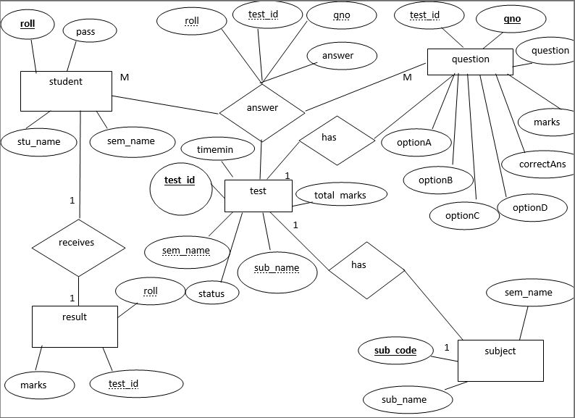

**Data Dictionary**

**Admin table**

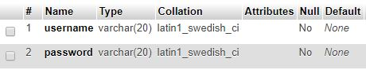

**Question table**

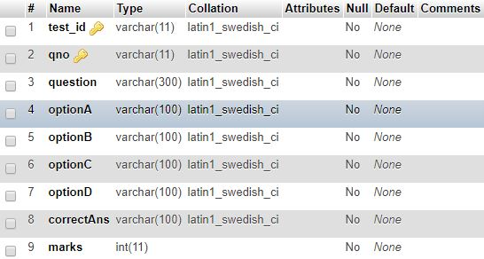

**Result table**

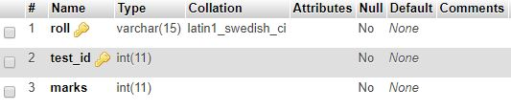

**Answer table**

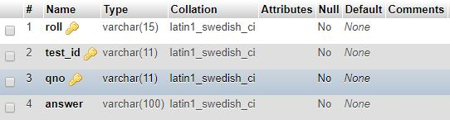

**Subject table**

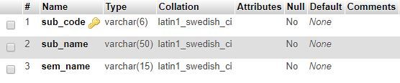

**Student table**

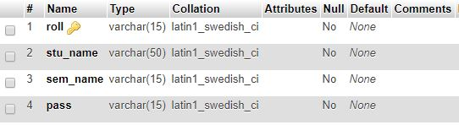

**Test table**

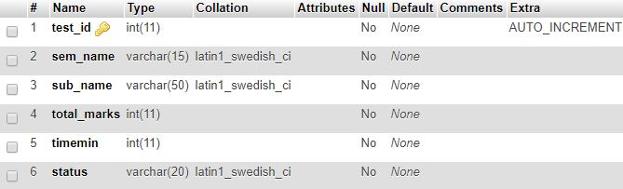

**SCREENSHOT OF THE PROPOSED SYSTEM AT VARIOUS RUNNING STATES**

**Index**

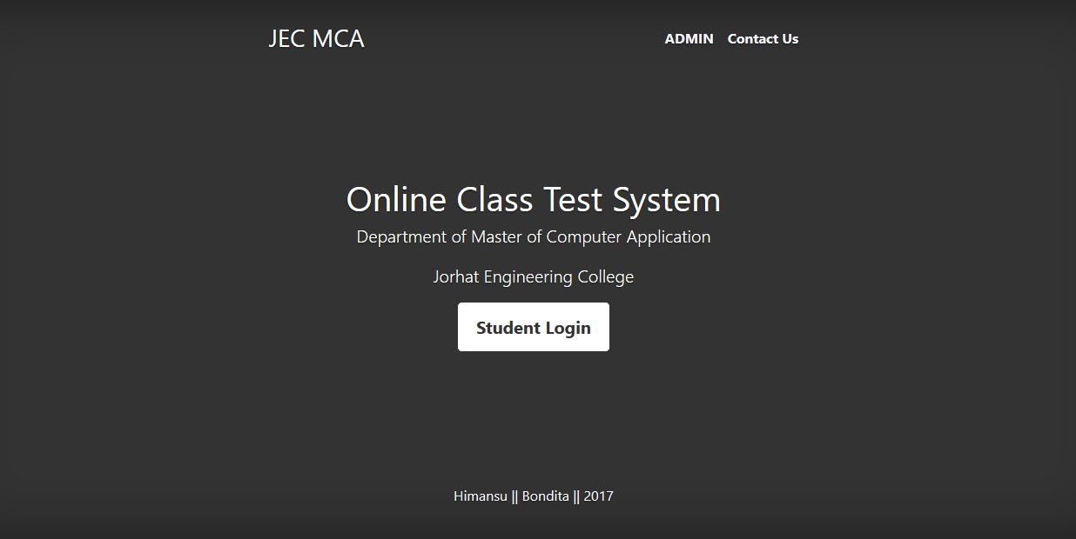

**Admin Home**

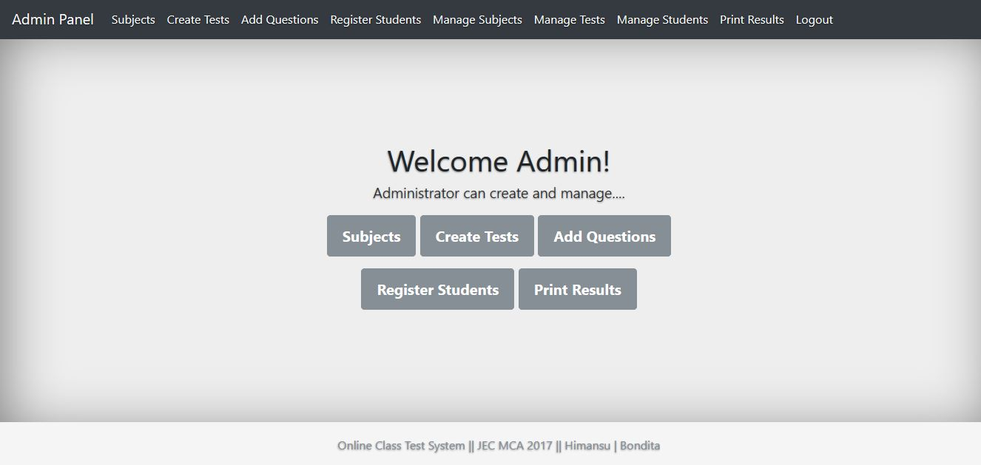

**Student Home**

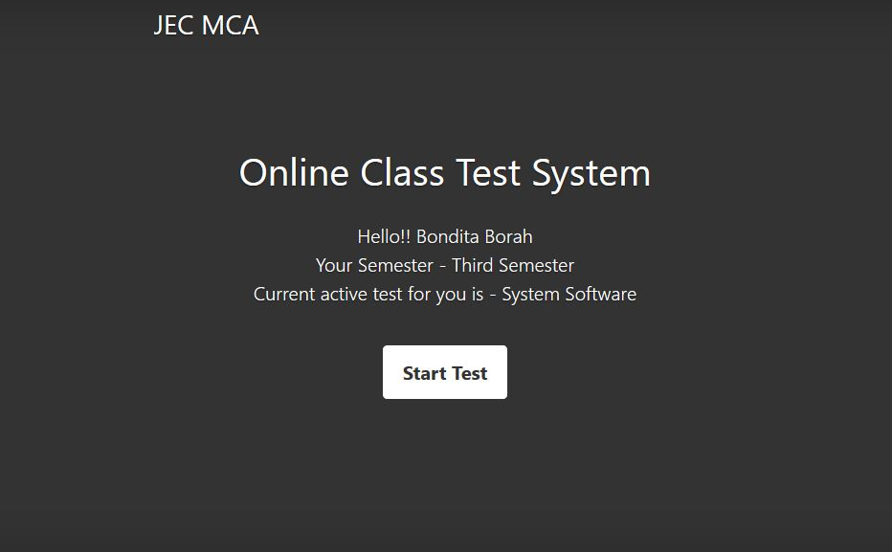

**Running Test**

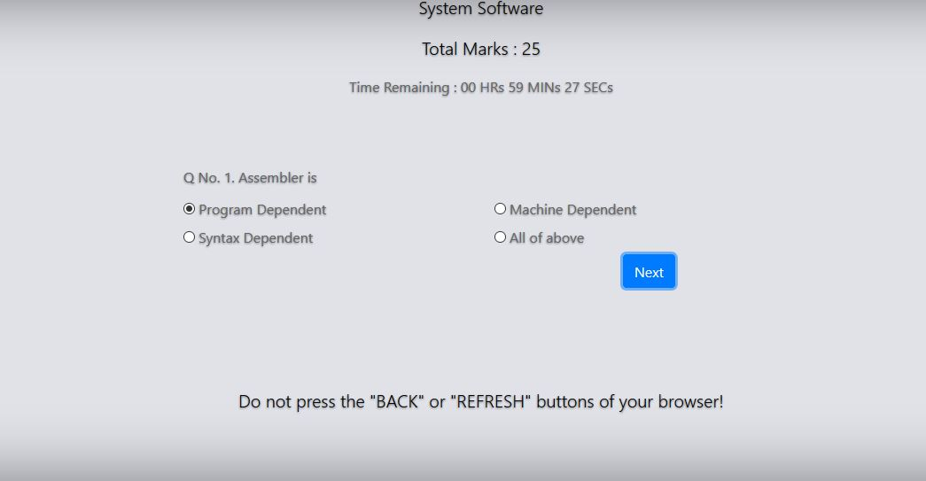

**Question Add**

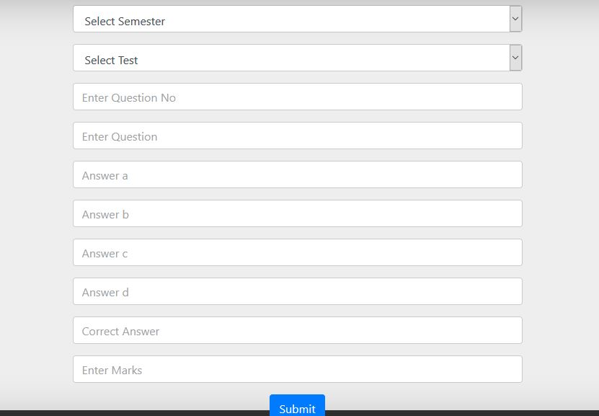

**Subject Manage**

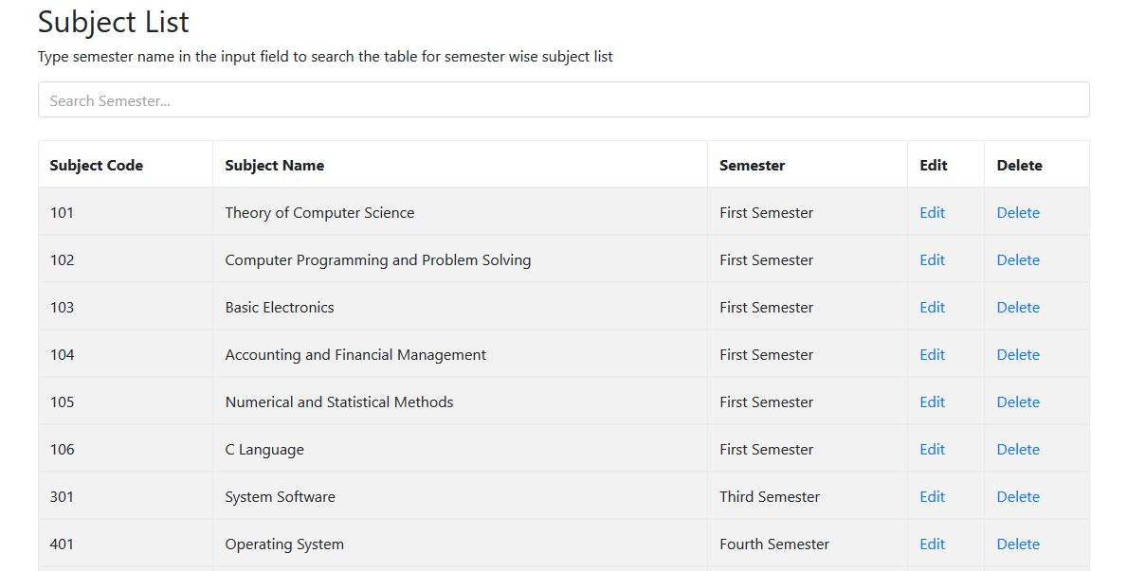

**Create Test**

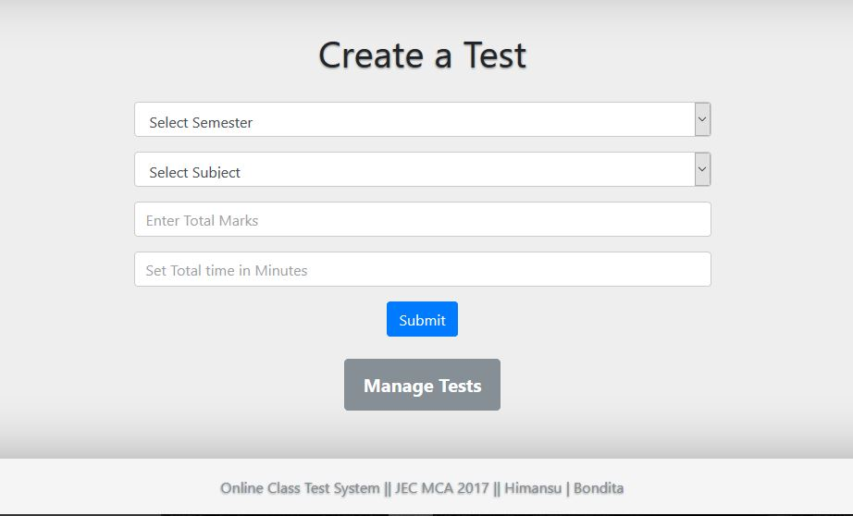

**Manage Test**

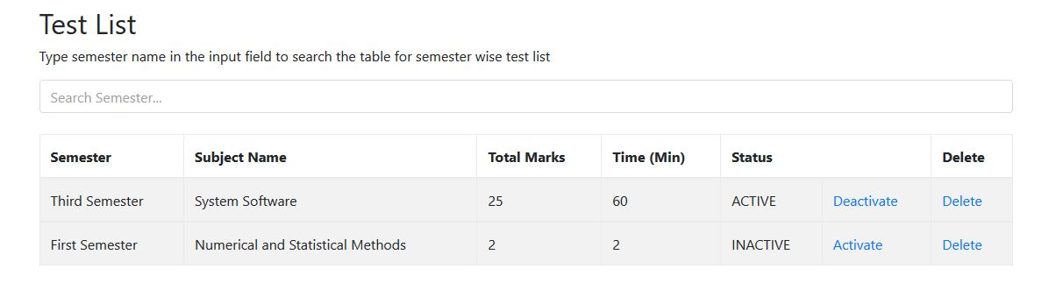

**Student Registration**

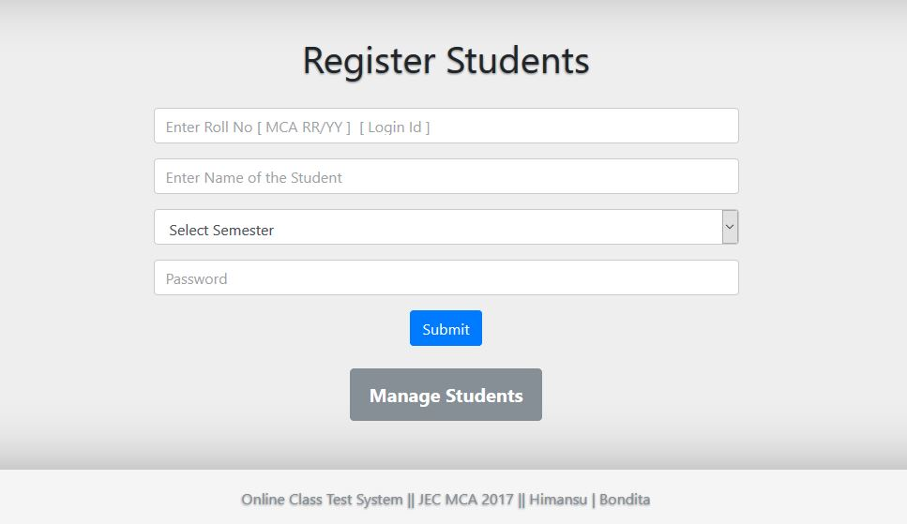

**Manage Student**

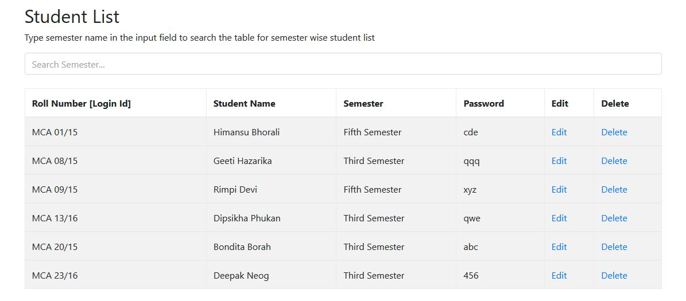

**Add Subject**

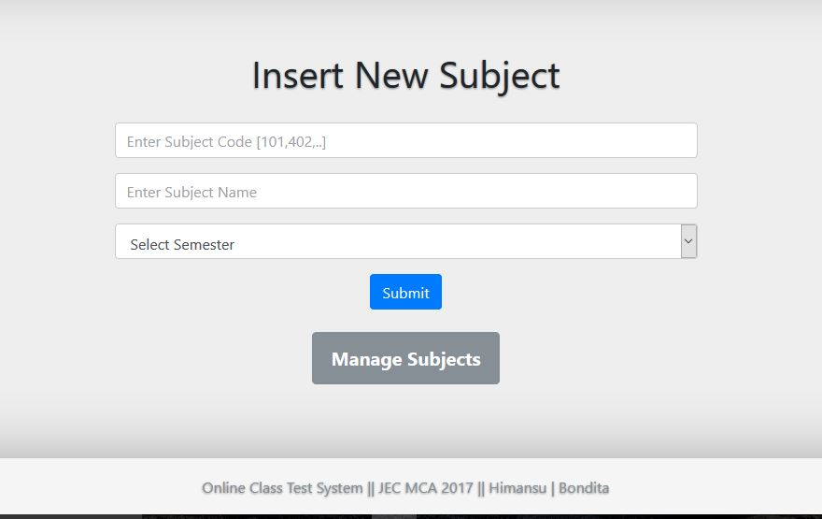

**Print result**

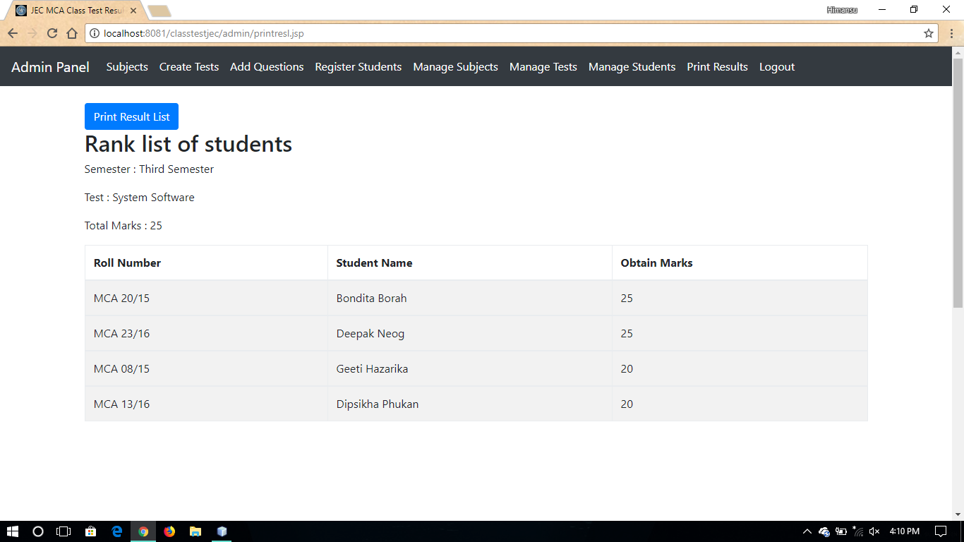

**Conclusion & Future Scope**

Simplicity is never simple. As we have seen in this project, the process of creating a user-friendly and straightforward platform that facilitates the administrator’s job is one filled with complexity. From understanding user requirements to system design and finally system prototype and finalization, every step requires in-depth understanding and commitment towards achieving the objectives of the project.

Although the database management module is not fully integrated to the system and used on real time, the system prototype demonstrates easy navigation and data are stored in a systematic way. Overall, efficiency has improved and work processes simplified. Although all the objectives have been met, the system still has room for improvement. The system is robust and flexible enough for future upgrade using advanced technology and devices.

It is hoped that this project will help the future developers to modify and implement the system. After modifying some techniques of the program it will give us the best performance as our requirements.

The project will be very useful for the users and all level of management.

_____________________

**References**

* codeforge.com
* w3schools.com
* javatpoint.com

____________________________