Passerelles numériques Cambodia

Street 371 Phum Tropeang Chhuk (Borey Sorla), Sangkat Tek Thla

Khan Sen Sok P.O. Box 511 Phnom Penh, Cambodia

Tel: +855 23.99.55.00

[info.cambodia@passerellesnumeriques.or](http://www.kh.passerellesnumeriques.org/)

[g](http://www.kh.passerellesnumeriques.org/)

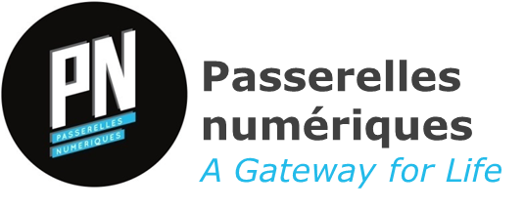

**Homework**

1. Font serif there are: Old Style, Transitional, Modern, Slab-Serif and Times New Roman.
2. Font sans-serif there are: Grotesque, Neo-Grotesque, Humanist, Geometric and Klavika.
3. possible difference between sans-serif and serif:

* For font sans-serif: More clean and modern than Serif font, easier to read on computer screen.
* For font serif: Has little stroke attached to the main part of the letter and classic look Suitable for traditional project, print publication on the magazine or newspaper.

1. Because font serif easy looking from the people. So the Company likes to use font serif and give the popular company. Furthermore, company most needed this is company newspaper or company sell the book.