SQL Select statement

Basic SELECT statement
- Write a query to display the names (first_name, last_name) using alias name “First Name", "Last Name" from employees table.

Answer: SELECT first_name "First Name",last_name "Last Name" FROM employees;
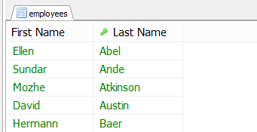
- Write a query to get unique department ID from employees table.

Answer: SELECT DISTINCT department_id FROM employees;
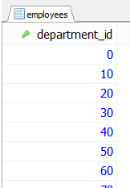
- Write a query to get all employee details from the employees table order by first name, descending.
Answer: SELECT * FROM employees ORDER BY first_name DESC;
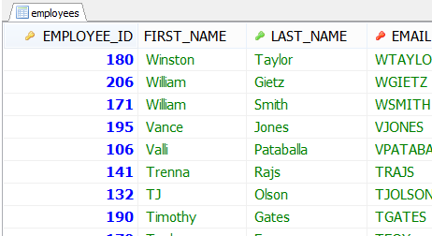

- Write a query to get the names (first_name, last_name), salary, PF of all the employees (PF is calculated as 15% of salary).
Answer: SELECT first_name, last_name, salary, salary*.15 PF FROM employees;

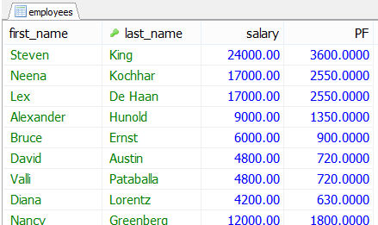

- Write a query to get the number of jobs available in the employees table.
Answer: SELECT COUNT(DISTINCT job_id) FROM employees;
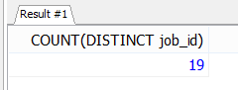
- Write a query get all first name from employees table in upper case.
Answer: SELECT UPPER(first_name) FROM employees;
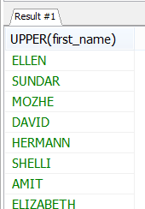

- Write a query to get the first 3 characters of first name from employees table.
Answer: SELECT SUBSTRING(first_name,1,3) FROM employees;

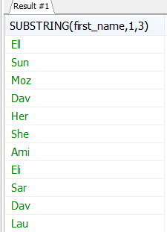
- Write a query to get the names (for example Ellen Abel, Sundar Ande etc.) of all the employees from employees table.
Answer: SELECT CONCAT(first_name,'',last_name)'Employee Name' FROM employees;
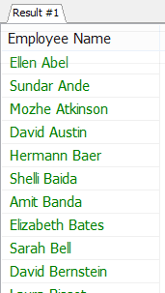

- Write a query to get first name from employees table after removing white spaces from both side.
Answer: SELECT TRIM(first_name) FROM employees;
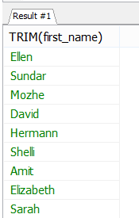

- Write a query to get the length of the employee names (first_name, last_name) from employees table.
Answer:SELECTfirst_name,last_name,LENGTH(first_name)+LENGTH(last_name) 'Length of Names' FROM employees;
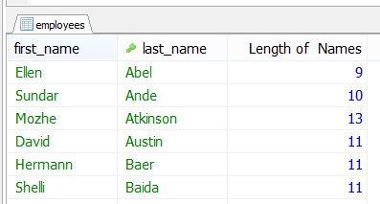

MySQL Restricting and Sorting Data

- Write a query to display the names (first_name, last_name) and salary for all employees whose salary is not in the range $10,000 through $15,000.
Answer: SELECT first_name, last_name, salary FROM employees WHERE salary NOT BETWEEN 10000 AND 15000;

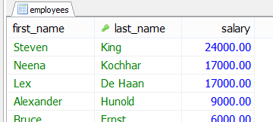

- Write a query to display the names (first_name, last_name) and department ID of all employees in departments 30 or 100 in ascending alphabetical order by department ID.
Answer: SELECT first_name, last_name, department_id FROM employees WHERE department_id IN (30, 100) ORDER BY department_id ASC;

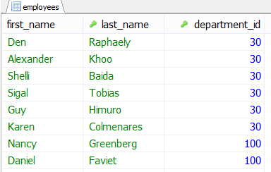

- Write a query to display the names (first_name, last_name) and salary for all employees whose salary is not in the range $10,000 through $15,000 and are in department 30 or 100.
Answer: SELECT first_name, last_name, salary, department_id FROM employees WHERE salary NOT BETWEEN 10000 AND 15000 AND department_id IN (30, 100);

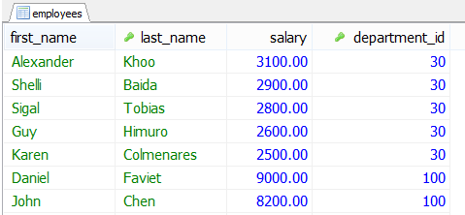

- Write a query to display the names (first_name, last_name) and hire date for all employees who were hired in 1990.
Answer: SELECT first_name, last_name, hire_date FROM employees WHERE YEAR(hire_date) LIKE '1987%';
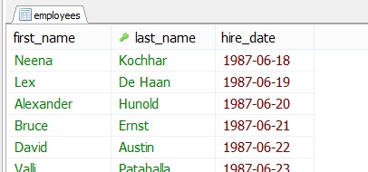

- Write a query to display the first_name of all employees who have both an "b" and "c" in their first name.
Answer: SELECT first_name FROM employees WHERE first_name LIKE '%b%' AND first_name LIKE '%c%';
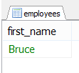
- Write a query to display the last name, job, and salary for all employees whose job is that of a Programmer or a Shipping Clerk, and whose salary is not equal to $4,500, $10,000, or $15,000.
Answer: SELECT last_name, job_id, salary FROM employees WHERE job_id IN ('IT_PROG', 'SH_CLERK') AND salary NOT IN (4500,10000, 15000);
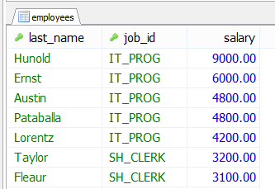

- Write a query to display the last names of employees whose names have exactly 6 characters.
Answer: SELECT last_name FROM employees WHERE last_name LIKE '______';
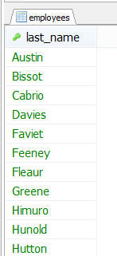

- Write a query to display the last names of employees having 'e' as the third character.
Answer: SELECT last_name FROM employees WHERE last_name LIKE '__e%';
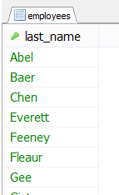

- Write a query to display the jobs/designations available in the employees table.
Answer: SELECT DISTINCT job_id FROM employees;
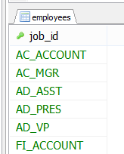

Aggregate Functions and Group by

- Write a query to list the number of jobs available in the employees table.
Answer: SELECT COUNT(DISTINCT job_id) FROM employees;
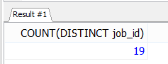
- Write a query to get the total salaries payable to employees.
Answer: SELECT SUM(salary) FROM employees;
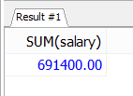
- Write a query to get the minimum salary from employees table.
Answer: SELECT MIN(salary) FROM employees;
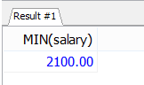

- Write a query to get the maximum salary of an employee working as a Programmer.
Answer: SELECT MAX(salary) FROM employees WHERE job_id = 'IT_PROG';
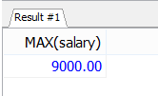
- Write a query to get the average salary and number of employees working the department 90.
Answer: SELECT AVG(salary),count(*) FROM employees WHERE department_id = 90;
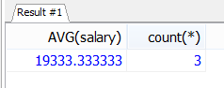
- Write a query to get the highest, lowest, sum, and average salary of all employees.
Answer:SELECTROUND(MAX(salary),0)'Maximum',ROUND(MIN(salary),0) 'Minimum',ROUND(SUM(salary),0)'Sum',ROUND(AVG(salary),0)'Average'FROM employees;
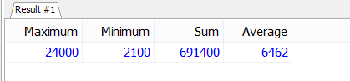

- Write a query to get the number of employees with the same job.
Answer: SELECT job_id, COUNT(*) FROM employees GROUP BY job_id;
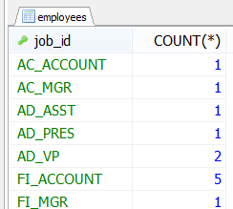
- Write a query to get the difference between the highest and lowest salaries.
Answer: SELECT MAX(salary) - MIN(salary) DIFFERENCE FROM employees;
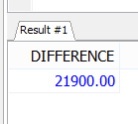
- Write a query to find the manager ID and the salary of the lowest-paid employee for that manager.
Answer: SELECT manager_id, MIN(salary)FROM employees WHERE manager_id IS NOT NULL GROUP BY manager_id ORDER BY MIN(salary) DESC;
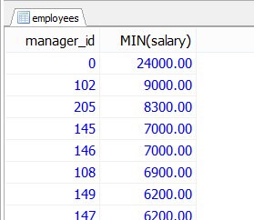
- Write a query to get the department ID and the total salary payable in each department.
Answer:SELECTdepartment_id, SUM(salary)FROM employees GROUP BY department_id;

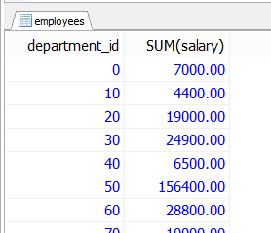

- Write a query to get the average salary for each job ID excluding programmer.
Answer: SELECT job_id, AVG(salary) FROM employees WHERE job_id <> 'IT_PROG' GROUP BY job_id;
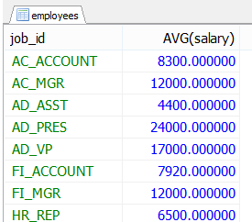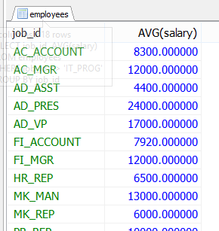

- Write a query to get the total salary, maximum, minimum, average salary of employees (job ID wise), for department ID 90 only.
Answer: SELECT job_id, SUM(salary), AVG(salary), MAX(salary), MIN(salary)FROM employees WHERE department_id = '90' GROUP BY job_id;

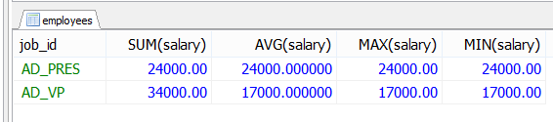

- Write a query to get the job ID and maximum salary of the employees where maximum salary is greater than or equal to $4000.
Answer: SELECT job_id, MAX(salary) FROM employees GROUP BY job_id HAVING MAX(salary) >=4000;
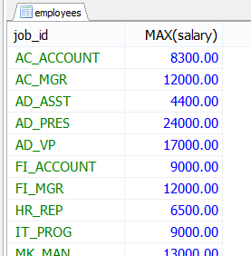

- Write a query to get the average salary for all departments employing more than 10 employees.
Answer: SELECT department_id, AVG(salary), COUNT(*) FROM employees GROUP BY department_id HAVING COUNT(*) > 10;

