1. What is the output of the code below?

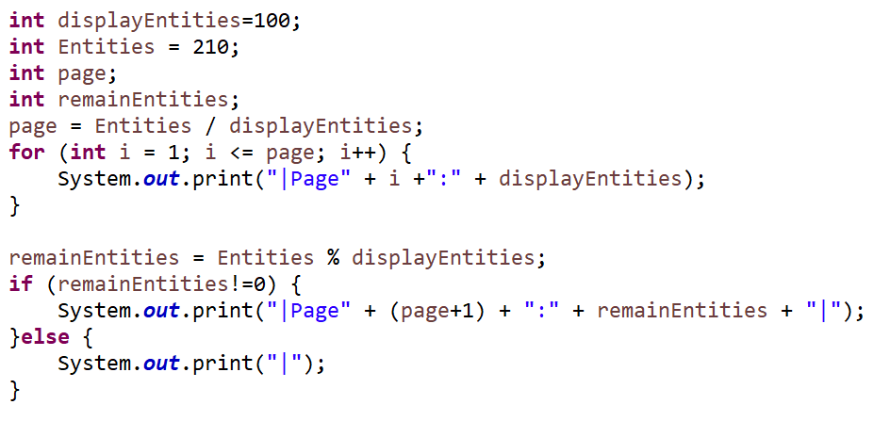

1. What is the output of the code below?

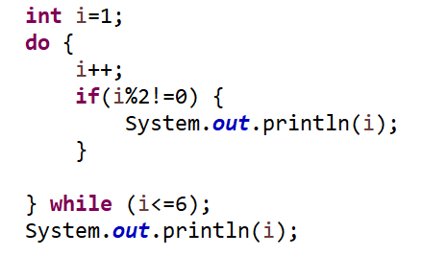

1. What is the output of the code below?

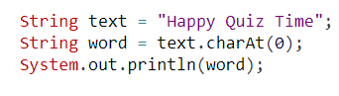

1. What is the output of the code below?

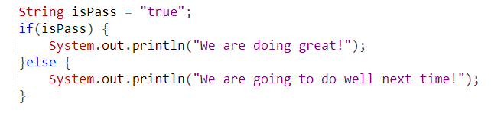

1. What is the output of the code below?

