Cyber-Crime Management System

CICS 314: Advanced Visual Basic.Net Programming

Patrick Fiifi Dadzie 040518013  
 Department Of Informatics  
 Ghana Technology University College  
 Accra, Ghana  
 dadzie101@yahoo.com

Nana Esi Abaka-Wilson 040518009 Department Of Informatics  
 Ghana Technology University College  
 Accra, Ghana  
 queeny001eaw@gmail.com

Derrick Sefa Boateng 040118034 Department Of Informatics  
 Ghana Technology University College  
 Accra, Ghana  
 boatengsefa0@gmail.com

ABSTRACT

The world in its present time is technology-driven as it is employed in various sectors of the economy to increase performance and to maintain quality assurance in the production of both goods and services. In the case of the implementation and enforcement of the law in this technological era, law enforcement agencies are mandated to use improved and integrated computing systems in the combatting of computer-aided crimes. in this effect the use of cyber-crime management systems is employed to keep and maintain a centralized record of crimes and criminals involved in computer/cyberspace crime activities. Crime is an act that goes against the laws of a society and is a threat to the peace and security of people and this requires effective and efficient monitoring to curb this menace. The crime records system employed by security agencies is majorly manual, which is, the use of pen and ledgers. This approach of record-keeping renders the records to be exposed to environmental hazards and also uncensored manipulation from individuals both authorized and unauthorized. This archaic method has resulted in problems with the integrity and authenticity of crime records. This project aims at the design and implementation of a cyber-crime management system. In the development of the system, the incremental cycle of the waterfall model of the system development life cycle was adopted. The system is implemented using Visual Basic.Net Windows Forms Application for the design of a high-end interactive user interface and Microsoft Access for a robust database. The cyber-crime management application will enhance the crime-fighting abilities of forensic investigators and will result in a lower threat level to the cyber life of citizens, thus, improving national buoyancy.

**INTRODUCTION**

Rules and regulations are paramount to all aspects of life and it accommodates both how one wishes to live, and how others should accommodate one’s lifestyle. (Mubaraka, 2013) Certain proponents have asserted that crime which is a violation against laws of the society, is integral to human nature and hence the society can never be completely free from it. Modern society is characterized by increasing levels of risk posed by internal and external security threats. Within this context, security driven by technology is increasingly being used by government, corporate bodies and individuals to monitor and reduce risk. (Muhammed, n.d.)

The proposed cyber-crime management system is an integrated approach to the investigation of cyber/computer-related crimes. The implementation of the cyber-crime management system is based on the digital forensic approach, that is, the acquisition, examination, analysis, and presentation of computer-related evidence in court. The system aims to devise a common platform that will enable forensic investigators to capture and preserve all requisite digital evidence of crimes committed in cyberspace, right from the first incident report to the generation of a forensic report to be presented before a court. The cybercrime management system enhances the crime recording operations of the security agencies. The data is stored in a centralized database that holds information about criminals, crime, and users of the system. Thus, all information on the database is remotely accessible via authentication access. Furthermore, the robustness of the centralized database will allow functions such as Interstation communication in real-time and also Improve the operational efficiency of the security agencies. Ad-hoc functions of the system include crime report generation and statistical analysis of crime data.

**BACKGROUND OF STUDY**

The widely employed crime record management approach used by security agencies is mostly a manual process. This approach entails the use of pen and ledgers in the documentation of criminal information. The petitioner fills in a First Information Report [FIR] form which includes his or her statement concerning the accused. When the accused is brought in, their details are handwritten into case files. Before the invention of computers, case files were kept in wooden or metal cabinets under lock and key. This approach of record-keeping renders the records to be exposed to environmental hazards and also uncensored manipulation from individuals both authorized and unauthorized. In recent years, as a result of the global rise in the application of computers in various aspects of life, desktop applications such as Microsoft Excel were adopted, thereby causing the approach to become both manual and slightly computerized.

**PROBLEM STATEMENT**

Although there are various implementations of computerized systems for criminal records, these system’s strengths lay in the foundation that it allows storage of multiple data for the criminal. However, a weakness observed is that it lacks in covering all the necessary entities required for a cyber-crime management system, it has no interface; as only the database was designed, there is no generation of crime analysis and report.

However, this method of record-keeping results in inconsistencies, wastage of disk space and poor control and coordination of data. The employment of this method results from reasons such as:

1. lack of or little funding in the development of crime management systems

2. Corruption and extortion on the part of some officers of the law enforcement agencies

3. Lack of technological skills and resources for statistical information management

**METHODOLOGY**

The Waterfall model of the software development life cycle was adopted throughout the stages of requirement elicitation process from stakeholders of the system to the system’s design and analysis using tools such as entity-relationship diagrams for the database and use case diagrams which describe user requirement. This model follows a sequential order which ensures that each phase of the development cycle is completed before another phase begins.

The stages of the waterfall include;

1. **Requirements Analysis:** this phase encompasses the gathering of requirements from the users of the system. The requirements are collected in a requirements specification document.

**Functional Requirements**

The functional requirements of the cyber-crime management system define the functions the system should carry out. About the cyber-crime management system, the system should:

1. Add users (forensic investigators) and assign them their different level of privileges
2. Validate user login details and ensure user-level privileges to information.
3. Store and retrieve information about crime and criminals.
4. Perform search functions based on some specified criteria.
5. Perform crime analysis and statistics as well as to generate adequate reports.
6. Generate criminal report.

**User Requirements**

User Requirements describe functions that are performed by the users on the system. The users of the cyber-crime management system are categorized into six levels namely levels one to six. The requirements for these users are described in tables below using use case diagrams:

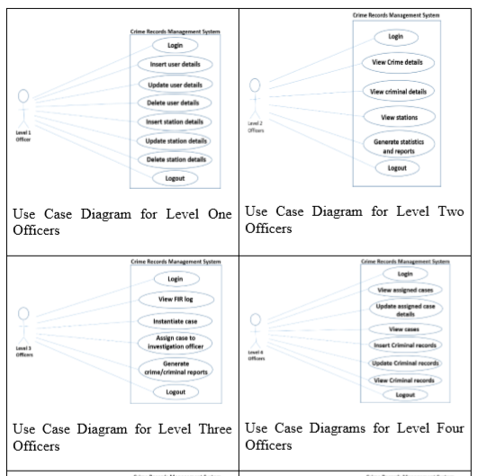

Table 1: Describes the functions of a level 1 and level two officer of the system



Table 2: Describes the functions of a level Three and level Four officer of the system

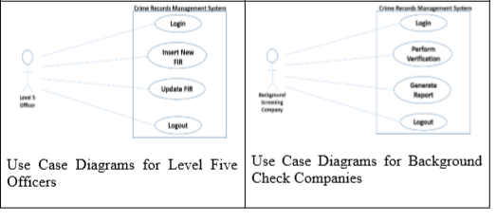

Table 3: Describes the functions of a level Five and level Six officers of the system

1. **System Analysis and Design**: The requirement analysis and specifications are studied and the system design is implemented. Analysis of the existing system is also carried out in this phase; the limitations of the existing system are analyzed and improved upon. Design tools used for this project include;

* Microsoft Visual Studio 2015 Professional
* Visual Basic.Net
* Microsoft Access

The Entity-Relationship diagram of the cyber-crime management system is shown below. It shows the various entities used in the database and also shows the individual relationships that exist between them.

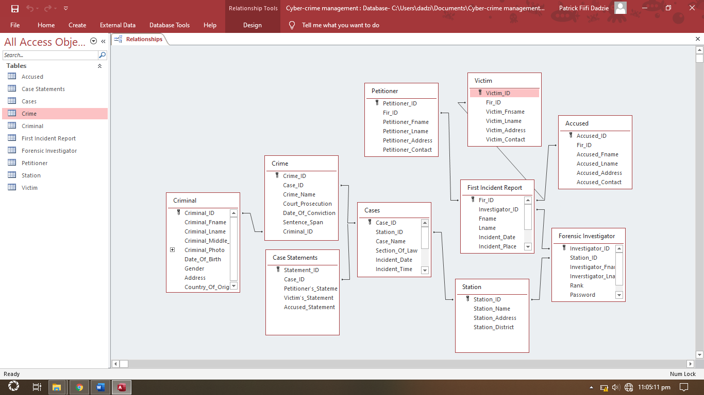

Fig.1 The Entity Relationship Diagram of the System

**SOFTWARE REQUIREMENT**

1. Operating System: Windows (7, 8, win 10)
2. Graphical User Interface: Windows Form Applications
3. Application Logic: Visual Basic.Net
4. Database: Microsoft Access

**HARDWARE REQUIREMENTS**

1. Processor: Dual Core – 900 MHz
2. 512 MB RAM
3. 4GB recommend hard disk space
4. **Implementation**: The cybercrime management system is implemented using Visual Basic.Net and Windows Forms Application for the graphical user interface. Microsoft Access is used in designing a robust database.
5. **Testing:** Individual windows forms application pages were developed in the implementation phase are integrated into to be a system after testing of each unit. Post system integration testing is done, to ensure the entire system is tested for any faults and failures.
6. **System Deployment**: Once both unit and system testing have been conducted successfully, the system is deployed in the working environment or released to be fully operational. The proposed system is installed in the new environment and the transition phase from the old system is explicitly monitored. This stage the documentation of the system and also involves the training of officers that will be given the privilege of operating the system, populating the database with existing records, and adding new records.
7. **Maintenance**: In the maintenance phase, issues arising on the deployment of the client environment are fixed. To fix these issues, patches are released. Also to enhance the product some better versions are released. Maintenance is done to deliver changes in the customer environment.

**SYSTEM IMPLEMENTATION, TESTING AND RESULTS**

System implementation uses the structure created during design and the results of system analysis to construct system elements that meet the stakeholder requirements and system requirements developed in the early life cycle phase (sommerville, 2004). It is the implementation of an algorithm as a program software through computer programming. This demonstrates the physical development of the system through coding. The software testing is categorized into three sections namely database testing, interface testing, and system testing.

1. **Database Testing**: A database is a repository of various information in various data types. As a result of this, integration and implementation errors may occur in large database file systems, which in turn harms system operations. It is therefore of great importance to maintain effective database operations to obtain a database that satisfies the ACID (atomicity, consistency, isolation, durability) properties of a database management system. (Korth, 2010). Normalization is carried out to eliminate data redundancy and concurrency. Below are some screenshots of the tables that exits in the database of the system.

**Crime Table**

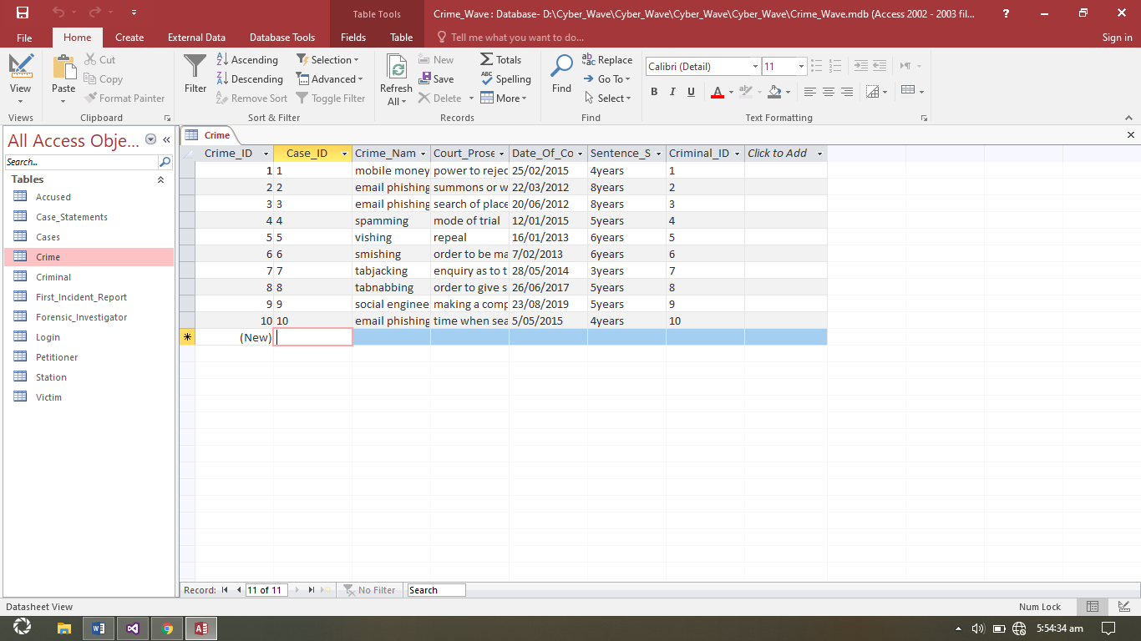

Table 4: Shows the Crime table which holds information on the crime. It contains the crime id as the primary key and crime specifications such as; crime name and has the case id as foreign key.

**Forensic investigator Table**

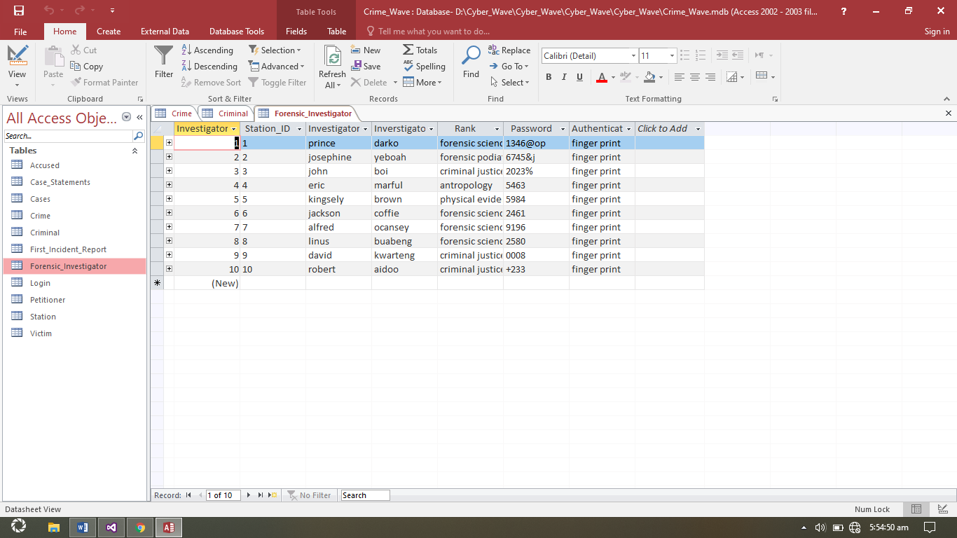

Table 5: Shows the Forensic investigator table which holds information on the forensic investigator of a crime. It contains the investigator id as the primary key and investigator specifications such as; investigator name, rank and password .it also has the station id as foreign key.

**Criminal Table**

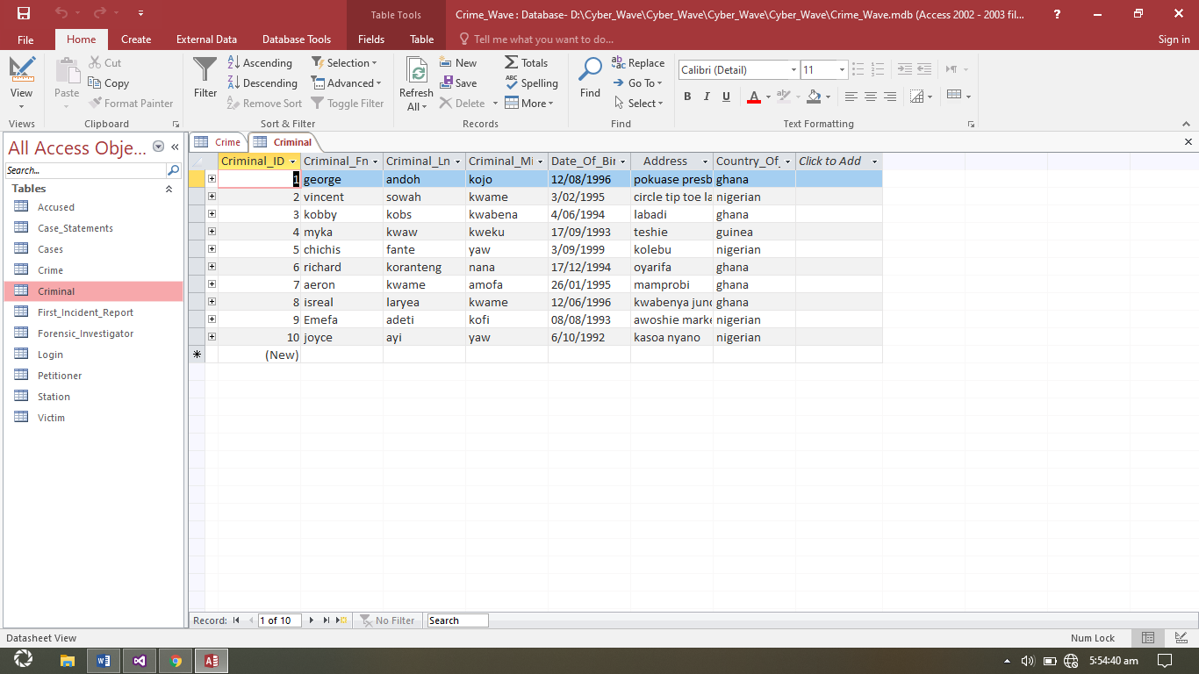

Table 5: Shows the Criminal table which holds information on Criminals involved crimes. It contains the criminal id as the primary key and criminal specifications such as; criminal name, address, and nationality.

1. **Interface Testing:** this phase gives shows the tests carried out on the design of the graphical user interface. This is to ensure that the system components are correctly integrated to share information and maintain the coherence of the system. The various tests that have been performed include:

**Login Module**

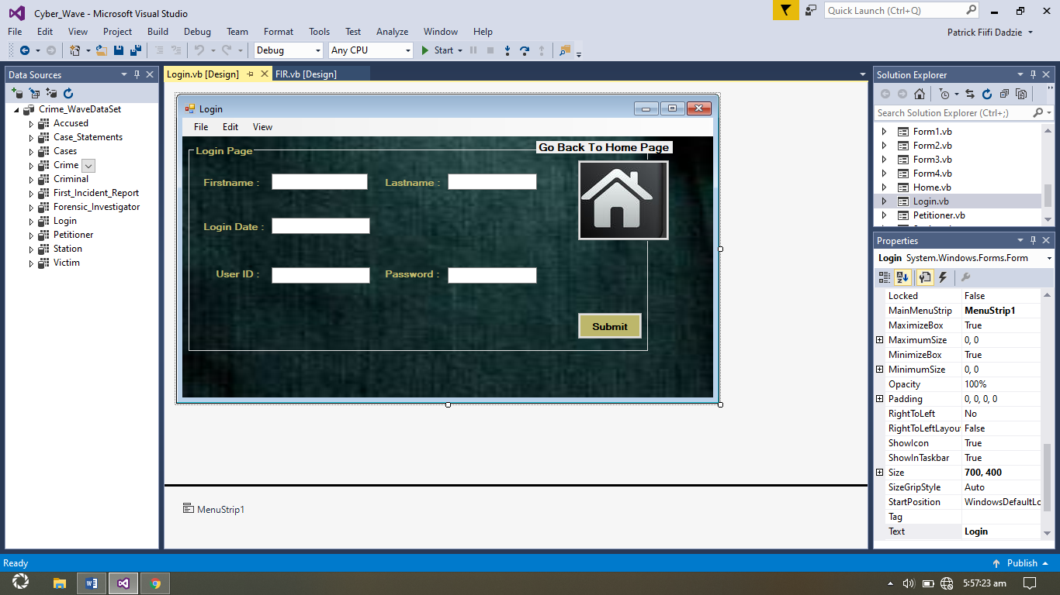

Figure 2: shows the Login page. This is also known as the authentication module. This module is responsible for logging users into the system. This is done by providing a correct and already registered user id and password, without which the user is denied access to the system.

**Add Forensic Investigator Module**

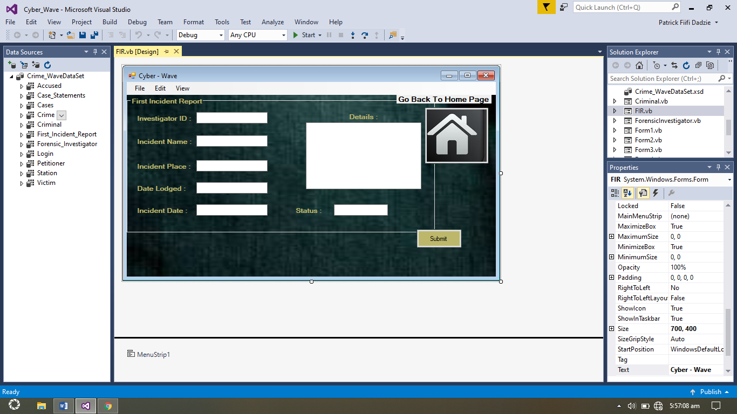

Figure 3: Shows the Forensic Investigator page. This page enables logged in investigators to the sign up new investigators and assign them with respective privileges to the system.

1. **System testing:** This phase involves the integration of the various modules of the system, integrating the various components into one coherent whole, and testing the cybercrime management system as a whole. A system test of a component module is shown below;

**Crime History View**

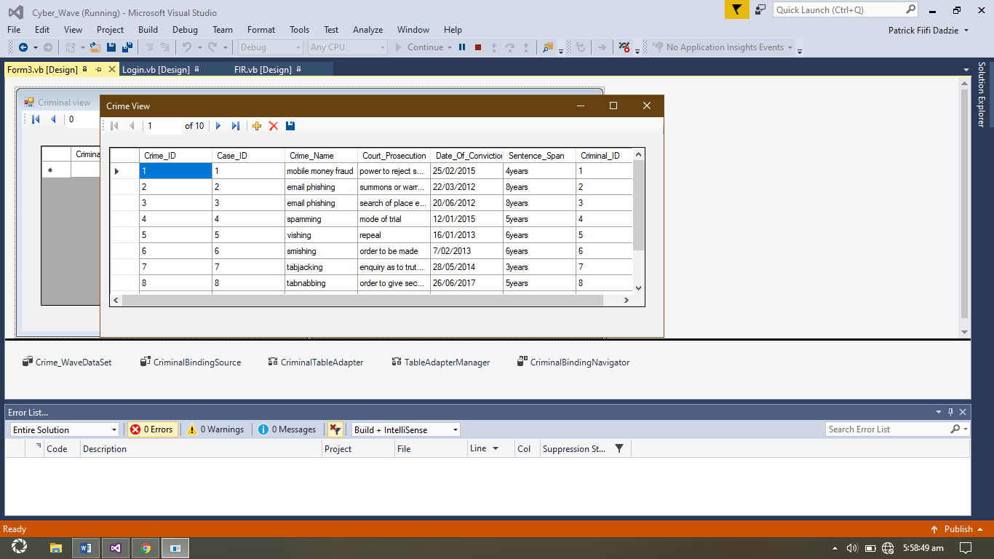

Figure 4: Show the display of an integrated module of the database and interface to produce an output that shows a view of the crime history

**LIMITATIONS**

In the course of developing the system, the major limitation encountered was the eliciting of functional requirements from Forensic investigators; as the officers were not forthcoming with information thereby making it complex to specify requirements of the system.

**CONCLUSION**

In the course of the development of the cybercrime management system, the major challenge faced was the gathering of requirements from stakeholders of the system, but we were able to pull through by using closely related systems to aid in eliciting system requirements. The system was measured in terms of authentication, real-time access, and centralized storage, and was proven efficient.

The need for an integrated approach to solving computer-related crimes cannot be overemphasized. The cybercrime management system enhances effective and efficient management of crime records by forensic investigators thereby helping in making informed decisions and improving reliability thus improving law enforcement operations. This, in turn, has a decreased effect on the crime rate of the country, thereby increasing national security.

# References

Awodele, O., Onuiri, E. E., Olaore, O. A. & Sowunmi, O. O., May 2015. A REAL-TIME CRIME RECORDS MANAGEMENT SYSTEM FOR NATIONAL SECURITY AGENCIES. *European Journal of Computer Science and Information Technology,* Volume Vol.3, No.2, pp. pp.1-12,.

European Centre for Research Training and Development UK (www.eajournals.org), May, 2015. Cyber-Crime Investigations. *European Journal of Computer Science and Information Technology,* Vol.3(No.2), pp. pp.1-12.

International council on archives, 2008. Guidelines and Functional Requirements for Electronic Records Management Systems. *Principles and Functional Requirements for Records in Electronic Office Environments,* 2(13).

Johnson, W. A., Johnson, J. & Ifedayo, T. E., July 2012. Evaluation and structures and operations of the Nigerian police public relations department. *Kuwait Chapter of Arabian Journal of Business and Management Review,* Volume Vol. 2, No.11, pp. pp.1-2..

Mubaraka, C. J. I. &. N. P., 2013. Innovative systems design and engineering. *Integrating ICT in the Traffic Police Department in Uganda; Design and development of a traffic case management system. ,* pp. pp.1-11.

Muhammed, D. M. R. M. J. F. &. A. K., n.d. *CRIMINAL RECORDS MANAGEMENT SYSTEM,* s.l.: s.n.

Osayande, P. B., 2008. Understanding the mandate and operations of the police service commission in the context of the rule of law. *Factors Inhibiting Police.*

point, T., 2014. *sdlc_waterfall_model.* [Online]   
Available at: http://www.tutorialspoint.com/sdlc/sdlc_waterfall_model.htm   
[Accessed 20 march 2020].

sommerville, I., 2004. *CS2 software engineering note2,* s.l.: s.n.

Vijay, 2013. *All about database testing.* [Online]   
Available at: http://softwaretestinghelp.com/database-testing-process/  
[Accessed 20 March 2020].