CPE 048

Embedded Systems 3

4-way Traffic Lights System with at least

2 Pedestrian Lanes Counter

Submitted By: Dylan Thomas M. Rañola

Submitted To: Engr. Aubrey Ubando

2024, august

**INTRODUCTION**

In Group 7, which included six members, my main contributions were in both the design and practical implementation of our project. Working closely with our group leader, I played a key role in planning and designing how the traffic light system would function. This involved brainstorming ideas on how the system should operate to maintain smooth and efficient traffic flow.

Beyond the initial planning, I was deeply involved in the technical side of the project. I played a major role in coding the system, and after I wrote the code, our leader optimized it to make it more efficient and compact. I also actively participated in building the necessary circuits and took on the responsibility of constructing the hardware, ensuring that all parts were assembled correctly and worked properly. My contributions were essential to the project's successful completion, combining both planning and hands-on work.

**LIST OF MATERIALS**

In our project, we used several key components to build and operate the traffic light system:

1. **Arduino R3**: This is a small, programmable microcontroller that served as the "brain" of our project. It controlled the traffic light system by following the code we wrote.

2. **LEDs x23**: Light Emitting Diodes (LEDs) are small lights used to represent the traffic lights. We used 23 of them to simulate the red, yellow, and green signals.

3. **Resistors x23**: These are small components that help control the amount of electrical current going to each LED, preventing them from burning out.

4. **Breadboards x2**: These are boards for building and testing circuits without soldering. We used them to connect all the components easily and securely.

5. **Jumper Wires**: These wires were used to connect different components on the breadboards, making it possible for electricity to flow between them.

6. **Battery with Battery Jack**: This provided power to the Arduino and the whole system, allowing it to operate independently of a computer.

7. **PC/Laptop**: A computer was used to write and upload the code to the Arduino, as well as to test and debug the system.

Each of these components played a vital role in our project, allowing us to create a functioning traffic light system that could be controlled and tested efficiently.

**CODE/PROGRAM**

**int trafficLights[] = {2, 3, 4, 5, 6, 7, 8, 9, 10, 11, 12, 13, A0, A1};**

**int totalLights = sizeof(trafficLights)/sizeof(trafficLights[0]);**

**unsigned long time[] = {30000, 5000, 30000, 5000, 30000, 5000};**

**int totalPhases = sizeof(time)/sizeof(time[0]);**

**int config[7][14] = {**

**{0, 0, 1, 1, 0, 0, 0, 0, 1, 1, 0, 0, 1, 0},**

**{0, 0, 1, 0, 1, 0, 0, 0, 1, 0, 1, 0, 1, 0},**

**{1, 0, 0, 0, 0, 1, 0, 0, 1, 0, 1, 1, 0, 0},**

**{0, 1, 0, 0, 0, 1, 0, 0, 1, 0, 1, 0, 1, 0},**

**{0, 0, 1, 0, 0, 1, 1, 0, 0, 0, 1, 0, 1, 1},**

**{0, 0, 1, 0, 0, 1, 0, 1, 0, 0, 1, 0, 1, 0},**

**{0, 0, 1, 0, 0, 1, 0, 0, 1, 0, 1, 0, 1, 0}**

**};**

**void litLights(int phase) {**

**for (int i = 0; i < totalLights; i++)**

**digitalWrite(trafficLights[i], config[phase][i]);**

**delay(time[phase]);**

**}**

**void setup() {**

**int startLight = 6, startTime = 5000;**

**for (int i = 0; i < totalLights; i++)**

**pinMode(trafficLights[i], OUTPUT);**

**litLights(startLight);**

**delay(startTime);**

**}**

**void loop() {**

**for (int i = 0; i < totalPhases; i++) {**

**litLights(i);**

**}**

**}**

**This code is the algorithm like in 4-way Traffic Lights for Intersection in AB Fernandez Ave. - Arellano St., Dagupan. This code controls traffic lights and pedestrian signals with an Arduino. It sets up pins for each light and uses the config array to define their states for each traffic phase. The time array specifies how long each phase lasts. The setup function initializes the lights, and the loop function continuously cycles through phases, updating the lights based on the current phase's settings and duration. This ensures organized traffic flow and pedestrian safety.**

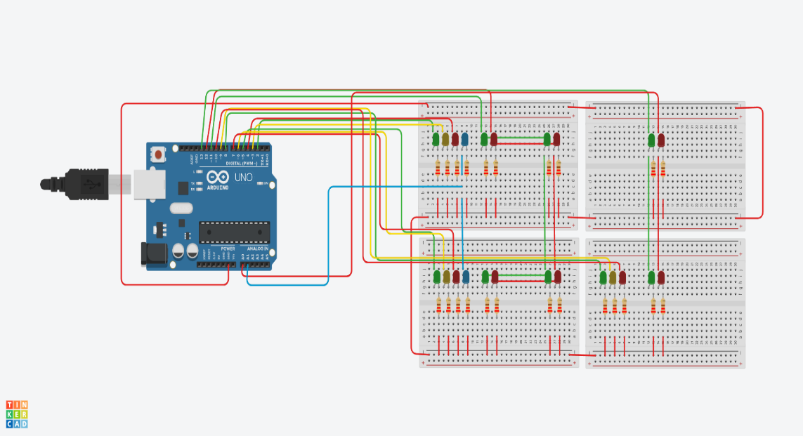**DOCUMENTATION**

