Portfolio Documentation

Audience

The audience for the web page is:

* The entire world wide web
* Anyone with access to the web
* Business prospects
* Future possible hirers

Wireframe

Created a basic wireframe on paper getting inspiration from other portfolios online

Attempted to create a wireframe online using an online wireframe creator called mockflow.com, found it to be unresponsive, tedious and difficult to use for desired designs. Stuck with the paper designs originally created.

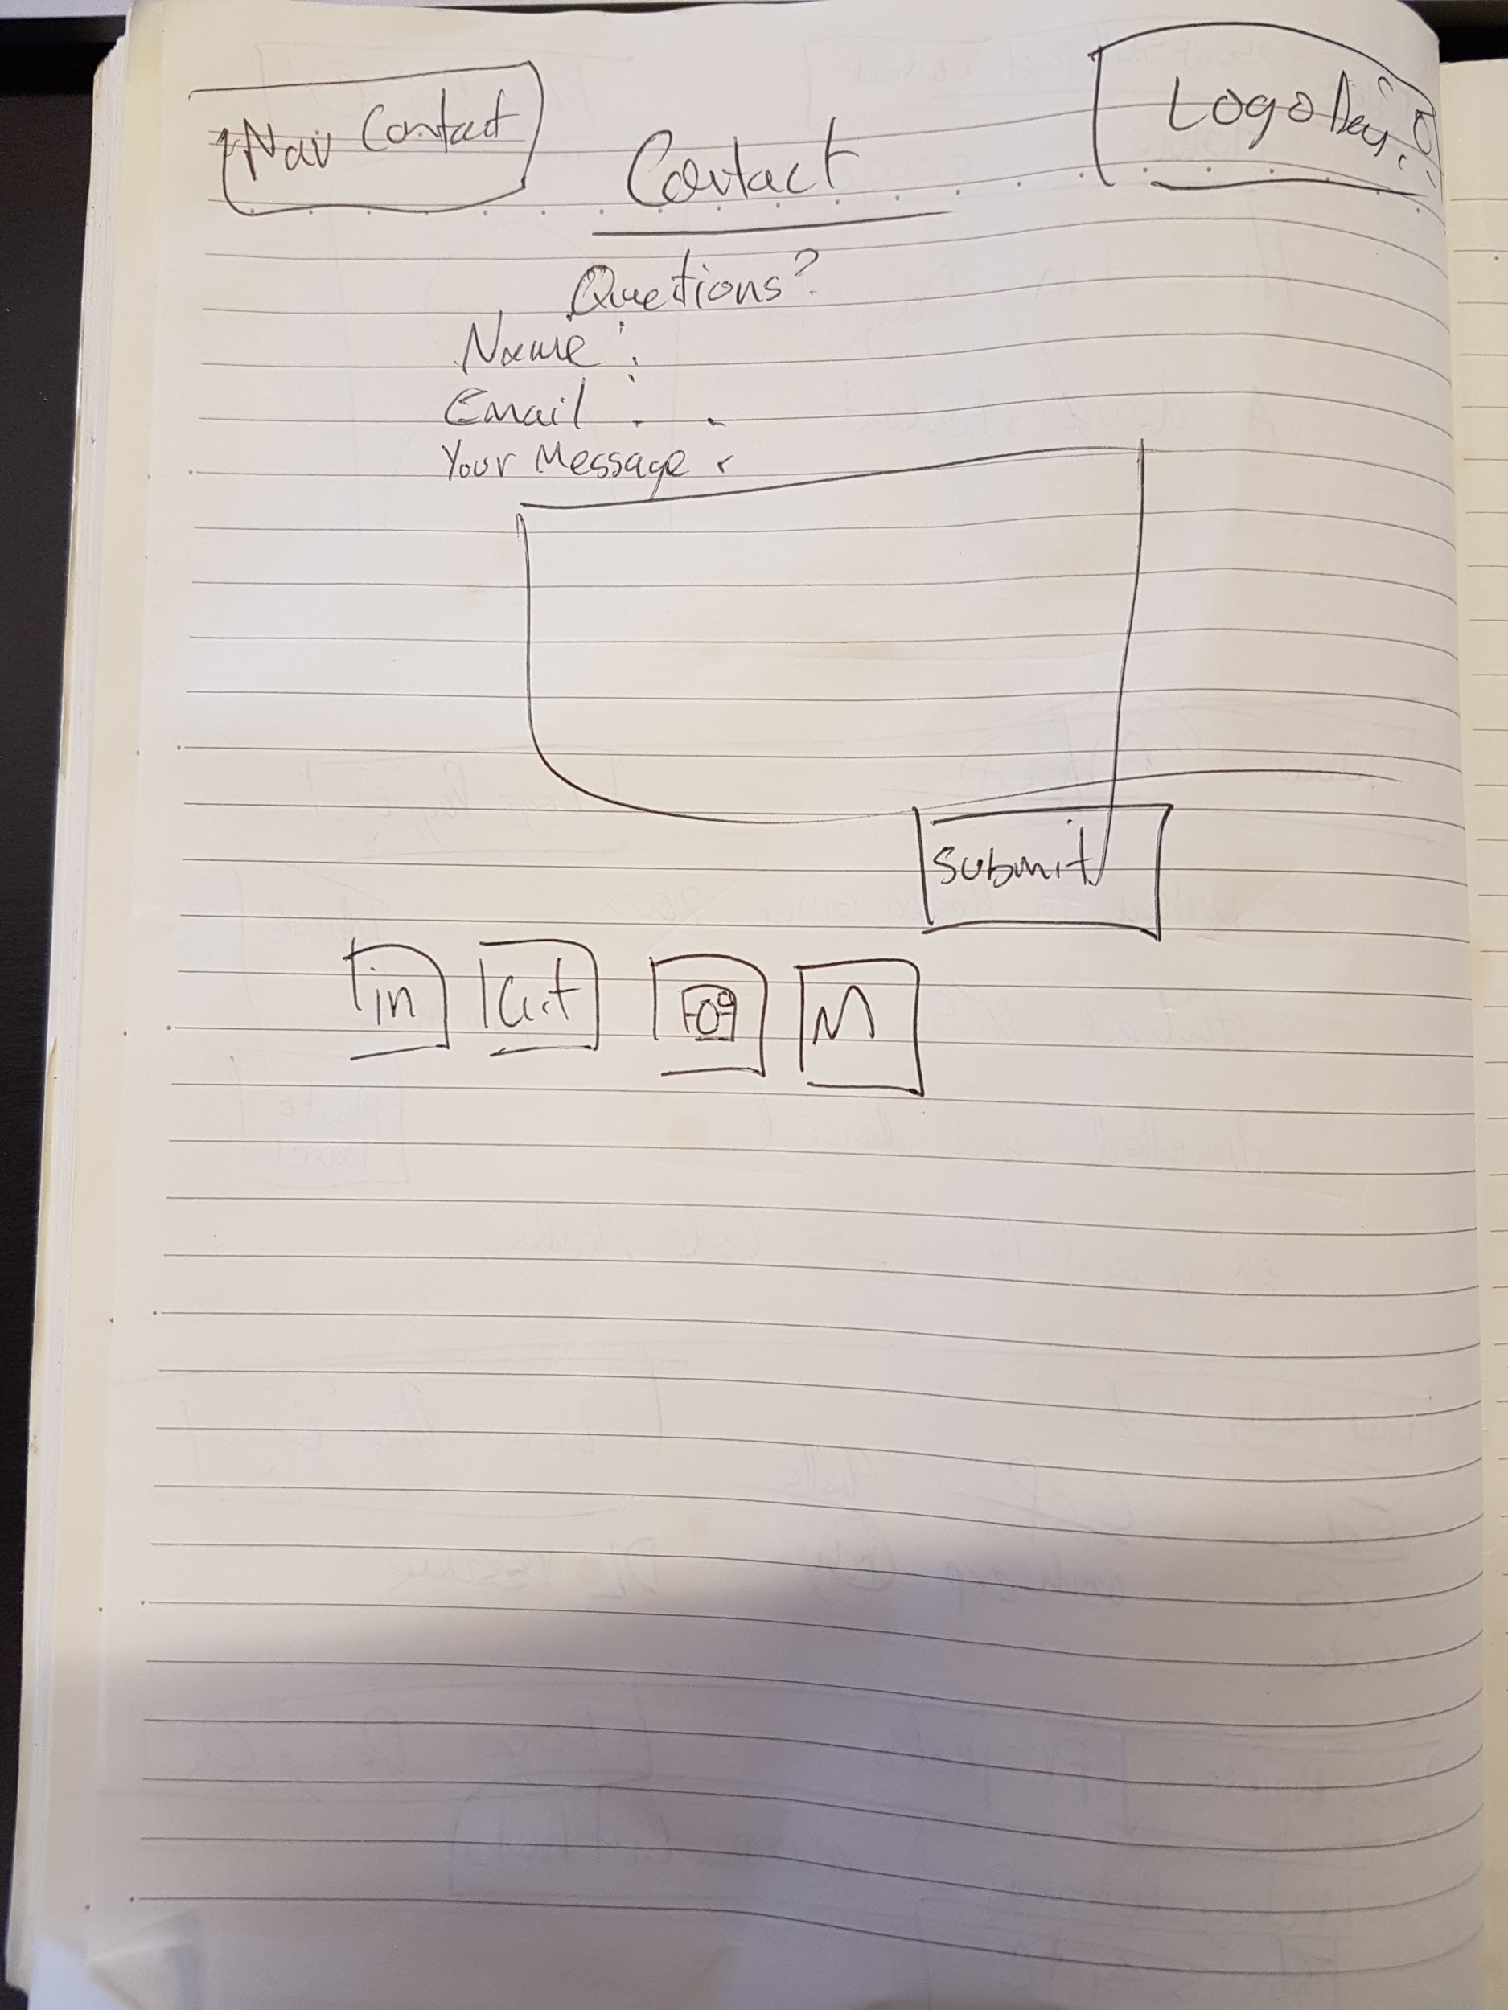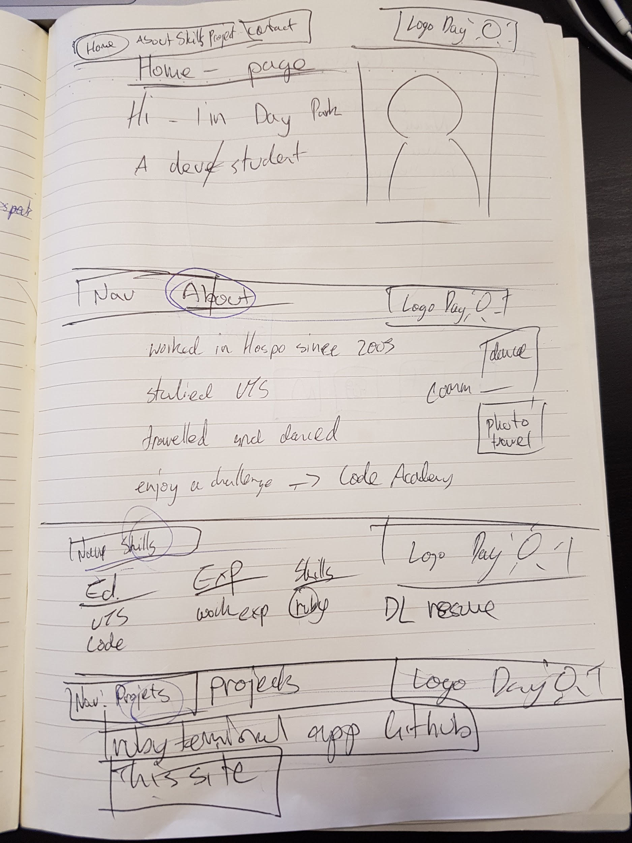

Style guide/usability heuristics

Sticking to one style of font, linked from google fonts, “raleway” with the back up fonts helvetica and sans-serif.

Used svg icons so the quality stays the same

Although the site was tested in powermapper.com

The site reported an error with svg images stating that the images are not supported with IE 8 and older android devices.

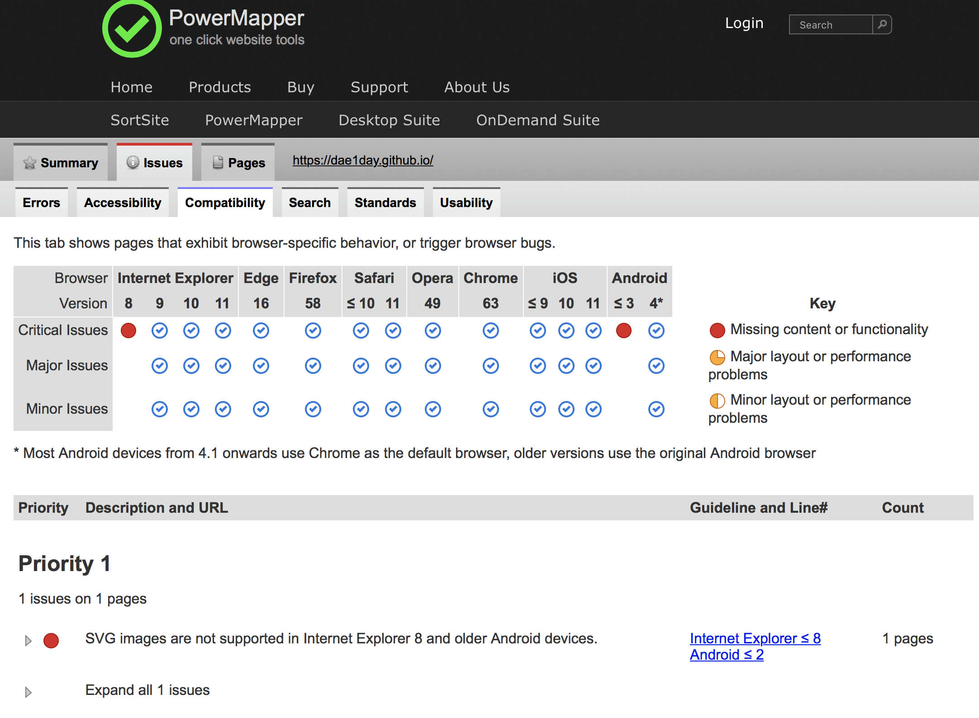

Chosen color palette, using a photo I took, which contained primarily of an image of the sky, decided to base the color palette based off this image. Googled light blue color palette

Came across the site colorcombos.com and found this combination of colors:

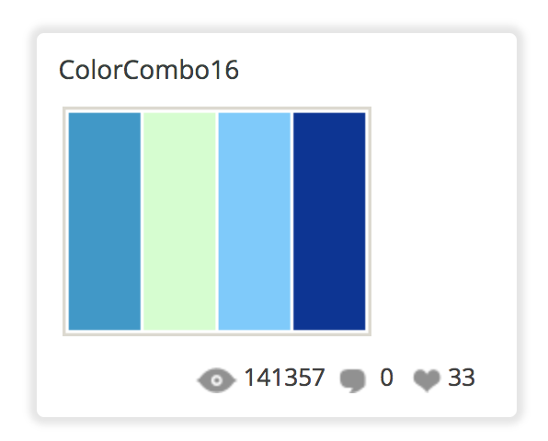

Had to change the background and certain parts of the page accordingly to match this color scheme. Including the color of the fonts had to be changed to white for the font to stand out.

Chose the colors in here for the buttons and fade in buttons. Chose the navbar color also based on this combination.

Basic colors not too complex in order to not overcomplicate.

Personal logo

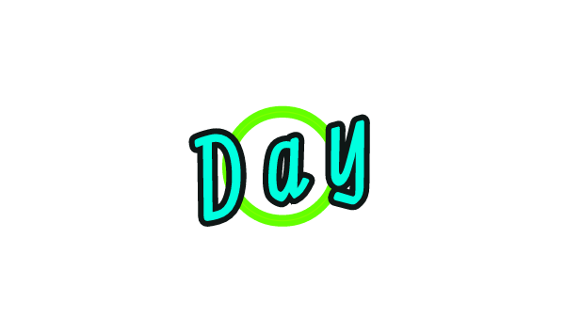

Created a logo using logomakr.com . tried to incorporate it into the nav but but couldn’t quite get the overflow effect desired. The favicon was created before the logo but as it worked, was left in.