Project Description: LED Key Chain Date: 03-06-2021 (D/M/Y)
Project Code : ELEC2840

PCB Description : PCB - LED Key Chain
PCB P/N: PCB001 PCB Rev: 1.0
PCB Dimensions : (35.0)L x (25.0)W mm
Total Number of Layers and layer assignment:
Single Double 3 4 5 6 Other ( )

TOP LAYER (L1) | 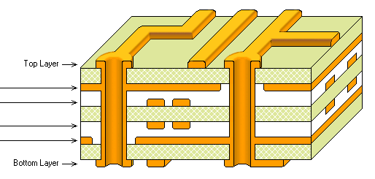
Inner 1: NOT AVAILABLE
Inner 2: NOT AVAILABLE
Inner 3: NOT AVAILABLE
Inner 4: NOT AVAILABLE
BOTTOM LAYER (L2)

PCB Base Material:
FR-4 CEM-1 Aluminum Other (Specify )
PCB Base Thickness:
0.6mm 0.8mm 1.0mm 1.2mm 1.6mm
Copper Thickness:
½ oz 1 oz 2 oz Other ( oz)
Tracks & Holes:
Track width (min) = 1.00mm Track clearance (min) =0.30mm Hole & Via Dia. (min) = 1.5mm

Technological Requirements (Click all applied)
Gold Plating | Lead-Free HAL
Immersion Gold | Gold Finger
Buried Via | Blind Via
Plug Hole | Other ( )

Silkscreen and Solder-Mask Requirements:
TOP LAYER |  | BOTTOM LAYER
Silkscreen Color | Solder-Mask Color | Silkscreen Color | Solder-Mask Color
White | White | White | White
Black | Black | Black | Black
Other ( ) | Green | Other (Nil) | Green
 | Other (Anti-UV) |  | Other (Anti-UV)
REMARKS:
- Line width tolerance: ±20% for track width equal or below 0.5mm, +/-0.1mm for track width above 0.5mm
- Drill Holes' Tolerance: PTH (dia.<6mm): 0.08mm, NPTH (dia.<6mm): 0.05mm, Hole (dia.>6mm): 0.10mm
- Reflow technology board using surface mount pads resist mask to pad artwork registration shall be ±76.2μm (no mask on pads allowed except where noted)
- Board to be 100% tested for opens and shorts with an automated fixture designed for the application.

