February 5, 2021

Ms. Gemma Pajo
Owner
Quadro King Water Station
Las Pinas City

Dear Madam,

We the students of AMA Computer College Las Pinas campus taking Bachelor of Science in Information Technology (BSIT) would like to ask your permission to allow the undersigned proponents to conduct an interview in your prominent institution.

The proponents are engaged to conduct a research study regarding your existing Ordering and delivery system as a partial requirement for our IT Capstone Project 1 – IT 6398. In line with this project, the proponents would like to gather accurate and helpful information through an interview method, which will guide in analysing and designing an Ordering and delivery tracker app that will benefit your institution.

The “Ordering and delivery tracker app for Quadro King Water Retail Store” will enable you to provide secure, reliable and efficient processing of information, as well as providing timely reports needed by the organization in terms of decision-making.

The proponents will be very grateful to your institution if you will accept this project proposal and rest assured that any gathered information will be used strictly for study purposes only and remain confidential.

Hoping for your kind consideration

Respectfully yours,
_______
Luis Gabriel O. Belbis
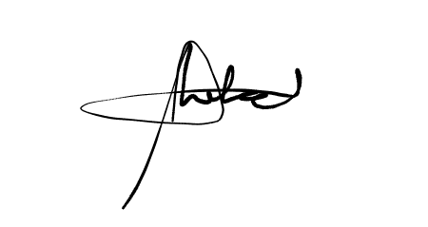
____________________
Marlo Dael
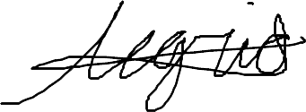
_____________________ Received by :
Floren Joseph Alegrid
Noted by: 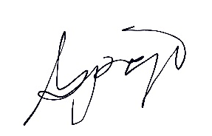
___________________________ __________________________

Prof. Karren V. de Lara Gemma Pajo
IT Capstone Project 1 Adviser Owner

