**Database System**

**Lecture2**

**IMS (Hierarchical Model)**

- Example Hierarchy

Segment Structure

IMS / DL/1 Operations

- Example PL/1 Program #1

- Example PL/1 Program #2

- What’s Bad About IMS/PL1?

Logical Data Independence

Schemas Change for Many Reasons

Study break #1

Questions

Solution

**CODASYL (Conference/Committee on Data Systems Languages)**

Example CODASYL Network

Example: Find Cages Joe Keeps

Codasyl Problems

Relational Principles

**Relational Data Model**

Zoo Tables

Zoo Tables (last lecture)

Relational Algebra

Join as Cross Product

Relational Identities

Push Down Example

Join Ordering Example

Study Break #2

Questions

Solution

**IMS vs CODASYL vs Relational**

Physical Independence

Logical Data Independence

Key Idea: View

Views Example

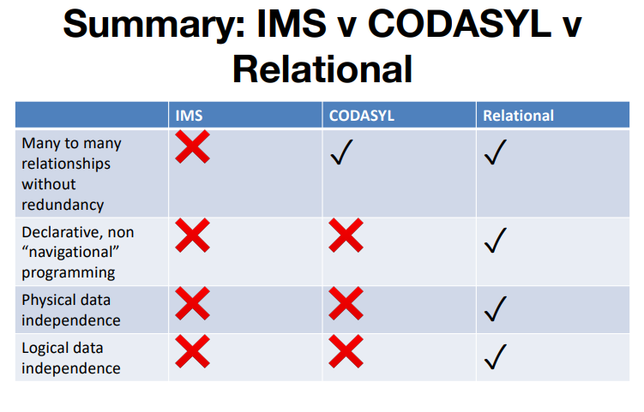

**Lecture3**

Aliases and Ambiguity

Aggregation

Left Join?

**Self Join**

Question: Keepers who keep bears and giraffes

Need to build two tables, Bear keepers and Giraffe keepers, and intersect them.

SELECT bear_keepers.name

FROM keepers AS bear_keepers

JOIN keeps AS bear_keeps ON bear_keepers.id = bear_keeps.kid

JOIN cages AS bear_cages ON bear_keeps.cageno = bear_cages.no

JOIN animals AS bear_animals ON bear_animals.acageno = bear_cages.no

JOIN keepers AS giraffe_keepers

JOIN keeps AS giraffe_keeps ON giraffe_keepers.id = giraffe _keeps.kid

JOIN cages AS giraffe_cages ON giraffe _keeps.cageno = giraffe _cages.no

JOIN animals AS giraffe_animals ON giraffe _animals.acageno = giraffe _cages.no

WHERE bear_animals.species = ‘Bear’

AND giraffe_animals.species = ‘Giraffe’

AND giraffe_keepers.id = bear_keepers.id

But, 7-way join

**Nested Queries**

SELECT bear_keepers.name

FROM (

SELECT id, keepers.name FROM

keepers JOIN keeps ON id = kid

JOIN cages ON cageno = no

JOIN animals ON acageno = no

WHERE species = ‘Bear’

) AS bear_keepers

JOIN (

SELECT id, keepers.name FROM

keepers JOIN keeps ON id = kid

JOIN cages ON cageno = no

JOIN animals ON acageno = no

WHERE species = ‘Giraffe’

) AS giraffe_keepers

ON giraffe_keepers.id = bear_keepers.id

**Simplify with Common Table Expression (CTEs)**

WITH bear_keepers AS (

SELECT id, keepers.name FROM

keepers JOIN keeps ON id = kid

JOIN cages ON cageno = no

JOIN animals ON acageno = no

WHERE species = ‘Bear’

),

giraffe_keepers AS (

SELECT id, keepers.name FROM

keepers JOIN keeps ON id = kid

JOIN cages ON cageno = no

JOIN animals ON acageno = no

WHERE species = ‘Giraffe’

)

SELECT bear_keepers.name

FROM bear_keepers JOIN giraffe_keepers

ON giraffe_keepers.id = bear_keepers.id

SQL can get complex

Study Break

Solution

※ 결과값에서 중복값 제거하려면 SELECT 할때 SELECT DISTINCT

**Recursive Queries**

Recursive Example

**Window Functions**

Other Window Functions

Examples

Study Break

Soln

What is SimpleDB?

Module Diagram

Database

Catalog

BufferPool

HeapFile (Implements DbFile)

HeapPage (Implements Page)

SeqScan (Implements Dblterator)

**Lecture 4**

Entity Relationship Modeling Already Saw with Zoo

**ER Diagrams**

More ER Modeling

Converting to Relations

Study Break

Solution

Hobbies Example

Hobby DB, Attempt 1

Types of Anomalies

Hobby DB Attempt 2

**Normalization**

Schema From ER Diagram

Why Does Redundancy Arise?

Functional Dependencies

FDs are a Property of the Application, Not the Data

Boyce-Codd Normal Form (BCNF)

BCNFify

BCNFify Example for Hobbies

Account, Client, Office

A Dilemma

BCNF vs 3NF

Study Break

Solution