**LOGIC APPS HANDS ON LABS**

***Twitter Scenario***

**Objective**

In this lab, a Logic App will be created which triggered once a tweet is created with a certain hashtag. After the tweet is detected, the Logic App calls out to Microsoft’s Cognitive Service for Sentiment Analysis. Sentiment Analysis will score the sentiment of the tweet and return a score between 0 and 1. We then store the tweet and relevant information in an Azure Storage Account – in Table Storage. We record, based on the sentiment score returned whether the tweet is positive (scored >0.7), negative (scored < 0.3) or neutral (scored <0.7 but >0.3). Finally, we build a basic PoweBI visualization which plots the tweets on a map.

**Pre-requisites**

* An active Azure subscription
* Your Twitter account and user credentials
* PowerBI Desktop (can download for free at <https://powerbi.microsoft.com/en-us/pricing/>  )

**Exercise 1**

Before we create our Logic App, there are a few steps we need to go through first. First, we need to connect create our connection to the Sentiment Analysis Cognitive Service and secondly we need to create a storage account which we will use to store information about the Twitter data.

1. Open your browser and navigate to https://portal.azure.com, and login using your username and password.
2. When we create our Logic App, we will be using Microsoft’s Cognitive Service for Sentiment Detection, so therefore, before we create our Logic App, let’s provision an instance of Sentiment Detection that we can leverage.
   1. Click on ***+ Create a resource*** and search for and select Text analytics



* 1. Click **Create**
  2. Enter the following on the Create – Text Analytics screen:
     1. Name: ***DetectSentiment***
     2. Location: ***East US***
     3. Pricing Tier: ***F0 (5K Transactions per 30 days)***
     4. Resource Group: Create new 🡪 ***TwitterHOL***
  3. After the resource has been created, click on it.
  4. While on the Overview Screen, locate the endpoint, copy it into Notepad and save it for later. Mine is https://eastus.api.cognitive.microsoft.com/text/analytics/v2.0.
  5. Next, click on ***Keys*** in the left- hand panel.
  6. Copy Key 1 and paste it in Notepad (we will need this information when we create our Logic App)

1. Now, let’s create a storage account that we can use to hold the data related to this exercise (it will make it easier to clean up things going forward).
   1. Click ***on + Create a resource*** and search for storage account
   2. Select ***Storage account – blob, file, table, queue***
   3. Click ***Create***
      1. For resource group: ***TwitterHOL***
      2. Storage account name: ***twitterholdstorage (you may need to add a number to the end or use another unique name – just keep in mind what you call this)***
      3. Location: ***East US***
      4. Accept the rest of the defaults and select ***Review* + create**
      5. After the validation has passed, click ***Create***
   4. Once the deployment has completed, click on Go to resource
   5. Click on Properties and copy the Primary Table Service Endpoint and paste it into your notepad (you’ll need this URL later when you import the table data into PowerBI)
   6. Click on Access Keys and copy the key1 key into your Notepad (again we will need this later, for exercise 3)
   7. Next, click on Tables
   8. Click + Table
   9. For Table name enter twitterdata
   10. Click Ok

**Further Reading**

* Explore more capabilities of Microsoft’s Text Analytics API by reviewing [What is Text Analytics?](https://docs.microsoft.com/en-us/azure/cognitive-services/text-analytics/overview)
* Review other storage options at [Azure Storage Documentation](https://docs.microsoft.com/en-us/azure/storage/)

**Exercise 2**

In this exercise we will create our Logic App. This Logic App will listen for tweets matching certain criteria, run those tweets through sentiment analysis, and then store those tweets in Azure table storage.

Let’s get started….

1. Click ***+ Create a resource***, search for and select Logic App.
2. Enter the following details for the Logic App:
   1. Name: ***TwitterLogicAppHOL***
   2. Resource group: ***TwitterHOL***
   3. Location: ***East US***
   4. Click ***Create***
3. It will take a few moments for your new Logic App to be created. Once you have been notified it has been created click ***Go to resource***.
4. Click ***Logic App Designer***
5. Click ***When a new tweet is posted***

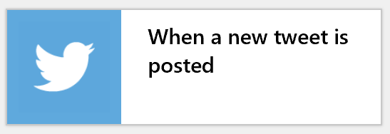

1. Click ***Sign in*** (Note: If you receive an error during this step, try in Chrome or IE)
2. Provide your Twitter credentials, authorize the app, and allow access to your Twitter account.
3. Click ***Continue***
4. In the When a new tweet is posted box select the following:
   1. Search text: I am using ***#steelers*** but you can choose whatever you’d like. Just keep in mind, Twitter is public site updated live, you never know what type of information might be returned. Consider your audience.
   2. Interval: I will check for items every **10** minutes
5. Click ***+ New step***
6. Search for ***Text Analytics*** and select the node Detect Sentiment (preview) – Text Analytics
   1. On the Text Analytics screen enter the following:
      1. Connection Name:  **DetectSentiment**
      2. Account Key: Copy and paste your key from earlier
      3. Site URL: Copy and paste your endpoint from earlier
      4. Click ***Create***
7. Click ***+ New step***
8. Search for **condition** and select ***Condition – Control***
9. The first portion of the condition will be “***If score < 0.3***”. In order to select Score, click on ‘Add dynamic content’ and select ***Score***.
10. The second part of the condition is AND location is not NULL. We want to specify this because for this scenario, we are only interested in Tweets which have a corresponding location, because we are going to plot them on a map. Similarly to above, you will select Location from dynamic content. In order to specify not null you will indicate Location 🡪 Is not equal to 🡪 and simply leave the last field blank.

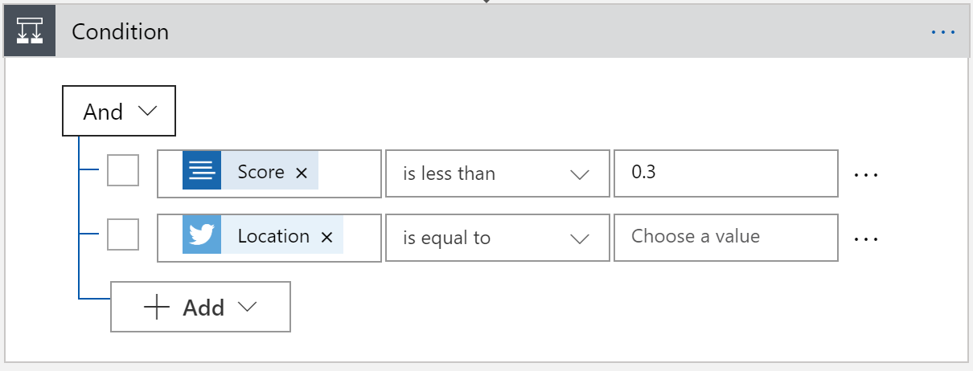

1. Under the If true section, click on Add an action.
2. Search for Azure table and select Insert Entity 🡪 Azure Table Storage
3. Enter the following for the Insert Entity node:
   1. Connection name: ConnectToAzureTableStorage
   2. Select the Azure Storage account you created in Exercise 1: twitterholstorage
   3. Click Create
4. On the Insert Entity screen enter the following:
   1. Table: twitterdata
   2. In the Entity section we want to enter the following JSON

{

"RowKey": <insert Request ID from dynamic content>,

"Name": <insert User Name from dynamic content>,

"PartitionKey": "negative",

"Location": <insert location from dynamic content>,

"Score": <insert Score from dynamic content>,

"Tweet": <insert Tweet text from dynamic content>

}

1. Click Save
2. Now we will work on adding a condition for neutral tweets – those between 0.3 and 0.7 in sentiment.
   1. Click the + between the Condition node and the Detect Sentiment node.
   2. Select Add a parallel branch
   3. Search for **condition** and select ***Condition – Control***
   4. Select Score (from dynamic content) is greater than or equal to and enter 0.3
   5. Click + Add and specify Score is less than or equal to 0.7
   6. Click + Add and specify Location is not equal to <leave the value field blank>
   7. Under If true, click on Add an action.
   8. Search for Azure table and select Insert Entity 🡪 Azure Table Storage
   9. Enter the following for the Insert Entity node:
      1. Connection name: ConnectToAzureTableStorage
      2. Select the Azure Storage account you created in Exercise 1: twitterholstorage
      3. Click Create
   10. On the Insert Entity screen enter the following:
       1. Table: twitterdata
       2. In the Entity section we want to enter the following JSON

{

"RowKey": <insert Request ID from dynamic content>,

"Name": <insert User Name from dynamic content>,

“PartitionKey”: “neutral”,

“Location”: <select Location from dynamic content>,

“Score”: <select Score from dynamic content>,

“Tweet”: <select Tweet text from dynamic content>

}

1. Click Save
2. Finally, we will add a condition for positive tweets – those greater than 0.7.
   1. Click the + between the Condition node and the Detect Sentiment node.
   2. Select Add a parallel branch
   3. Search for **condition** and select ***Condition – Control***
   4. Select Score (from dynamic content) is greater than 0.7
   5. Click + Add and specify Location is not equal to <leave the value field blank>
   6. Under If true, click on Add an action.
   7. Search for Azure table and select Insert Entity 🡪 Azure Table Storage
   8. Enter the following for the Insert Entity node:
      1. Connection name: ConnectToAzureTableStorage
      2. Select the Azure Storage account you created in Exercise 1: twitterholstorage
      3. Click Create
   9. On the Insert Entity screen enter the following:
      1. Table: twitterdata
      2. In the Entity section we want to enter the following JSON

{

"RowKey": <insert Request ID from dynamic content>,

"Name": <insert User Name from dynamic content>,

“PartitionKey”: “positive”,

“Location”: <select Location from dynamic content>,

“Score”: <select Score from dynamic content>,

“Tweet”: <select Tweet text from dynamic content>

}

1. Click Save
2. Let’s run the Logic App to ensure everything is working properly
   1. Click Run
   2. After you receive the message “Successfully checked the trigger”
   3. Click on the Overview tab of the Logic App
   4. Click on the top message in the run history (this should hopefully say Successful)
   5. You can click through the Run History to see what tweet was picked up and what criteria it met (negative, neutral, or positive) based on the sentiment detection.
   6. Next, you should review the Azure Table to ensure that the specified information on the tweet has been written to Azure Table Storage.

**Further Reading**

* Review more information on the over 200 connectors available for use with Logic Apps at [Connectors for Logic Apps](https://docs.microsoft.com/en-us/azure/connectors/apis-list)

**Exercise 3**

In this exercise, you will be building a PowerBI map visualization to provide a visual depiction of the tweets you have collected.

Let’s get started…

1. Open PowerBI Desktop (if you do not have PowerBI Desktop installed, please refer to the link contained in the Pre-requisites section)
2. Click on Get Data and then select More
3. Select Azure 🡪 Azure Table Storage 🡪 click Connect
4. For account name or URL, paste in the Primary Table Service Endpoint that you copied into Notepad in exercise 1.
   1. <https://twitterholstorage.table.core.windows.net/>
5. Click ***OK***
6. For Account Key, paste in the Access Key that you pasted into notepad in exercise 1
7. Check the checkbox next to the twitterdata table and click ***Edit***
8. Another panel comes up (Power Query Editor). Click the arrow next to the Content column header to expand the data in the Content field

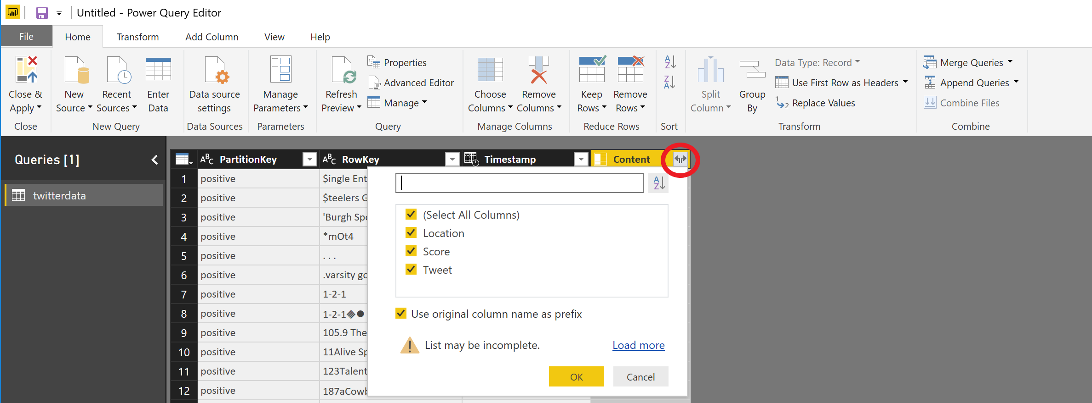

1. Select all columns and click OK
2. **NOTE**: If the Name field is not identified, you can manually modify the query to ensure it gets imported. You will need to edit the content and the headers. It should look something like this:
   1. = Table.ExpandRecordColumn(twitterdata1, "Content", {"Location", "Score", "Tweet", “Name”}, {"Content.Location", "Content.Score", "Content.Tweet", “Content.Name”})
3. Click Close and Apply in the upper left hand corner

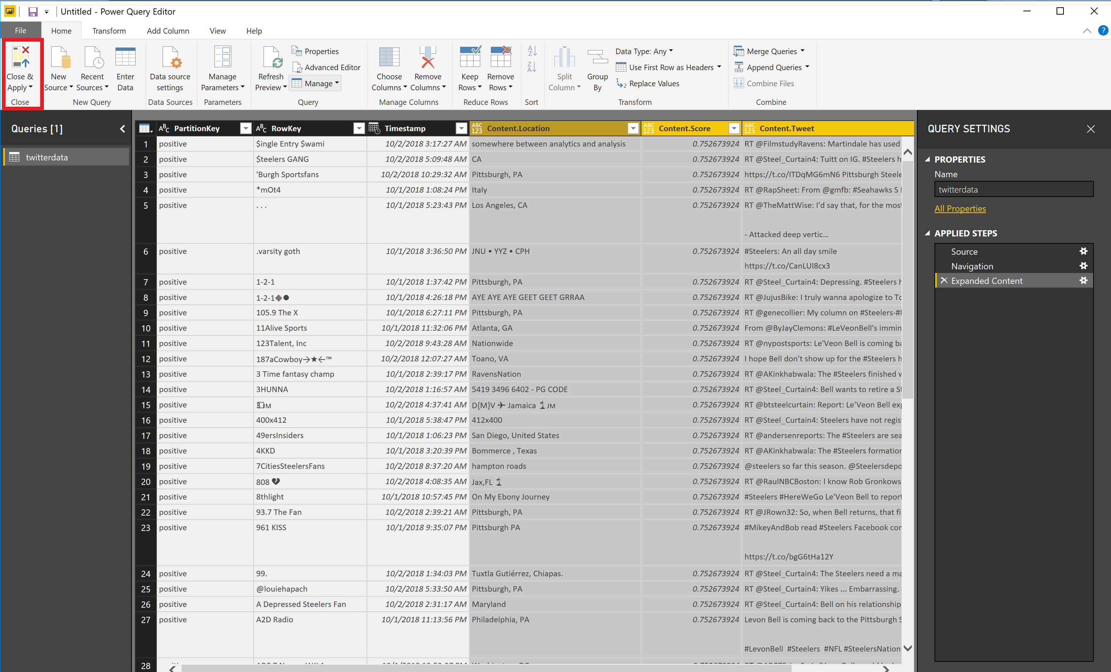

1. Now we will create a Map visualization. Click on the Map icon from the Visualization panel.

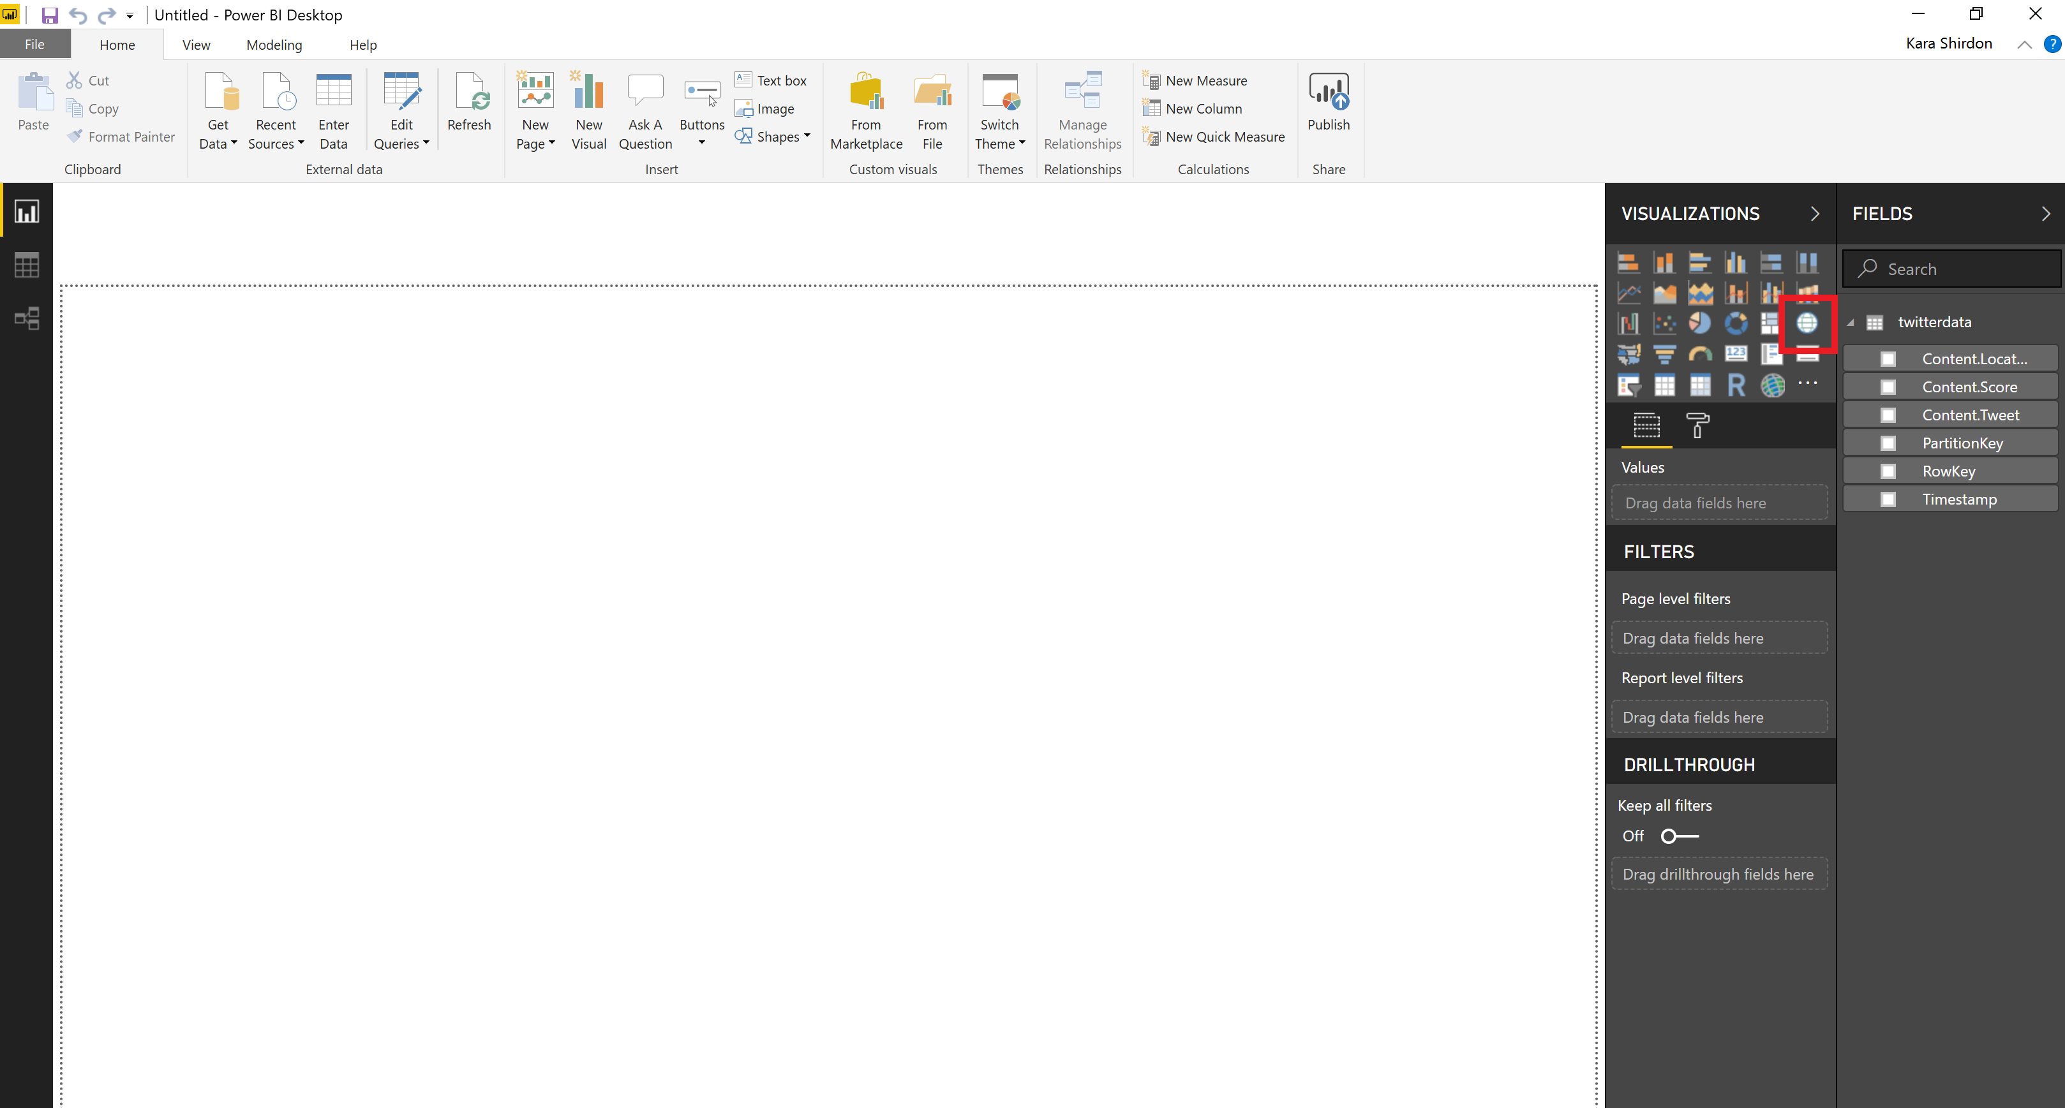

1. Drag Content.Location into the Location field
2. Drag PartitionKey into the Legend Field
3. Drag RowKey, Content.Location, Score, and Content.Tweet into the Tooltips field

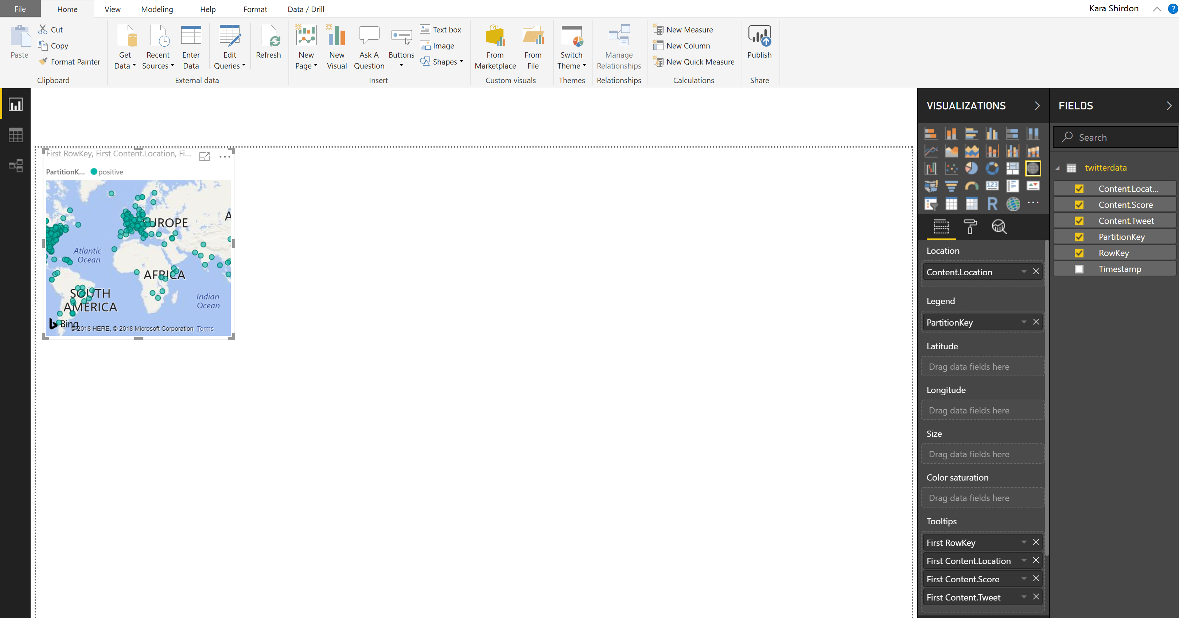

1. You can resize the map to make it larger by dragging from the corner
2. Click on the paint roller (Format icon)
3. Expand the Legend section and change Legend Name to Sentiment
4. Collapse the Legend section
5. Expand the Data Colors section
6. Change the colors to the following:
   1. Negative = red
   2. Neutral = yellow
   3. Positive = green
7. Now you can hover over the different bubbles to see the detail associated with the tweets

**Further Reading**

* Learn more about Power BI through [Guided Learning](https://docs.microsoft.com/en-us/power-bi/guided-learning/)

**CONGRATULATIONS, YOU HAVE COMPLETED THE LOGIC APPS TWITTER SCENARIO HANDS ON LABS!**