**Investment and Trading Project**

**Stock Prediction Project Definition**

**Project Overview**

This is an attempt to predict the stock prices using historical data and applies to the investment and trading domain. While there are multiple factors that can affect stock pricing – economic, political, social etc., we will use only the past stock prices themselves to solve a classification problem (buy or sell) or a regression problem (close price). I am primarily interested in stock prices of some semi-conductor companies "WIKI/INTC", "WIKI/QCOM", "WIKI/NVDA", "WIKI/TXN", "WIKI/BRCM", and "WIKI/AAPL" since these are few of the companies that have been successful the past decade but also because I work in this industry. My main motivation for this project is to learn how to effectively solve a time-series problem with a LSTM as the neural network. [1], [2], [3], [4], [5], [6] are just a few academic works that incorporate Recurrent Neural Networks (RNN)and specifically Long Short Term Memory (LSTM) Neural nets for time series problems. [1] shows that LSTM model is superior to other models while [5] shows that an LSTM model performs better than the statistical ARIMA model. [2] used different structural and analytical techniques to create a feature vector that could then be passed to a predictive model (LSTM) to identify market correlation.

**Datasets and Inputs**

The input dataset is downloaded using quandl APIs for each of the stocks. This is how the data looks like: Date,Open,High,Low,Close,Volume,Dividend,Split,Adj_Open,Adj_High,Adj_Low,Adj_Close,Adj_Volume 2017-12-20,174.87,175.42,173.25,174.35,23475649.0,0.0,1.0,174.87,175.42,173.25,174.35,23475649.0 2017-12-19,175.03,175.39,174.09,174.54,27436447.0,0.0,1.0,175.03,175.39,174.09,174.54,27436447.0

Dataset has stock prices since its inception, but I will use only the data starting 2006/1/1 onward.

Apart from the downloaded data from quandl, I will also experiment using some stock indicators such as Relative Strength Index, Average Directional Movement Index, Volatility volume ratio, Simple Moving Average and Stochastic oscillator to create a model that predicts future closing prices.

Quandl : <https://docs.quandl.com/docs/python-time-series>

Stockstats: <https://pypi.python.org/pypi/stockstats>

### Problem Statement

All traders do wish to be able to foretell the price of a stock as it amounts to significant wealth (or loss). There have been many attempts to use statistical analysis and machine learning to predict stock prices. However, is it possible? Random walk theory for stock prices states that the price changes of a stock have same distribution and are completely independent of each other and hence the past movement of stock cannot be used to predict the future. However, as [7] argues, there is no conclusive evidence that stock prices movement is random and cannot be outperformed. With that said, we will use a Deep neural network to test the theory ourselves.

Here we will attempt to predict future stock prices by using publicly available stock data and using a LSTM neural network. Stock prediction is essentially a time-series sequence prediction problem and the underlying architecture of a LSTM network makes it a good fit. LSTM networks have the capability to store contextual information for an arbitrary duration of time and can use this context along with the input to make a prediction. It also can discard inputs that are seemingly random. This ability makes it apt for stock markets where prices fluctuate based on a pattern with intermittent highs and lows.

The questions that we will answer are:

1. Can we find correlation between these 6 stocks which belong to the same market segment?
2. What is predicted Adjusted Close of a stock based on historical data?
3. What will be the stock price N days into the future?

### Metrics

The main object of the project is to be able to predict the Adjusted Close price of a stock. This is essentially a regression problem and I will use Root Mean Squared Error metric to measure the performance of the model(s). Here we are evaluating the residual error of the prediction and hence RMSE can give the absolute measure of fit for the model. The unit for RMSE is the same as the input and hence it is more intuitive to understand how well it fits the model. A low RMSE score would indicate a better fit to the model.

## Stock Prediction Analysis

### Data Exploration

We begin by downloading the stock prices for the interesting stocks and visualize the closing prices/growth of the stock post 2006. 2006 is just a cut-off used since this would be the more relevant data for prediction. Using this cut-off, we find that the number of samples available for each of the stock is around 3065 (see count in Table 1) except for BRCM which is about 2536. Stock prices shows a very strong correlation between the close, open, volume, high, low of a stock on a day to day basis. [I think this is expected since these values more or less vary similarly on a day to day basis. Hence, we will try to understand only the Adj. Close price since this is the quantity we are going to predict. In this project, I have chosen 6 stocks INTC, QCOM, NVDA, TXN, BRCM, AAPL to see if we find correlation between them. Correlation could help in strengthening prediction.

|  |  |  |  |  |  |  |
| --- | --- | --- | --- | --- | --- | --- |
| title | INTC | QCOM | NVDA | TXN | BRCM | AAPL |
| count | 3065 | 3065 | 3066 | 3066 | 2536 | 3065 |
| mean | 21.93807 | 46.92908 | 33.57737 | 37.39588 | 32.17619 | 62.72796 |
| std | 8.484741 | 12.78424 | 46.54202 | 21.25682 | 8.747484 | 45.78066 |
| min | 9.052754 | 23.53545 | 5.474608 | 11.25386 | 12.66826 | 6.511801 |
| 25% | 15.54266 | 34.68717 | 12.82357 | 23.69801 | 26.87465 | 21.25235 |
| 50% | 18.732 | 47.53824 | 17.36719 | 28.01993 | 31.27222 | 54.28429 |
| 75% | 29.0066 | 57.08591 | 23.91198 | 47.75263 | 36.02959 | 96.69283 |
| max | 52.19 | 72.67418 | 249.08 | 120 | 58.32 | 179.98 |

Table 1: Closing price statistics for six Stocks

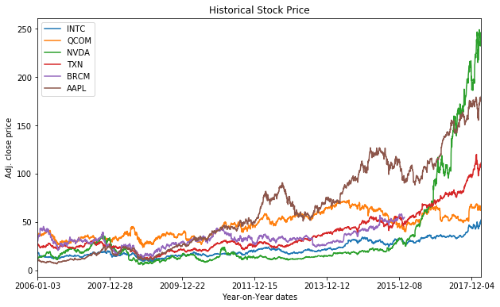

Fig 1: Historical stock closing price for the six stocks

Table 1 and Fig 1 together show a good description about how each of our stocks behaved. In terms of the closing price of each stock, we see that there are significant differences between the stocks. NVDA clearly shows a significant change in stock prices during the 2006-2018 period (77% of data is the 4th quartile). However, the closing prices themselves do not help much in understanding trends. We should rather use percentage change to understand stock behavior. Plotted below is a box-plot to describe day-on-day percentage change for the six different stocks. 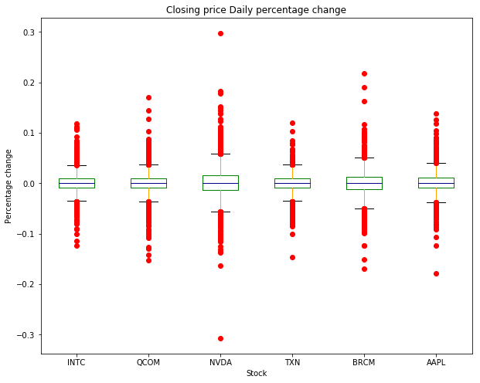

Fig 2: Stock Percentage Change Box Plot

The general trend of all the stocks seems to be in the 1st or the 4th quartile. It clearly shows that the period between 2006 and 2018 had resulted in significant changes in each of the stocks. There are a few obvious steep changes in closing price for NVDA, BRCM seems to be the only outlier in the data.

The correlation matrix (fig 3) shows that there is not significant correlation between the different stock prices. (Note: A low value means there is very low correlation). The most seems to be between TXN and INTC but even there it is about 66%. This implies that we should be attempting to model each stock independently. We will create models separately for each stock and hope to predict close prices based on the trained model. In the rest of the project, I will use only QCOM data for training / evaluation and test purposes.

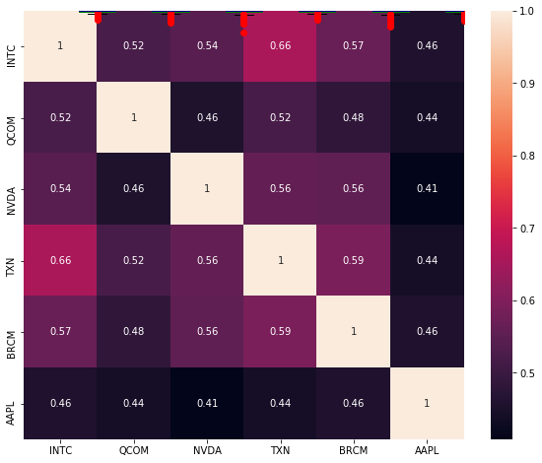

Fig 3: Correlation Matrix Between Stocks

### More input features:

Investment decisions are primarily based on fundamentals or technical analysis. Fundamental analysis uses financial information about the company whereas technical analysis uses the stock/market information. Since we are using only the stock prices per-se, we will work on a few technical analyses that identify momentum or trends in a stock and see if the combination of a closing-price and these technical indicators help in predicting future stock prices. A few technical analyses used are:

#### Relative Strength Index (RSI):

RSI is a momentum oscillator i.e. it measures the rate of increase or decrease of stock prices over a period (typically 14 days) and essentially states if a stock is overbought (when above 70) or oversold (when below 30). RSI depends primarily uses the **closing** price of a stock.

#### Average Directional Movement Index (ADMI):

ADMI is a trend indicator i.e. it basically measures the strength or weakness of a trend and hence provides a better judgement on when to enter and exit the market. ADMI also uses the **closing** price of a stock over a period (14-days typically) using either the observed positive or negative Directional Movement. Unlike RSI, it is a lagging indicator i.e. a trend is set before it can be observed.

#### Volatility Volume Ratio (VR):

VR is used to measure price range and is an indicator breakout or changes in the price range. It considers the change in **close** prices of a stock along with the **volume** and calculated over a 26-day period.

#### Simple Moving Average (SMA):

Here we calculate the Simple moving average of **close** price of the stock over 14 days.

#### KDJ Stochastic Oscillator:

This is a stochastic oscillator that determines the underlying strength and direction by analyzing short term movements. It basically considers **close**, **high**, **low** and **range** of a stock price for a set period (typically 9 days).

The idea is to use the above indicators also as input features to a model and understand if these will help us better predict future stock prices.

Plotting correlation matrix between the technical indicators and the stock closing-prices, we can see that there is very minimum correlation between them ascertaining the fact that we can potentially use the technical indicators also as feature inputs.

### Algorithms and Techniques

Stock market prediction is characterized as a time-series problem where values from previous time steps affect the subsequent ones. To that end, we need a neural network model that is able to capture dependencies between events. Recurrent Neural Networks (RNN) are a type of feedback networks which have outputs are fed back to the input on the next time step. This allows an output to be influenced by not only the current input but also the previous value. LSTM are a variant of the RNN but are able to capture/learn long-term dependencies between events and hence are better suited for time-series problems where we would like to base a decision based on past events.

**LSTM**:

LSTM network can preserve error that can be back propagated through many layers over different time steps and hence can counter the vanishing gradient issue as seen in RNN. This ability to retain contextual information is due to the structure of each cell. Each LSTM layer can have multiple cells (referred to as neurons in code) which propagate information between them while deciding how best to retain context. Each cell has a cell state and the information is protected and controlled by three gates i.e. Input, forget and output gate. Each gate is made of a sigmoid unit and a pointwise multiplication. Different set of weights filter the input for input, output and forget gates. Below are a few mathematical formulae to understand each gate and their outputs better:

Forget gate decides the inputs not needed in cell

Forget Gate Output at time t, Ft = sigmoid(Weightf ⨀ [ht-1, xt] + biasf)

Pointwise multiplication of Input gate and tanh layer decides the new information to store in cell

Input Gate Output at time t, It = sigmoid(Weighti ⨀ [ht-1, xt] + biasi)

Tanh layer output Tt= tanh(Weightc ⨀ [ht-1, xt] + biasc)

New state to use to update the current cell state is the addition of the Input and Forget Gate

New cell state at time t, Ct = Ft ⨀ Ct-1 + It ⨀ Tt

Now we create the output which is essentially only the parts desired

Output Gate output at time t, Ot = sigmoid(Weighto ⨀ [ht-1, xt] + biaso)

The output is run through a tanh function to filter only desired value to next hidden layer

Output to hidden layer at time t, ht = Ot ⨀ tanh(Ct)

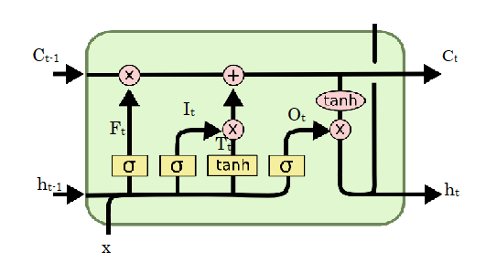

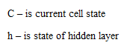

Fig 4: Graphical representation of an LSTM cell Attributed to http://colah.github.io/posts/2015-08-Understanding-LSTMs/

**Implementation Techniques:**

We will measure the performance of the deep neural network against a baseline model to understand if we do need a deep neural network. We will create models to predict one time-step ahead or multi-time step ahead. While using past data to make prediction is necessary, I will also measure how good are the predictions themselves to predict future values. The result would be a model that can predict N days into the future using M historical days (M > N). As part of this project, I will try to predict the stock close prices using (a) a sequence of close-prices (b) a sequence of close-price along with the technical indicators. Note that we will be continuously using only QCOM stock for the rest of our analysis.

The input feature space has values with different ranges. Hence, we need to normalize the data so that learning will be done in a definite time and that the network will converge to some good minima. We will use MinMax scaler on the train and test sets.

The model will be evaluated using Root Mean Squared Error. With RMSE, a lower value indicates a better model. We need to evaluate the model similar to how real-time prediction would be done and ensure that there is no lookahead bias. To that end, we will use sklearn’s TimeSeriesSplit to generate multiple splits for example, 40/20, 60/20, 80/20 where we ensure test is done on 20% of the sample after the initial train sample. Note that data must not be shuffled so that we continue to maintain sequence. By testing on a constant sample size, we can aggregate the test result to know a more realistic performance of the model.

A more realistic way to evaluate the model is by using a rolling forecast or walk-forward validation. In real world use case, we are more interested in predicting using an online-model i.e. a model which is built on the most recent corpus of data. We decide on a set of samples to be used for training (like the most recent 60 days) and make a prediction for the next (or future) time. With new data, the model is retrained. This is repeated for as many samples required. Note that this would mean we would end up creating many models which is compute intensive.

### Benchmark Model

There are multiple ways to design a benchmark model. As part of this project, I would like to opt for two different benchmarks. The first benchmark model will simply predict the current day's closing-price for the next day. While this will perform very well it is not super useful. A 2nd benchmark model will predict closing-price using a simple moving average over past M days. The parameter M needs to be picked based on empirical tests and to some extent on domain knowledge. For comparison against the final model, we do create a TrainTestSplit and evaluate the test data without any need for training.

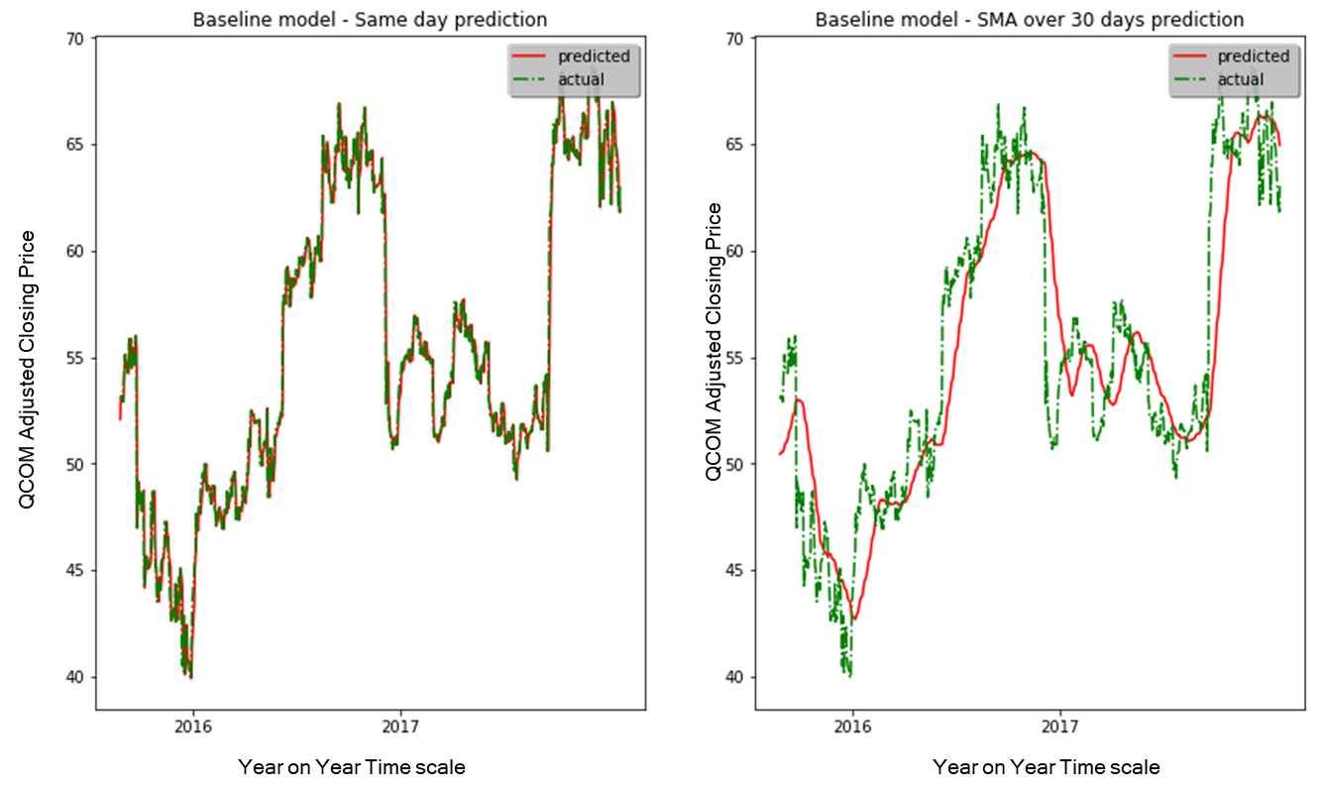

Fig 5 (a, b): Stock market prediction for baseline model

As can be seen from the graph, the predictions follow the actual closing-price very closely for same day prediction while the SMA prediction follows it with a slight lag.

RMSE Scores:

Baseline model using current day value as prediction: 0.88

Baseline model using SMA over 14 historical days as prediction: 2.50

### Data Preprocessing

Since we are using a LSTM network and a default activation of tanh, I plan to normalize all the input data to a scale of (-1 to 1). Normalization is done so that the deep neural network can learn the weights and biases and will be able to converge to a minima in reasonable time. Furthermore, we need to ensure that the scaling is done separately for the train and test data set to mimic a real-world use case. Since we are learning to predict a sequence using LSTM, there is a need to convert the data to a format that is useable by a LSTM network. The input layer of a LSTM expects data in 3 dimensions i.e. (num_samples, timesteps, num_features) where,

Num_samples - the number of samples/examples we will create

Timesteps - Each timestep includes one observation - so if we wish to use a sequence length of 14 days, this will be the closing-prices for a stock for 14 days in a sequence.

Num_features - the prediction for one time-step. In our case, this will be of length 1 since we are trying to predict 1 future value.

The function prepareLSTMdata converts the dataset to feed into the LSTM network. Similarly, when we use the Closing price along with the technical stats about the stock, the multiple variable input data to the LSTM is created using function prepareLSTMMultiVariateData.

### Implementation

As detailed in the data preprocessing step, we first scale the LSTM input data and then create the input to feed to the LSTM network. I use a stacked LSTM model here. The input of the LSTM is a 3D vector of shape (num_samples, timesteps, features) and the output is a 1-dimensional value that is the stock's closing price. Since we are using a stacked LSTM model, the 2nd layer LSTM needs to get inputs in the form of a sequence. Hence, we set the return_sequences flag in the first LSTM layer for it to return a sequence that can be fed into the next layer.

#### Model tuning

While there is significant domain knowledge on stock market prediction, I would prefer to choose the model parameters based on experiments. For example, how many historical dates to use, how far can we predict to get a decent accuracy. Many other parameters are specific to the model i.e. number of epochs to train on, should we use a stateful LSTM or not, what are the optimizers to use. All of these different combinations have been tried out in the *capstone_parameter_tuning.ipynb*. The results of the experiments are stored in the consolidated_exp.csv file. The run_id is the column which identifies the experiment. Below is a table about the parameters and the different values searched.

**run1** - LSTM model trained on 1 of 5 folds and tested on 2nd fold

**run2** - LSTM model trained on 1st and 2nd of 5 and tested on 3rd fold

**run3** - LSTM model trained on 1st to 3rd fold and tested on 4th fold

**run4** - LSTM model trained on 1st to 4th of 5 folds and tested on 5th fold

**runtime** - Time taken to train each model

**run_id** mHistory-nPredict-Stateful-NumNeurons-NumEpochs-LossFunction-Optimizer-BatchSize where,

|  |  |  |
| --- | --- | --- |
| mHistory | Number of historical dates to use for evaluation | 14,30,60 |
| nPredict | Number of days to predict into the future. Set to 1 for next day prediction | 1 |
| Stateful | Is the model stateless or stateful? Runs with batch size of 1 alone used stateful as True | False, True |
| NumNeurons | Number of neurons to set for the LSTM model. Note that I have already decided it to be a stacked layer since my other experiments showed that a stacked layer did perform better. | 5, 10, 30 |
| NumEpochs | How many epochs to train for to get a performant model | 1, 10, 30 |
| LossFunction | What is the loss function to use? For regression model both Mean Average Error and Mean Squared Error | mae, mse |
| Optimizer | Different Optimzers to use. | Adam, rmsprop,  rmsprop, adagrad |
| BatchSize | Size of a batch that is used for training | 1, 10, 30 |

To pick a model that performed well but also within a reasonable amount of time, I ranked them by best average run (runAvg), best run (run4) and best time (runtime)

|  |  |  |  |  |  |  |
| --- | --- | --- | --- | --- | --- | --- |
| **run_id** | **runAvg** | **bestRun** | **runtime** | **avgRank** | **bestRank** | **timeRank** |
| 30-False-30-10-mae-sgd-1 | 0.945391 | 1.000325 | 1799.575 | 11 | 1 | 72 |
| 30-False-5-30-mae-sgd-1 | 0.959429 | 1.006807 | 4015.19 | 12 | 2 | 80 |
| 30-False-30-30-mae-adam-10 | 0.910713 | 1.018957 | 797.7032 | 3 | 3 | 60 |
| 30-False-30-10-mae-adam-1 | 0.921206 | 1.031175 | 1841.651 | 9 | 4 | 74 |
| 30-False-30-30-mae-sgd-1 | 0.882626 | 1.036082 | 4849.072 | 1 | 5 | 85 |
| 60-False-5-30-mae-sgd-1 | 0.913145 | 1.038763 | 8720.263 | 6 | 6 | 87 |
| 30-False-10-10-mae-adam-1 | 1.020891 | 1.051325 | 1593.927 | 21 | 7 | 69 |
| 14-False-30-30-mae-sgd-10 | 0.905476 | 1.063039 | 423.3219 | 2 | 8 | 38 |
| 14-False-30-30-mae-adam-1 | 0.914517 | 1.064395 | 2246.662 | 7 | 9 | 77 |
| 60-False-5-30-mae-adam-1 | 0.993296 | 1.067381 | 8377.297 | 19 | 10 | 86 |

Table 3: Experiment runs ranked by Best Rank

|  |  |  |  |  |  |  |
| --- | --- | --- | --- | --- | --- | --- |
| **run_id** | **runAvg** | **bestRun** | **Runtime** | **avgRank** | **bestRank** | **timeRank** |
| 14-False-5-1-mae-adam-1 | 1.795426 | 2.097321 | 14.7436 | 74 | 71 | 1 |
| 14-False-5-1-mae-adam-10 | 2.497602 | 2.44468 | 23.55608 | 86 | 84 | 2 |
| 14-False-5-1-mae-sgd-10 | 2.320291 | 2.508564 | 31.67611 | 83 | 85 | 3 |
| 14-False-5-1-mae-sgd-1 | 1.827691 | 2.177736 | 70.64825 | 76 | 76 | 4 |
| 14-False-10-1-mae-adam-10 | 1.976825 | 2.119987 | 72.4324 | 79 | 73 | 5 |
| 14-False-10-1-mae-sgd-10 | 1.993942 | 2.28457 | 82.41248 | 80 | 80 | 6 |
| 14-False-5-10-mae-adam-10 | 1.544108 | 1.925539 | 87.27631 | 57 | 62 | 7 |
| 14-False-5-10-mae-sgd-10 | 1.568693 | 1.869406 | 93.81633 | 58 | 56 | 8 |
| 14-False-10-1-mae-adam-1 | 1.704251 | 2.183855 | 114.7566 | 67 | 78 | 9 |
| 14-False-10-1-mae-sgd-1 | 1.584822 | 1.90817 | 122.8447 | 59 | 60 | 10 |

Table 4: Experiment runs ranked by Best Run Time

We can clearly see that better performance comes at the cost of a much larger run time. I think this is one of the major disadvantages of using LSTM. I will pick the 14-False-30-30-mae-sgd-10 configuration for my final model. It has a very good average run and time taken is within 50 percentile range of all the runs.

#### Implementation details:

There are 3 subsections that are covered in this implementation: a) Model Evaluation using next-day prediction b) Single variable (closing-price) prediction for N days into the future c) Multiple variable (closing-price and technical indicators) prediction for N days into the future

##### *Model Evaluation using next-day prediction*

A time-series evaluation cannot be done in the traditional sense of a deep neural network regression model since the sequence or order of events need to be maintained. To be able to evaluate the model, we will use the TimeSeriesSplit and use the train split for training while the test split is used for validation. Using a timeSeriesSplitCount of 4, we simulate a 4-fold cross-validation setup as follows:

* Train on 1st fold and validate on 2nd fold
* Train on 1st and 2nd fold and validate on 3rd fold
* Train on 1st to 3rd fold and validate on 4th fold
* Train on 1st to 4th fold and validate on 5th fold

The final evaluation is done on the validation set. While this may seem incorrect, I would like to use a test set that follows the trained sequence and the validation set is the most appropriate. Keeping a held-out data that is too far ahead from the training is also not the most appropriate since we would then be testing on a sequence whose immediate prior data wasn't seen.

##### *Single variable (closing-price) prediction for N days into the future*

While predicting a day ahead will result in a very good model, it isn't as interesting as if we can predict well into the future. Here we will try to make the prediction for N days into the future (N = 14) using a historical data of M days (M = 30). (N = 14 was our objective and M was arrived at by experiments to find a good model that is developed in reasonable amount of time.)

The base implementation is identical to the code for Model evaluation. However, here we will use a TimeSeriesSplit of 2 to split the data into a train and test set only. The model is trained on the train set. We use a stateful stacked LSTM model as before. The test set is also created in the form of (num_samples, timesteps, num_features). The timesteps is essentially a matrix where the rows are a sequence. For a prediction using 30 days historical data, this is of shape 1x30. However, there is a subtle addition to be done to achieve prediction N days into the future. We use the model to make the next day prediction and then feed this prediction as a next time step in the sequence. In doing so we also drop the earliest timestep i.e. the zeroth one. We repeat this for N times to get the prediction for the Nth day, see function appendWithPrediction. The actual vs predictions plots is shown in Fig 6.

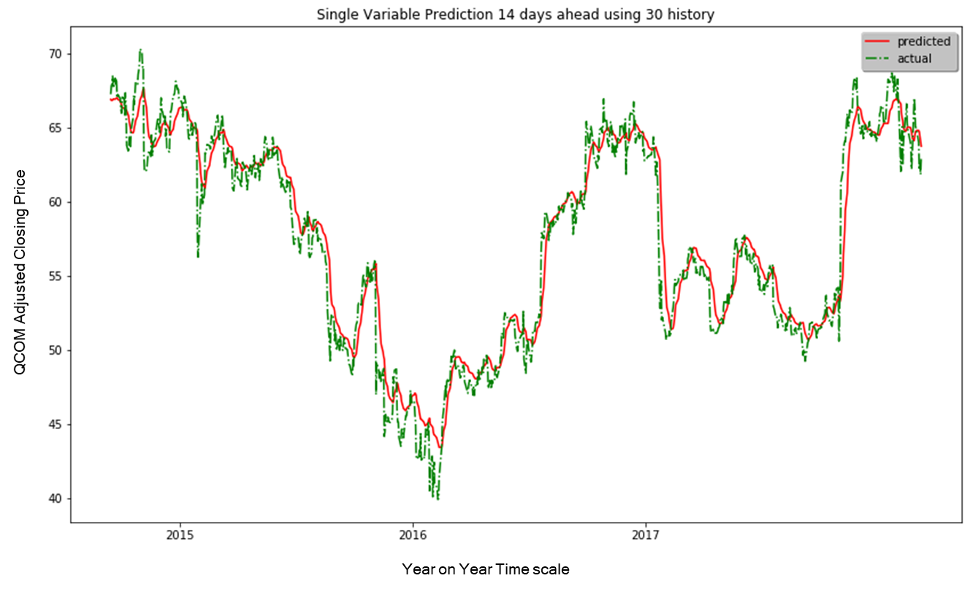

Fig 6: Single Variable Stock prediction for 14 days ahead using 30-day historical data

##### *Multiple variable (closing-price and technical indicators) prediction for N days into the future*

In the earlier model, we fed a timesteps that contains sequence of only the Closing-price. Here we train a model using sequences of the closing-price and four of the five technical indicators. These should be helpful as we noticed that there is very less correlation between the indicators (except for SMA) to the closing-price. The major change from the previous implementation is related to the shape of the input to the LSTM model. The num_features in the 3-dimensional array for the Univariate model was of size 1 whereas for the multi-variate it is going to be 5 (closing-price, RSI, StocOsci, ADMI, VVR). The model is still trained to predict the closing-price. Similarly, we need to ensure the same shape is maintained on the test set as well. Fig 7 plots the actual and predicted closing-prices for QCOM stock.

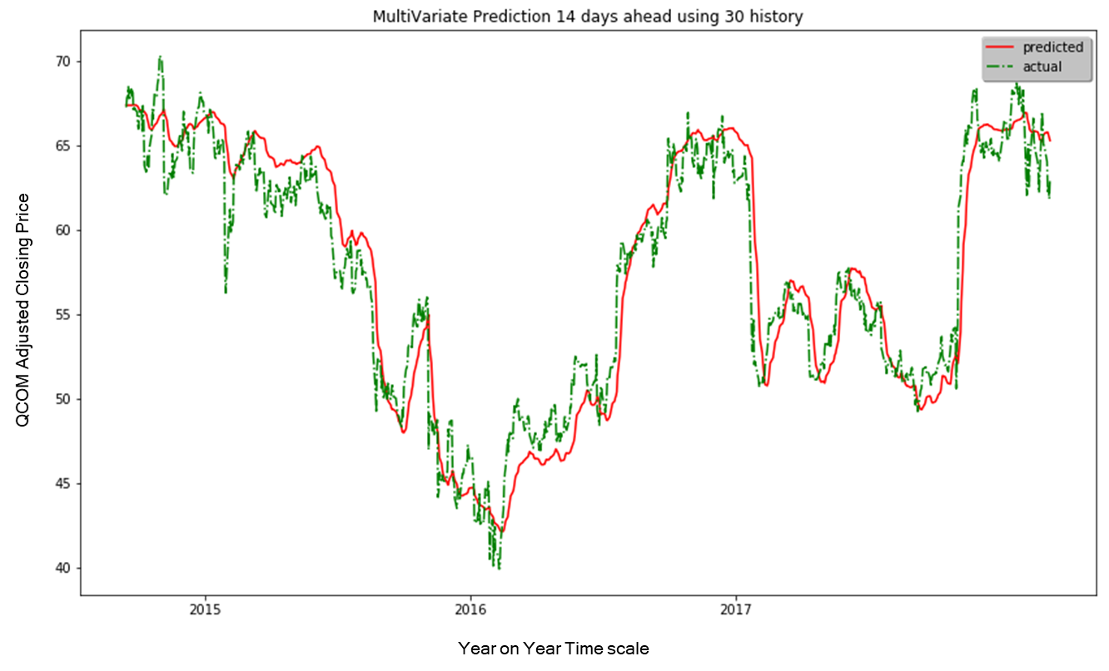

Fig 7: Multiple Variable Stock prediction for 14 days ahead using 30-day historical data

#### **Complications**

There have been multiple implementation challenges to getting here. A few listed in the order of complexity:

1. Training time
2. Creating the input data for LSTM model
3. Picking the right domain-based parameters and model hyper parameters
4. Train test and validation for the LSTM model

The inputs for an LSTM model is very different from any other deep neural network models. The train/validation/test cycle is also different when working with time-series data sets. One of the more complicated parameters to wrestle with was the stateful parameter. When using stateful=True, we need to be able to set a batch size that is appropriate for the input. This is so because the states are propagated to the next batch i.e. the state of the i’th instance in batch N is propagated to the i’th instance of batch N+1. However, with a dynamically configured data set, it was not easy to be able to configure the batch size appropriately for the train and test sets. Training was extremely slow on my personal computer and Amazon EC2 p2.8xlarge wasn’t much helpful.

#### **Refinement**

At the start of the model building exercise, I had fed the closing price values as-is. However, this resulted in extremely long training times and poor scores. I then opted to scale the inputs to a (0,1) range and used a sigmoid activation unit before the final layer. This did result in better results. However, I seemed to be creating a bias in the training/test set as the inputs were scaled for the complete data set. I refined this so that the scalers treated train and test sets separately. I also opted to use tanh as the activation function and scaled inputs between -1 to 1. This did improve model generalization and training time slightly.

My initial attempt did not consider batch sizes – so the model used all the data. However, this performed very poorly. Running multiple experiments helped arrive at a batch size of 30. While using stateful model, the state of the model will be maintained across batch sizes. Hence to reset the state after each epoch, we make a call to model.reset_states(). The shuffle argument also had an impact on the model performance. While using a shuffle=False [which should be the case for stateful=True] scores better, I notice that it is not the same when using stateful as False. I notice that the stateful model performed marginally better than the stateless one, the run time was extremely high.

The different optimizers did not show significant difference in the scores. Hence, I opted to go with SGD which seemed to rank better during parameter search. The number of cells to use was decided based on the number of historical dates used to train i.e. 30. My earlier experiments with fewer cells (5 or lesser) in the LSTM layer seemed to indicate that the model behaved poorly.

### Model Evaluation and Validation:

While we did evaluate across different train/validation set, I would say the evaluation of the model is best captured by the last train/validation split (since it captures all the sequences known and tests on the most recent known sequence). The loss graphs using stateful as False is shown in Fig 8.

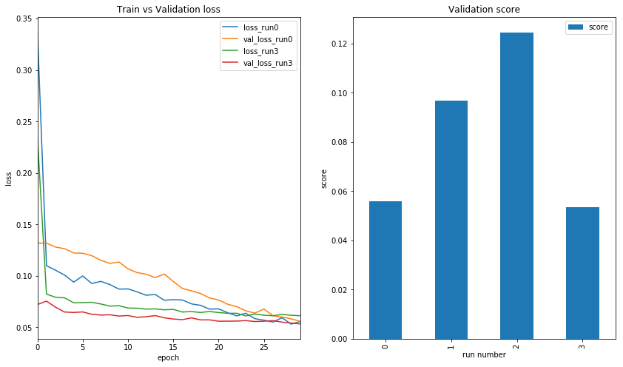

Fig 8: Model Evaluation – Learning curves and validation set scores when stateful = False

There were two major observations:

**When using a stateful model:** I observed that training and validation loss had extreme fluctuations validation loss between the different runs. If we train for very long, we do see that the training loss seems to be reducing over multiple epochs trained there are some exceptions, which is identical to the validation loss curves. This could be attributed to the fact that for the runs where the validation set is dissimilar to the training set the loss is higher and more representative validation set has lower loss. However, it is difficult to ascertain if the model has high variance (overfit) or high bias (underfit) or underfitting the data from the graphs.

**When using a stateless model:** The train and validation loss graphed suggested that model had been improving over multiple iterations. Both train and validation loss reduced drastically till about epoch=3 and then continued to reduce at a much slower rate beyond epoch=5. It is obvious the model does not underfit the data. The model does not overfits the data since the validation loss continues to reduce along with the training loss. [For an overfit model, we should be seeing the validation loss increase after the meeting point of the train and validation curves]. It is likely that running it for more iterations could give a better judgement call. Also, having used shuffle=False may have allowed the model to generalize well for unseen cases. However, to conclude that it is a good fit may not be entirely true since we don't see the curves getting any closer. I think creating multiple feature inputs that can better model stock price would be a good addition to create a LSTM model that generalizes well for the input.

### Justification

Below is a score comparison of the different model trained and how they fare against one another.

**Baseline** - Predict using current day closing-price price: 0.88

**Baseline** - Predict using SMA of closing-price: 2.50

**Model Evaluation** – Next day prediction using LSTM based on 30-day history: 0.05

|  |  |  |  |
| --- | --- | --- | --- |
| **Historical days used** | **Predict N days head** | **Univariate LSTM** | **Multivariate LSTM** |
| 14 | 1 | 2.02 | 2.03 |
| 30 | 14 | 1.72 | 2.24 |
| 60 | 14 | 1.72 | 2.32 |

It is evident that we cannot reach the best baseline score - since this is predicting only a single day in advance. Our evaluated model which was configured to predict next day using 30-day history does show better scores (using the last fold of the validation set) indicating that the LSTM can perform as well as a baseline algorithm. I think the main reason why the evaluated model performs well is that unlike the best baseline model, it can use the sequence but also weigh heavily on the more recent values of the sequence.

### Free-form Visualization

A realistic usage begs us not to use a next day prediction but rather many days into the future. Fig 5(b) that plots the baseline SMA shows a clear lag in prediction. A large moving window would indicate a larger lag. Fig 6 which shows the univariable LSTM model [model that used only sequences of closing-price] performs better than the SMA baseline algorithm (the lag is not as prominent). I believe this is because it is behaving more like the SMA baseline algorithm but with better understanding of the sequence. It is a similar case with the multi variable LSTM model [model that uses both closing-prices and technical indicators in the input sequence]. Comparing fig 7 and fig 9 shows the lag is more prominent in the multivariate LSTM model when the historical dates used is increased. The score changes over usage of historical data and how far ahead to predict does make an important case i.e. stock market can be modeled and given more intelligent use of the data we should be able to get more accuracy.

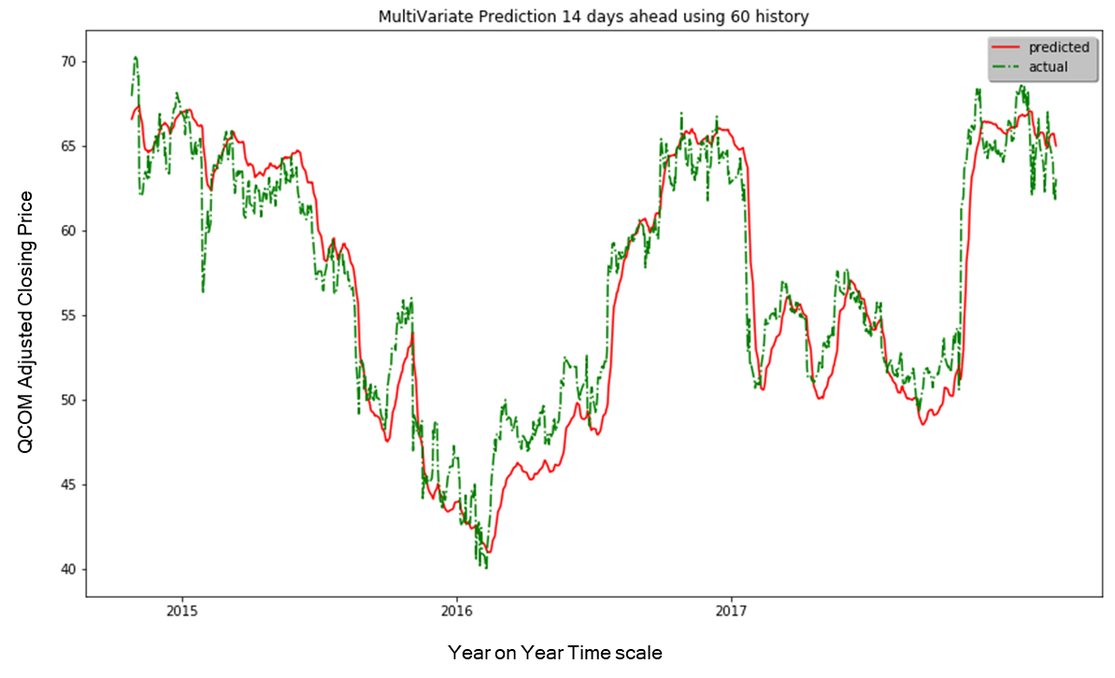

Fig 9: Multiple Variable Stock prediction for 14 days ahead using 60-day historical data

### Conclusion

We have successfully created a deep neural network-based model that can predict closing-price of a stock. To achieve this, a baseline algorithm was initially implemented to compare against the final model. Different techniques were used to identify good domain parameters and model hyper-parameters to achieve our objective. Graphical visualization tools were used to understand the input features and the final output. One of the more interesting things I learnt in this project was that the approach to a sequence prediction problem seems very different from the other regression or CNN problems. From data preprocessing to model building to validation and testing, every step was completely different from what I had learnt during the course. One another aspect of the project which I found interesting was the use of technical indicators as the input. I wasn't sure how this would turn out especially considering that most technical indicators were derived from the closing-price of the stock itself. I was pleasantly surprised that a multi-variable LSTM does score as well or better than a single variable LSTM model. I am extremely thankful to the numerous research articles and blogs that helped me get to this point with my project.

### Improvements

We saw that technical analysis can be used as input. Similarly, we could use a stocks fundamental. This would be an interesting case-study as it would consider the financial health of the company which is a strong indicator of how well it can perform in the future. Unfortunately, Stock markets are also driven by the human ideas and motivations - hence we would need to find a suitable way to provide this as inputs. Twitter feeds and news reports are a good source to model human motivations. For an end-user, sometimes, the actual close-price may not be very useful compared to predicting stock decision labels such as buy / sell / hold. We can feed the output of the regression model into a classifier that can then predict these labels. On a more interesting note, we could create a hybrid model that feeds on the current developed model and a 2nd model that is modelled based on tweets, news, fundamentals and use the hybrid model to predict the label.

##### *References:*

[1] TimeSeriesPrediction: PredictingStockPrice https://arxiv.org/pdf/1710.05751v2.pdf

[2] <http://snap.stanford.edu/class/cs224w-2015/projects_2015/Predicting_Stock_Movements_Using_Market_Correlation_Networks.pdf>

[3] <http://ieeexplore.ieee.org/document/7364089/>

[4] <https://etd.auburn.edu/bitstream/handle/10415/5652/Application%20of%20machine%20learning%20techniques%20for%20stock%20market%20prediction.pdf?sequence=2>

[5] <https://arxiv.org/pdf/1801.04503.pdf>

[6] https://arxiv.org/ftp/arxiv/papers/1803/1803.06386.pdf

[7] Share prices and Random Walk : <https://www.tcd.ie/Economics/assets/pdf/SER/2007/Samuel_Dupernex.pdf>

[8] <http://colah.github.io/posts/2015-08-Understanding-LSTMs/>

[9] https://deeplearning4j.org/lstm.html

[10] Stateful LSTM: philipperemy.github.io/keras-stateful-lstm/

[11] <https://www.investopedia.com/university/technical/>

[12] <http://www.binaryoptionsthatsuck.com/kdj-stochastic-indicator-can-you-improve-on-perfection/>

[13] Rolling forecast: <https://www.otexts.org/fpp/2/5/>

[14] TimeSeries Validation: <https://machinelearningmastery.com/backtest-machine-learning-models-time-series-forecasting/>

[15] <http://francescopochetti.com/pythonic-cross-validation-time-series-pandas-scikit-learn/>