From Launch to Litter:

Orbital Overload

Course Details
Title: Data Visualisation
Code: DAT5001 S2_25
Term: Autumn 2025
Assessment: WRIT1

Student Details
Tom Rowan ST20285213

Project Tutor
Dr. Imtiaz Khan

Table of Contents
Course Details 1
Student Details 1
Project Tutor 1
Part 1 - Introduction 3
Part 2 – Materials and Methods 4
Data Collection 4
Data Cleaning and Processing 5
Data Cleaning 5
Feature Engineering 6
Design Principles and Tools 8
Tool Selection 8
Palette Selection 8
Chart Selection 9
Storyboard 9
Part 3 - Results – From Launch to Litter 10
What is the current state of orbital congestion, and how has it evolved since space exploration began in the late 1950s? 10
What trends in satellite launches are driving the risk of Kessler Syndrome? 13
How do different nations and private firms contribute to orbital congestion? 13
What mitigation strategies are feasible? 15
Part 4 - Discussion 16
References: 17

Part 1 - Introduction
The Space Age began in 1957 with the successful launch and entry into orbit of Sputnik-1 by the USSR. In the subsequent sixty-eight years, space technology has become an essential part of modern life. From GPS navigation to weather forecasting, communications, defence, Earth imaging and scientific exploration, satellites underpin much of our daily existence. This report discusses a growing existential threat against use of space technology to support our way of life.
Earth’s orbit has become increasingly congested with satellites, rocket stages, and debris fragments from past missions. While many these objects decay naturally over time or are purposefully caused to re-enter the atmosphere, a huge number remain in orbit many years after launch. Even small fragments as tiny as a paint fleck can damage spacecraft when travelling at orbital speeds (7–8km/s).
The congestion in orbit means that collisions already occur between objects. As the number of objects in orbit grows, there is an increased chance that occasional collisions will happen. Each impact generates more fragments, in turn increasing the likelihood of additional collisions. The most severe accident so far is the 2009 collision between Iridium-33 and Cosmos-2251, which generated more than 1,800 pieces of debris (Johnson 2009).
In 1978, Donald J. Kessler and Burton G. Cour-Palais authored a paper which describes a scenario whereby the density of objects in Low Earth Orbit (LEO) reaches a tipping point (Kessler 1978).
Under this model, collisions between objects become a cascade, creating a debris cloud and causing more objects to collide until and all satellite payloads have been destroyed. A Low Earth Orbit devoid of usable safe orbits would be catastrophic for modern civilisation; the resultant debris could last many generations.
While catastrophic cascading has not yet occurred, incidents such as Iridium-Cosmos demonstrate that the risk is real. The 2013 film “Gravity” depicts a Kessler cascade, which destroys most orbiting satellites, including the International Space Station (ISS), and kills nearly everyone in orbit (Cuarón 2013).
This report will answer the following questions:
- What is the current state of orbital congestion, and how has it evolved since space exploration began in the late 1950s?
- What trends in satellite launches are driving the risk of Kessler Syndrome?
- How do different nations and private firms contribute to orbital congestion?
- What mitigation strategies are feasible?
The hypothesis is that without coordinated international regulation, and active debris removal, orbital congestion will reach a tipping point within the next few decades. To test this assertion, this report will analyse available data on objects that are in orbit, along with launch trends to assess the likelihood and potential impact of the Kessler Syndrome.
This report seeks to show that this is not a distant theoretical risk, but as an imminent danger shaped by seven decades of satellite launches and accelerating commercially led activity.
By examining orbital conditions, launch trends, and mitigation strategies, the report aims to provide a comprehensive understanding of the issue. The goal is to highlight the necessity of international cooperation and technological innovation to ensure that Earth’s orbital environment remains a useful resource.

Part 2 – Materials and Methods

Data Collection
To answer these questions, it was necessary to obtain and prepare a suitable dataset. Finding complete and free data sources regarding satellites initially proved to be surprisingly challenging. Simple searches for “satellite datasets” tend to return samples taken by optical imaging satellites for machine learning purposes.
The obvious place to target search was the NASA website. NASA appear to have once provided a useful dataset called the National Space Science Master Catalog (NASA 2025) but this web resource is no longer responding to requests, from both UK and USA based IP addresses. NASA funding has been recently reduced (Luscombe 2025) and this may have had some impact on web services provided.
A search uncovered the Union of Concerned Scientists Satellite Database, which was last updated in May 2023, covering 7,560 satellites. Exploratory analysis revealed 28 data points offered per satellite – such as mass, apogee and operator - but crucially there is no re-entry date recorded. Moreover, the dataset only covers satellite payloads, not debris. (UCS 2023).
The n2yo.com website offers live tracking data for satellites. It has regularly updated database of around 66,000 satellite payloads from Sputnik 1 until today. As the free API is intended to give access to live tracking it is strictly rate-limited (N2YO 2025).
It is possible to scrape data from the website by direct object reference, for example: https://www.n2yo.com/satellite/?s=66645. Python code was written using the “requests” and “BeautifulSoup” libraries and tested against a small number of pages. However, collecting a complete dataset would have required tens of thousands of GET requests. Every access to a website costs money for processing and bandwidth costs, and this could be considered unethical, especially as the site survives through donations. Furthermore, this database also covers only satellite payloads.
An article on the n2yo.com website (Pultarova 2023) led to a free database that is updated daily. It is maintained by Jonathan McDowell who works for the Harvard-Smithsonian Centre for Astrophysics. (McDowell 2019). This dataset contains data on debris, satellite payloads and other objects. It provides over forty data points on each object. Supporting datasets are also available regarding space related organisations and launch sites. This dataset was chosen to support this report.
As well as suitable datasets, news reports showing instances when fragments of space debris have caused issues for satellites, space craft and humans in space were sought to anchor the issue. In the timeframe of this project, there has been an instance of three Chinese taikonauts being stranded on the Tiangong space station due to debris striking their return capsule (Livescience 2025).

Data Cleaning and Processing
The McDowell dataset is split into several databases, provided as tab separated files. The documentation for the datasets is very comprehensive (McDowell 2019). A few datasets were selected for use. Initial exploration revealed the information in the following table:
Database | Purpose | Columns | Rows
Satcat | Detail on the launch and initial state of objects. | 42 | 66,650
Events | Subsequent changes to object status. | 42 | 7,345
Payloads | Additional information on satellite payloads. | 28 | 24,724
Launch Site | Details of launch sites, including latitude and longitude. | 17 | 3,968
Organisations | Data on all related organisations, such as manufacturers and users of satellites. Includes latitude and longitude. | 18 | 707

These databases were downloaded and loaded into individual pandas data frames, allowing for manipulation using python in Jupyter notebooks. The aim was to create a single combined dataset.

Data Cleaning
The datasets contained many columns that were not useful for this report. These were removed and the remaining columns renamed for readability.
In all datasets, the date values were found to be inconsistent. For example, some entries were dates, some had date and time values; unknown dates were referenced as ‘-’ or ‘?’. These were cleaned to date only values, and Null values used to replace unknown dates. Any objects without a known launch date were dropped. Finally, dates were converted to UK format (Day/Month/Year).
The dataset has missing values in many columns. It was not desirable to drop large numbers of rows where there was missing data because most rows had sufficient data to nonetheless make their inclusion in the study useful. Therefore, prior to creating a graph of a given feature, care was taken filter affected Null values.

Feature Engineering
Each dataset was assessed individually, and features could be derived or added to aid analysis, or to make drawing charts more effective.
In Orbit
One of the most important features to derive was a reliable boolean flag for whether the object is still in orbit or not. “Decay Date” can be taken to reference that the object is no longer in orbit, however, there are a significant number where there is no value recorded.
The Status column provides useful data. According to the documentation:
“An artificial space object … can be in one state. Each time the object transitions to another state (undocks, is attached to something, reenters, changes which body it is orbiting, etc.) marks the beginning or end of a phase. Most objects in GCAT have only a single phase - they separate from an object (launch vehicle) and then are either still in free flight or have re-entered. However, some objects go through many phases. Objects with more than one phase have their subsequent phases listed as entries in the event object catalogs.” (McDowell 2019)
Thus, the Satcat dataset includes only the statuses for the initial phase of the objects. Applying the data in the Events database updates this to the most recent state of the object. It is then possible to determine whether an object is still in orbit.
The most recent update can be found at the highest index value, so a de-duplicated version of the Events database was created. This was merged with the Satcat data, overwriting and updating the original values.
Working out whether an object is orbiting still requires comparing against a definitive list of status codes. A Decay Date can be used to indicate “not in orbit” where the object status is not in either of these lists:
In orbit | In Orbit, Attached in orbit, Docked
Not in orbit | Reentered, Landed, Deorbited, Reentered attached, Reentered inside, Landed attached, Landed inside
Dates
In the Satcat Launch Date is the date of launch, while Decay Date is the date of re-entry. These additional date columns were derived from these values:
- Launch Year
- Launch Month (Numerical)
- Launch Month (Long Text)
- Launch Decade (For example, 1950 is 1950-1959.)
- Decay Year
- Decay Month (Numerical)
- Decay Month (Long Text)
- Decay Decade
A temporary column 'Effective Decay Date' was copied from 'Decay Date' or set to “today's date” if the object is still in orbit. This allowed for object orbit lifetime values to be calculated.

Organisations Dataset
Many of the organisations had an ‘English readable’ name recorded, some only had a localised name, and a large number had an entry for both. A single replacement column was created from these columns, preferring the English name where available; other name columns were dropped.
The Nominatim geocoding API was used to perform a reverse look up of latitude and longitude values adding values for city, state, country and country code into the Organisations dataset (Nominatim 2025). This API is strictly rate limited. Therefore, the requesting lambda function made one request every 1.5 seconds to guarantee avoiding an IP address ban. There are over 3,600 entries in the dataset, meaning that this process took between two and three hours.
The organisations database was merged into the Satcat dataset. Organisations have a “Org Code”. This was merged by comparing to the “Owner Code” and “Manufacturer Code” columns in the Satcat dataset. There were two operations so that the resultant dataset includes two sets of columns copied from the Organisations database, prefixed respectively as Operator and Manufacturer.
Status Codes
The datasets use codes to indicate the state, type, class or category of the object. These letter codes are not intuitive without the provided documentation (McDowell 2019).
JSON mappings were created between the documented letter codes and descriptive text labels suitable for producing meaningful charts. These were applied to the appropriate columns, the letter code columns dropped. For example, the Type mapping was as follows:
type_json = {
"P": "Payload",
"C": "Component",
"R": "Rocket Body",
"D": "Debris",
"S": "Suborbital payload",
"X": "Deleted Object",
"Z": "Spurious Entry"
}
The Type field included “spurious” and “unknown” entries which were removed to cut down on the size of the dataset. The Category field included codes for multiple categories in one such as Scientific Studies and Imaging; these were split into primary and secondary categories.
Finally, the resultant dataset was saved out to a CSV file.

Design Principles and Tools
This section of the report will discuss the design principles and tools used to create the storyboard and infographics for the presentation.

Tool Selection
As described above, the exploration of the data, and subsequent cleaning and feature engineering was carried out in Jupyter notebooks running on Microsoft vsCode on Linux. The graphs and figures used in this report and the presentation were derived from the resulting dataset, and were generated using a variety of python libraries, including:
- Matplotlib – Standard charting library
- Seaborn - Standard charting library
- Geopandas – Used with matplotlib to create choropleth maps
- NetworkX – Network diagrams
- Holoviews – Used for chord charts
Not all charts that are used in the visually rich presentation are in this report. These charts were exported as images and imported into LibreOffice on Linux.

Palette Selection

Colour palette selection is an important part of effective data visualisation and storytelling. The choice of colours influences not only the aesthetic appeal of a report or presentation but also its ability to convey meaning (Munzer 2014). Ideas of clarity and inclusive accessibility were also considered. Palettes used in this project were based on those generated using the Coolors platform. (Bianchi 2025).
Figure 1 - Muted palette for report.
For this written report, a muted palette was chosen to align with the academic tone of the document. Colours such as dusk blue, taupe, and olive leaf were used to provide differentiation between categories. The use of black lines and text against a white background helps readability. This palette aims to enhance clarity in a printed document.

In contrast, the palette for the presentation was designed for impact in a purely visual. Brighter, high-contrast colours such as gold, burnt orange, and sky blue stand out vividly against the dark blue background, which was chosen to evoke a “space theme”.
Figure 2 - Vibrant palette for presentation.
This palette makes charts and graphics more dynamic and easier to interpret immediately. White lines on a dark background improve visibility presentation environments, while more muted colours like slate and light grey provide balance to the vibrant colours (Munzer 2014).

The gradient colours used for the bubble charts and colouring of maps are more optimal for displaying sequential datasets than the discrete colours in the palettes discussed above (Crameri 2024). The base colours are taken from the above palettes however, so that charts have the same look and feel.

Chart Selection
The type of charts used were chosen to match the nature of the data. (Ladipo 2022)
Horizontal bar charts were employed for categorical comparisons with long labels, such as countries, organisations or space exploration programs.
Bubble charts were used to display relationships between three variables simultaneously, for example allowing orbital density to be show by program and satellite count over the years. It was sometimes necessary to scale the bubbles carefully using log functions to avoid hugely out of proportion values (like Starlink) from swamping other data.
Doughnut charts were selected to illustrate proportions of a whole, such as the share of satellites by type, with the central space providing room for labels showing a total or summary figure. This gives a “modern infographic” style to the resulting presentation slide.
Maps were chosen to show data on a per country basis, with sequential colour gradients used to allow comparison between counts or proportions.
Efforts were made to avoid direct red/green contrasts to ensure interpretability for colour-blind viewers. Furthermore, design principles included using uniform colours, fonts and line styles across charts to give a consistent feel (Munzer 2014).

Storyboard
The presentation slides were used initially to create a storyboard that placed a series of infographic charts in a sequence to build a narrative flow as follows:
- Overview and context, “introducing the Kessler problem”.
- Trends in launches and objects in orbit.
- Explaining the risks.
- Possible mitigation.
This flow informed the charts that needed to be created to backfill the storyboard.
Together, these design choices aimed to ensure that the charts were not only visually appealing, both on paper and on screen, but also effective in guiding the viewer.

Part 3 - Results – From Launch to Litter
This section of the report will use graphs and diagrams to illustrate the issue and answer the questions posed above. The following terminology may be useful to the reader:
Terminology | Definition
Payload | A satellite, space craft or permanent space station.
Debris | Trackable objects over 10cm (4 inches) in size. This is the current threshold for possible monitoring.
Component | Small objects, such as rubbish bags, gloves, lost tools.
Rocket Body | Piece of a launch vehicle, such as a rocket stage or booster engine.

What is the current state of orbital congestion, and how has it evolved since space exploration began in the late 1950s?
The early decades of spaceflight were dominated by military and geopolitical competition; the Cold War led to rapid satellite proliferation. The main players in deployment were the USA and the USSR; few other countries had the resources to develop payloads or to fund launches. The UK Government used NASA rockets to launch its first satellites named Ariel 1-3 in 1962, 1964 and 1967 respectively.
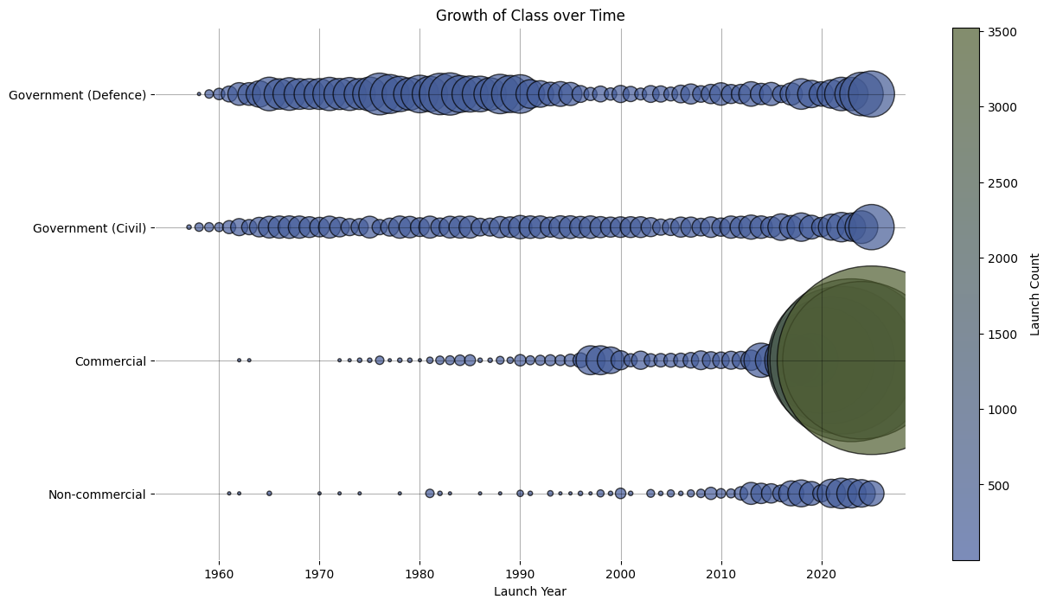
In the 1950s and 60s, satellite technology was mainly focused on defence capability and on space exploration. While there was some private commercial interest, most satellite programs were government backed.
Figure 3 - Showing class of payload through time.
From the 1990s onward, while government sponsored launches declined, more private companies started to become interested in space launching satellites for telecommunications, Earth observation and imaging, and navigation. Google Earth, for example, utilised NASA satellites for commercial purposes. This shift introduced new stakeholders to space technology and accelerated growth and competition. The 24 payloads involved in the first full GPS constellation went live.
Early space missions left debris in orbit without much thought for long-term sustainability. The late 1990s saw a notable collision between an Ariane rocket piece and the French Cerise satellite (Alby 1997). At this time, rocket bodies often broke up increasing the debris count significantly, as shown Figure 2, leading to guidelines around improving sustainability and debris reduction (COPUOS 1999).
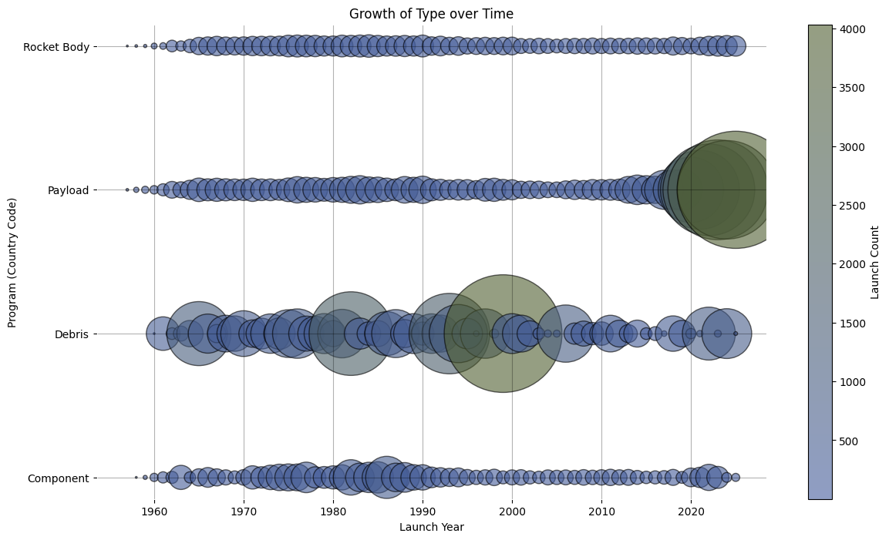
Figure 4 - Debris has always been an issue, but especially so in the late 1990s.

The late 2010s and 2020s have marked a turning point, with firms like SpaceX, OneWeb, and Amazon becoming the majority stakeholders in satellite deployments. Figure 1 also shows a recent increase in the deployment of defence capability, which may be a reaction to global hostilities.
At the time of writing in early December 2025, there are over 32,000 tracked objects, and many millions more that are too small to monitor. Around 17,300 objects are satellite payloads, although many are no longer in active service. Russia continues to operate a large fleet of military and civilian satellites, while the USA maintains extensive constellations for communications, navigation, and Earth observation. Figure 6 below shows a breakdown of objects by type and category.

The number of objects in orbit has grown over time, as the number added has increased faster than objects have re-entered the atmosphere, as shown in Figure 4.
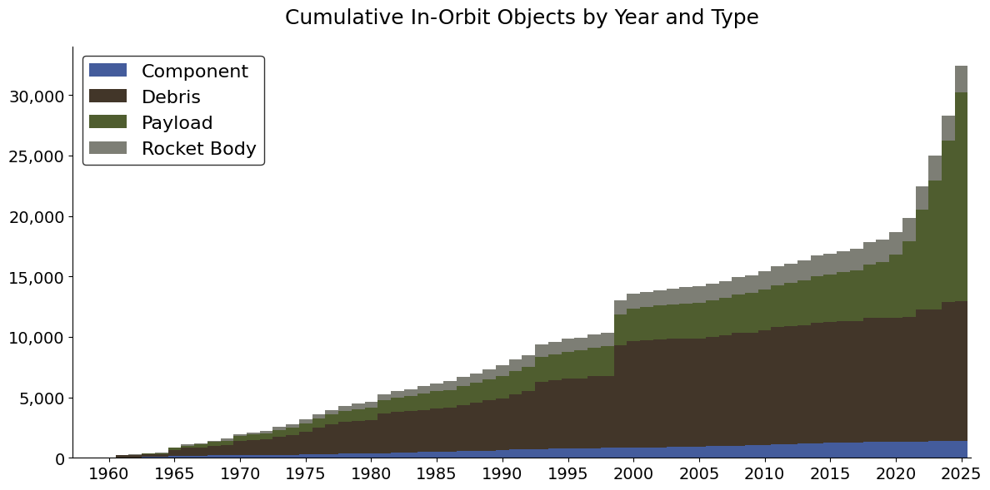
Figure 5 - Breakdown of payloads in orbit, as of 1st December 2025

The total mass of the satellite payloads in orbit is 13,174 metric tons, which is the same as 1,062 London buses (London Assembly 2014). Figure 6 shows the relative mass of the top twenty satellite programs. The bulk of the global satellite fleet are commercial communications devices.
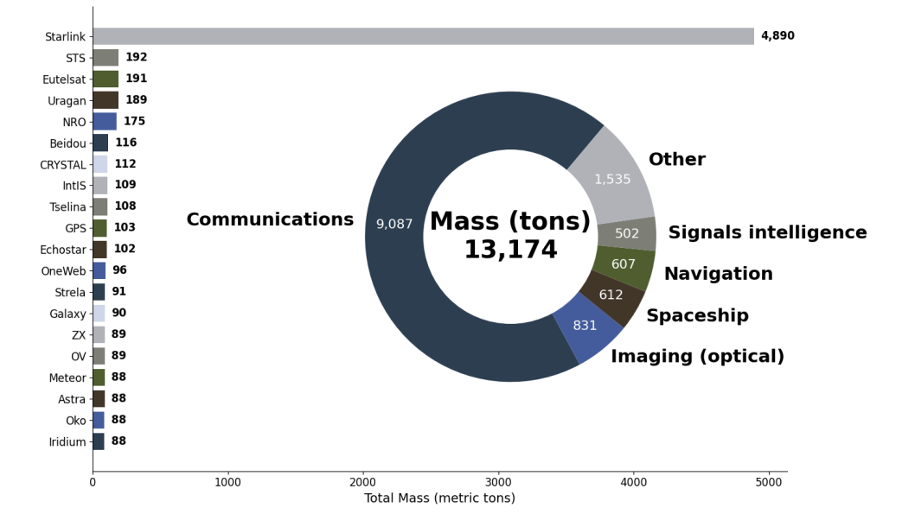
Figure 6 - Masses of payloads in orbit, as of 1st December 2025

What trends in satellite launches are driving the risk of Kessler Syndrome?
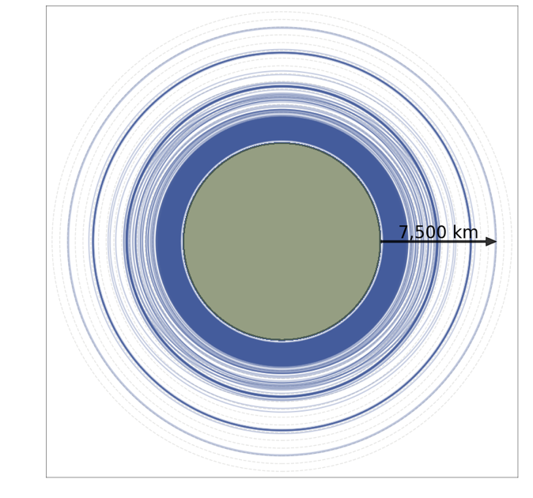
The most significant trend of the past decade has been the concept of mega-constellations. Companies like SpaceX, OneWeb, and Amazon plan to deploy tens of thousands of satellites in Low Earth Orbit. These constellations rely on mass production of identical payloads. This scale is unprecedented compared to earlier decades.
Figure 7 - Population of LEO shells
Low Earth Orbit, particularly altitudes between 500–1,200 km, is the most crowded region due to being used communications and Earth imaging satellites. SpaceX would like to replace cell towers for standard mobile telephones is remote areas, which necessitates a very low orbit (SpaceX 2025).
Figure 7 shows how congested the orbital shells are very close to the Earth.
Another trend is the diversification of launch providers. Nations such as China and India are rapidly expanding their fleets, while private firms worldwide are lowering launch costs through reusable rockets.
Finally, shorter satellite lifespans are contributing to a growing population of defunct and inactive spacecraft.

How do different nations and private firms contribute to orbital congestion?
The current levels of payload density are the cumulative result of decades of activity by both national space agencies and private firms.
Historically, the United States and the Soviet Union (later Russia) were the primary contributors, launching thousands of satellites and rocket stages during the Cold War. In recent decades, China has emerged as a major player, with rapid expansion of its satellite fleet and the construction of the Tiangong space station. India, Japan, and the European Union also now contribute significantly.
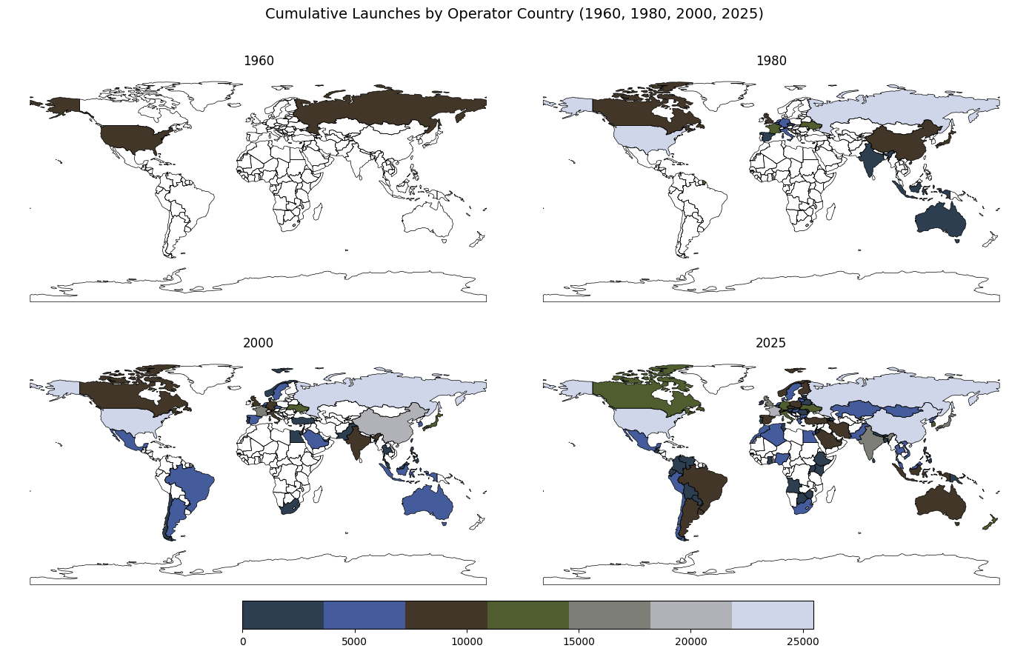
Figure 8 - Countries with active space programs.
Most launches in the 2020s have been sponsored by commercial organisations.
SpaceX, the American firm owned and run by Elon Musk, launched its first satellite in 2018. It has experienced incredible growth in the following seven years and there are now 9092 Starlink satellites in orbit. The company aims to launch many more Starlink satellites to increase coverage and bandwidth for global Internet access, and to improve cellular phone communications (Starlink 2025, Pultarova 2025).
Earlier in the Starlink program in around 2019, each Falcon 9 launch carried up to sixty satellites per flight. This number has decreased over time due to the satellites becoming larger and more capable. As of October 2025, SpaceX typically launches 28 Starlink satellites per mission. (Robinson-Smith 2025). As a side issue, each Falcon 9 launch emits approximately 336 metric tons of CO₂, contributing to climate change. (Franklin-Cheung 2020)
OneWeb and Amazon’s Project Kuiper are also planning mega-constellations.
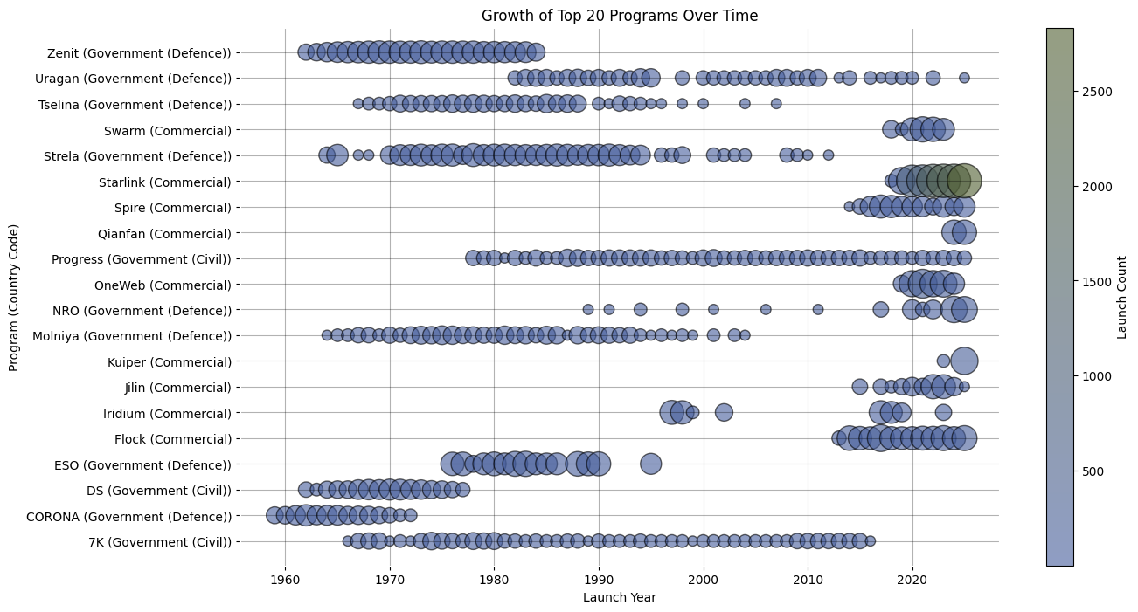
Figure 9 - Showing the major satellite programs over time.

What mitigation strategies are feasible?
Mitigating the risk of Kessler Syndrome requires a combination of technological, regulatory, and operational strategies.
One possible approach is active debris removal, where robotic spacecraft would capture and de-orbit large defunct satellites or rocket stages. Methods include nets, robotic arms, and atmospheric drag sails. ESA’s planned ClearSpace-1 mission aims to demonstrate active debris removal. (ESA 2020).
Another strategy is to design for de-orbit, where satellites are engineered to burn up in Earth’s atmosphere at the end of their lifespan, either through burning up fuel reserves or passive devices like drag sails. This approach is ultimately likely to be cheaper
Collision avoidance systems are also increasingly used, with satellites equipped to manoeuvrer away from predicted collisions. Operators must be prepared to regularly adjust their payload trajectories, balancing reduced lifespans due to fuel exhaustion. Starlink made twenty-six thousand avoidance corrections from 2020 to 2022 (Universe 2023).
On the policy side, international guidelines such as those from the UN and national space agencies encourage debris mitigation practices. The Space Debris Mitigation Guidelines issued by the United Nations Committee on the Peaceful Uses of Outer Space Guidelines (COPUOS 1999) and the IADC Space Debris Mitigation Guidelines (IADC 2025), set out voluntary measures for debris prevention, disposal, and collision avoidance.

Part 4 - Discussion
The results highlight several key bottlenecks that complicate effective management of orbital congestion.
Firstly, there are limitations to the level of tracking and monitoring of debris and components. While objects over 10cm can be monitored, smaller fragments are difficult to detect let alone track and yet pose significant collision risks. Even a 1mm object can cause serious damage at orbital speeds (ESA 2023).
Secondly, coordination and cooperation barriers exist between countries and private firms. Regulatory frameworks and agreements, such as the Committee on the Peaceful Uses of Outer Space Guidelines (COPUOS 1999) and the IADC Space Debris Mitigation Guidelines (IADC 2025) provide some governance, but adherence is largely voluntary and inconsistent.
Thirdly, economic constraints hinder clean up initiatives. While designing new satellites to de-orbit at their end of life is relatively cheap the cost of actively removing old hardware and debris is likely to be prohibitive; there are no direct financial incentives to do so.
Finally, the rapid growth of ‘mega-constellations’ increases orbital density, exponentially increasing risks that existing collision management systems struggle to address.
The questions posed by this report stem from the points raised above. The central question is whether current practices are likely to result in a Kessler collision cascade. There are observed gaps in monitoring, regulation, and mitigation of existing orbiting objects, while commercial interests push to launch more payloads into Earth’s orbit. Meanwhile, collisions between spacecraft and debris occur regularly causing damage.
The hypothesis that without coordinated international regulation, and active debris removal, orbital congestion will reach a tipping point within the next few decades appears to have some merit. Whether this reports goal to inform stakeholders, raise the alarm and encourage investment in sustainable orbital practices is reached remains to be seen.

Section | Word Count
Part 1 – Introduction | 508 words
Part 2 – Materials and Methods | 2121 words
Part 3 – Results | 1231 words  7 charts
Part 4 – Discussion | 288 words
(References - not counted) | (523 words)
Total | 4148 words  7 charts

References:
- Alby, F (1997), Collision of Cerise with Space Debris, Available at: https://www.researchgate.net/publication/234180433_Collision_of_Cerise_with_Space_Debris, Access on: 28/11/2025
- Bianchi, F. (2025), The super fast color palettes generator!, Available at: https://coolors.co, Accessed on: 24/10/2025
- Crameri, F., Shephard, G. E., & Heron, P. J. (2024). Choosing suitable color palettes for accessible and accurate science figures. Current Protocols, 4, e1126. doi: 10.1002/cpz1.1126, Available at: https://currentprotocols.onlinelibrary.wiley.com/doi/10.1002/cpz1.1126. Accessed on: 24/10/2025
- COPUOS (1999) Space Debris Mitigation Guidelines of the Committee on the Peaceful Uses of Outer Space, Available at: https://www.unoosa.org/documents/pdf/spacelaw/sd/COPUOS-GuidelinesE.pdf, Accessed on: 21/11/2025
- Cuarón, A (2013) Gravity (Movie), Information available at: https://www.imdb.com/title/tt1454468/, Accessed on: 24/10/2025
- ESA (2020) ClearSpace-1 Mission, Available at: https://www.esa.int/Space_Safety/ClearSpace-1, Accessed on: 21/11/2025
- Franklin-Cheung, A. (2020) Can space exploration be environmentally friendly?,
Available at: https://www.sciencefocus.com/science/environmentally-friendly-space-travel, Accessed on: 12/11/2025
- IADC (2025) IADC Space Debris Mitigation Guidelines, Available at: https://documents.un.org/doc/undoc/gen/v25/005/01/pdf/v2500501.pdf, Accessed on: 21/11/2025
- Johnson, N. (2009) The Collision of Iridium 33 and Cosmos 2251: The Shape of Things to Come, Available at: https://ntrs.nasa.gov/api/citations/20100002023/downloads/20100002023.pdf, Accessed 28/11/2025
- Kelvey, J. (2024) Understanding the misunderstood Kessler Syndrome, Available at: https://aerospaceamerica.aiaa.org/features/understanding-the-misunderstood-kessler-syndrome/, Accessed on: 25/10/2025
- Kessler, D.J. and Cour-Palais, B.G. (1978) Collision Frequency of Artificial Satellites: The Creation of a Debris Belt, Journal of Geophysical Research, Vol. 83, No. A6, pp. 2637-2646.
- Ladipo, A. (2022) Chart Suggestions Guide, Available at: https://public.tableau.com/app/profile/adedamola8122/viz/ChartSelectionGuide2/Dashboard, Accessed on: 25/10/2025
- Livescience (2025) Three Chinese astronauts stranded in space after debris hits their return capsule, Available at: https://www.livescience.com/space/space-exploration/three-chinese-astronauts-stranded-in-space-after-debris-hits-their-return-capsule, Accessed on: 05/11/2025
- London Assembly (2014), New Bus for London - vehicle weight, Available at: https://www.london.gov.uk/who-we-are/what-london-assembly-does/questions-mayor/find-an-answer/new-bus-london-vehicle-weight-1, Accessed on 01/12/2025
- Luscombe, R. (2025) Universe’s mysteries may never be solved because of Trump’s Nasa cuts, experts say, Available at: https://www.theguardian.com/us-news/2025/may/29/trump-nasa-cuts, Accessed on: 26/11/2025
- McDowell, J. (2020) General Catalog of Artificial Space Objects, Available at: https://planet4589.org/space/gcat, Accessed 24/10/2025
- Mogensen, A. (2023), Pierced Canadarm2, Available at: https://www.esa.int/ESA_Multimedia/Images/2023/12/Pierced_Canadarm2, Accessed on: 26/11/2025
- Munzer, T. (2014) Visualization Analysis and Design, CRC Press, Boca Raton.
- N2YO (2025) Satellite Database, Available at: https://www.n2yo.com/database/, Accessed: 16/10/2025
- NASA (2024), Tracking Satellites and Space Debris in Earth Orbit (Feb 2024) Available at: https://svs.gsfc.nasa.gov/5258, Accessed on: 26/11/2025
- NASA (2025) NASA Master Catalog, Available at: https://data.nasa.gov/dataset/national-space-science-data-center-master-catalog, Access attempted on: 13/10/2025 (NB: times out)
- Nominatim (2025) Open-source geocoding with OpenStreetMap data, Available at: https://nominatim.org/, Accessed on: 21/11/2025
- Pultarova, T. (2023) How many satellites can we safely fit in Earth orbit?, Available at: https://www.n2yo.com/satellite-article/How-many-satellites-can-we-safely-fit-in-Earth-orbit/86, Accessed on: 16/10/2025
- Pultarova, T. (2025) Starlink satellites: Facts, tracking and impact on astronomy, Available at: https://www.space.com/spacex-starlink-satellites.html, Accessed 12/11/2025
- Shepardson, D. and Roulette, J. (2025), SpaceX buys wireless spectrum from EchoStar in $17 billion deal, Available at: https://www.reuters.com/business/media-telecom/spacex-buys-wireless-spectrum-echostar-17-billion-deal-2025-09-08/, Accessed on: 21/11/2025
- SpaceX (2025) The Future of Starlink Direct to Cell, Available at: https://www.spacex.com/updates#dtc-gen2-spectrum, Accessed on: 12/11/2025
- Sutter, P., 2021, Who's going to fix the space junk problem?, Available at: https://www.space.com/space-junk-growing-problem-complicated-solution, Accessed on: 12/11/2025
- Robinson-Smith, W. (2025) SpaceX launches 28 Starlink satellites on 550th Falcon-9 mission, Available at: https://spaceflightnow.com/2025/10/22/live-coverage-spacex-to-launch-28-starlink-satellites-on-550th-falcon-9-rocket/, Accessed on: 12/11/2025
- Union of Concerned Scientists (2023) UCS Satellite Database, Available at: https://www.ucs.org/resources/satellite-database, Accessed: 13/10/2025
- Universe (2023) Starlink satellites performed 26 thousand avoidance maneuvers Available at: https://universemagazine.com/en/starlink-satellites-performed-26-thousand-avoidance-maneuvers/, Accessed on: 12/11/2025

Correct as of 26/11/2025, figures change daily.
Available at https://datascience.daemonchild.com/year2/dat5001/pres1/datasets/space_objects_latest.csv
A cluster of identically tasked satellites working together is known as a constellation.
Dataset last updated: 1st December 2025.

