Submission Cover Sheet

Course Details
Title: Applied Data Science
Code: DAT5003 S2_24
Term: Spring 2025
Assessment: WRIT1, Task3 – Analytical Summary Report

Student Details
Tom Rowan ST20285213

Project Tutor
Dr. Angesh Anupam
Table of Contents
Course Details 1
Student Details 1
Project Tutor 1
Analytical Summary Report 3
The Data 3
Analytical Questions 3
Summary of Findings 3
Positive Actions 4
Conclusion 4

Analytical Summary Report

The Data
The dataset provides a year of average hourly readings from a metal oxide semi-conductor pollution sensor in an Italian city, recorded in 2004 to 2005. There are readings from several sensors, each tuned to a particular pollutant. Readings were also taken for temperature and humidity.

Analytical Questions
This report aims to answer the following questions:
- Is it possible to predict future pollution levels based on historical data?
- Can this data be used to inform residents of the city about potentially risky times, and when to take precautions or to avoid going outside without a mask?

Summary of Findings
These heatmaps show that pollution levels are at their highest from 0730 to 1000, and from 1630-2030 on weekdays
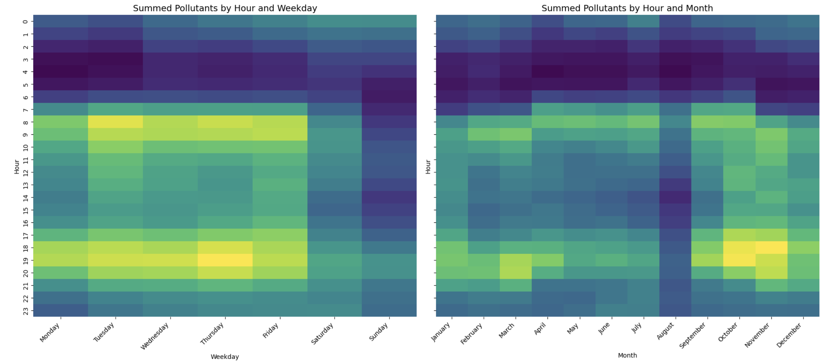
The pollution is present throughout daytime hours. Thursday evenings are the worst time to be outside. The air is less polluted at weekends, especially on Sunday.
This effect is greater winter months, when more people drive to work due to the colder, wetter weather. August is comparatively pollution free when Italians tend to take their summer holidays.
These charts are likely to be a good indicator of future pollution levels.

This chart shows the relative concentration of pollutants and identifies periods of high pollution over time, to allow focussed public health interventions:
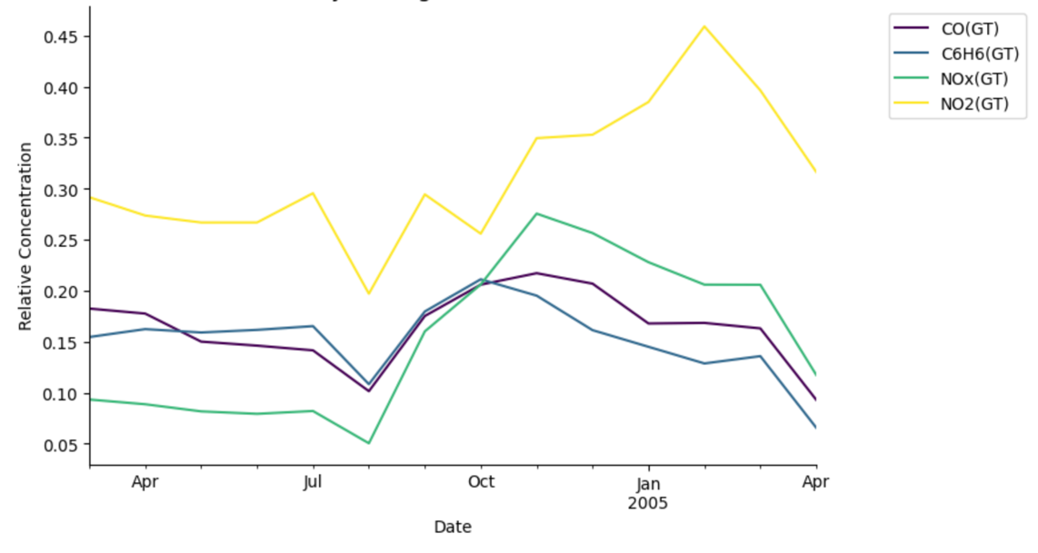
Unfortunately, the pollutant levels frequently breached World Health Organisation safety limits:
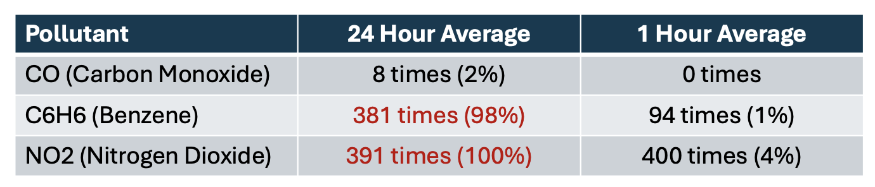

Positive Actions
To reduce pollution levels, the following actions can be taken by city planners:
- Encourage home working
- Incentivise using public transport
- Incentivise using electric vehicles and bicycles
- Define ‘low pollution zones’ like London ULEZ

Conclusion
It is possible to predict future pollution levels from past data, particularly with reference to time of day and month of the year.
(290 words)

