Fundamentals of

Artificial Intelligence

Course Details
Title: Artificial Intelligence
Code: DAT6002 S2_25
Term: Spring 2026
Assessment: WRIT1

Student Details
Tom Rowan ST20285213

Project Tutor
Dr. Imtiaz Hussain Khan

Table of Contents
Part 1 - Symbolic AI 3
Task 1: Semantic Network Design for Medieval Weaponry 3
Structural Design and Abstraction 3
Task 2: Semantic Network Implementation 4
Python Implementation 4
Prolog Implementation 5
Sample Queries 6
Ethical Considerations 11
References 11
Semantic Networks 11
Part 2: Connectionist Methods 13
Dataset Preparation 13
Encoding and Scaling 17
One-Hot Encoding 17
Binary Variable Encoding 17
Normalisation Functions 17
Removal of Problematic Features 18
Correlation with Dependent Variable ‘y’ 19
Post Processing 20
Implementation of ANN From Scratch 21
Network Architecture 22
Feed Forward Pass 22
Back Propagation 23
Weight and Bias Update Step 23
Performance Evaluation 24
ANN Implementation with Libraries 28
Choice of Library 28
Model Parameter Configuration 28
Performance Comparison 29
Advantages and Disadvantages 30
Parameter Tuning and Model Optimisation 31
GridSearchCV 31
Genetic Algorithm Optimisation 33
Appendix A – Prolog Rule Code 35
Rules 35

Part 1 - Symbolic AI

Task 1: Semantic Network Design for Medieval Weaponry
A semantic network is a way of representing knowledge about a subject by modelling relationships and attributes as ‘nodes’ and connecting ‘edges’ on a graph. In this project, the subject being represented is medieval weaponry, with the ‘medieval period’ defined as starting with the fall of the Western Roman Empire in 476 AD through to the beginning of the Protestant Renaissance Period in 1517 AD. [references – wikipedia,etc]

Structural Design and Abstraction
The semantic network was constructed using a hierarchical classification system, grouping items by shared properties and function. This reduces redundancy and follows the taxonomical classification found biological classification which groups organisms based on shared ancestral traits (Campbell 2005).
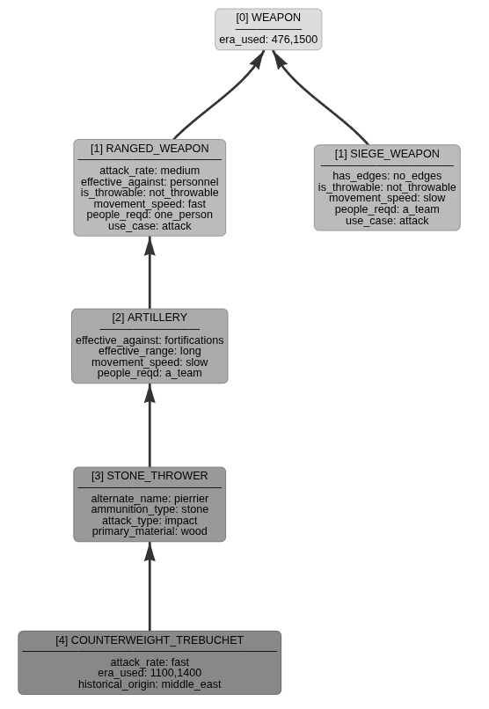Figure 1: Showing Trebuchet, Siege and Ranged Weaponry Inheritence
An attribute is a possible general characteristic known to the network, while a property is an instance of an attribute that is attached to a distinct item.

Items that are closer to the root of the relationship tree have fewer but more general properties. Conversely, objects that are leaves are likely to have more properties. Items inherit properties from objects that are closer to the root; these can be overridden (hidden) by more specific properties.

The design separates the taxonomy where an item belongs to a class from attributes belonging to the item.

A challenge emerged in this design regarding whether to use multiple inheritance. While a tree structure works for most weapons, certain items are not simple to categorise. For example, trebuchet functions both as a siege weapon and a ranged weapon. Figure 1 shows this relationship with the trebuchet having been determined as primarily a ranged weapon.

My design uses a strict tree without multiple inheritance. This is known as a Monohierarchy. To fully capture the trebuchet, the tree would have to be modified allowing a single node to inherit properties from multiple parents. This highlights the difference between the simplicity of a tree and the enhanced representation allowed for by a polyhierarchical Directed Acyclic Graph (DAG) approach.

Task 2: Semantic Network Implementation
The network was implemented in both Prolog and Python.

Python Implementation
A python class was created to allow a user to model any generic semantic network. It allows the user to add nodes and edges to the graph as ‘is_a’ and ‘has_a’ relationships. From the resulting network, the user can output the network into JSON, CSV and Prolog files. The class can also create interactive graphical visualisations which was the primary reason for implementing in python.

As the network is sizeable, containing 84 is_a relationships and 341 has_a properties, output visualisations are too detailed to display in their entirety in this report. They can be viewed here:

Visualisation Type | URL
Hierarchical Tree | https://datascience.daemonchild.com/year3/dat6002/Medieval_Weapons_Hierarchy.html
Network Node Diagram | https://datascience.daemonchild.com/year3/dat6002/Medieval_Weapons_Node_Diagram.html

The implementation creates filtered hierarchical diagrams including only selected nodes as have been used elsewhere in this report.

There were a number of challenges in writing the python implementation. The NetworkX library is used to implement the underlying graph storage, storing items as nodes and relationships as labelled edges. It does not natively make a distintion between ‘is_a’ and ‘has_a’ edges. The ‘get_node_level’ function calculates the ‘distance’ from the root using a subgraph structure. It was written to avoid the network taking shortcuts via ‘has_a’ edges, and only to traverse ‘is_a’ paths.

Another challenge was working with the model parameters of the PyVis library to ensure that the visualisations show the appropriate data as required and look appealing.

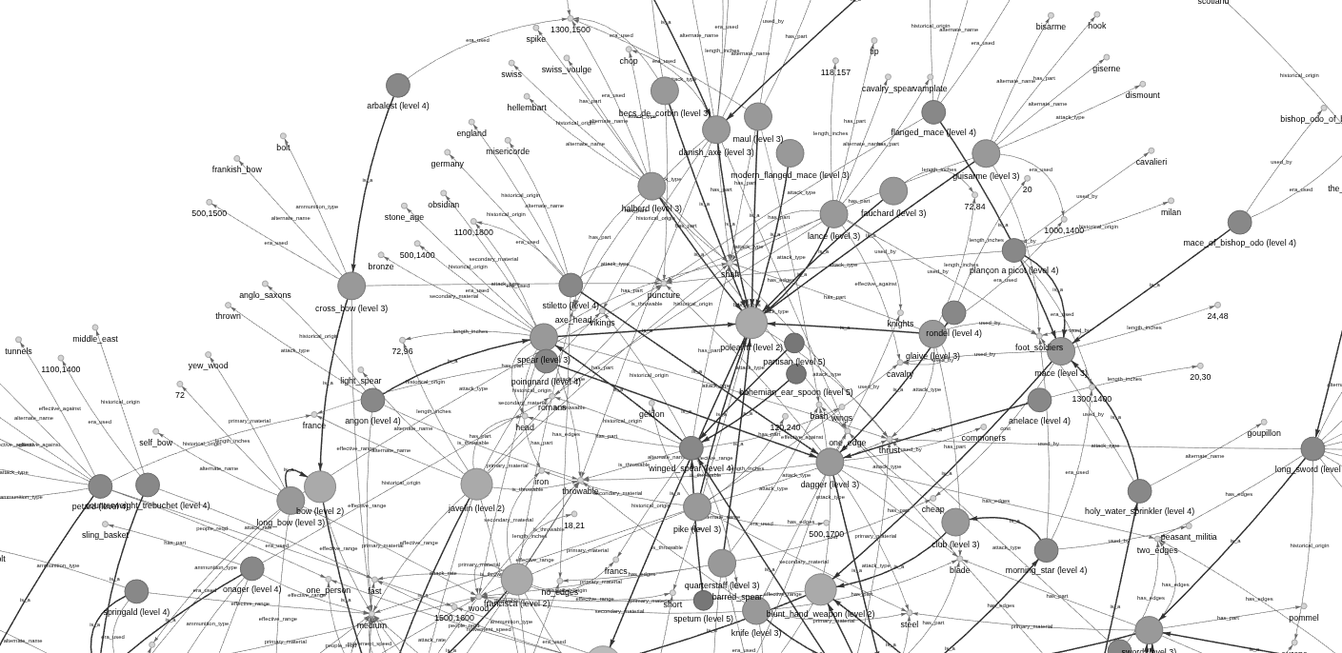Figure 2: Showing part of a network visualisation

Prolog Implementation
The python class does not provide an inference engine, so the network is written out to a Prolog file.
In Prolog the network is implemented using two types of fact:

- is_a facts
- has_a facts

The relationships between items in the network are defined in a parent-child hierarchy using the predicate ‘is_a’. This builds a tree of relationships in the form is_a ( child, parent ).

is_a( melee_weapon, weapon ).
is_a( bladed_hand_weapon, melee_weapon ).
is_a( sword, bladed_hand_weapon ).

The properties of an object are defined as ‘has_a’ facts:

has_a( melee_weapon, effective_against, personnel ).
has_a( bladed_hand_weapon, effective_range, close_quarters ).
has_a( sword, has_part, blade ).
has_a( sword, has_part, hilt ).
has_a( sword, has_part, pommel ).

By defining nodes such as 'bladed_hand_weapon', the network utilises shared inheritance. Each class below this, for example ‘sword’, automatically inherits properties like 'effective range'. Querying the network for the unique attributes defined for a generic sword would therefore return the following, with the attributes being inherited from further up the tree:

- has_part (from sword)
- effective_range (from blade_hand_weapon)
- effective_against (from melee_weapon)

The Closed World Assumption (CWA) is a fundamental tenet of Prolog. Under CWA any statement that cannot be proven true within the knowledge-base is assumed to be false. For example: has_a (sword, colour, pink) is not specifically stated, and cannot be inherited from a parent, so Prolog will conclude that this is false. Taking this further, the inference engine utilises the Negation as Failure (NAF) principle (Clark, 1978). If the system attempts to prove a sword is pink and finds no supporting evidence the proof fails, and the statement is treated as logically false.

The CWA also ensures that the Prolog inference engine operates within a defined plausible version of reality. While other facts may be possible – such as a pink sword – the model is unable to hallucinate anything beyond the defined network. This has the disadvantage that the model also cannot make new leaps of understanding outside of its knowledge-base.

In additional, rules have been written for querying this network. Most of these functions are generic and work for any suitably defined semantic network.

- is_a_member - check class/parent membership
- has_a_property - does the item have a property?
- list_all_items - list all the items in the network (pretty output)
- get_all_items - get all the items in the network into sorted list
- list_all_attributes - list all the attributes in the network (pretty output)
- get_all_attributes - get all the attributes in the network into sorted list
- list_properties - list the defined properties for an item (including inherited)
- list_items_with_property - list all items that have a specific property-value pair (pretty output)
- show_tree - list items in an attractive tree

The following functions are specific to medieval weaponry:

- longer_range - compares two weapons for range
- list_weapons_by_year - find all weapons in use in a specific year

Sample Queries
The following queries were run under SWI Prolog version 9.0.4 on Linux.
It is always possible to as Prolog to answer questions about the facts directly, for example:
is_a(sword, ranged_weapon) which is false.

Using the rules network can also answer questions about parent relationships. The following examples ask the question “Is a long sword a melee weapon?”, and asks Prolog to show the lineage of a long sword:

? is_a_member(long_sword, melee_weapon).
true .

?- is_a_member(long_sword, W).
W = sword ;
W = bladed_hand_weapon ;
W = melee_weapon ;
W = weapon ;

The same concept works for properties. This example shows the properties of the sword class, firstly using the raw facts (no inheritance), and secondly using the has_a_property rule to also obtain inherited properties from further up the tree, as also shown in the diagram.
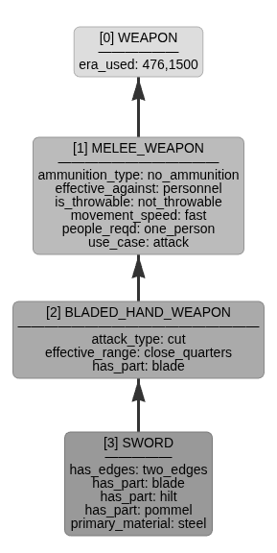Figure 3: Properties of a sword and classes above.

?- has_a(sword, Property, Value).
Property = has_edges,
Value = two_edges ;
Property = has_part,
Value = blade ;
Property = has_part,
Value = hilt ;
Property = has_part,
Value = pommel ;
Property = primary_material,
Value = steel.

TRACE!

?- has_a_property(sword, Property, Value).
Property = has_edges,
Value = two_edges ;
Property = has_part,
Value = blade ;
Property = has_part,
Value = hilt ;
Property = has_part,
Value = pommel ;
Property = primary_material,
Value = steel ;
Property = attack_type,
Value = cut ;
Property = effective_range,
Value = close_quarters ;
Property = ammunition_type,
Value = no_ammunition ;
Property = effective_against,
Value = personnel ;
Property = is_throwable,
Value = not_throwable ;
Property = movement_speed,
Value = fast ;
Property = people_reqd,
Value = one_person ;
Property = use_case,
Value = attack ;
Property = era_used,
Value = (476, 1500) ;

My list_properties rule acts as a wrapper to make the same output easier to read:
?- list_properties(sword).
Properties for sword:
----------------------------------------
- ammunition_type = no_ammunition
- attack_type = cut
- effective_against = personnel
- effective_range = close_quarters
- era_used = 476,1500
- has_edges = two_edges
- has_part = blade
- has_part = hilt
- has_part = pommel
- is_throwable = not_throwable
- movement_speed = fast
- people_reqd = one_person
- primary_material = steel
- use_case = attack

Using a specific instance of a sword shows how inheritance works when a more specific property overrides generalisations applied further up the tree. Note from the above output that the property ‘era_used’ for a sword is ‘476 to 1500’ which is inherited from the root ‘weapon’ class.

Long swords were introduced in 1250:

?- has_a_property(long_sword, era_used, When).
When = (1250, 1550)

However, the specific instance of a long sword belonging to William Wallace has a more specific use date:

?- has_a_property(the_wallace_sword, era_used, When).
When = 1298 ;

When all the properties for The Wallace Sword are listed, the more specific date overrides both the value for era_used applied at the root of the tree and that applied to all long swords. This list shows a mixture of local, inherited and overridden properties, including the era_used property:

?- list_properties(the_wallace_sword).
Properties for the_wallace_sword:
----------------------------------------
- alternate_name = bastard_sword
- alternate_name = great_sword
- alternate_name = hand_and_a_half_sword
- ammunition_type = no_ammunition
- attack_type = thrust
- effective_against = personnel
- effective_range = close_quarters
- era_used = 1298
- has_edges = two_edges
- has_part = fullers_aka_blood_grooves
- historical_origin = scotland
- is_throwable = not_throwable
- length_inches = 40,48
- movement_speed = fast
- people_reqd = one_person
- primary_material = steel
- use_case = attack
- used_by = william_wallace
- weight_kg = 2.7

The underlying has_a_property rule implements recursive inheritance with local overrides. The cut operator (\+) is used to stop general properties from being included when a more specific instance is available.

Most of the rules that I created would work against a network defined in the same way whatever the subject. It is also possible to ask some specific questions of the network using rules like longer_range:

?- has_a(biological_weapon, effective_range, Value).
Value = long.

?- has_a(long_bow, effective_range, Value).
Value = long.

?- has_a(dagger, effective_range, Value).
Value = close_quarters.

?- longer_range(long_bow, biological_weapon).
false .

?- longer_range(long_bow, dagger).
true .

As the effective_range property is a linguistic variable rather than a numerical value, the following weighting facts were used to convert to numbers and allow direct comparison in the longer_range rule. The specific values do not matter as this is only to allow comparison of these terms. [citation fizzy logic]

% Higher number = longer range
range_to_weight(long, 3).
range_to_weight(medium, 2).
range_to_weight(short, 1).
range_to_weight(close_quarters, 0).

The rules are included in an appendix to this report.
One final example shows the output of the show_tree rule, which gives each of the weapons and their level in the hierarchy:

?- show_tree(weapon).
-- weapon (0)
-- melee_weapon (1)
-- bladed_hand_weapon (2)
-- dagger (3)
-- anelace (4)
-- poingnard (4)
-- rondel (4)
-- stiletto (4)
-- knife (3)
-- sword (3)
-- arming_sword (4)
-- almace (5)
-- broad_sword (4)
-- falchion (4)
-- cleaver_falchion (5)
-- cusped_falchion (5)
-- medici_falchion (5)
-- long_sword (4)
-- the_wallace_sword (5)
-- blunt_hand_weapon (2)
-- club (3)
-- morning_star (4)
-- wallace_collection_morning_star (5)
-- mace (3)
-- flanged_mace (4)
-- holy_water_sprinkler (4)
-- royal_armouries_holy_water_sprinkler (5)
-- plançon_a_picot (4)
-- mace_of_bishop_odo (4)
-- flail (3)
-- horsemans_pick (3)
-- polearm (2)
-- becs_de_corbin (3)
-- danish_axe (3)
-- pollaxe (4)
-- bardiche (5)
-- sparth (4)
-- fauchard (3)
-- glaive (3)
-- guisarme (3)
-- halberd (3)
-- lance (3)
-- maul (3)
-- modern_flanged_mace (3)
-- pike (3)
-- quarterstaff (3)
-- spear (3)
-- winged_spear (4)
-- bohemian_ear_spoon (5)
-- spetum (5)
-- corsque (5)
-- ranseur (6)
-- partisan (5)
-- angon (4)
-- ranged_weapon (1)
-- artillery (2)
-- cannon (3)
-- bombard (4)
-- petard (4)
-- stone_thrower (3)
-- ballista (4)
-- counterweight_trebuchet (4)
-- mangonel (4)
-- onager (4)
-- springald (4)
-- traction_trebuchet (4)
-- bow (2)
-- cross_bow (3)
-- arbalest (4)
-- long_bow (3)
-- francisca (2)
-- gun (2)
-- arquebus (3)
-- musket (4)
-- cavalier (4)
-- hand_cannon (3)
-- javelin (2)
-- siege_weapon (1)
-- battering_ram (2)
-- biological_weapon (2)
-- chemical_weapon (2)
-- psychological_weapon (2)
-- moveable_structure (2)
-- cat_and_weasel (3)
-- siege_tower (3)

Ethical Considerations
The network design considerations made for this project would be valid for most subject matter. The implementation in both python and Prolog languages has been made in as generic manner as possible. This would have allowed for almost any subject to have been used to give example to the construction of a semantic network.
While there is nothing inherently malicious about using historic articles of warfare as an example, there are some ethical considerations regarding the use of a medieval weaponry dataset to study semantic networks and programming in Prolog. Switching to non-violent objects can make the study of computer science feel more welcoming to those who might otherwise feel alienated or intimidated by this dataset.
Humans can understand the historical context of this dataset, whereas AI systems do not have this distinction, and may struggle to give adequate weighting to non-aggressive features. Moreover, if an AI agent were to use this network as a knowledgebase to solve a problem, it is unlikely to have the human-level understanding that a particularly attractive item is a museum piece!
Furthermore, if the output of this exercise were to be fed into connectionist neural network models, there is a danger that the system may learn bias in the system, such as predicting or advocating violence based on properties such as 'causes_damage'. Worse, there is a risk that this aggression might be internalised by the neural network in a ‘black-box’ manner making such bias harder to detect and mitigate. (reference needed).

References

Semantic Networks

Campbell, N.A., Reece, J.B. et al, (2005) Biology. 7th edn. Harlow: Pearson. (Available at: https://cssplatformbytha.com/wp-content/uploads/2024/10/Biology-by-Neil-A.-Campbell-Jane-B.-Reece-z-lib.org_.pdf)

Clark, K. L. (1978). Negation as Failure. In: Gallaire, H. and Minker, J. (eds) Logic and Data Bases. Plenum Press, New York, pp. 293–322. (Available at: https://www.doc.ic.ac.uk/~klc/NegAsFailure.pdf)

https://resources.metmuseum.org/resources/metpublications/pdf/Arms_and_Armor_Permanent_Collection_The_Metropolitan_Museum_of_Art_Bulletin_v_49_no_1_Summer_1991.pdf

https://fiveable.me/europe-1000-1500/unit-1/defining-middle-ages-chronology-geographical-scope/study-guide/PdAHuoPDDX2anH9c

https://education.nationalgeographic.org/resource/protestant-reformation/

https://en.wikipedia.org/wiki/Fall_of_the_Western_Roman_Empire

https://en.wikipedia.org/wiki/Reformation

https://www.oxfordsemantic.tech/faqs/what-is-negation-as-failure

FOUNDATIONS OF
KNOWLEDGE REPRESENTATION
AND REASONING Martins, J.P.

Part 2: Connectionist Methods

Dataset Preparation
The ‘Bank Full Dataset’ is related to the phone based direct marketing campaigns of a Portuguese bank from May 2008 to November 2010. Often, more than one contact to the same client was required in order to assess if the individual would be a subscriber to the deposit product or not.

The dataset includes 17 inputs, ordered by date and contains just over 45,000 rows. The classification goal of my Multi-Layer Perceptron (MLP) is to predict if the client will subscribe (variable y).

Exploratory Data Analysis (EDA) was carried out and the dataset was audited for quality and consistency. There is not scope in this report to discuss every feature, although all were considered individually during this phase. This section discusses of the report some of the more interesting features to show how a variety of techniques were required to handle the broad range of data.

A Biased Dataset
Exploring the target dependent variable 'y' shows that there is considerable bias in the dataset. While the success rate is actually very good for a cold calling telephone marketing campaign (Cognism 2025), the majority of people did not deposit funds.

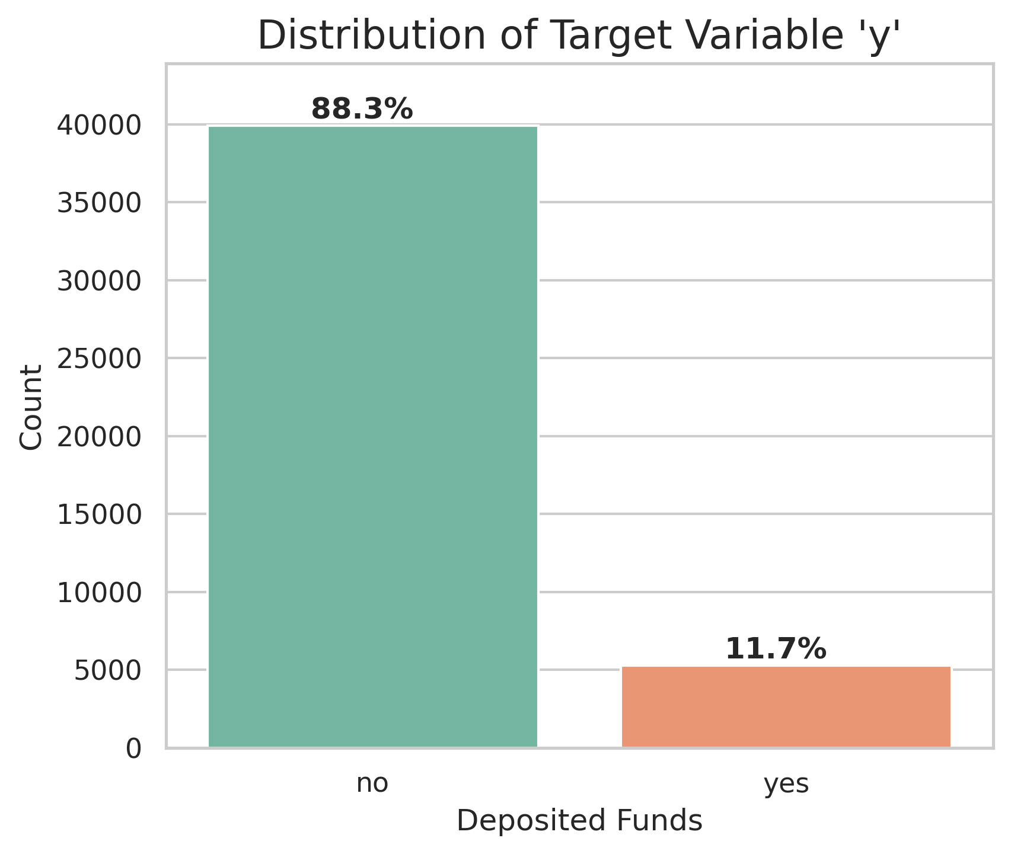Figure 4: Showing that the dataset is highly biased towards 'no'.
This bias causes issues for the neural network because the weights will tend to shift to favour negative responses; there are not many instances of positive responses to learn from. The network is likely learn to predict ‘no’ whatever the input because this is most often correct.

Each of the other features was assessed individually to determine whether it would be useful or potentially derogatory to the performance of the MLP.

Outliers
Four features that were likely to contain outliers and/or very wide distributions: age, balance, campaign and previous.
The plot shows a massive bulge between 30 and 45. This is expected and is the target audience for the bank's marketing department. The tail shows the older outliers who are people over 65-70 years old.
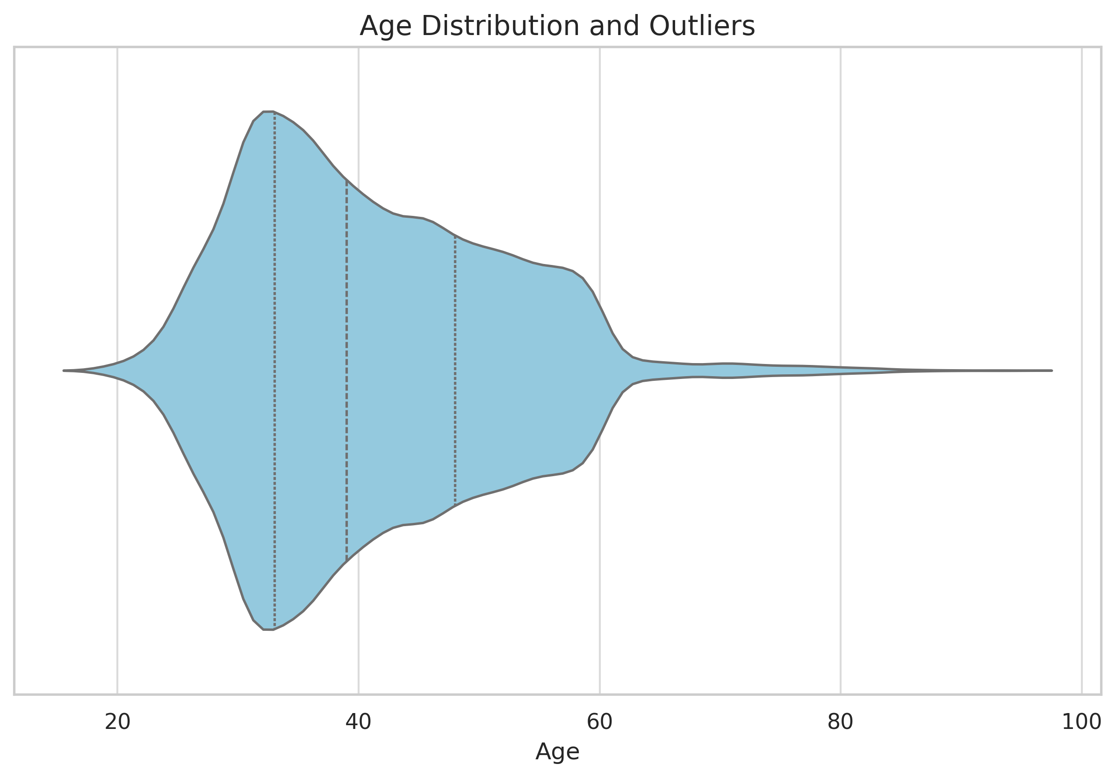Figure 5: Violin plot for age, showing distribution and outliers
To encode the features with outliers, a Standardised Z-Score Scaler was used.

Education
While the dataset is largely complete, there are several features where there are ‘unknown’ values. These were identified and handled as behavioural categories.

The unknown group in the education feature had a success rate of 13.6%, which is higher than the dataset average (11.7%). Thus, unknown was treated as a specific feature rather than being dropped. It was mapped to sit between secondary and tertiary education, preserving the ordnial meaning of educational progression. A numeric version of the feature was engineered to allow scaling.

Contact Type
The contact feature relates to the type of medium used to make contact with the individual.
This is either landline telephone, cellular phone or unknown. Today, mobile communication is most prevalent for all, with a landline possibly indicating an older person; this was not true in 2010. Since there is a significant group of unknown values, using one-hot encoding allows the model to learn their unique signature without my needing to guess if they ‘should have been’ cellular or landline contacts.

Pdays
The pdays feature required special consideration. People who have never been called before are represented as -1, while the rest of the data shows how long it has been since they were contacted previously. The uncontacted make up the majority of the data:

When the -1 values are filtered out, the pdays distribution is multi-modal, exhibiting several local maxima. There are peaks at approximately 100, 180, 275 and 365 days. This suggests a re-engagement strategy based on quarterly cycles.
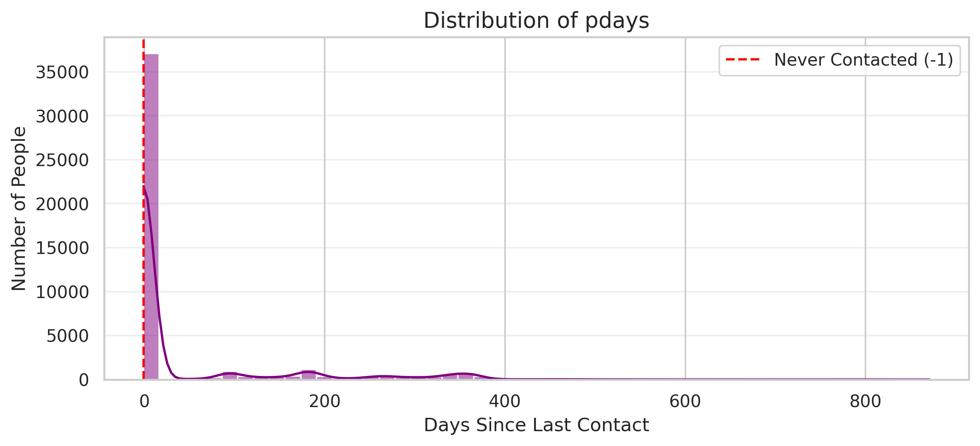Figure 6: Distribution of entire pdays feature.
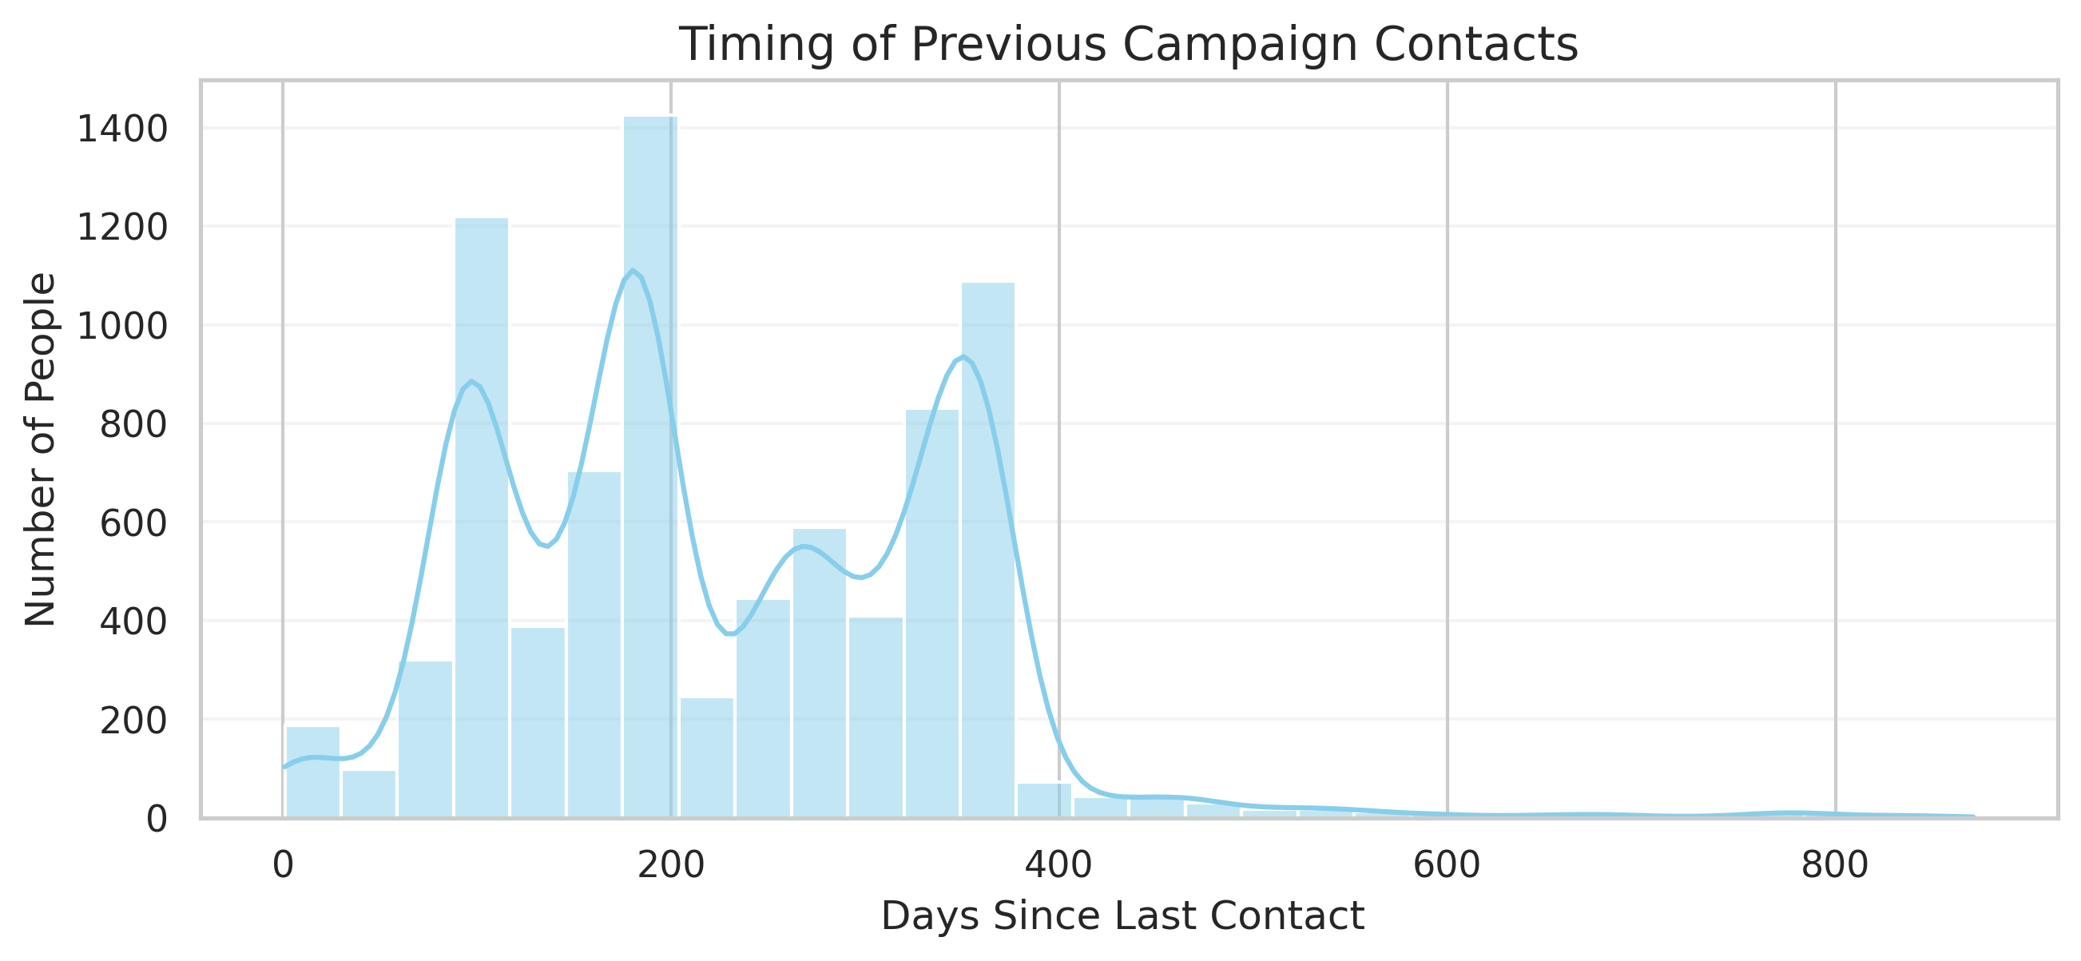Figure 7: Distribution of filtered pdays feature (-1 removed)

To ensure the MLP captures these specific windows of time, I used a binning strategy based around these values:

Bin Value | Range
0 | -1 (never Contacted)
1 | < 30 days
2 | < 150 days
3 | < 250
4 | Longer term

Previous Outcome
It makes sense that the ‘previous outcome’ feature would likely be a useful indicator for predicting the future outcome.

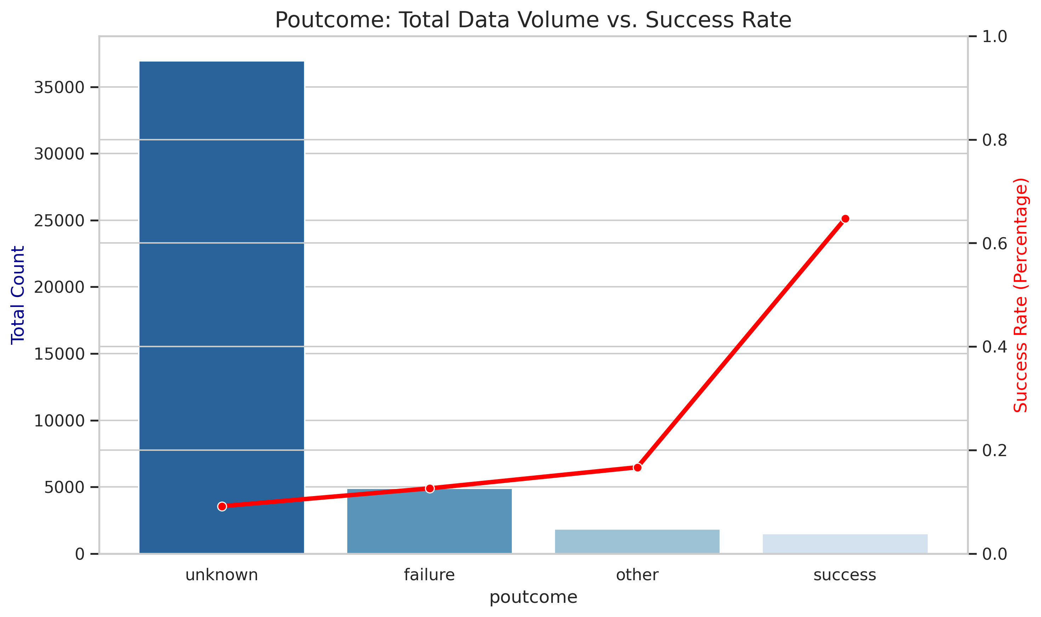Figure 8: Exploring previous outcome

The graph shows that there is a massive disparity in the results, and if an individual said "yes" last time, they are overwhelmingly likely to say "yes" again.

One Hot Encoding would allow the MLP to determine for itself that the previous outcome is an excellent indicator. However, as the number of unknowns is very high in comparison, there is a strong chance that the MLP might miss these relatively rare signals of success. This may be made worse as they are distributed across training, validation and test sets.

To assist the MLP in spotting these rare but strong indicators, I used a map to manually weight these values highly to reflect their importance:

Value | Weighted Map
Success | 7
Other | 2
Failure | 0
Unknown | 1

Encoding and Scaling
Values for all features were encoded as numerics and scaled to give a floating point value between -1.0 and 1.0 depending on the encoding method used, as described below.
This table shows how each included feature was handled.

Encoding | Features
Binary | ‘housing', 'loan', 'y'
Z-Score Standardisation | ‘age', 'balance', 'campaign', 'previous'
Min-Max Scaling | 'pdays_binned','month_numeric','education_numeric', 'poutcome_numeric’
One Hot Encoding | 'job', 'marital', 'contact'

One-Hot Encoding
The non-ordinal categorical features job, marital, contact were expanded using One Hot Encoding. This prevented the model from assuming a false linear relationship between unrelated categories for example "Single" vs. "Married". In reality, there is no "ascending" or "descending" order that matches such status categories, and there is no hidden meaning in the data. One-hot encoding allows the MLP to treat each status as a unique binary value.

Binary Variable Encoding
Binary features were simply encoded as ‘yes’ = 1.0 and ‘no’ = 0.0.

Normalisation Functions
Z-Score Standardisation was applied to features with significant outliers, such as balance and campaign because this centres the values around 0 as the mean. The standard deviation is used calculate the spread of values.

$x_{scaled} = \frac{x - \mu}{\sigma}$

Min-Max Scaling was used for other numeric features to squash values into a 0 to 1 range.

$ x_scaled = \frac{x – min(x)}{max(x)-min(x)}$

Removal of Problematic Features
A number of features were removed from the model The ‘duration’ feature is the most interesting problem because as well as being highly skewed by outliers, it also allows for data leakage ‘from the future’ into the model.

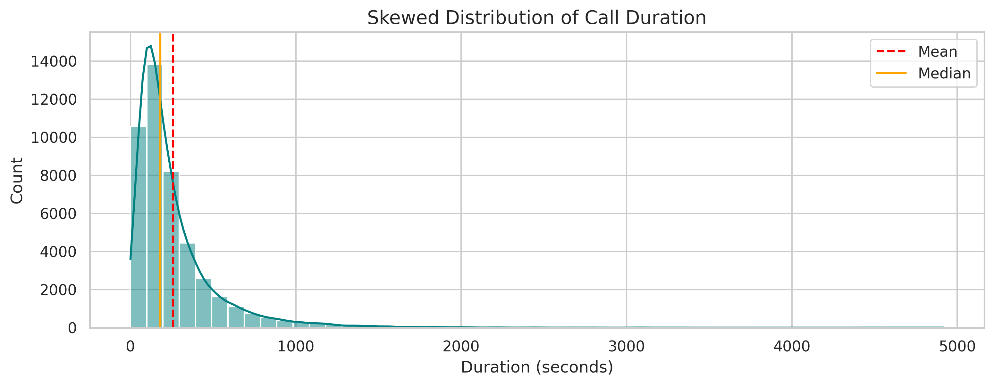Figure 9: Showing skew for call duration
If a person talks for 30 minutes, they have almost certainly already said "Yes". Conversely, if they end the call after a very short time, then they are likely to have said "No". The longer duration is a result of positive intent, not a cause.

The purpose of the MLP is to assist the bank to decide who to call tomorrow based on known data. Since they haven't called yet, they have no "duration" value to give the model. The duration only becomes known after the decision has already been made, and the target value for 'y' is known. Therefore, including it would poison the model outcome.

Other features were also dropped for the following reasons:

Feature | Action | Reasoning
Duration | Dropped | Target leakage; duration is not known at the time of prediction.
Default | Dropped | Near-zero variance; 98% of entries are 'no'.
Day | Dropped | Does not appear to add value; no obvious trends.
Pdays | Binned Version Kept | Re-encoded to handle multi-modal distribution and -1 values.
Month | Encoded version kept | Re-encoded as values 1-12
Education | Encoded version kept | Re-encoded as values 0-3
Poutcome | Encoded version kept | Re-encoded as values 0-7

Correlation with Dependent Variable ‘y’
The remaining features in the dataset were compared with the target variable ‘y’ to show which features have the best correlation. I would expect these features to correspond to strong indicators for the MLP to learn from.
Strongest Positive Correlation: poutcome_numeric (0.289), contact_cellular (0.136) and pdays_binned (0.129). The previous outcome was already shown to be a strong indicator, but contact by cellular phone is a slight surprise.
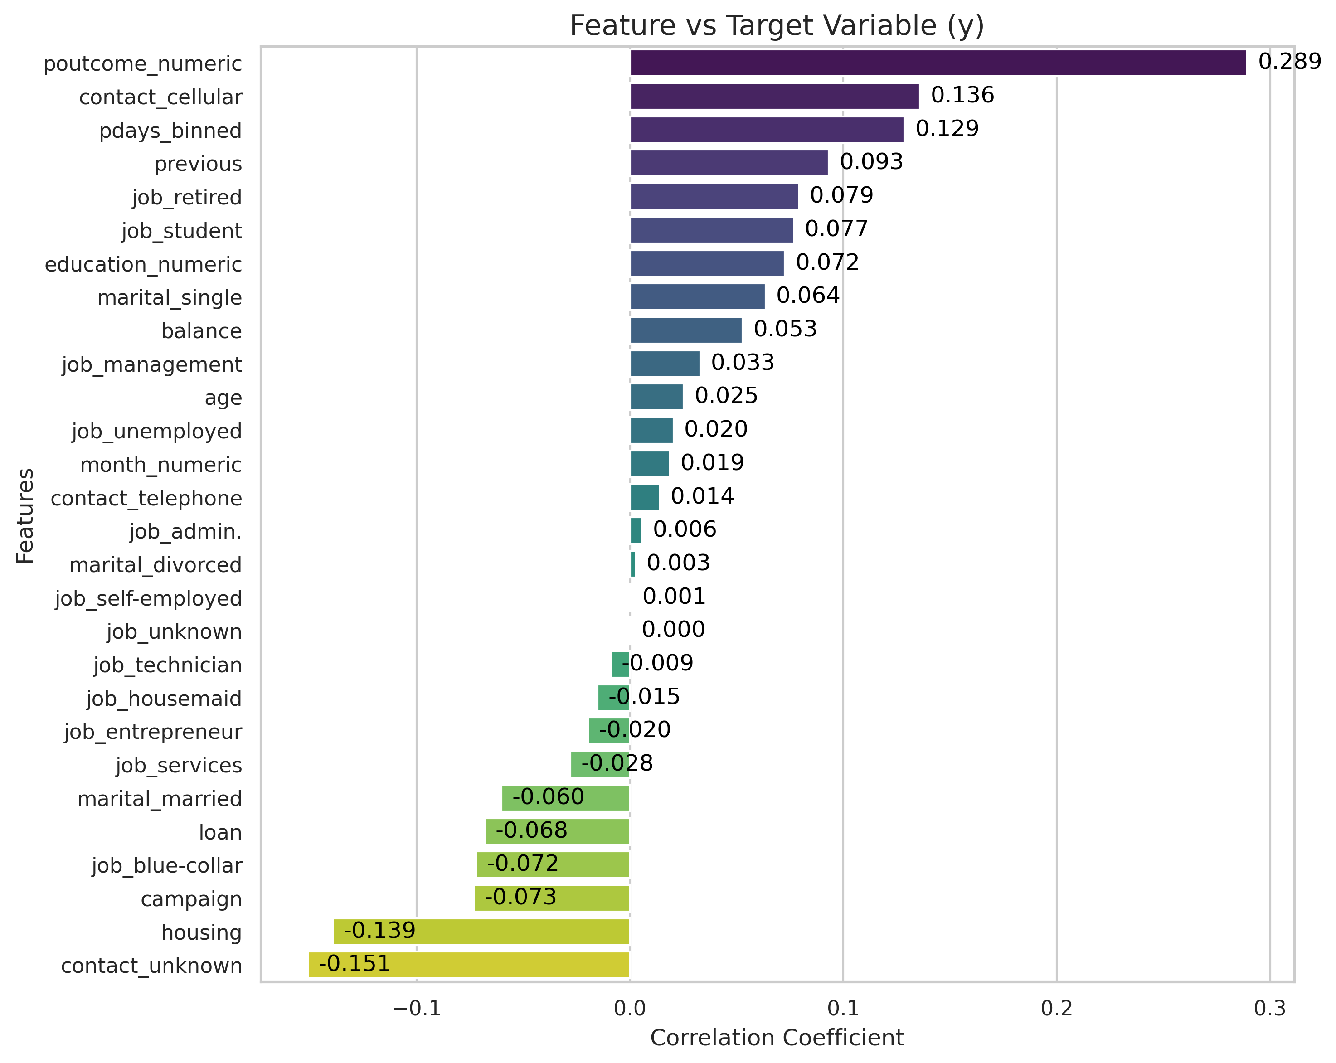Figure 10: Correlation of features vs 'y'
Demographics: job_retired, job_student, and marital_single are all positively correlated with success. This confirms that specific life stages are more likely to say "yes". Students, for example, are likely planning for their future and trying to make savings, while the retired likely have spare cash to invest.
Weak correlation: Balance (0.053) is more weakly correlated than might be expected. It is not the primary driver for a ‘yes’ result in this campaign.

Post Processing
After preprocessing, the dataset was written out to a new CSV file to allow exactly the same data to be used in both the MLP written ‘from scratch’ and the MLP based on SciKit Learn Python libraries.

Before loading the data into either MLP implementation, one further step was be required: splitting the dataset into training, validation and testing data. The data was split 80% towards the training data, with 20% going to form the test dataset. The training data was split further, again 80:20, into training and validation sets.

The dataset is date ordered, meaning that it must be shuffled to avoid the MLP learning patterns based on the sequence of the rows, such as time-of-year trends.
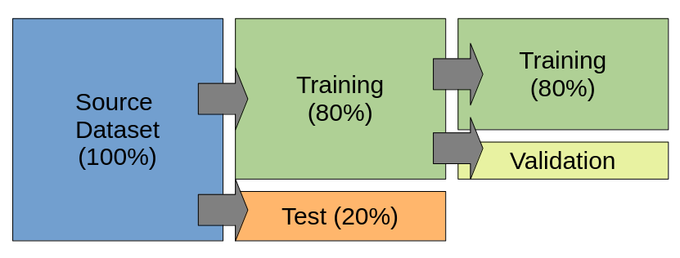Figure 11: Training, validation and test data splitting method

Furthermore, ‘stratified sampling’ of the success and failure classes means that the target variable imbalance (88.3% vs 11.7%) was preserved across the training, validation and testing datasets. This prevents the result from being skewed by a disproportionate distribution of target variables in these datasets.

In the instance of the ‘from scratch’ MLP, this was done using a custom python function, whereas splitting the data for the Scikit-Learn based MLP utilised the train_test_split function with the stratify and shuffle parameters enabled.

Implementation of ANN From Scratch
The ‘from scratch’ MLP was implemented in Python as a Class ‘MLP_From_Scratch’. It provides a number of public functions:

Function | Purpose
Class Constructor | Creates new network using provided training and test datasets, automatically splitting out validation data. The number of input neurons is determined by the input dataset.  Allows user to tune parameters:  - no_hidden_neurons  - no_output_neurons  - output_threshold  - validation_split (%)
train_network | Performs network training for a user supplied number of epochs. Allows user to define learning_rate.  Steps:  - Feed Forward  - Back Propagation (Output Layer)  - Back Propagation (Hidden Layer)  - Weights and biases updated
evaluate | Return accuracy.
plot_error | Plots the training and validation set losses for comparison.
plot_confusion_matrix | Plots a graphical confusion matrix.
print_confusion_matrix | Prints a text representation of the confusion matrix.
save_weights | Save out the weights and biases for future use.
load_weights | Load in a set of saved weights.
get_report | Print a report of model accuracy, recall, precision and F1-score.
set_model_parameters | Allows user to reset learning_rate and output_threshold hyper-parameters.

Network Architecture
After encoding, the input layer consists of N=28 neurons. The hidden layer is explicitly defined as 10 neurons. As this is a binary classification, the output layer consists 1 neuron using a Sigmoid activation function, outputting a probability score.

Figure 12: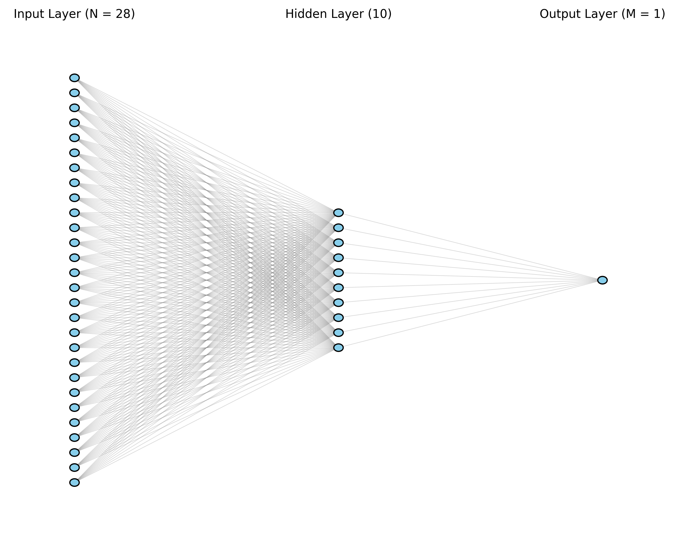 Neural network architecture

Feed Forward Pass
The forward pass is simply computing the dot product of weights and inputs (z = w \cdot x + b) and applying activation functions at the hidden and output layers.

The ReLU (Rectified Linear Unit) function is used in the hidden layer. Initially, I was using the Sigmoid function for both hidden and output layers. However, performance was improved significantly using ReLU at the hidden layer. The network likely experienced a vanishing gradient due to the limitations of the sigmoid derivative function – the weight values become very small, very quickly.

The Sigmoid function $\sigma(x) = \frac{1}{1 + e^{-x}}$ is the standard choice for the output layer in a binary classification task because it squashes any input into a value between 0 and 1, which represents the probability of an individual subscribing. (Bishop 2006, pp236) The default threshold for the output later was set at >0.5 = ‘yes’.

Back Propagation

The backwards pass works by calculating the partial derivative of the loss with respect to each weight. Originally, I had used Mean Squared Error to calculate the loss in the back propagation passes. The performance of the model was poor, so I explored other options.

Following the recommendations in Bishop, the loss function was transitioned from Mean Squared Error to Binary Cross-Entropy. This gave much improved results. MSE assumes the data follows a Normal distribution, whereas BCE works with data that follows a binary output, in this case ‘yes’ or ‘no’, in a Bernoulli distribution (Deisenroth 2021). It cancels out the way the gradients become ‘flat’ with the sigmoid function and prevents the learning from slowing down over time.

Weight and Bias Update Step
The final step of the learning process is where the gradients calculated during backpropagation are used to adjust the weights and biases.

This model employs Gradient Descent, governed by the following update rules:

$$w_{new} = w_{old} - \left( \eta \cdot \frac{\partial L}{\partial w} \right)$$$$b_{new} = b_{old} - \left( \eta \cdot \frac{\partial L}{\partial b} \right)$$

The ‘learning rate’ determines the step size taken toward the local minimum. In early testing, I had set the learning rate too high (0.03), which caused the error lines on the loss graph to diverge, as the updates overshot the local minima. Through experimentation, a lower rate was selected.

While weights determine the strength and direction of the relationship between input features and the prediction, biases provide the model with flexibility. By adding a bias, the activation function can shift its position on the graph away from the origin. This is crucial because real-world data patterns rarely start at zero; the bias allows the neural network to move its decision boundary for the specific dataset.
As only 11.7% of customers subscribed, the bias is particularly important. The bias reflects the skewed reality of the dataset. It forces the model to be pessimistic, only predicting a ‘yes’ when the evidence is overwhelmingly positive in the features.

Performance Evaluation
To monitor the model's ability to work with as-yet unseen data, the training of the model was validated every 100 epochs by using a validation dataset. This is split from the supplied training dataset automatically on model initialisation.

The Binary Cross-Entropy loss was calculated for both the training and validation subsets. This allows me to monitor the behaviour of the model as training progresses.

These losses are stored and plotted after the training is completed. It is possible to see where learning stops by observing the change in the curve.

The following graph shows how the losses flatten out over 10,000 epochs after an initial steep learning period. There is little point in continuing any further as the improvements in the model over time do not justify the additional compute requirements for more training epochs.
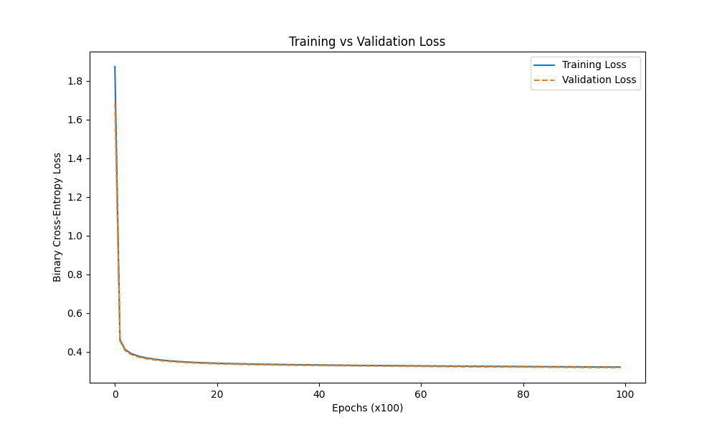
After training, a confusion matrix is drawn to show the true behaviour of the MLP at predicting against the test dataset.
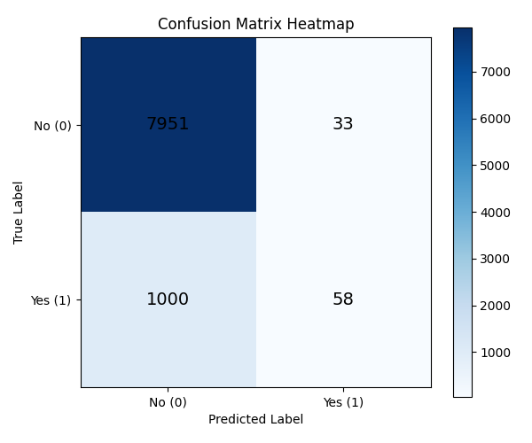

True Negatives: The model is excellent at identifying people who will not subscribe. This is expected because ‘no’ is the majority class.

True Positives: The model correctly identified only 58 successful deposits.

False Positives: The model predicted a ‘yes’, but it didn't happen. This number is quite low, which means that the bank wouldn’t waste much effort if they called these people and were told ‘no’.

False Negatives: There were 1000 people who actually said ‘yes’ but the model predicted they would say ‘no’, meaning that the bank would be unlikely to expend the effort to call them. This would mean that the bank missed out on a large number of deposits.

Using the above values, the following metrics were calculated:

Accuracy | 0.8858
Precision | 0.6374
Recall | 0.0548
F1-Score | 0.1010

Metric | Mathematical Formula | Description | What it tells the Bank
Accuracy | $\frac{TP + TN}{TP + TN + FP + FN}$ | The proportion of total predictions that were correct. | Overall success rate
Precision | $\frac{TP}{TP + FP}$ | The proportion of positive identifications that were actually correct. | "When we call someone a potential customer, how often are we right?"
Recall | $\frac{TP}{TP + FN}$ | The proportion of actual positives that were identified correctly. | Out of everyone who would have said 'Yes', how many did we actually find?
F1-Score | $2 \times \frac{\text{Precision} \times \text{Recall}}{\text{Precision} + \text{Recall}}$ | The mean of Precision and Recall. | The "balanced" score that punishes models for ignoring the minority class.

The confusion matrix reveals that while the MLP achieves a high accuracy of 88.6%, it suffers from a significant number of False Negatives. The model is heavily biased toward the majority class 'no', resulting in a very low recall of 5.7%. This indicates that the model is predicting the most frequent outcome. This was expected and predicted during the data preparation phase.

While the bias shifts the activation function to reflect probability of the majority 'no' class, a standard 0.5 classification threshold was too high. The model was tuned using the output threshold at this point to determine whether these scores could be improved. The output threshold was varied from 0.0 to 1.0, the performance metrics calculated. These results were plotted on the following graph:
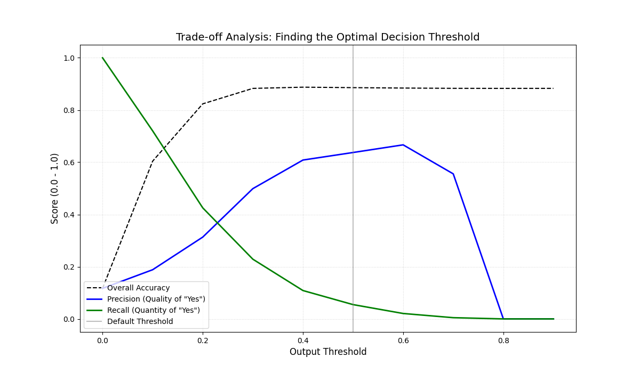
The point at which the recall and precision lines cross gives the best trade off between these scores. This is approximately 0.23. The confusion matrix for the threshold set at this value is:

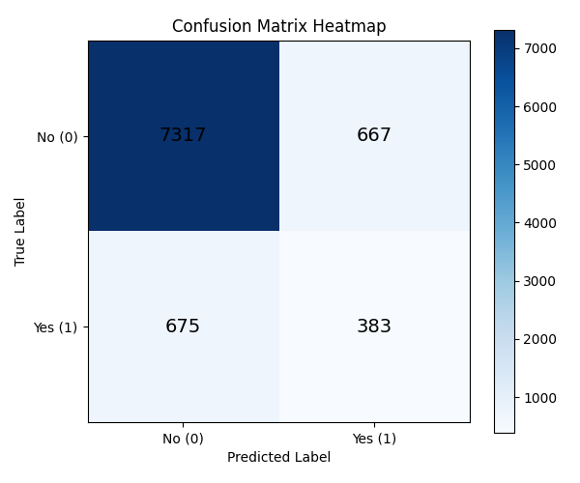
This is a much more balanced result.

Accuracy | 0.8516
Precision | 0.3648
Recall | 0.3620
F1-Score | 0.3634

Lowering the threshold seems to contradict the role of the bias, but actually allows me to place more priority on the recall of the model. By adjusting the output threshold the recall improved dramatically from 5.4% to 36.2%. While this resulted in a slight decrease in accuracy and precision, the model became more useful for a bank marketing campaign.

In this context, the cost of a phone call resulting in a False Positive is relatively low compared to the high value of a 'True Positive'. This ensures the bank will contact more potential customers. Adjusting the threshold is a business decision made after the models training has finished.

ANN Implementation with Libraries
An MLP was also developed using the Scikit-Learn library to act as a comparison against the ‘from scratch’ version discussed above.

Choice of Library
As before the preprocessed dataset was split 80:20 into training and test; validation being internal to the model. I used the Scikit-Learn library ‘train_test_split’ function with the stratify and shuffle parameters enabled. The Keras library does not provide functions for data manipulation, so would have either had to do this myself as before, or use the Scikit-Learn library anyway.

I also chose to use Scikit-Learn rather than Keras because the dataset is only moderately sized. Once engineered, it has 28 input features and around 45,000 rows. Keras is built by Google to use TensorFlow or PyTorch and is designed for large-scale deep learning projects. (Keras.io ??)

Keras requires the user to define input shapes explicitly, and need to have access to specific back ends libraries, such as TensorFlow, which can be challenging to set up on a workstation. Scikit-Learn handles the underlying maths and provides a simple interface without needing further libraries, beyond numpy.

Model Parameter Configuration
The MLPClassifier class was used to create the neural network.

To ensure a fair comparison, I chose parameters for the network that would be as close to the ‘from scratch’ configuration as possible:

From Scratch MLP Setting | MLPClassifier Setting
10 hidden neurons | hidden_layer_sizes = (10,)
Hidden layer activation: ReLU  Output layer activation: Sigmoid | activation = ‘relu’
Weight updates: gradient descent | Solver = ‘sdg’
Default Learning Rate = 0.005 | learning_rate_init = 0.005
Epochs = 10,000 | max_iter = 10000

This aims to ensure that comparison between the models will be based on the implementation, rather than the underlying mathematical functions in use.

Performance Comparison
As before, a confusion matrix was drawn to show the true behaviour of the MLP at predicting against the test dataset. The test dataset accounts for 9043 people:

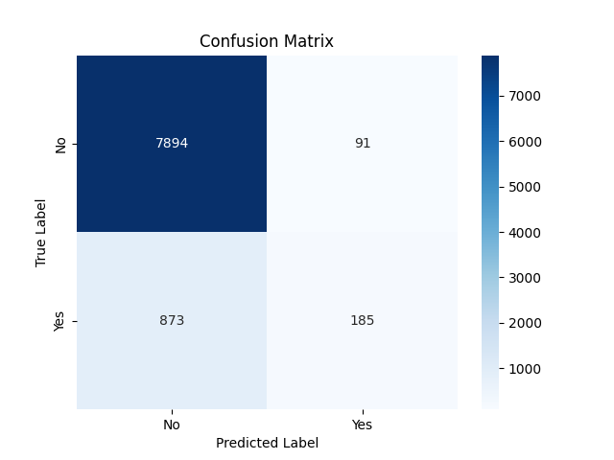
The performance of the library based model was much better than the base ‘from scratch’ MLP in several ways:

 | From Scratch, TH=0.5 | From Scratch, TH=0.23 | SKL MLP
True Negatives (TN) | 7,951 | 7,317 | 7,894
True Positives (TP) | 58 | 383 | 185
False Positives (FP) | 33 | 675 | 91
False Negatives (FN) | 1000 | 667 | 873

In both implementations, the number of both true and false negatives was high. This was expected due to the skewed nature of the input dataset.
The TH=0.5 ‘from scratch’ model is very conservative, predicting ‘no’ in most cases. The number of False Positives is very low, so when it does predict a ‘yes’ you can usually believe it. It misses nearly everyone else, however!
The TH=0.23 model is much better as a marketing tool. It prioritises differently, allowing it to catch many more ‘yes’ results. This has come at the cost of a large increase is False Positives. As mentioned previously, the cost to the bank of calling these people once anyway is low. While there would be more people who say ‘no’, the number of deposits made would be significantly higher.
The SKL model has much better internal optimisation. It found more True Positives than the TH=0.5 model, and also has a low False Positive rate. The ‘from scratch’ models took around a minute of CPU time to train; SKL took only 3 seconds to completely reach this level of prowess. It implements an ‘early stopping’ monitor meaning that 10,000 epochs weren’t needed either. It would likely achieve even better results if tuned to the same 0.23 threshold as the ‘from scratch’ version.
Metric | Custom (TH=0.5) | Custom (TH=0.23) | SKL MLP
Accuracy | 88.58% | 85.16% | 89.35%
Recall | 5.48% | 36.48% | 17.49%
Precision | 63.74% | 36.20% | 67.03%
F1-Score

The SKL MLP achieved the highest overall accuracy. However, in the business context of the dataset, accuracy is not the correct metric to use alone. Even though the SKL model is more accurate it still misses 873 potential subscribers.
The TH=0.23 model is the clear winner wither respect to the bank’s marketing requirements. It improved the Recall Score from a terrible 5.48% to a winning 36.48%. This represents and increase of around 6.5 times in the number of successful responses.
The SKL MLP has the best Precision, meaning the "yes" predictions are the most reliable. However the cost of calling a customer who says "no" (a False Positive) is generally much lower than the value of missing a customer who would have said "yes", so it is not the best model from this perspective.

Advantages and Disadvantages
One disadvantage is that the library does not expose how the validation set is composed, or allow me to graph this as was possible in my own implementation. This reduces visibility of the training process. While early stopping is internally implemented, the inability to plot the validation loss does not allow for the same visual check against over fitting.

Furthermore, as well as having access to the loss calculations, I have complete control over the validation dataset in my model, allowing me to analyse it, including printing it all out if I really wanted to. I can also access the weights and biases at any given time, even during training.

Another disadvantage of the library MLPClassifier is that it includes some rigidity in the implementation. The configured activation function applies to all layers, and cannot be varied across layers. Conversely, the ‘from scratch’ implementation is more modular. It allows for flexibility and experimentation with different activation functions at different levels. I used ReLU for the hidden layer and Sigmoid for the output layer, which is not possible using the library for the network.w

The main disadvantage of using the ‘from scratch’ model is the length of training time. Many thousands of Python loops over matrix calculations are very slow, even though numpy itself is highly optimised internally. The Scikit-Learn library uses C library code in the background and is highly optimised.

Writing a model from scratch gives control, while using a library provides speed, built-in optimisation and and convenience. Developing the model from scratch provided transparency to monitor the impact of class imbalance in the dataset by plotting the validation loss, and by modifying output thresholds accordingly.

Parameter Tuning and Model Optimisation

GridSearchCV
A lot of the optimisation steps applied so far have been adhoc, and based on observation and educated guesses. To move beyond manual trial-and-error changes to settings, GridSearchCV from Scikit-Learn was used to systematically make changes to hyperparameters in the SKL based model.

I have already identified that the accuracy metric is not the best for this dataset, so the optimisation target was set to Recall as this best combats the class imbalance in the target variable.

CV stands for Cross-Validation, which means that the data is rotated to that each row has the chance to be part of the training and validation datasets. I have used cv=3, which defines three ‘folds’ of the data. This means that the model is trained three times, using the data folds as follows:

Training | Validation
1 + 2 | 3
1 + 3 | 2
2 + 3 | 1

This method reduces any errors that might be derived from the data itself, such as the lucky inclusion of ‘easy’ rows which might contain hidden shortcuts to the target variable. An example of such a shortcut would be the duration feature, which was removed entirely during the preprocessing phase.

I defined the following grid of parameters to extensively test different model architectures, learning rates and weight/bias adjustment algorithms:

'hidden_layer_sizes': [(10,), (15,), (10, 5), (15, 5)],
'learning_rate_init': [0.001, 0.01, 0.005, 0.03, 0.05],
'max_iter': [2000, 5000, 10000, 15000, 20000],
'solver': ['sgd', 'adam', 'lbfgs', 'newton-cg']

This is an extensive search grid. To optimize the hyperparameter search, the n_jobs parameter was set to -1 to make python use all the cores in my workstation. By distributing the Grid Search across all CPU cores, the computational time was significantly reduced. This allowed for a more exhaustive search of the parameter grid (comparing different solvers and architectures) than would have been feasible otherwise. Even so, this grid took 14 minutes to run through.

The best parameters were found to be:

'hidden_layer_sizes' = (15, 5)
'learning_rate_init' = 0.05
'max_iter'= 2000
'solver'= 'adam

The grid search revealed that the 'Adam' optimizer and two hidden layers of 15 and 5 neurons provided a more stable descent than the model defined previously. Running the test data through the best model produces the following confusion matrix:

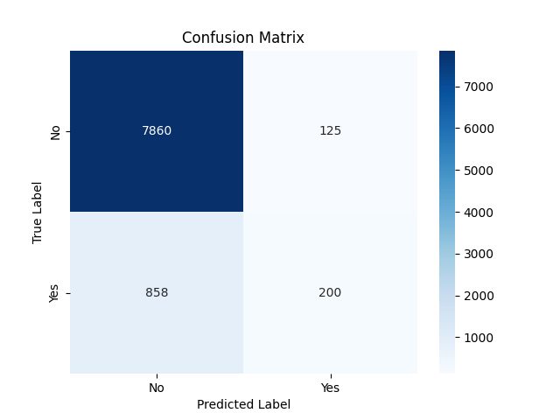
Adding these results to the table:

 | From Scratch, TH=0.5 | From Scratch, TH=0.23 | SKL MLP | Grid Optimum
True Negatives (TN) | 7,951 | 7,317 | 7,894 | 7,860
True Positives (TP) | 58 | 383 | 185 | 200
False Positives (FP) | 33 | 675 | 91 | 125
False Negatives (FN) | 1000 | 667 | 873 | 858

And the metric table is also extended:

Metric | Custom (TH=0.5) | Custom (TH=0.23) | SKL MLP | Grid Optimum
Accuracy | 88.58% | 85.16% | 89.35% | 89.13%
Recall | 5.48% | 36.48% | 17.49% | 18.90%
Precision | 63.74% | 36.20% | 67.03% | 61.54%
F1-Score |  |  |  | 28.92%

A true comparison is best made between the SKL and Grid Search optimised versions as these are based on the same underlying code. There is some improvement in the recall, but not significantly. As expected, there is a trade-off between recall and precision.

Genetic Algorithm Optimisation
I implemented a genetic algorithm version of my ‘from scratch’ MLP class code. In a standard MLP, back propagation using derivatives is used to find the gradient. In the Genetic Algorithm (GA) version the back propagation process was removed and replaced with evolutionary operators.

References:

Deisenroth, M et al. Mathematics for Machine Learning

Smith, G. Introductory Mathematics: Algebra and Analysis

https://www.cognism.com/blog/cold-calling-success-rates

Bishop, C. M. (2006). Pattern Recognition and Machine Learning. Springer.

https://keras.io/getting_started/about/

A Logical Calculus of the Ideas Immanent in Nervous Activity, McCulloch-Pitts

Appendix A – Prolog Rule Code

These are the Prolog rules that were written for this assignment. They require that the network is defined using facts per these examples:

%
% ***** IS-A Facts
%

is_a( melee_weapon, weapon ).
is_a( bladed_hand_weapon, melee_weapon ).
is_a( sword, bladed_hand_weapon ).
...etc...

%
% ***** HAS-A Facts
%

has_a( melee_weapon, effective_against, personnel ).
has_a( bladed_hand_weapon, effective_range, close_quarters ).
has_a( sword, has_part, blade ).
has_a( sword, has_part, hilt ).
has_a( sword, has_part, pommel ).
...etc...

Rules
%
% ***** Generic is_a / has_a Semantic Network Rules
%

% Inheritance Rule - IS-A

% Rule: is_a_member/2

% Base case
is_a_member(Item, Class) :-
is_a(Item, Class).

% Recursive case
is_a_member(Item, Class) :-
is_a(Item, Parent),
is_a_member(Parent, Class).

% Rule: is_a_member_inc_self/2

% Get all parents and append self
is_a_member_inc_self(X, Y) :- X = Y; is_a_member(X, Y).

% Inheritance Rule - HAS-A Properties

% Rule: has_a_property/3

% Base Case
has_a_property(Item, Property, Value) :-
has_a(Item, Property, Value).

% Recursive Case
has_a_property(Item, Property, Value) :-
is_a(Item, Class),
has_a_property(Class, Property, Value),
% Allow overrides by stopping
+ has_a(Item, Property, _).

% Rule: list_all_items/0

% List all items in the network in a pretty way
% Should be functionally the same as `cat prolog_file.pl | grep -e '^is_a(' | cut -f 2 -d "," | tr -d " " | sort -u`
% Also counts the total (equivalent to | wc)

list_all_items :-
get_all_items(List),
length(List, Count),
format('All items defined in the network:~n'),
write('----------------------------------------'), nl,
forall(member(Item, List), format('- ~w~n', [Item])),
nl,
format('Total: ~w~n', [Count]).

% Rule: get_all_items/1

% Get all possible items in the network
% Returns a list

get_all_items(SortedList) :-
%Collect all occurrences of Item from the facts
findall(Item, is_a(Item, _), List),
% Sort this list (deduplicates)
sort(List, SortedList).

% Rule: list_all_attributes/0

% List all possible attributes in the network in a pretty way
% Should be functionally the same as `cat prolog_file.pl | grep -e '^has_a(' | cut -f 2 -d "," | tr -d " " | sort -u`
% Also counts the total (equivalent to | wc)

list_all_attributes :-
get_all_attributes(List),
length(List, Count),
format('All attributes defined in the network:~n'),
write('----------------------------------------'), nl,
forall(member(Attribute, List), format('- ~w~n', [Attribute])),
nl,
format('Total: ~w~n', [Count]).

% Rule: get_all_possible_properties/1

% Get all possible property types in the network
% Returns a list

get_all_attributes(SortedList) :-
%Collect all occurrences of Property (P) from the facts
findall(Attribute, has_a(_, Attribute, _), List),
% Sort this list
sort(List, SortedList).

% Rule: list_properties/1

% Display the output in a pretty way :-)

list_properties(Item) :-
% Collect all A-B pairs into a list
% (https://www.swi-prolog.org/pldoc/man?predicate=findall/3)
findall(A-B, has_a_property(Item, A, B), List),

% Sort this list (https://www.swi-prolog.org/pldoc/man?predicate=sort/2)
sort(List, SortedList),

% Print the output header (https://www.swi-prolog.org/pldoc/man?predicate=format/2)
format('Properties for ~w:~n', [Item]),
write('----------------------------------------'), nl,

% Print each line of output
forall(member(A-B, SortedList), format('- ~w = ~w~n', [A, B])).

% Rule: list_items_with_property/2

% Finds all items that have a specific property-value pair (including inherited).
% Prints out in a pretty manner.

list_items_with_property(Prop, Value) :-
findall(Item, has_a_property(Item, Prop, Value), List),
sort(List, Sorted),
format('Items with Property ~w = ~w:~n', [Prop, Value]),
write('----------------------------------------'), nl,
forall(member(I, Sorted), format('- ~w~n', [I])).

% Rule: show_tree/1

% Draws a nice tree from a given root position
% show_tree(weapon).
%-- weapon
% -- melee_weapon
% -- bladed_hand_weapon
% -- dagger
% -- anelace

% Usage: show_tree(weapon).
show_tree(Root) :-
show_tree(Root, 0).

% Recursive tree
show_tree(Item, Depth) :-
Indent is Depth * 3,
tab(Indent),
format('-- ~w (~w)~n', [Item, Depth]),
NewDepth is Depth + 1,
% Find all children and recursively print them
forall(is_a(Child, Item), show_tree(Child, NewDepth)).

%
% ***** Medieval Weapon Specific Rules
%

% Rule: list_weapons_in_use_year/1

% Finds all weapons used in a specific year and prints Era
list_weapons_in_use_year(Year) :-
% Find all pairs of Item-Era where the Item was active in the given Year
findall(Weapon-Era, (is_in_era(Weapon, Year), has_a_property(Weapon, era_used, Era)), List),
sort(List, Sorted),

format('Weapons active in the year ~w:~n', [Year]),
write('----------------------------------------'), nl,

% Split the Item and Era for formatting
forall(member(I-E, Sorted), format('- ~w (~w)~n', [I, E])).

% Success if Year falls within the Era defined for the Item
is_in_era(Weapon, Year) :-
has_a_property(Weapon, era_used, Era),
check_year(Year, Era).

% Exact match (eg: has_a(almace, era_used, 778))
check_year(Year, Year) :-
number(Year).

% Range match (eg: has_a(arbalest, era_used, (1300, 1500)))
check_year(Year, (Start, End)) :-
Year >= Start,
Year =< End.

% Rule: longer_range/2

% Define Weights
% Higher number = longer range

range_to_weight(long, 3).
range_to_weight(medium, 2).
range_to_weight(short, 1).
range_to_weight(close_quarters, 0).

% Compare two weapons based on range

longer_range(Weapon1, Weapon2) :-
has_a_property(Weapon1, effective_range, Value1),
has_a_property(Weapon2, effective_range, Value2),
% Get weights for each
range_to_weight(Value1, Weight1),
range_to_weight(Value2, Weight2),
% Compare
Weight1 > Weight2.

