|  |  |
| --- | --- |
|  | **G-EMS**  **DB Backup & Recovery**  **(Zmanda Install & Setting)** |

Document history information

| Version | Version  Date | Content | Preparing  person |
| --- | --- | --- | --- |
| 1.0 | 2016/07/22 | The first wirte | Leejaejin |
| 1.1 | 2016/09/01 | Zmanda install & additional manual setting | Leejaejin |
|  |  |  |  |
|  |  |  |  |
|  |  |  |  |
|  |  |  |  |
|  |  |  |  |
|  |  |  |  |
|  |  |  |  |
|  |  |  |  |
|  |  |  |  |

List

1.0 Install 4

1.1 Zmanda site access 4

1.2 Zmanda download version select 5

1.3 Zmanda wget download 6

1.4 RPM install 6

1.5 Zmanda install path & file list 7

1.6 full-backup && increment-backup directory creation & file move 7

1.7 full-backup setting 8

1.8 increment-backup setting 8

1.9 backup setting description 8

2.0 Backup 9

2.1 full-backup run 9

2.2 full-backup 9

2.3 full-backup file information 9

3.0 Recovery 12

3.1 Database drop 12

3.2 Database drop confirm 12

3.3 recovery run 13

3.4 recovery content confirm 13

3.5 Database confirm 13

3.6 put data 14

3.7 increment-backup run 15

3.8 increment-backup run result 15

3.9 increment-backup content 15

3.10 increment-backup log view 15

3.11 full-backup lately recovery 15

3.12 full-backup result confirm 16

3.13 increment-backup recovery 16

3.14 increment-backup result confirm 17

# 1.0 Install

1.1 Zmanda site access

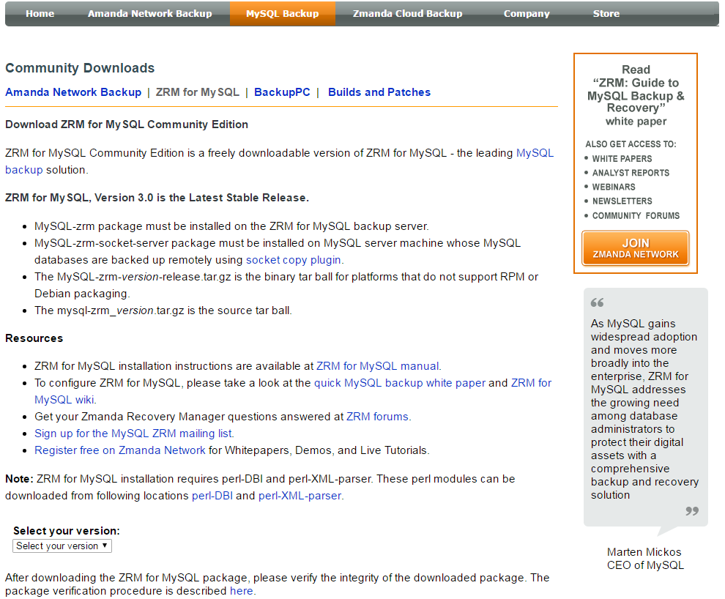

1.2 Zmanda download version select

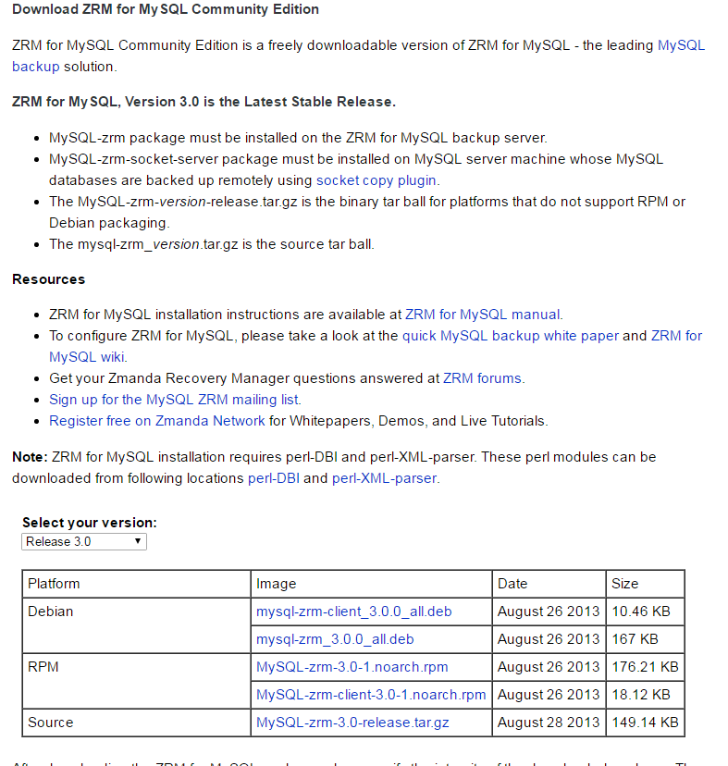

RPM link click & right mouse click & link copy

1.3 Zmanda wget download

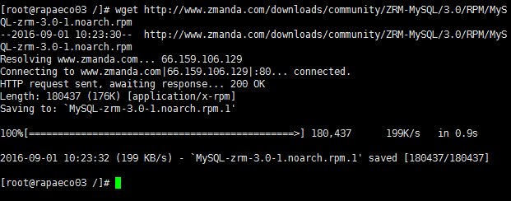

wget http://www.zmanda.com/downloads/community/ZRM-MySQL/3.0/RPM/MySQL-zrm-3.0-1.noarch.rpm

1.4 RPM install

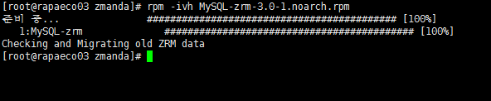

rpm -ivh MySQL-zrm-3.0-1.noarch.rpm

1.5 Zmanda install path & file list

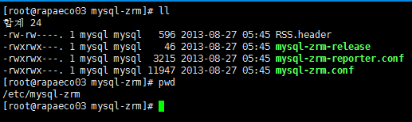

1.6 full-backup && increment-backup directory creation & file move

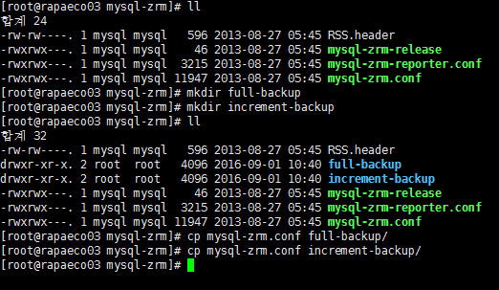

1.7 full-backup setting

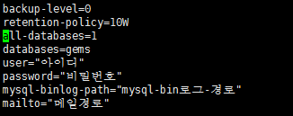

1.8 increment-backup setting

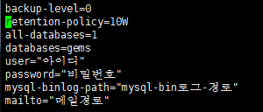

1.9 backup setting description

backup-level=(0 : the whole, 1 : increment)

destination=(backup save path)

retention-policy=(backup delete date)

all-databases=(1 : the whole databases)

databases=(database designate, if this is annotation then the whole databases)

user=(root account or root account with equivalent account creation put)

password=(password)

mysql-binlog-path=(mysql bin log path)

mailto=(mail address)

# 2.0 Backup

2.1 full-backup run

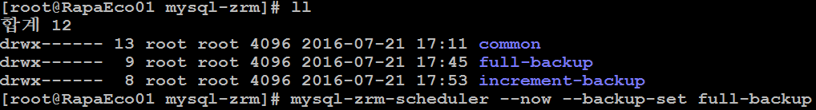

$> mysql-zrm-scheduler --now --backup-set full-backup

2.2 full-backup

- result content, /usr/bin/mysql-zrm started successfully confirm

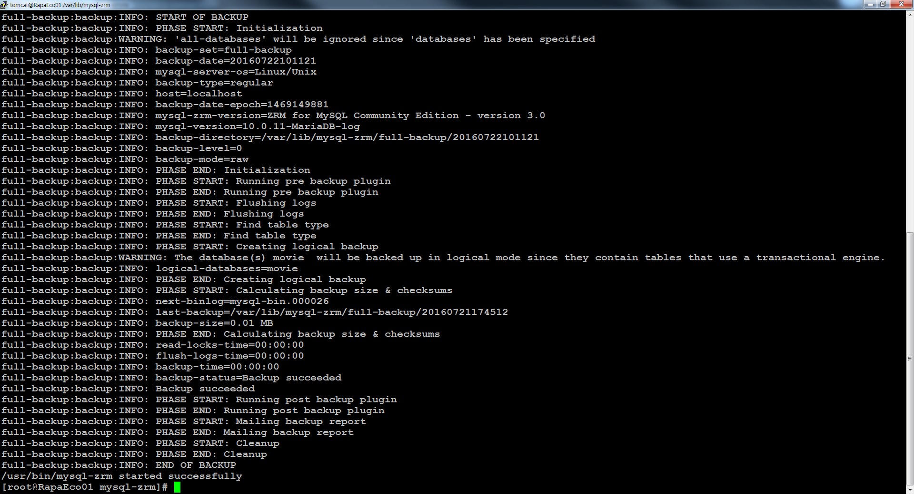

2.3 full-backup file information

* Backup directory creation confirm

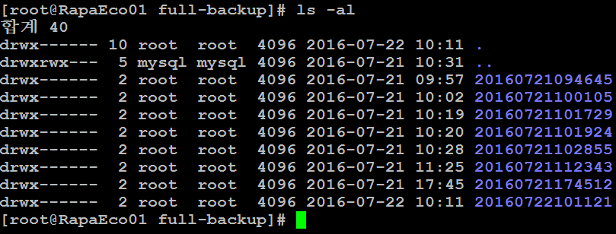

* Backup content confirm

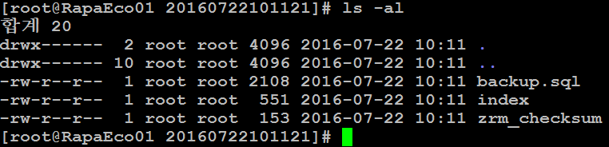

* index information confirm

$> vi index

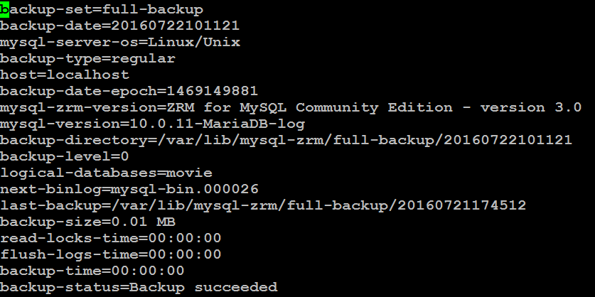

* backup.sql information confirm

$> vi backup.sql

* screen 1

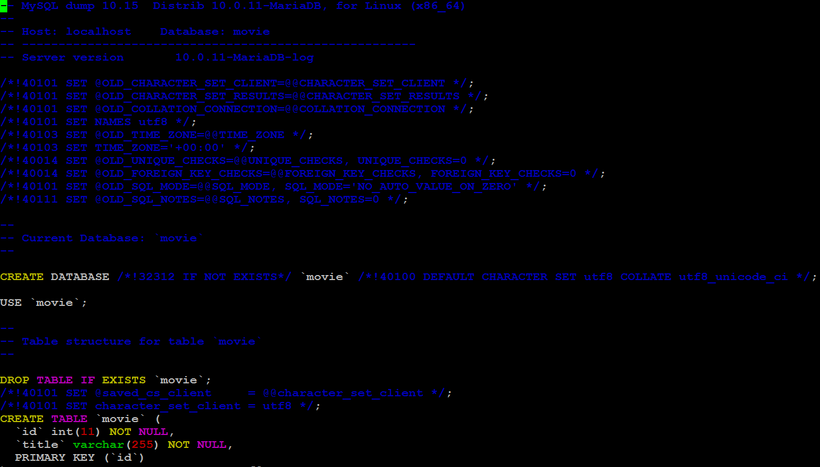

* screen 2

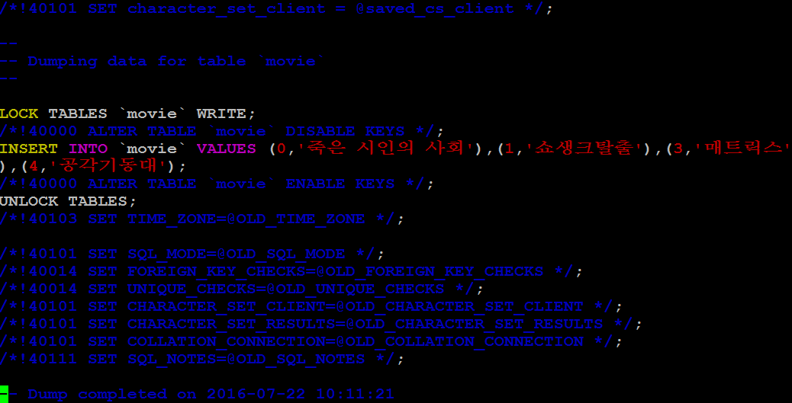

1. Recovery

3.1 Database drop

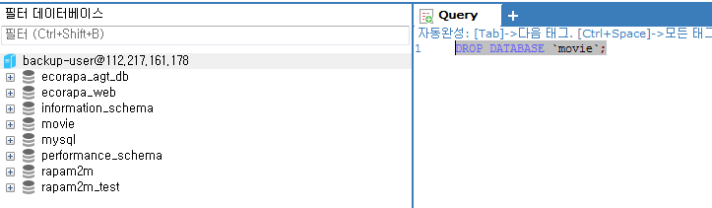

3.2 Database drop confirm

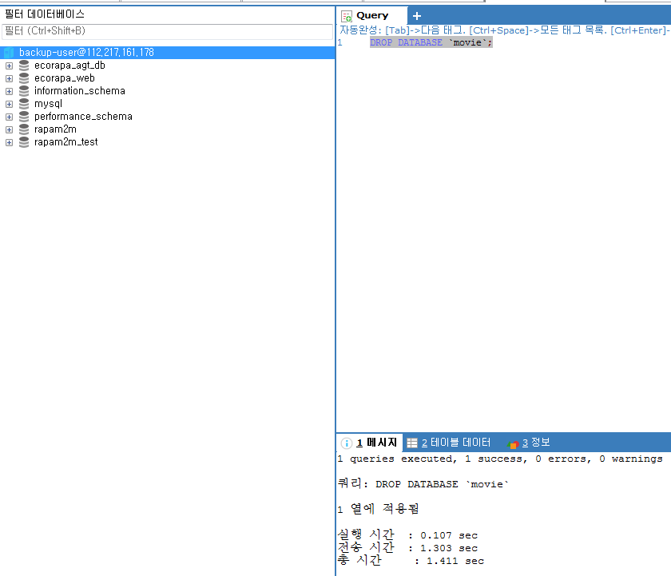

3.3 recovery run

$> mysql-zrm --action restore --backup-set full-backup --source-directory /var/lib/mysql-zrm/full-backup/20160722101121



3.4 recovery content confirm

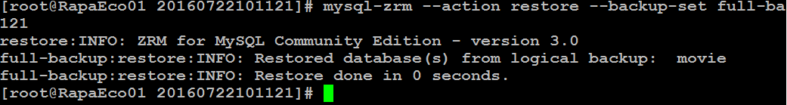

3.5 Database confirm

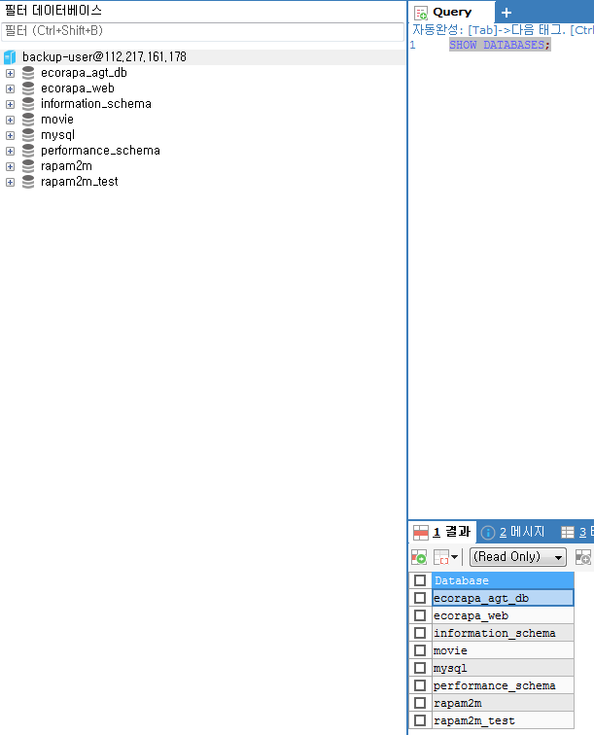

3.6 put data

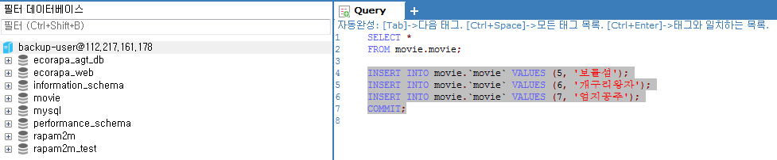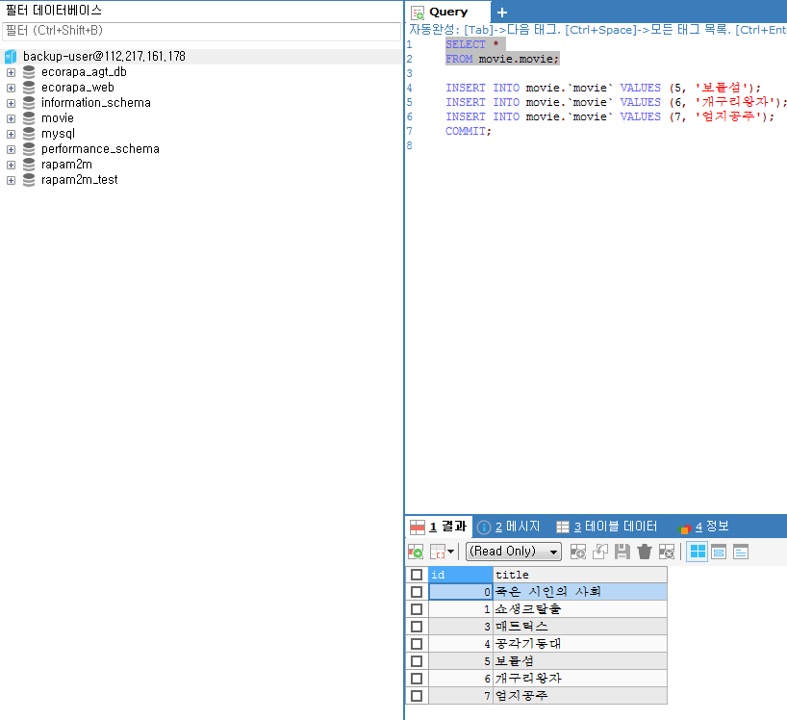

3.7 increment-backup run



3.8 increment-backup run result

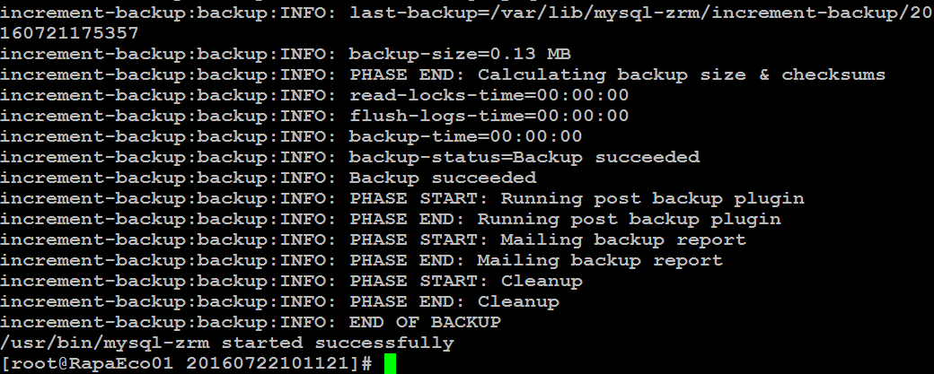

3.9 increment-backup content

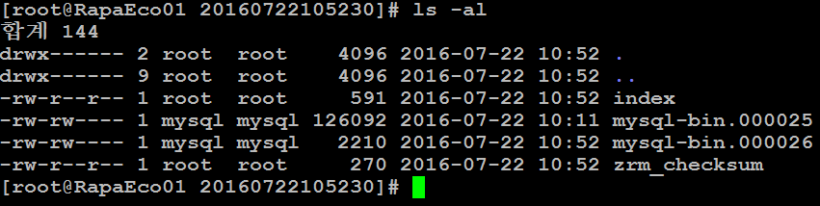

3.10 increment-backup log view

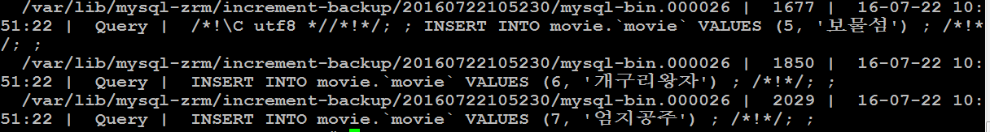

3.11 full-backup lately recovery



3.12 full-backup result confirm

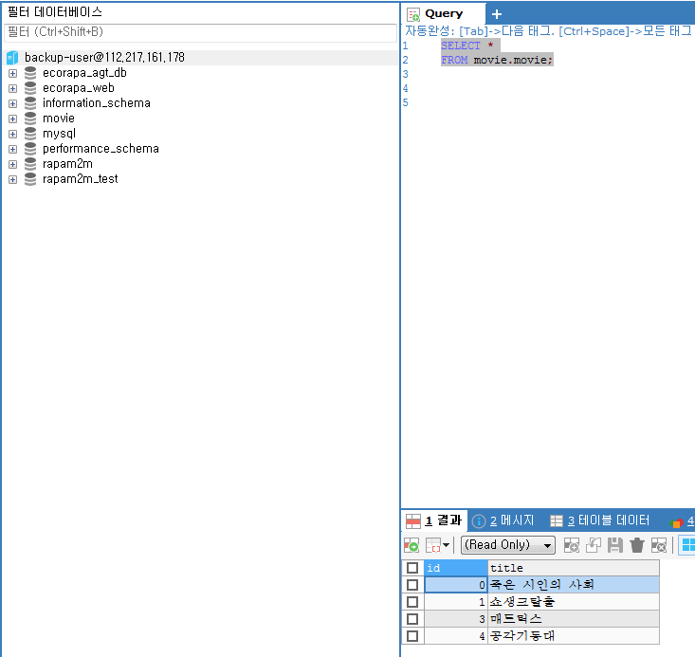

3.13 increment-backup recovery

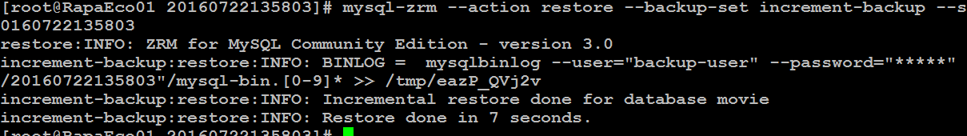

3.14 increment-backup result confirm

