**Third Assignment (1st Exercise)**

**Yogi Bear**

Yogi Bear wants to collect all the picnic baskets in the forest of the Yellowstone National Park. This park contains mountains and trees, which are obstacles for Yogi. Besides the obstacles, there are rangers, who make it harder for Yogi to collect the baskets. Rangers can move only horizontally or vertically in the park. If a ranger gets too close (one unit distance) to Yogi, then Yogi loses one life. (It is up to you to define the unit, but it should be at least that wide, as the sprite of Yogi.) If Yogi still has at least one life from the original three, then he spawns at the entrance of the park.

During the adventures of Yogi, the game counts the number of picnic baskets, which Yogi collected. If all the baskets are collected, then load a new game level, or generate one. If Yogi loses all his lives, then show a popup message box, where the player can type his name and save it to the database. Create a menu item, which displays a high score table of the players for the 10 best scores. Also, create a menu item which restarts the game.

**Connections between the events and event handlers**

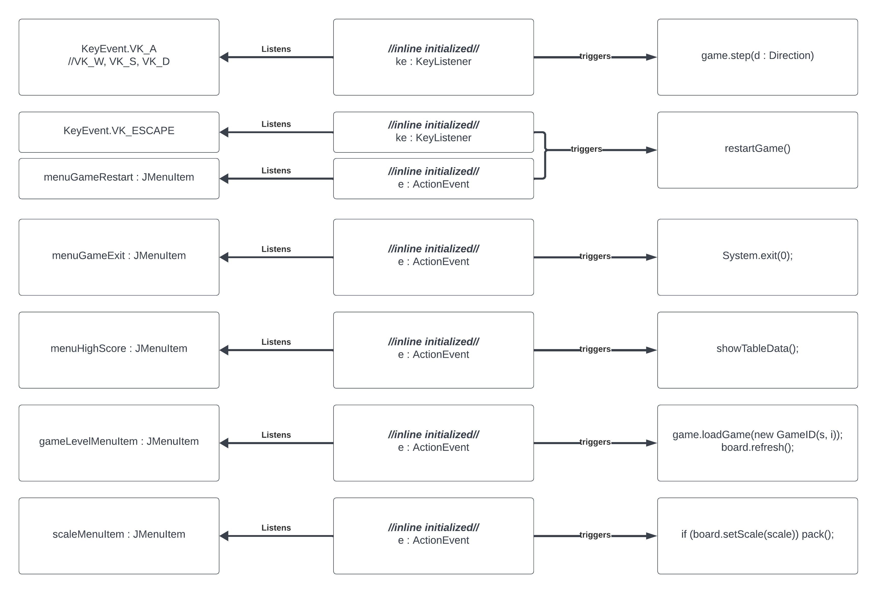

**UML Diagram**

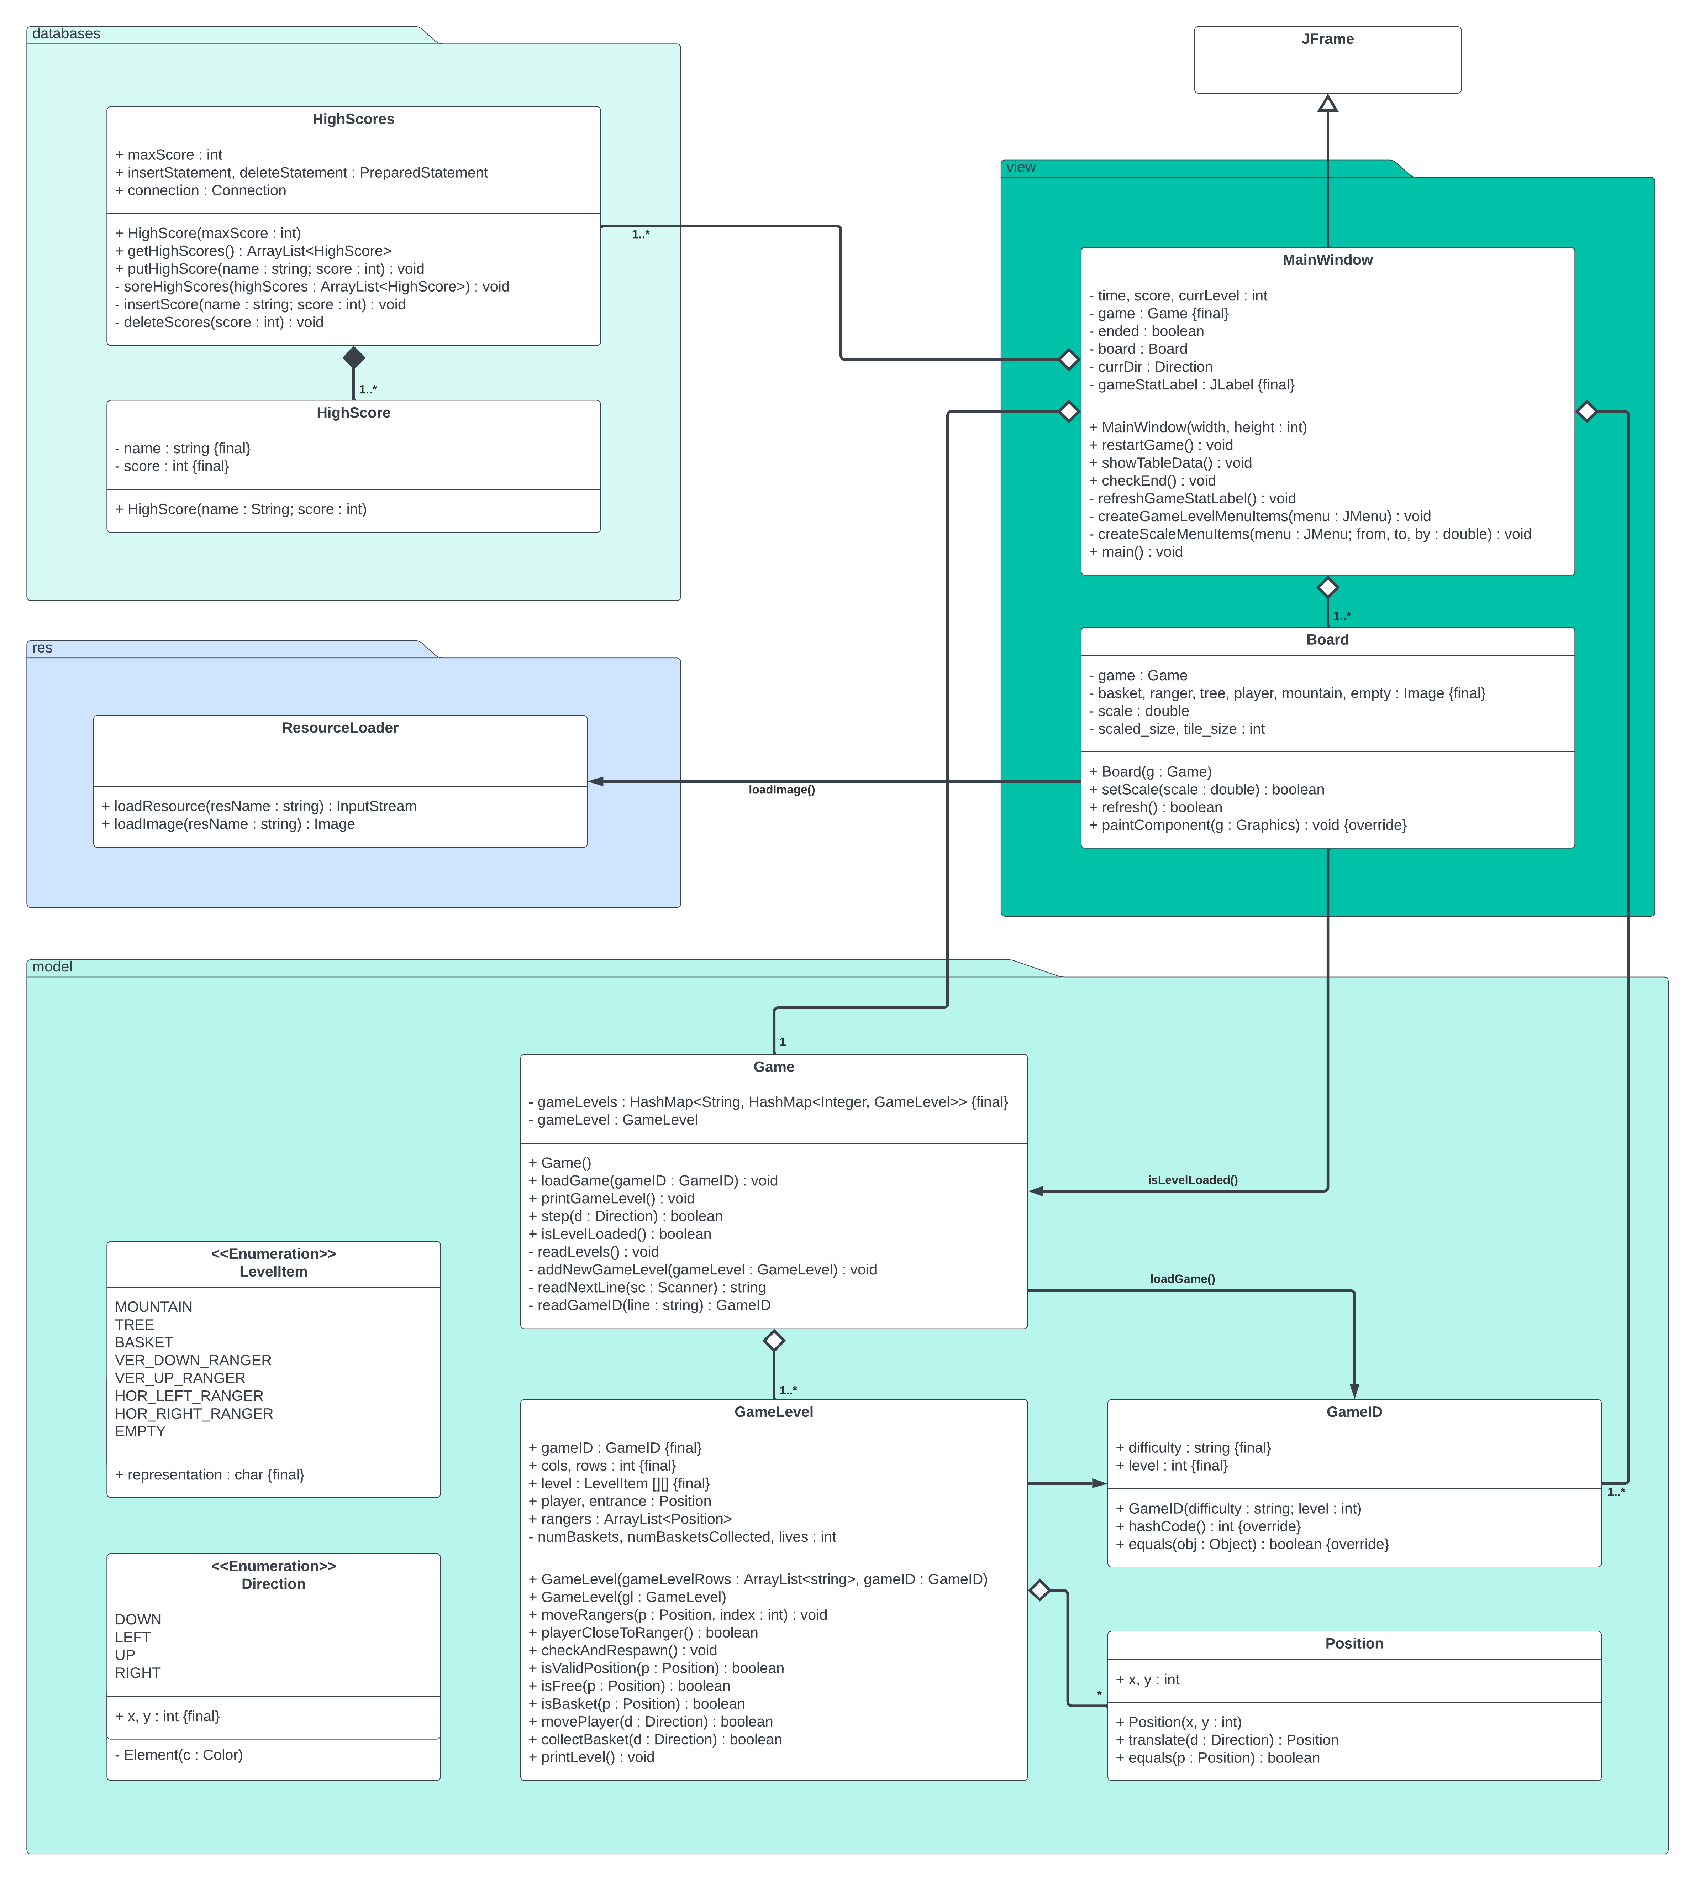

**Test Cases**

1. **Case:** Movement in every direction.   
   **Expectation**: Yogi can move in every direction unless there is no obstacle (tree, mountain), nor rangers.
2. **Case:** Different sized boards for every level.   
   **Expectation**: Board should adjust to every level and scale whenever other level is loaded.
3. **Case:** Win a level.   
   **Expectation**: You win a level whenever you manage to collect all the baskets, a congratulations message is shown, and the game continues to the next level.
4. **Case:** Win the last level.   
   **Expectation**: a congratulation message is shown, and a dialogue asking for the name to put in the high scores table.
5. **Case:** Yogi is standing or moving in a position to which some ranger is coming, or already have a ranger in it.

**Expectation**: when the ranger gets too close, Yogi loses one of his lives and go back to the entrance.

1. **Case:** Yogi loses all his 3 lives.  
   **Expectation**: A game over message is shown, and a dialogue asking for the name to put in the high scores table.