Introduction to Data Analytics
Assignment 3 Kaung Khant Kyaw
14447837

Data Mining Problem 2
Input 2
Output 2
Goal 2
Data Pre-Processing 3
Rule-based row Filter 4
Missing Value 4
Duplicate row filter 5
Numeric Outliers 5
Column Filter 7
Normalizer 7
Rule engine 8
Smote 8
Partitioning 9
Classifiers & Explanations 9
All predictors 9
Decision Tree 10
SVM Learner 12
Tree ensemble Learner 14
PNN learner 16
Naive Bayes Learner 17
KNN 17
Random Forest Learner 17
Best Classifier 17

Data Mining Problem

This assignment mainly focuses on data training and model optimization. This assignment required me to predict previous data by using and modifying classifiers as a data scientist in a company. I used KNIME software as a tool to see the dataset and use models in the tool to finish this assignment.

Input

The dataset given is about National Basketball Association players and their stats to train a model that can predict if they will be playing in the next 5 years future.

Output

The problem is that the data given includes some negative values as well as outliers, and since negative values are unstable to predict a model, we would have to pre-process this data first before training a model to predict. We also had to remove the outliers too.

Goal
The goal of this assessment is to demonstrate the ability to preprocess a dataset, train a predictive model, and optimize the classifier for predicting future outcomes. Identify and handle negative values in the dataset, ensuring the data is suitable for training a predictive model. Detect and remove outliers that could skew the model's performance. Utilize KNIME software to train a model on the preprocessed dataset. Experiment with various classifiers to determine the best fit for the data. Modify and fine-tune the selected classifier(s) to improve prediction accuracy. Evaluate the performance of the model using appropriate metrics. Use the trained and optimized model to predict whether NBA players will be playing in the next 5 years based on their stats.

Data Pre-Processing

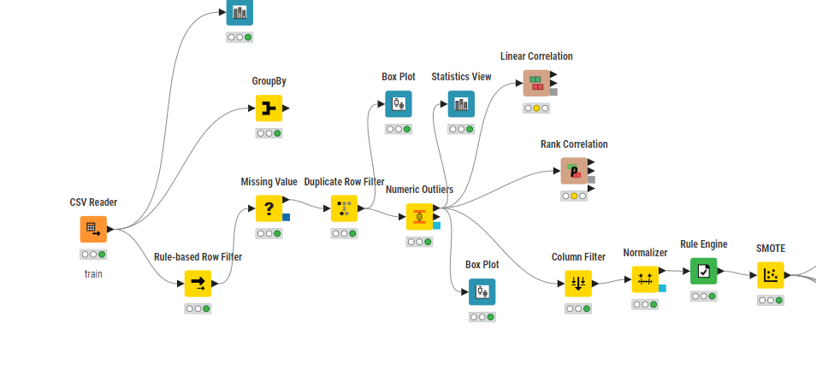CSV reader

Input the dataset given as a csv file type which is train.csv.

Rule-based row Filter
Filter out the negative values since they are unstable when building a model.
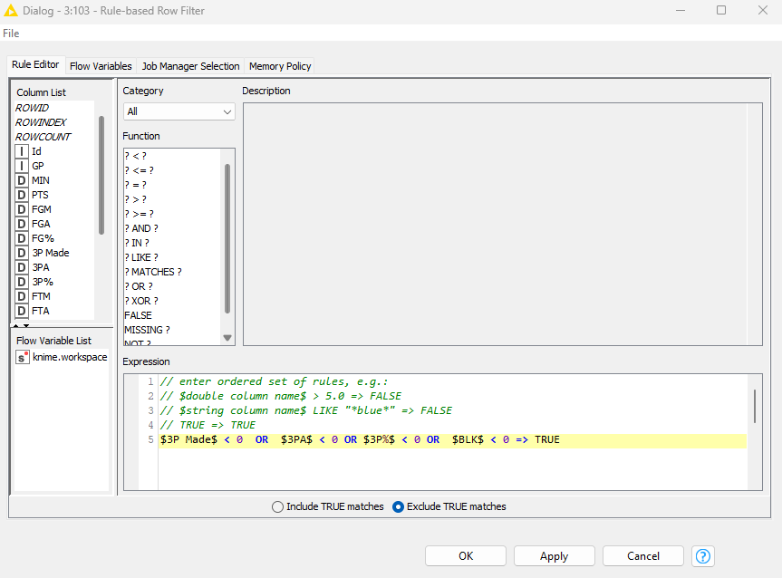

Missing Value
Even though, there were not any missing values, I set the missing values to the mean values just in case there is one and I could not find it.


Duplicate row filter
This node is for checking if there were any duplicate rows in the dataset, luckily there were not any, so I did not have to deal with it.
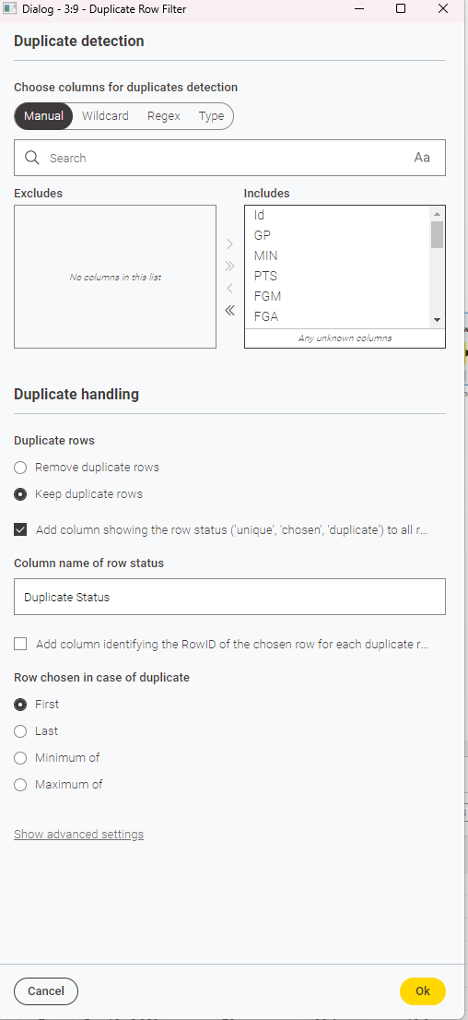

Numeric Outliers
I also used box plot to check the outliers before and after using numeric outliers which is used to replace the outlier values.
Box plot before using this node
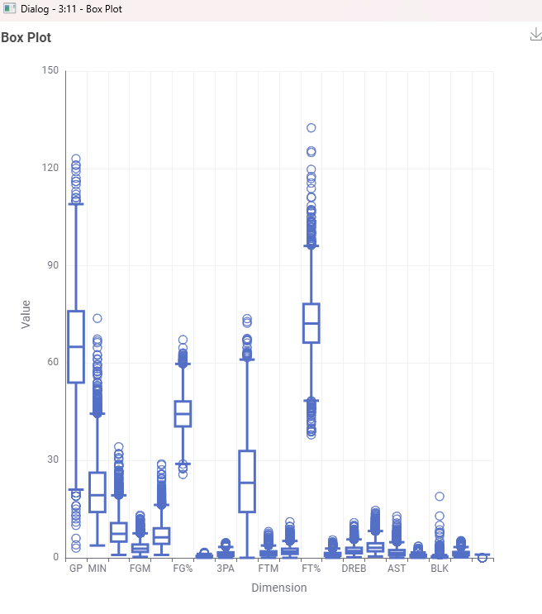
Numeric Outliers
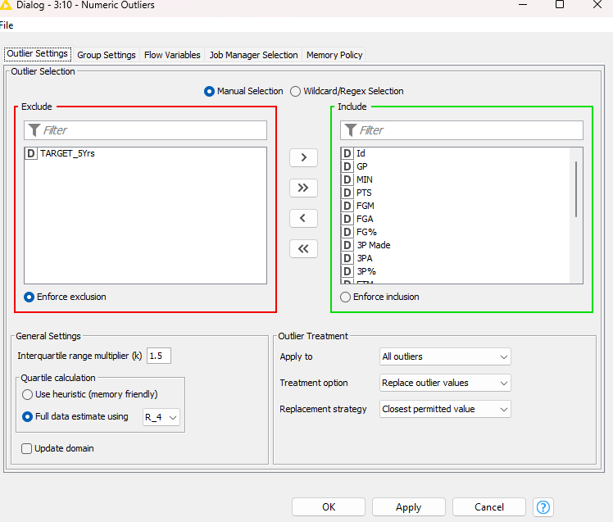

After using Numeric Outliers
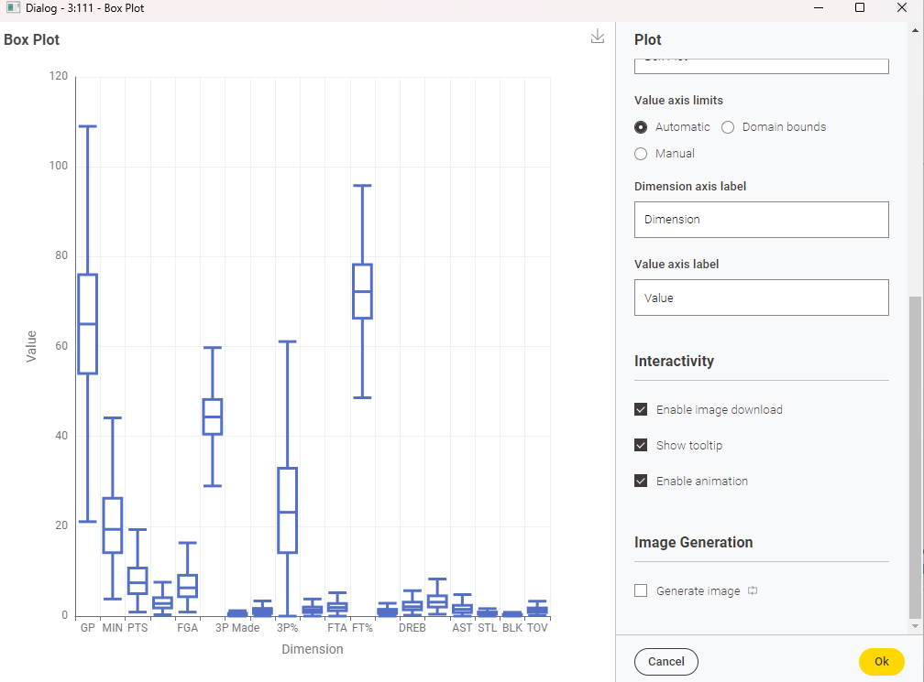

Column Filter
In the column filter, I filtered out the player’s ID. And the new duplicate status that is used to check if the row is duplicated or not.
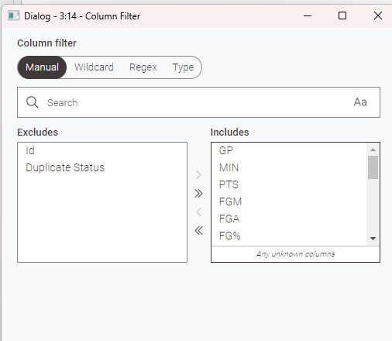

Normalizer
I normalized all the values except TARGET_5Yrs column to 0.0-1.0 ratio.
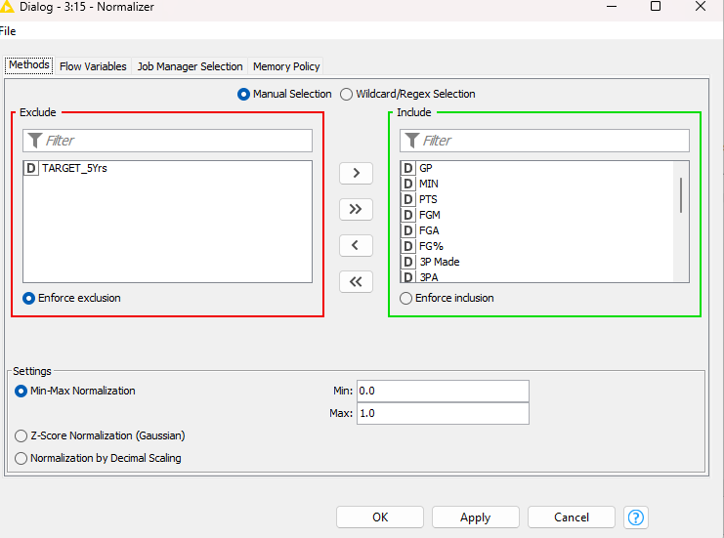

Rule engine
I used rule-engine to change my TARGET_5Yrs values (1,0) to (True,False) and nominal data type for the client to understand clearly and nominal for future modelling.
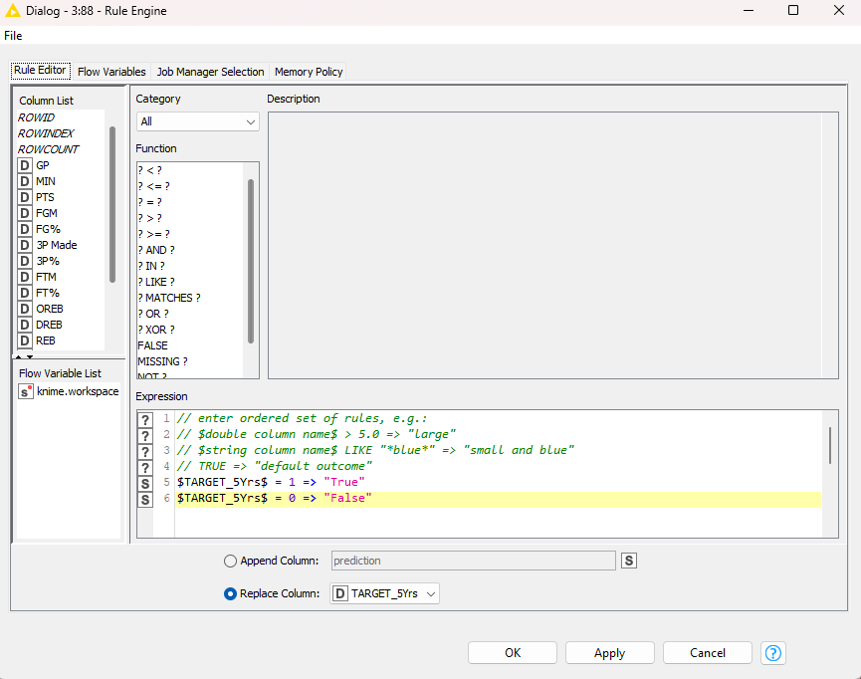

Smote
SMOTE (Synthetic Minority Over-sampling Technique) is used to oversample the input data to enrich the training data.
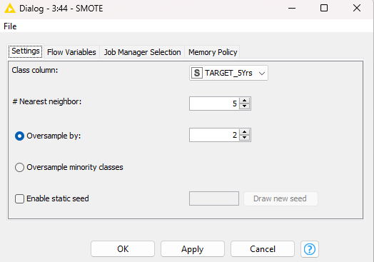

Partitioning
All the partitioning done in this model are 70 percent relative.
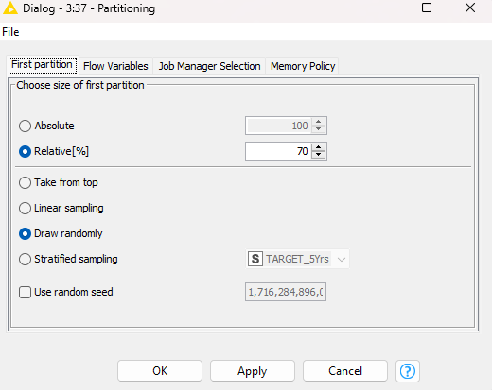

Linear and Rank Correlation
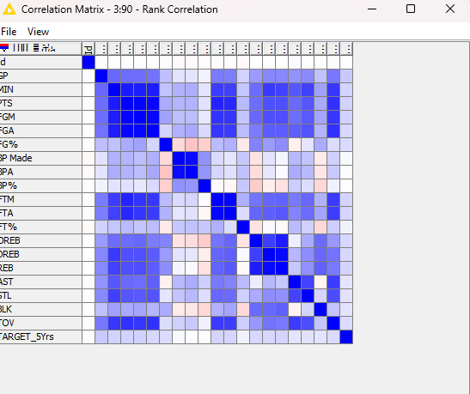
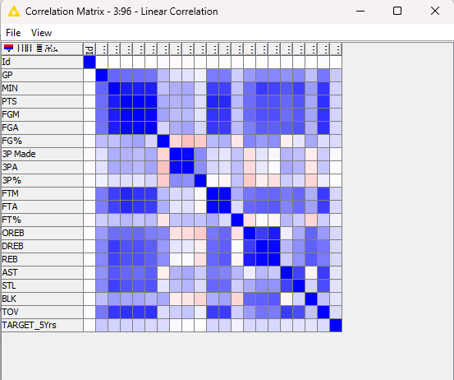

This matrix provides a quick overview of how pairs of variables are related, helping identify important relationships that might warrant further investigation or consideration in predictive models

Classifiers & Explanations

All predictors
I append a new column with a normalized class distribution to be able to see newly predicted columns in the ROC curve. This applies to all predictors used in this assessment.
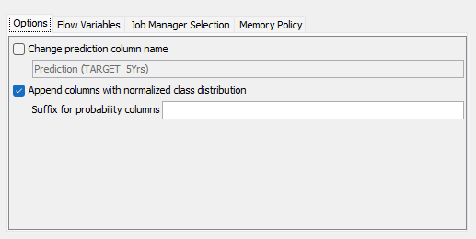

Decision Tree
This classifier worked and the data is predicted into structure trees. This is effective for noisy data and can handle both numerical and categorical data making it versatile.
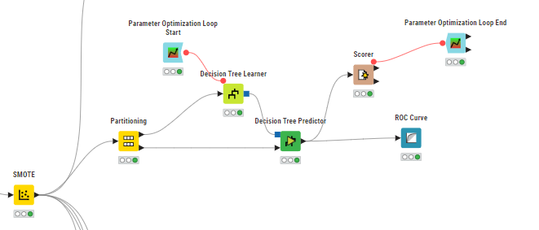
I used parameter optimization loop to adjust the parameter for the learner to have the highest accuracy for the score.
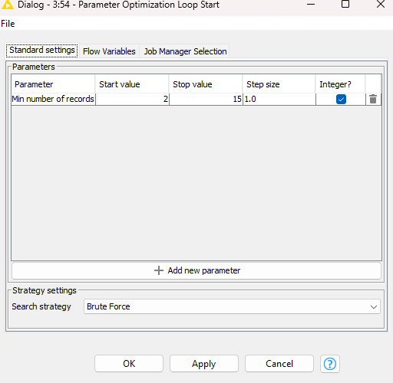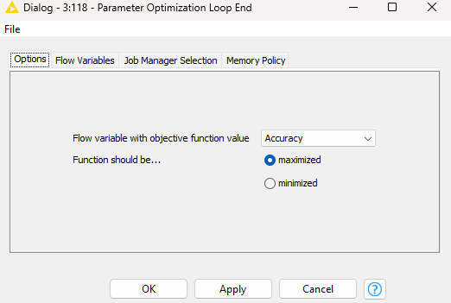

The loop shows that the accuracy would be the highest if the minimum number of records per node is 2, so I adjusted the node to 2 and resulted in the best accuracy possible for this classifier.
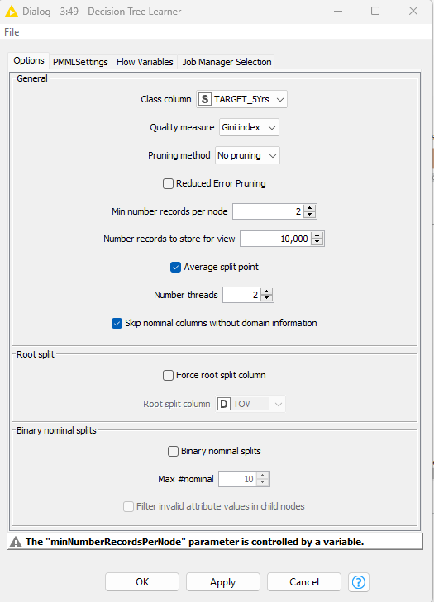

Here is the accuracy of the classifier
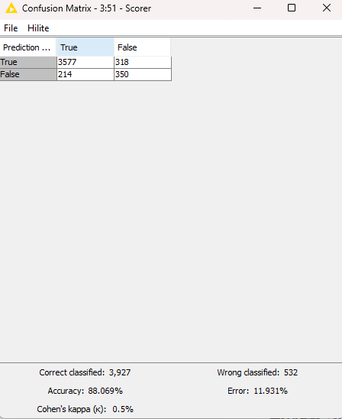
ROC Curve
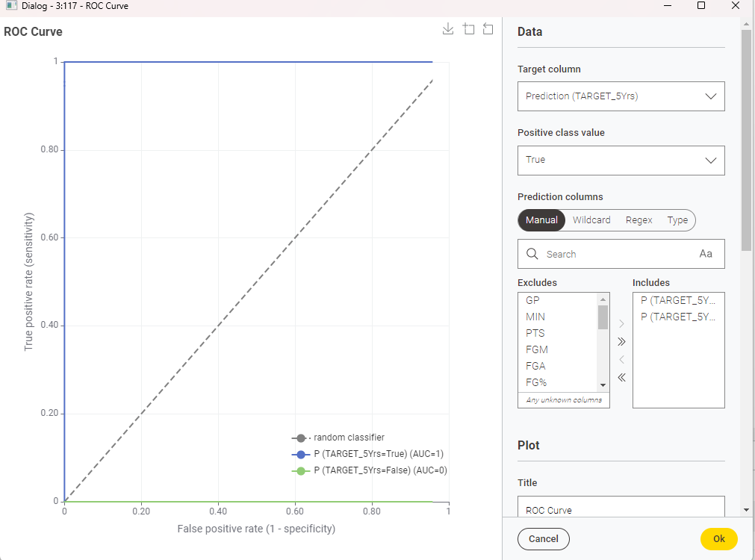

SVM Learner
Just as Decision Tree Learner, I used parameter optimization loop to adjust the polynomial variables to get the most accurate result possible.
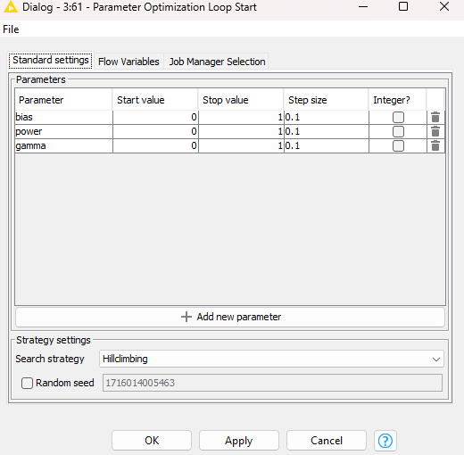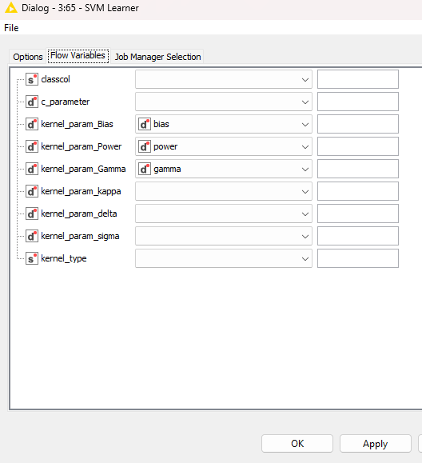
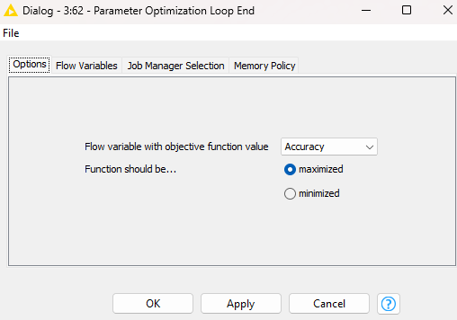

Using this finds the variables input for the best accuracy and, the settings of SVM learner are
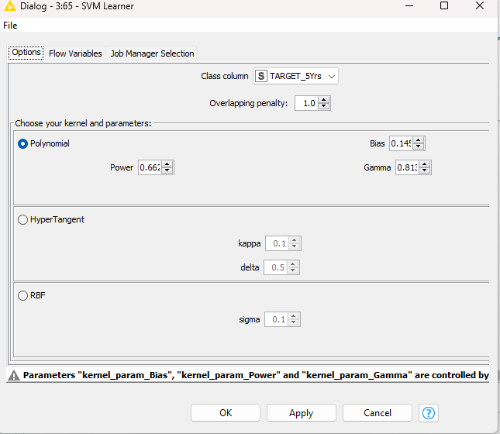
The score of this classifier is
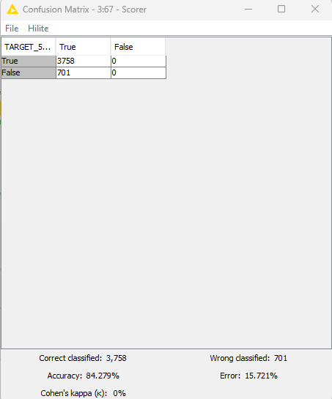

Tree ensemble Learner
As there are no changeable parameters in Tree ensemble learner, I used the default settings for the learner.
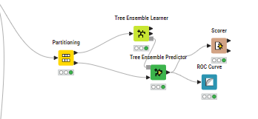
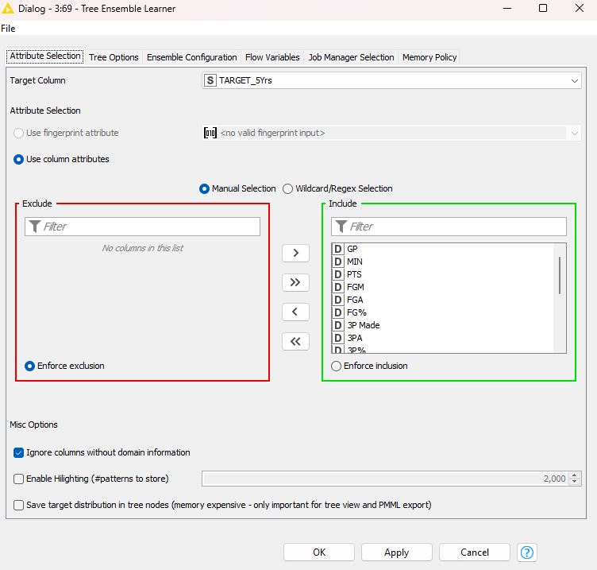

The score of this classifier is
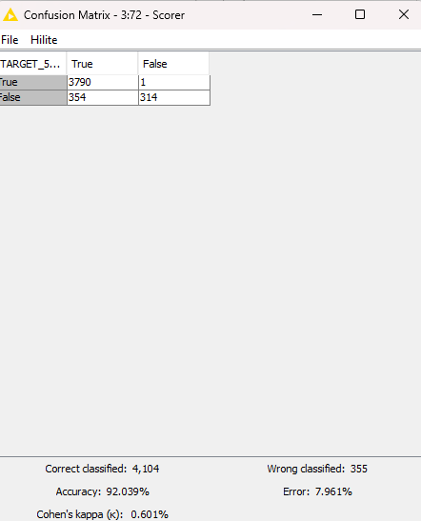
ROC curve
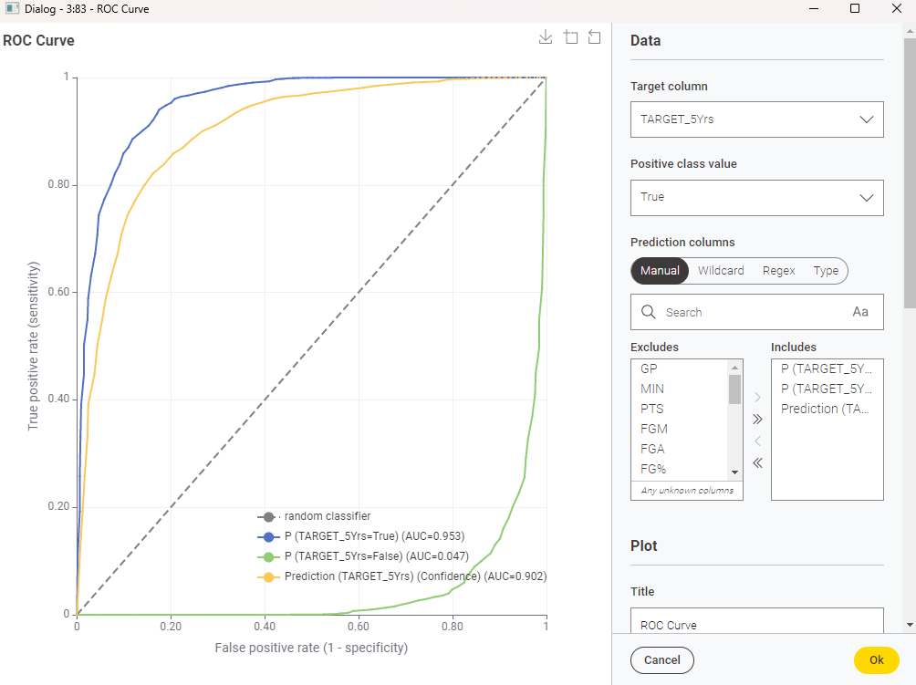

PNN learner

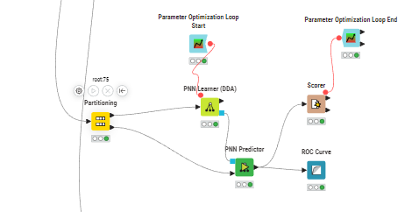
In the PNN learner, I used parameter optimization loop to find out the best possible accuracy, I made a variable for the maximum no of epochs. And the other settings are default

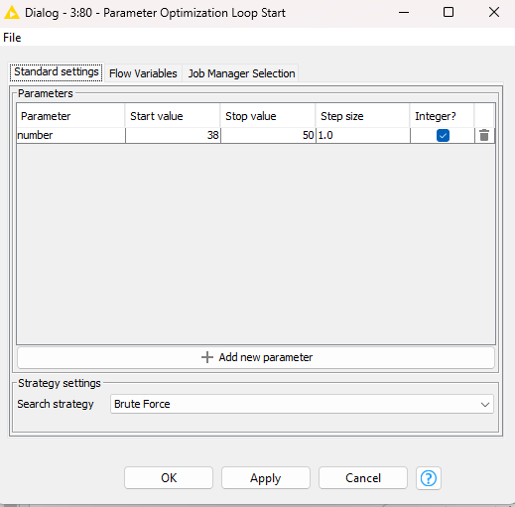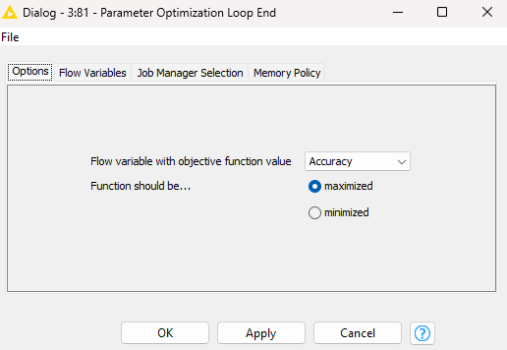

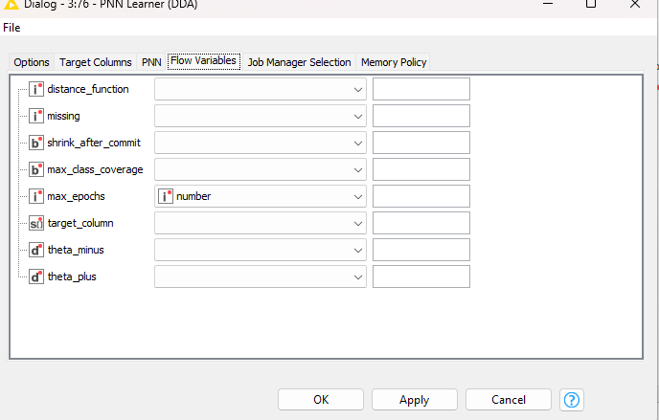
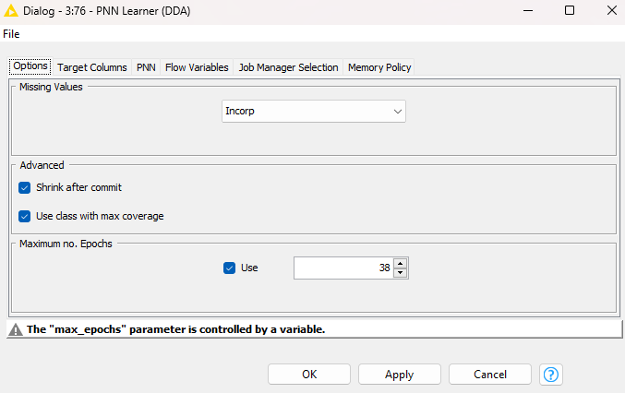
The score of the classifier is as follows

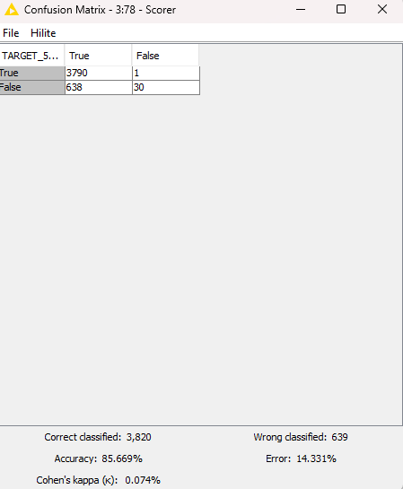

ROC curve
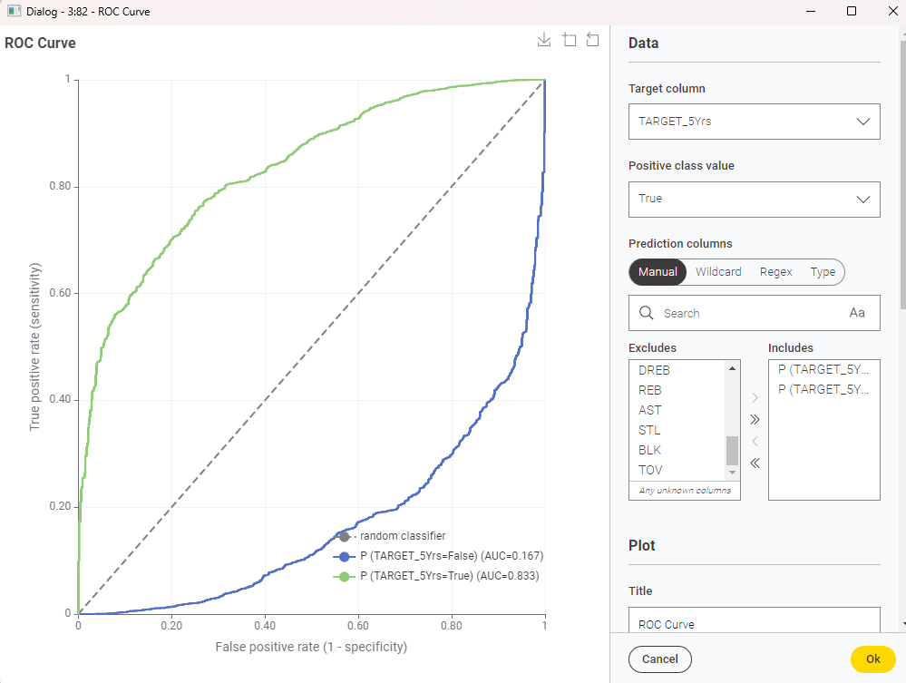

Naive Bayes Learner
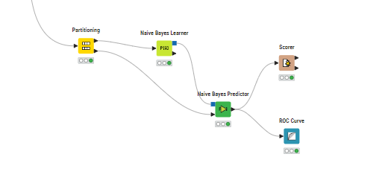
Naive Bayes Learner with the default settings

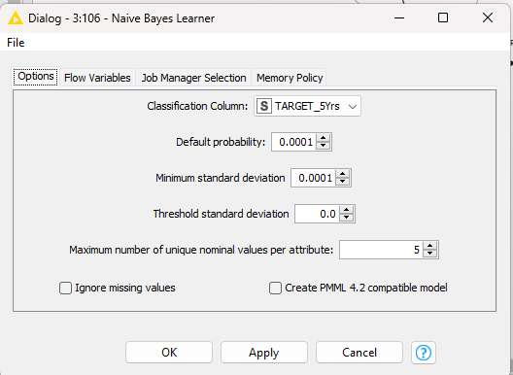

The score of Naive Bayes Learner
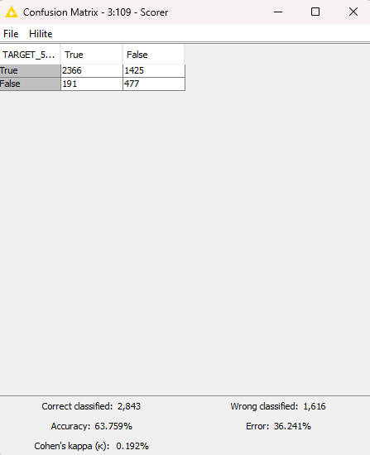
ROC curve
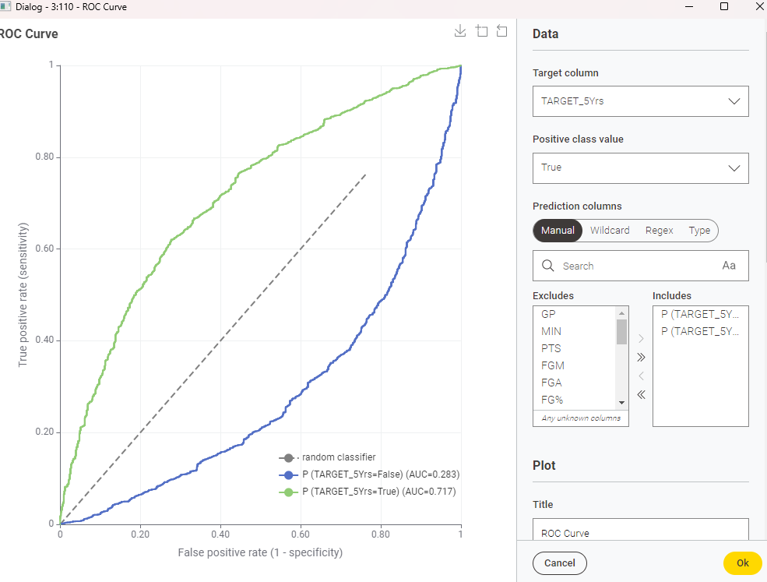

KNN
In the KNN classifier, I used Bootstrap Sampling node before partitioning, and X- partitioner for the partitioning node.
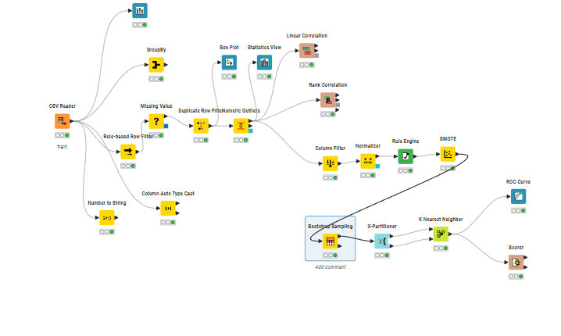
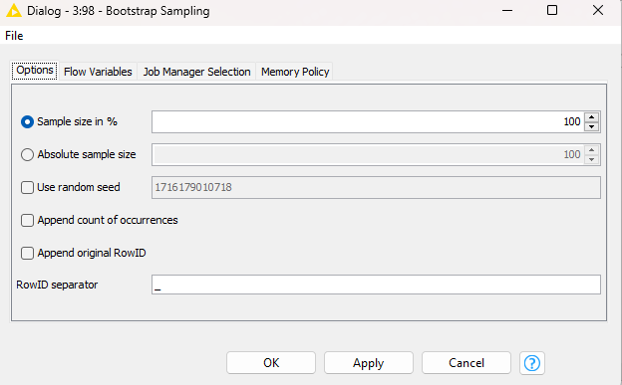

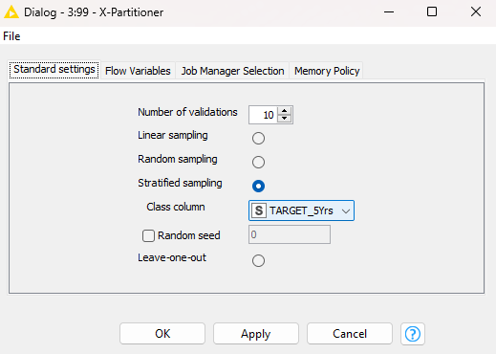
IN KNN, I used k value 4 so that it gives the higher accuracy than the default settings.
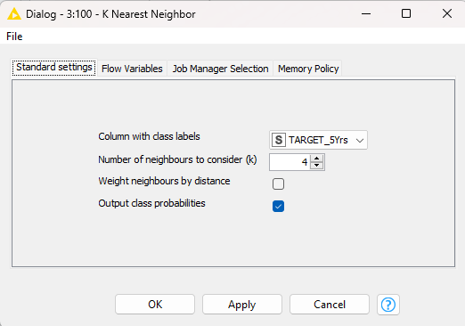

Here is the score of the classifier

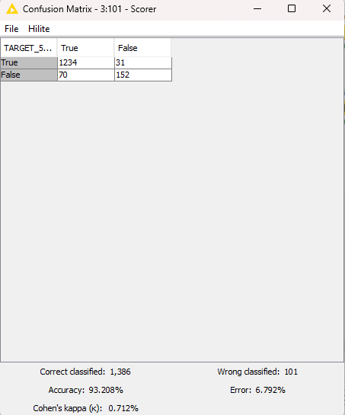

ROC curve
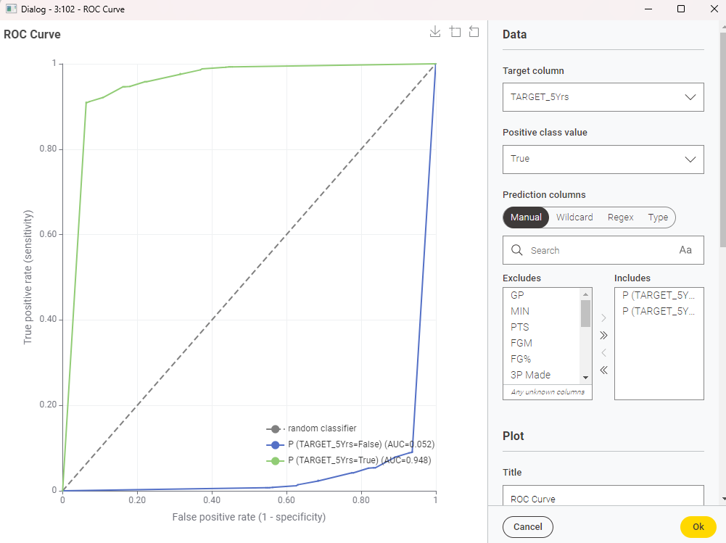

Random Forest Learner
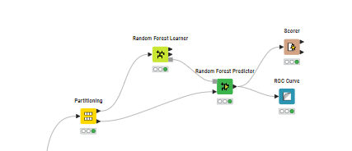
I used random forest learner default settings
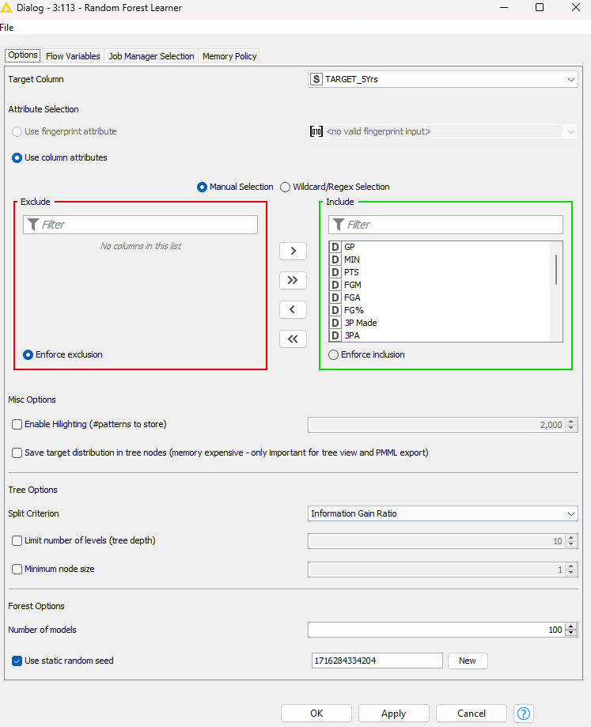

The score of this classifier is
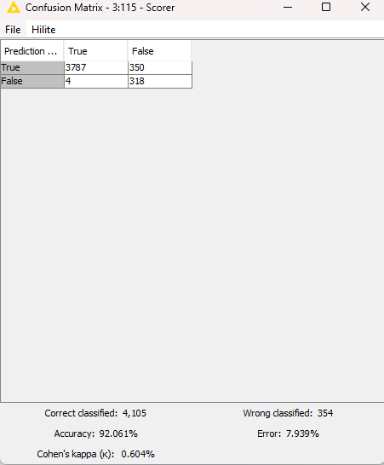

ROC Curve
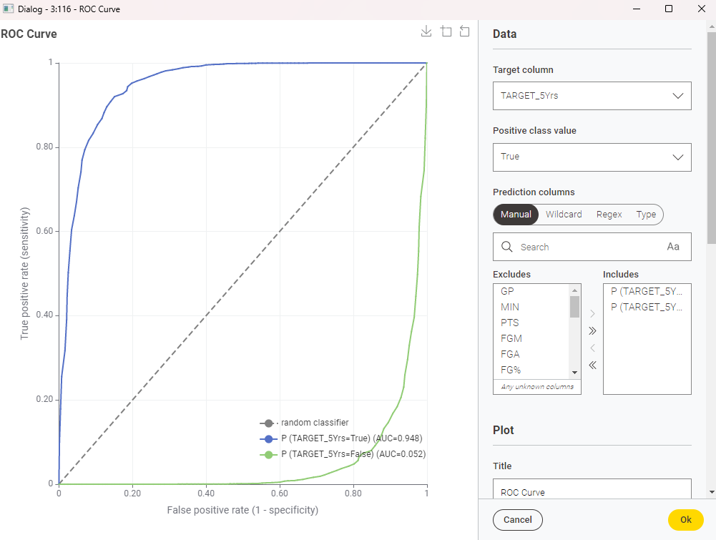

Best Classifier

 | Accuracy | Recall | Precision | F1 score
SVM | 84.279 | 1 | 1
Decision Tree | 88.069 | 0.9183 | 0.9435 | 0.9307
PNN | 85.669 | 0.8559 | 0.9997 | 0.9222
Naive Bayes | 63.759 | 0.9253 | 0.6241 | 0.7454
KNN | 93.208 | 0.9463 | 0.9754 | 0.9606
Tree Ensemble | 92.039 | 0.9145 | 0.9997 | 0.9952
Random Forest | 92.061 | 0.9989 | 0.9153 | 0.9552

With the metrics resulted, its accuracy, recall and precision is high on Tree Ensemble, also F1 score of Tree Ensemble is high.
Random Forest builds multiple decision trees (bagging) and combines their predictions. Each tree is trained on a random subset of features and instances.
Random Forest is robust, handles noisy data, and avoids overfitting. Its high precision suggests it’s good at minimizing false positives.

