CPE 314 — Software Design
University of Cebu
Computer Engineering Department

Trivia & Quiz Night Manager
Project Design Document

Group Name / No.: | 2
Members: | Justine Cuizon
 | Clarence Philip Elegino
 | Joshua Malaya
 | Gebrielle Mirasol
 | John Daevin Simbajon
Instructor: | Richyll Son
Term: | First Semester, S.Y. 2026-2027
Document Version / Date: | V0.1

Table of Contents

(Right-click anywhere in this box and choose "Update Field" -- or press F9 -- after finishing the document, to generate the real table of contents.)
Right-click and select "Update Field" to generate the Table of Contents.

Revision History

Update this table each week as your team adds or revises sections of this document.
Version | Date | Author | Changes
0.1 | 10/24/26 | Group 2 | Initial draft — Week 8 sections
0.2 |  |  | Week 9 sections added
0.3 |  |  | Week 10 sections added
1.0 |  |  | Final compilation and polish — Week 11

Formatting Guidelines

Follow these formatting rules consistently throughout the document so the final compiled version reads as one polished deliverable, not four stitched-together drafts.
Element | Rule
Body font | Calibri, 11pt (the default font of this template — do not mix fonts)
Headings | Use Word's built-in Heading 1/2/3 styles (already applied to every section title below) — this is required for the Table of Contents field to work
Margins | 1 inch on all sides
Line spacing | 1.15–1.5 line spacing for body paragraphs; singlespacing inside tables
Table captions | Label every table "Table N: short description" directly ABOVE the table, numbered sequentially from Table 1 through the end of the document
Figure/chart captions | Label every chart/screenshot "Figure N: short description" directly BELOW the figure, numbered sequentially from Figure 1
Code snippets | Use a monospace font (Consolas or Courier New), 9–  10pt, and keep each snippet under ~20 lines — link to the full file in your repository instead of pasting it all
Page numbers | Already automatic — every page footer includes a live page number field
Alignment | Body text left-aligned/justified; headings left-aligned; do not center body paragraphs

1. Introduction & Project Overview

Describe what your app does, who it's for, and which theme (or custom idea) your group chose. Summarize the problem being solved and the app's key value proposition in 2-4 sentences. This section is first drafted in Week 8 and should need only light editing later.
- Trivia & Quiz Game Night Manager is a Java desktop application that helps friends, classmates, and community groups organize and run trivia nights. Players enter their names, choose a category, and answer questions fetched live from the Open Trivia Database, with an “undo last answer” option for mistakes. Every player, game session, and score is saved in a local SQLite database, and past score history can be imported from CSV files. The app then analyzes the saved results and shows average score per category, most-missed questions, and score trends over time as labeled bar and line charts.
Theme: Custom idea (an entertainment and social-gaming tool for trivia nights).

Problem solved: Quiz hosts usually keep score on paper or in scattered spreadsheets, so results are easy to lose and hard to compare from one night to the next.

Key value proposition: One app that fetches questions, scores each player, stores the history, and turns it into clear charts, so groups can see who is improving and which categories are hardest.

2. Preliminary ER Sketch & Team Roles

Insert the preliminary entity-relationship sketch from your Week 8 proposal — entities, key attributes, and at least one relationship — and list every team member's name and primary role. This is a rough draft; it will be superseded by the finalized ERD in Section 4.
Entities and key attributes
- Category(id, name, parent_id FK → Category.id)
- Player(id, name)
- Question(id, text, correct_answer, incorrect_answers, difficulty, category_id FK)
- GameSession(id, played_at)
- Score(id, session_id FK, player_id FK, category_id FK, question_id FK (nullable), is_correct, points)
Relationships
Category --1:M--> Category (parent_id: a category has many subcategories)
Category --1:M--> Question (Question.category_id)
Category --1:M--> Score (Score.category_id)
Question --1:M--> Score (Score.question_id, optional for imported CSV rows)
Player(id, name) --1:M--> Score(id, session_id FK, player_id FK, category_id FK, question_id FK, is_correct, points) <--M:1-- GameSession(id, played_at)
Score resolves the many-to-many relationship between Player and GameSession: a player joins many sessions, and a session has many players.
Table 1: Team members and primary roles
Member | Primary Role
John Daevin S. Simbajon | Team Leader: project structure, schema, GitHub repo and branch rules, JavaFX MainApp shell, pull request reviews
Gebrielle P. Mirasol | Model: abstract Question class, ScienceQuestion, HistoryQuestion, EntertainmentQuestion, plus Player and Category
Justine B. Cuizon | Database and API: Database class, DAO classes (PreparedStatement), Open Trivia Database client and JSON parsing
Clarence Philip A. Elegino | Game Logic: GameEngine (Queue for questions, Stack for undo), recursive category-tree method, JUnit tests
Joshua Malaya | Analytics and Testing: data mining methods, AnalyticsService tests, charts

3. System Architecture & Object-Oriented Design

Present your class hierarchy (a diagram or a clear textual description) showing the abstract class/interface and its concrete subclasses, and justify how each class follows the Single Responsibility Principle. Explain the design rationale in a short paragraph.

Figure 1: Class hierarchy
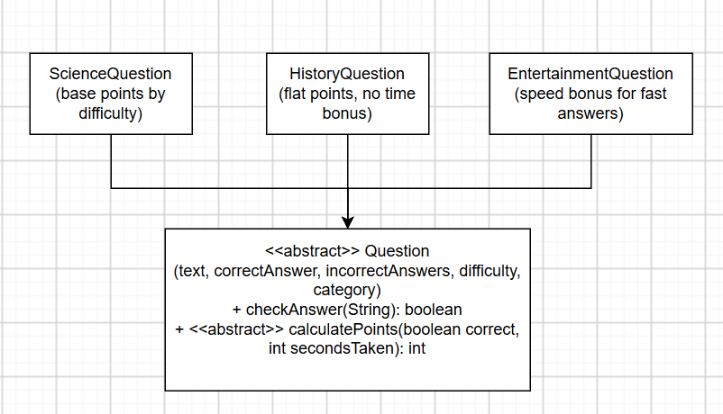
Supporting classes, grouped by package:
trivia.model - Question (abstract), ScienceQuestion, HistoryQuestion,
EntertainmentQuestion, Player, Category
trivia.db - Database, PlayerDao, QuestionDao, CategoryDao, ScoreDao
trivia.api - OpenTdbClient, QuestionParser
trivia.game - GameEngine (Queue + Stack), CategoryTree (recursion)
trivia.analytics - AnalyticsService
trivia.io - CsvImportTask (background thread)
trivia.ui - MainApp, SetupView, GameView, HistoryView, AnalyticsView, AnalyticsCharts

Table 2: How each class follows the Single Responsibility Principle
Class | Its single responsibility
Question and subclasses | Represent one question and compute its own points. Each subclass changes only its own scoring rule.
Player, Category | Hold data for one entity. No database or GUI code.
Database | Open the SQLite connection and run the schema.
PlayerDao, QuestionDao, CategoryDao, ScoreDao | Run the SQL (PreparedStatement) for one table each.
OpenTdbClient | Send the HTTP request and return the raw JSON.
QuestionParser | Turn JSON text into Question objects.
GameEngine | Run one game: Queue for question order, Stack for undo. No GUI or database code.
CategoryTree | Walk the category → subcategory tree recursively.
AnalyticsService | Compute averages, most-missed questions, and trends. It does not draw charts.
CsvImportTask | Read a CSV file on a background thread and report progress.
AnalyticsCharts and the *View classes | Display data only. They call the other classes and contain no business logic.

4. Data Model & Database Design

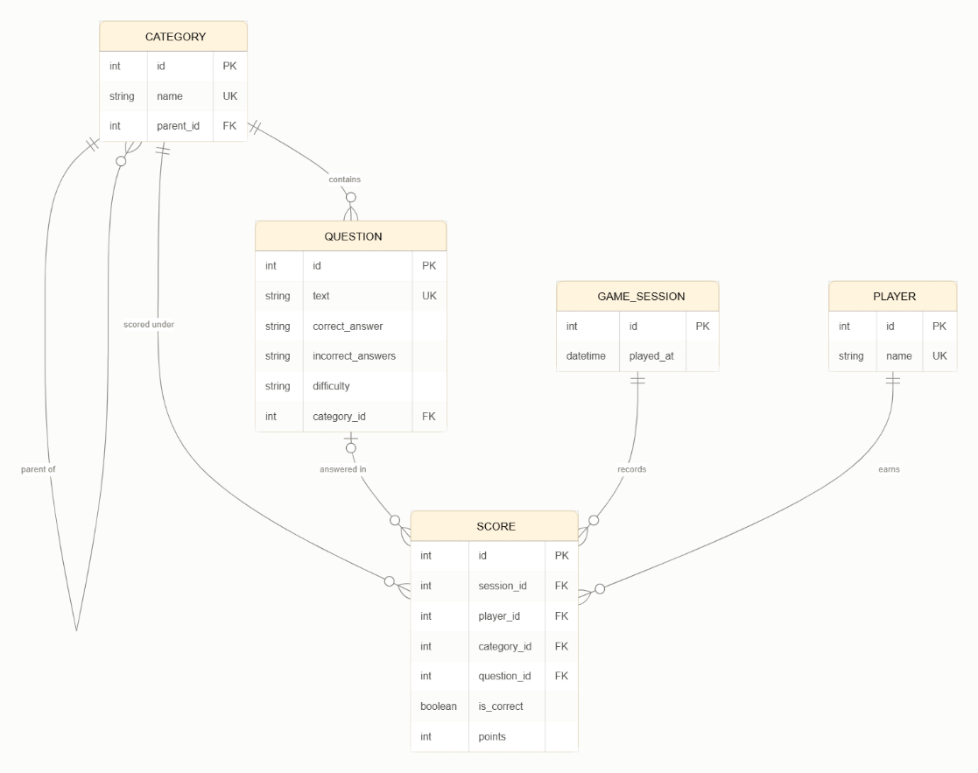
Include the finalized ER diagram (3+ entities, at least one relationship with correct cardinality) and the actual SQLite schema (CREATE TABLE statements or an equivalent schema table). This section supersedes the preliminary sketch from Section 2.

Table 3: Relationship and Cardinality
Relationship | Cardinality | Foreign Key | Meaning
category → category | 1:M | category.parent_id | A category has many subcategories (optional parent; NULL = top level)
category → question | 1:M | question.category_id | A category contains many questions; each question has exactly one category
category → score | 1:M | score.category_id | Each answer is recorded under one category
player → score | 1:M | score.player_id | A player has many score rows
game_session → score | 1:M | score.session_id | A session has many score rows
question → score | 1:M (optional) | score.question_id | A question can be answered many times. NULL for rows imported from CSV
player ↔ game_session | M:N | resolved by score | A player joins many sessions, and a session has many players

SQLite schema
PRAGMA foreign_keys = ON;

CREATE TABLE IF NOT EXISTS category (
id INTEGER PRIMARY KEY AUTOINCREMENT,
name TEXT NOT NULL UNIQUE,
parent_id INTEGER REFERENCES category(id)
);

CREATE TABLE IF NOT EXISTS player (
id INTEGER PRIMARY KEY AUTOINCREMENT,
name TEXT NOT NULL UNIQUE
);

CREATE TABLE IF NOT EXISTS question (
id INTEGER PRIMARY KEY AUTOINCREMENT,
text TEXT NOT NULL UNIQUE,
correct_answer TEXT NOT NULL,
incorrect_answers TEXT NOT NULL,
difficulty TEXT NOT NULL CHECK (difficulty IN ('easy','medium','hard')),
category_id INTEGER NOT NULL REFERENCES category(id)
);

CREATE TABLE IF NOT EXISTS game_session (
id INTEGER PRIMARY KEY AUTOINCREMENT,
played_at TEXT NOT NULL
);

CREATE TABLE IF NOT EXISTS score (
id INTEGER PRIMARY KEY AUTOINCREMENT,
session_id INTEGER NOT NULL REFERENCES game_session(id),
player_id INTEGER NOT NULL REFERENCES player(id),
category_id INTEGER NOT NULL REFERENCES category(id),
question_id INTEGER REFERENCES question(id),
is_correct INTEGER NOT NULL CHECK (is_correct IN (0,1)),
points INTEGER NOT NULL DEFAULT 0
);

CREATE INDEX IF NOT EXISTS idx_score_player ON score(player_id);
CREATE INDEX IF NOT EXISTS idx_score_category ON score(category_id);
CREATE INDEX IF NOT EXISTS idx_score_question ON score(question_id);

Design notes
- incorrect_answers stores the wrong options joined with | to keep the model simple. This is a deliberate trade-off, and a separate answer_option table would be the fully normalized alternative.
- UNIQUE on question.text prevents duplicate questions when the same API batch is fetched twice.
- CHECK constraints keep difficulty and is_correct valid even if bad data arrives from a CSV import.
- Every SQL statement in the DAO classes will use PreparedStatement, and the Database class turns on PRAGMA foreign_keys for each connection, since SQLite does not enforce foreign keys by default.

5. API Integration Design

Name the public API your app consumes, describe the endpoint(s) called, the shape of the JSON response, and how that data is parsed and used meaningfully in the app.
API consumed: Open Trivia Database (OpenTDB), a free public REST API that needs no API key.
Endpoint called
GET https://opentdb.com/api.php?amount=10&category=17&difficulty=medium&type=multiple&encode=url3986

Table 4: Endpoint’s parameter and purpose
Parameter | Purpose
amount | Number of questions to fetch (1-50)
category | OpenTDB category ID, chosen from the app’s category ComboBox (for example, 17 = Science & Nature, 23 = History, 11 = Film)
difficulty | easy, medium, or hard
type | multiple (multiple choice) or boolean (true/false)
encode=url3986 | Returns URL-encoded text, so the app can decode it cleanly instead of dealing with HTML entities such as &quot;

A second, optional endpoint, https://opentdb.com/api_category.php, returns the list of OpenTDB category names and IDs. The app can use it to fill the category ComboBox.
Figure 2: Shape of the JSON response
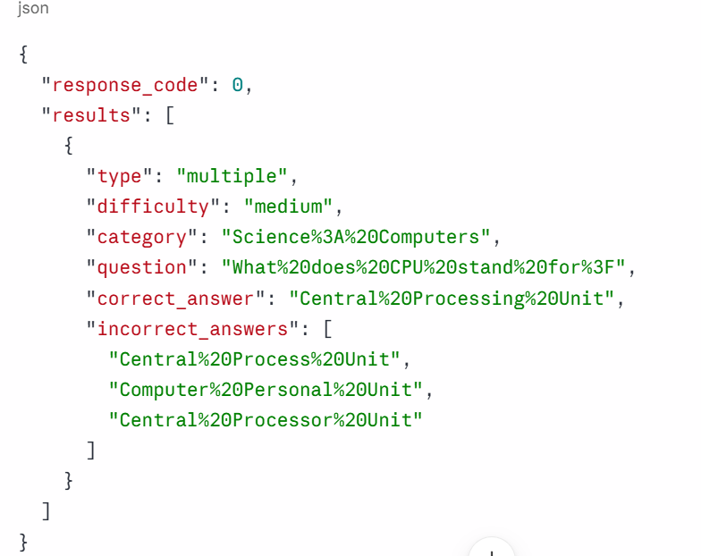
response_code 0 means success. Other values mean there were not enough questions (1), a bad parameter (2), or rate limiting (5, which happens if requests are sent more often than about once every 5 seconds).
How the data is fetched, parsed, and used
- OpenTdbClient builds the URL from the user’s choices and sends the request with Java’s built-in HttpClient. It returns the raw JSON string and does nothing else.
- QuestionParser checks response_code, reads each item in results, and URL-decodes every text field with URLDecoder. Because the response is simple and regular, a small hand-written parser or one small library can do it.
- The parser maps the category name to the right subclass: Science... becomes ScienceQuestion, History becomes HistoryQuestion, and the rest become EntertainmentQuestion. Each object keeps its own scoring rule.
- QuestionDao saves the questions in the question table (PreparedStatement). The UNIQUE text column skips duplicates, and the category_id links each question to the category tree.
- GameEngine loads the Question objects into its Queue and serves them one by one. The correct and incorrect answers are shuffled and shown on the answer buttons, and calculatePoints produces the player’s score.
- The saved answers feed the data mining (average score per category, most-missed questions) and the charts, so the API data drives the whole app rather than being printed once.
Concurrency and error handling
- The request runs in a JavaFX Task on a background thread, with a progress indicator, so the window never freezes during the network call.
- If there is no internet, a timeout, or response_code is not 0, the app shows a friendly message in an alert or status label. It can fall back to questions already stored in SQLite, so a game night can still be played offline.
- To respect the rate limit, the “Fetch questions” button is disabled while a request is running.
Requirement covered: #5 (REST API call with JSON parsed and used meaningfully), supported by #7 (background thread).

6. Concurrency Design

Identify the long-running operation(s) that run on a background thread, explain the threading approach used, and describe how the UI stays responsive during that operation.

7. Data Mining & Visualization Design

Describe the aggregation or frequency-analysis step performed on your app's data and the chart(s) used to visualize the result, including why that chart type was chosen.

8. Testing Summary

Summarize your JUnit test suite — how many tests exist, what they cover, and at least one meaningful edge case per tested class. A short table or list of key test cases is helpful here.

9. Individual Contributions

List what each team member specifically built or owned, referencing their git commit history, so the instructor can cross-check contribution during the Individual Q&A.

Appendix

(Add any additional references, links to full API documentation, licensing notes, or supplementary material here.)

