Environment

Linux, Intel i7, GTX 960M(4G memory)

Package: tensorflow, nltk, genism, numpy

Model description

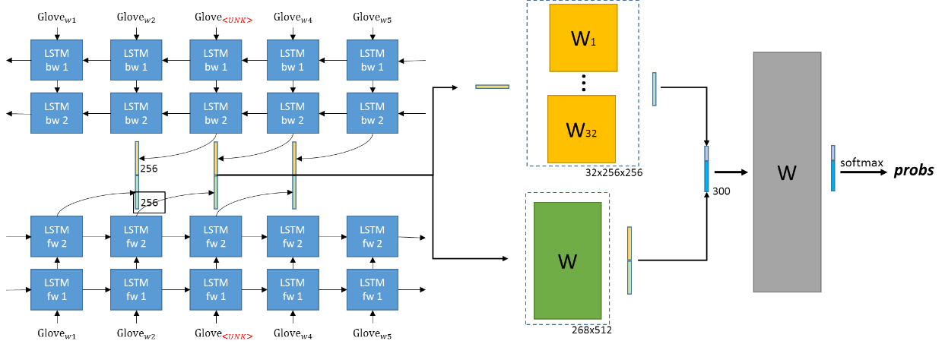

glove (<https://nlp.stanford.edu/projects/glove/>)

Performance

1. 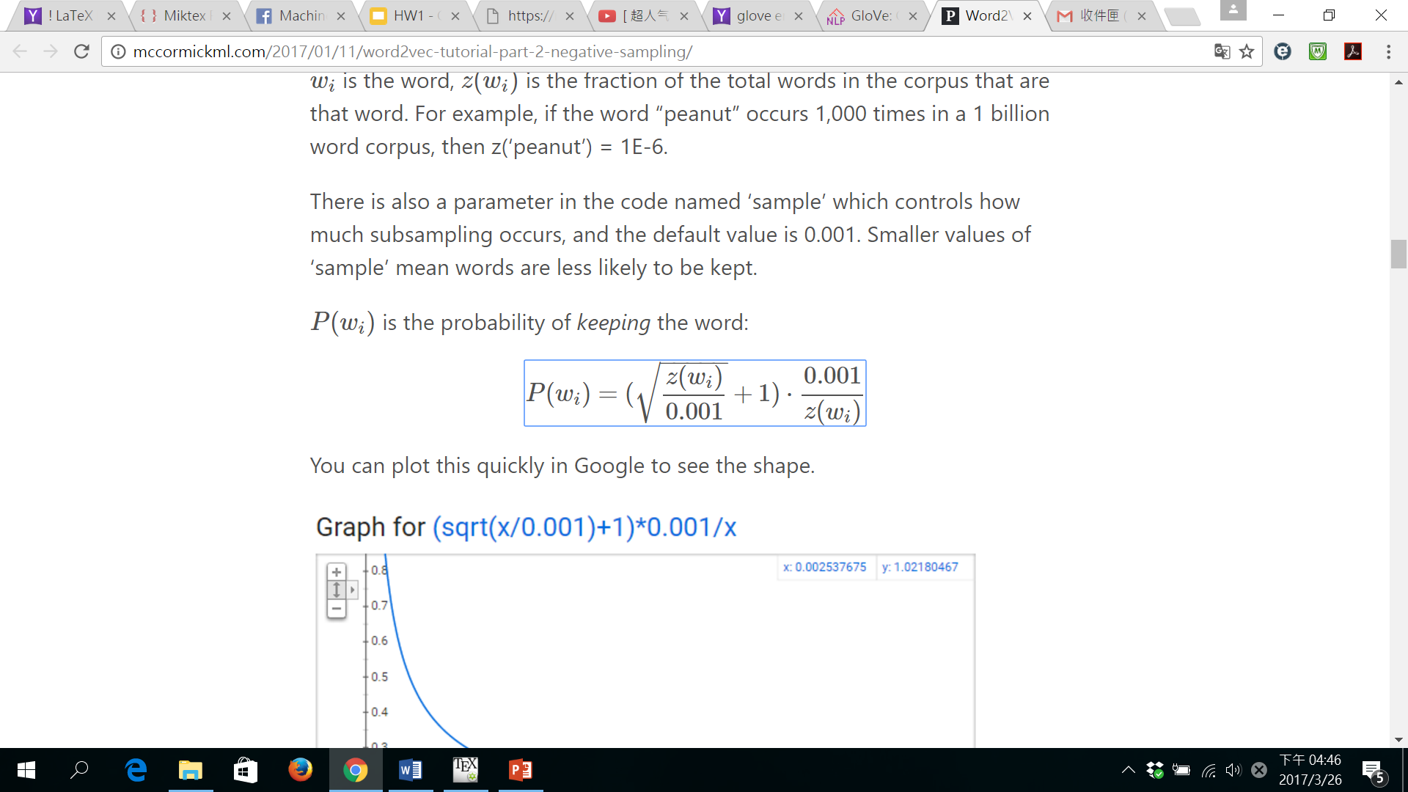Subsample target words according to frequency (~10%up)  
   (<http://mccormickml.com/2017/01/11/word2vec-tutorial-part-2-negative-sampling/>)
2. Finetune pre-trained embedding (~5%up)
3. 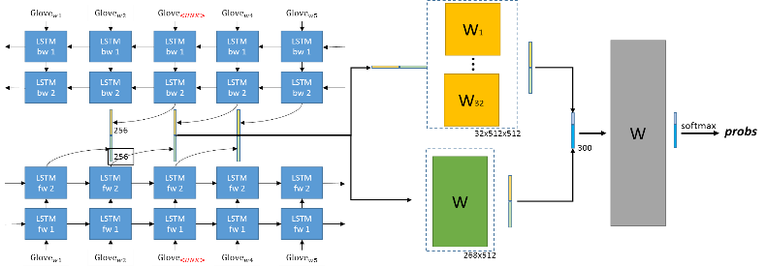Stack up to 2 BiRNN (~5%up)
4. Increase diversity of feature interaction by adding (~5%up)  
   (李弘毅老師3/24上課內容)
5. In inference time, sum up scores of neighbor words (5 words left and 5 words right) (~5%up)

Experiment settings and results

**# Model Structure**

Voc_Size = 60000

Hidden_Size_per_Single_LSTM_Cell = 256

Basic_Cell = tf.contrib.rnn.BasicLSTMCell(Hidden_Size, forget_bias=0.1)

Num_Stack_Layer = 2

Pre_Trained_Ebd = “Glove”

**# Training**

Train_Iters = 90000 # ~ 7 epochs = ~ 15 hours

Batch_Size = 64

Loss = “Sampled_Softmax_Loss”

Sampled_Softmax_Loss_Num_Sampled = 1024

Optimizer_Type = “Adam”

Learning_Rate = 0.01

Learning_Rate_Decay_Step = 39000 # ~3 epochs

Finetune_Embedding_Rate = 0.05 * current_learning_rate

SubSample_Rate = 0.001 #

**# Results**

**Public set: 0.62308 Private set: 0.65385**