Environment

Linux, Intel i7, GTX 960M(4G memory)

Package: tensorflow, nltk, genism, numpy

Model description

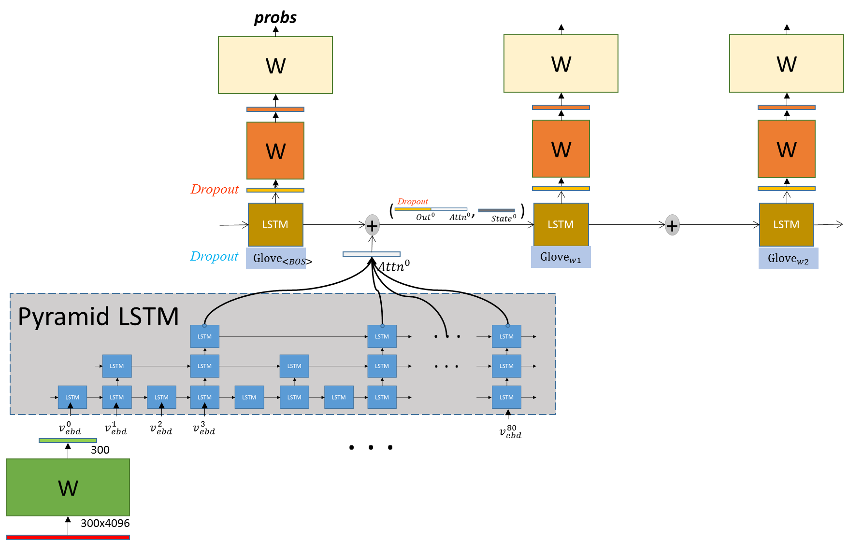

glove (<https://nlp.stanford.edu/projects/glove/>)

Performance

基本SV2T 或 Attention: BLEU $≅$ 0.250

1. Attention + Pyramid LSTM for video part: BLEU $≅$ 0.275
2. Attention + Pyramid LSTM for video part + Dropout: BLEU $≅$ 0.315

其他嘗試但無改善,不確定是否為實做問題

1. Schedule rate
2. Beam Search

Experiment settings and results

**# Model Structure**

Hidden_Size_per_Single_LSTM_Cell = 300

Basic_Cell = tf.contrib.rnn.BasicLSTMCell(Hidden_Size, forget_bias=1.0)

Pre_Trained_Ebd = “Glove”

**# Training**

Train_Iters = 36000

Batch_Size = 64

Loss = “Softmax_Loss”

Optimizer_Type = “Adam”

Learning_Rate = 0.001

Learning_Rate_Decay_Step = 24000

Finetune_Embedding_Rate = 0.05 * current_learning_rate

**# Results**

**BLEU: 0.313**