Algorithm description

I. Numerical Net:

jz(2,0)
jz(1,0)
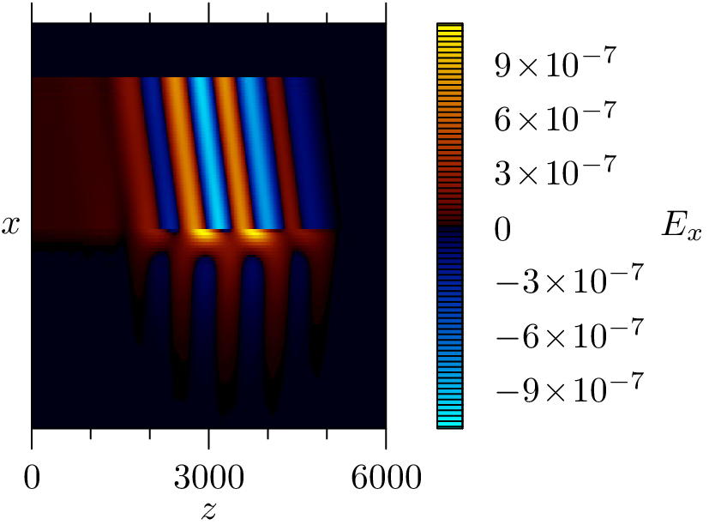
n(0,0)
n(2,0)
n(1,0)
Ez(1,0)
Ez(2,0)

jx(1,1)
jx(2,1)
Ex(2,1)
jx(0,1)
Ex(0,1)
Ex(1,1)

By(1,1)
By(2,1)

jz(2,1)
jz(1,1)
n(1,1)
n(2,1)
n(0,1)
x
Ez(1,1)
Ez(2,1)
dx

jx(1,2)
Ex(1,2)
jx(2,2)
Ex(2,2)
Ex(0,2)

By(2,2)
By(1,2)
dz
jx(0,2)
Calculation example
jz(1,2)
jz(2,2)
n(0,2)
n(1,2)
n(2,2)
Ez(2,2)
Ez(1,2)

z

II. Plasma Boundary:
jx(i, jb)=0
jb=Nx/BORDER

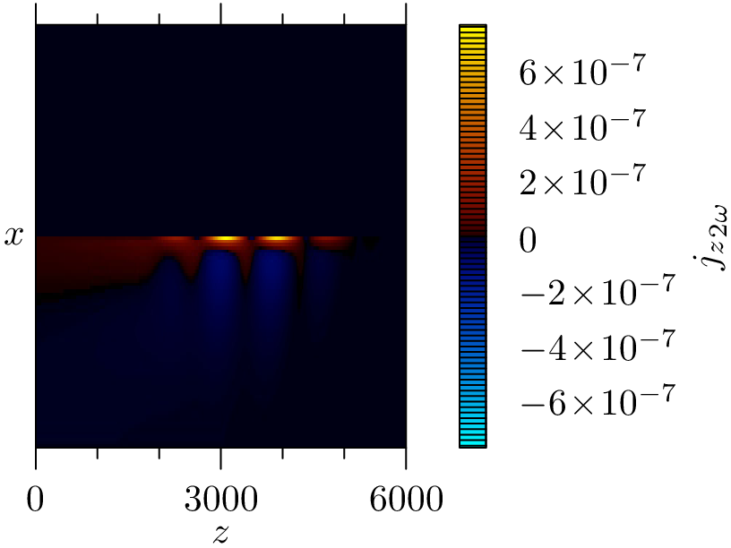
n(1,jb)
n(2,jb)
n(0,jb)
n(0,jb+1)
n(1,jb+1)
n(2,jb+1)
jz(2,jb)
jz(1,jb)
Ez(1,jb)
Ez(2,jb)
jz(2,jb+1)
jz(1,jb+1)
Ez(1,jb+1)
Ez(2,jb+1)
jx(1,jb+1)
Ex(1,jb+1)
Ex(1,jb)
Ex(2,jb+1)
jx(0,2)
Ex(0,jb)
Ez(1,jb-1)
Ez(2,jb-1)
Calculation example

Ex(2,jb)
jx(2, jb)=0
jx(1, jb)=0
dx
2
jx(0, jb)=0

III. Boundaries:
<somewhere in code> ne[i*N_r+j_{b}]+=-((j_r[i*N_r+j_{b}+1])/dr+(j_z[(i+1)*N_r+j_{b}]-j_z[i*N_r+j_{b}])/dz)*dt;
(j_r[i*N_r+j_{b}+1])/dr=(j_r[i*N_r+j_{b}+1]-j_r[i*N_r+j_{b}]=0)/dr

