| **Project Case** |  |
| --- | --- |
| ISYS6197 | ISYS6197003  Business Application Development |
| **Computer Science** | **O242-ISYS6197-SN04-00** |
| ***Valid on*** *Odd Semester Year 2023/2024* | **Revision 00** |

1. Kelompok tidak diperkenankan untuk:

*Members of the group are prohibited from:*

* + - Melihat sebagian atau seluruh jawaban kelompok lain,

*Seeing a part or the whole answer from other groups,*

* + - Menyadur sebagian atau seluruh jawaban dari buku, catatan, video, dan jenis referensi lainnya,

*Retell a part or the whole answer from books, notes, videos, and other references,*

* + - Menyadur sebagian atau seluruh jawaban dari internet,

*Retell a part or the whole answer from the internet,*

* + - Mengumpulkan jawaban yang tidak sesuai dengan tema soal,

*Submitting an answer with a different theme from the given case,*

* + - Melakukan tindakan yang menyebabkan jawaban dicontek oleh orang lain atau kelompok lain, baik disengaja maupun tidak disengaja,

*Doing action that could result the answer being copied by someone or other groups, intentionally or unintentionally,*

* + - Melakukan tindakan kecurangan lainnya.

*Committing other dishonest actions.*

1. Jika kelompok terbukti melakukan tindakan seperti yang dicantumkan pada butir ke-1, maka nilai mahasiswa dan/atau kelompok yang melakukan kecurangan, baik menyontek atau dicontek, akan dinolkan sesuai dengan peraturan yang berlaku.

*If it has been proven that a group has committed dishonest actions outlined in point 1 above, the whole groups related to the incident, regardless of which one copies or has their answer copied, will be issued a score of zero according to the regulation.*

1. Jawaban yang dapat diterima dan dinilai adalah jawaban yang dikumpulkan sebelum batas waktu yang telah ditentukan.

*The answer must be submitted before the designated deadline to be accepted and graded,*

1. Jawaban akan dinilai berdasarkan teknik atau metode yang diajarkan pada kelas praktikum dengan menggunakan software yang sudah ditentukan.

*The scoring will be based on the materials taught during the practicum classes using the designated software. Using different software than requested may result in your answer not being graded.*

1. Jika Anda tidak membaca peraturan ini, maka Anda dianggap sudah membaca dan menyetujuinya.

*By taking this exam, you agree to these regulations, regardless of whether you have read it or not.*

1. Persentase penilaian untuk matakuliah ini adalah sebagai berikut:

*The score will be distributed as follows:*

| **Tugas Mandiri**  *Assignment* | **Proyek**  *Project* | **UAP**  *Final Exam* |
| --- | --- | --- |
| 40% | 60% | - |

1. Perangkat lunak yang digunakan pada matakuliah ini adalah sebagai berikut:

*This course uses the following software:*

| **Software**  *Software* |
| --- |
| Eclipse 2020.6 R  Java 11.0.18  JavaFX 17.0.7  MySQL Java Connection Library 8.0.24  XAMPP 8.0.7 |

1. Ekstensi file yang harus dikumpulkan untuk matakuliah ini adalah sebagai berikut:

*Your answers must be in the following file extensions:*

| **Tugas Mandiri**  *Assignment* | **Proyek**  *Project* | **UAP**  *Final Exam* |
| --- | --- | --- |
| JAVA. CLASS | JAVA. CLASS, SQL | - |

1. File yang harus dikumpulkan adalah keseluruhan jawaban beserta dengan aset yang digunakan (gambar, audio, video, dll) dan dokumentasi proyek yang berisikan link referensi aset dan penjelasan mengenai aplikasi yang dibuat (terlampir bersama dengan soal).

*Include other files that can support your project, such as: all files in your project, other files (image, audio, video, etc.) used in your project, *.doc file (documentation of your project) that contains all pages in your project, reference links of additional files (image, audio, video, etc.) used in your project, the description about how to use your application, etc.*

## Soal

*Case*

**SNeam**

SNeam is an up and coming video game store. SNeam want to expand it’s reach even further by making SNeam available digitally. To make this happen, the owner asked you to create an application to manage SNeam products and transactions. The program should be made using **Java Programming Language,** with **MySQL Database Engine. Ensure that you didn’t use regex, Java FXML, JavaFX Scene Builder, or any library used outside the class materials in your project or it will affect your score.**

There are some requirements to build this application:

*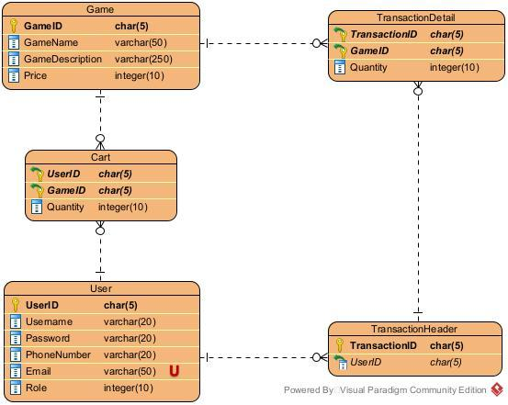****Figure 1 ERD***

Execute the provided create and insert query file on “**SNeam**” database! (“create+insert.sql”).

* + - 1. **Login Scene**

The first form that will appear when the program is started. The **Login Form** is used by users to **log in**, **in order to access the Home Scene.**

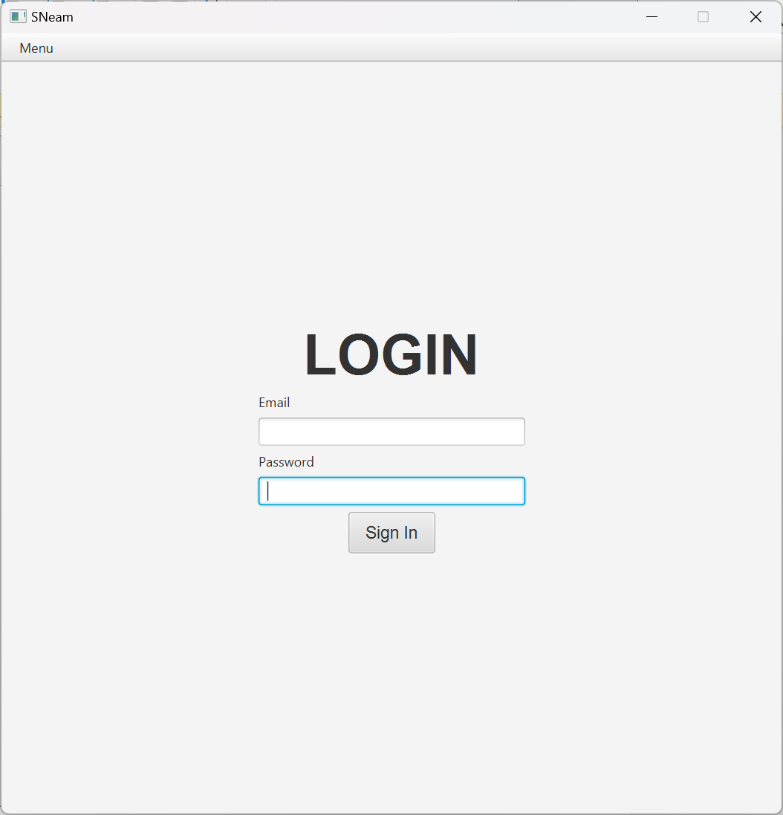***Figure 2 Login Form***

***Components:***

* **Label** for Login, Username and Password.
* **TextField** for Username input.
* **PasswordField** for Password input.
* **Button** for Login button.
* **Menubar, Menu** for navigation bar
* **MenuItem** for navigation to Register Scene

**Description:**

* **If user clicks Login button**, then **validate**:
  + **Username and Password must exist and match** in database.

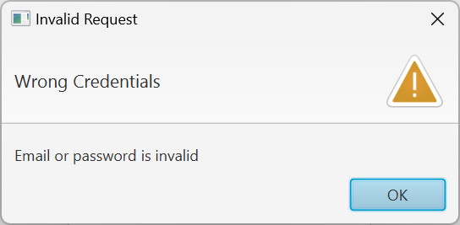

***Figure 3 credential doesn't exist or wrong***

* **If credential is correct**, the program **will save the current logged in user** and direct the user to **Home Scene.**
* **If the logged in user class is Admin** redirect to **Home Scene (Admin)**
* **If the logged in user class is Customer** redirect to **Home Scene (Customer)**
  + If user **failed to log in**, display a **Warning Alert.**
    - 1. **Register Scene**

The Register Form is **used by users to Register**.

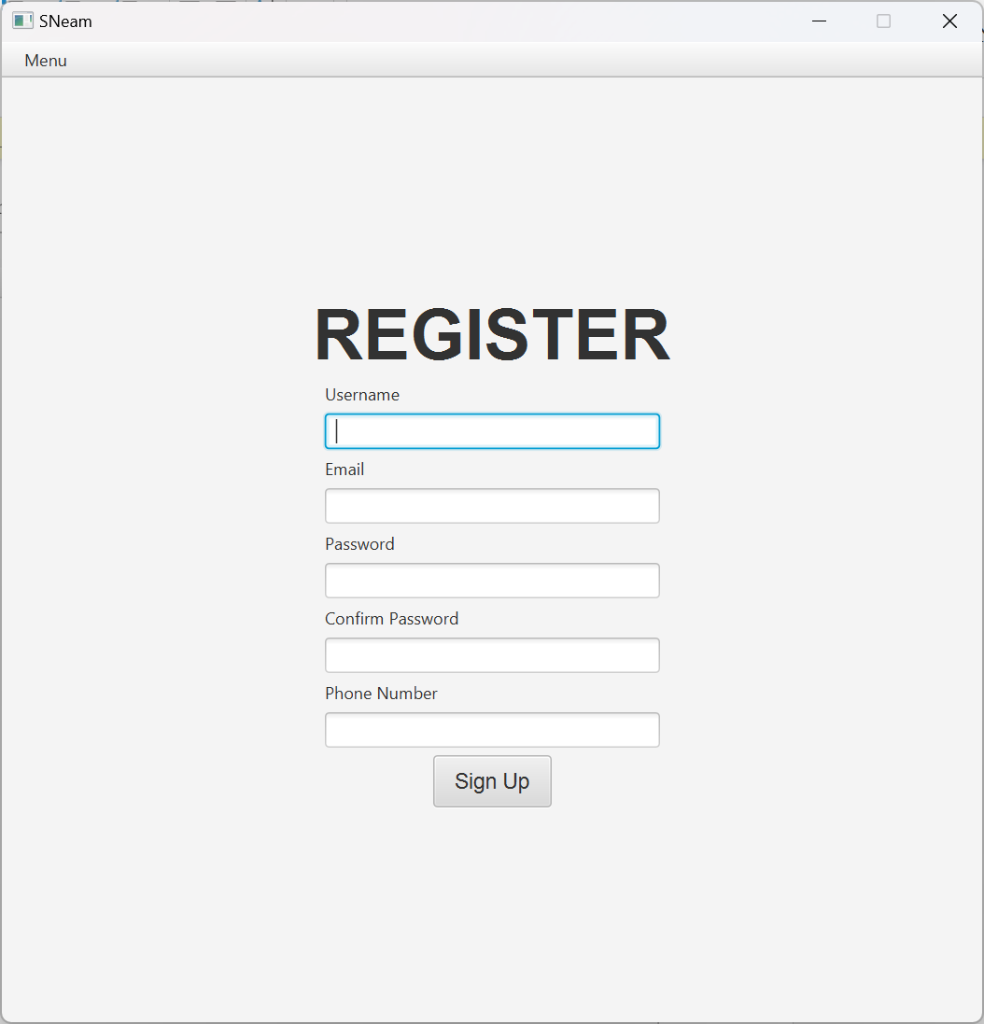

***Figure 4 Register Form***

***Components:***

* **Label** for Register, Email, Username, Password, Confirm Password, Phone Number.
* **TextField** for Email, Username, Phone Number input.
* **PasswordField** for Password, Confirm Password input.
* **Button** for Register button.
* **Menubar, Menu** for navigation bar
* **MenuItem** for navigation to Login Scene.

**Description:**

* **If user clicks Register button**, then validate:
  + **User ID** is generated with **format**:



* + **Username must contain 4 – 20 characters.**
  + **Email must contains “@” in it.**
  + **Email must be unique.**
  + **Password must contain 6 – 20 characters.**
  + **Password must be alphanumeric.**
  + **Confirm Password must be the same as Password.**
  + **Phone Number can only be numeric.**
  + **Phone Number must be 9 – 20 numbers.**
* **Every error message must be shown as Warning Alert.**

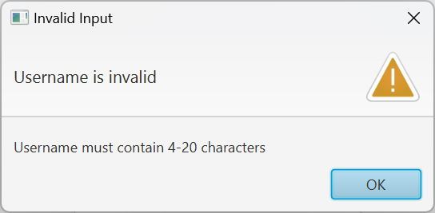

***Figure 5 Username didn’t contain 4 – 20 characters***

* **If user successfully register**, insert a new user to the database with **“Customer” role** and the generated User ID. **Then give a**n **information alert that shows that he has registered a new account.**

1. **Login Register Navigation Bar**

This navigation bar is **only available on Login Scene and Register Scene**. It is **used to navigate between Login Scene and Register Scene**.

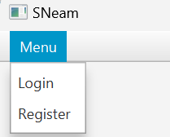

***Figure 6 Login Register Navigation Bar***

***Components:***

* **Menubar, Menu** for showing current scene. (Login or Register)
* **MenuItem** for navigation between Login and Register Scenes.

**Description:**

* **MenuItem Login** will redirect to **Login Scene.**
* **MenuItem Register** will redirect to **Register Scene**.

1. **Home Scene (Customer)**

Home Scene **that’s available for users with “Customer” Role** **can view all games from the database** on a **ListView**. User can **click on one of the games** on the list to **show the details of the selected game**.

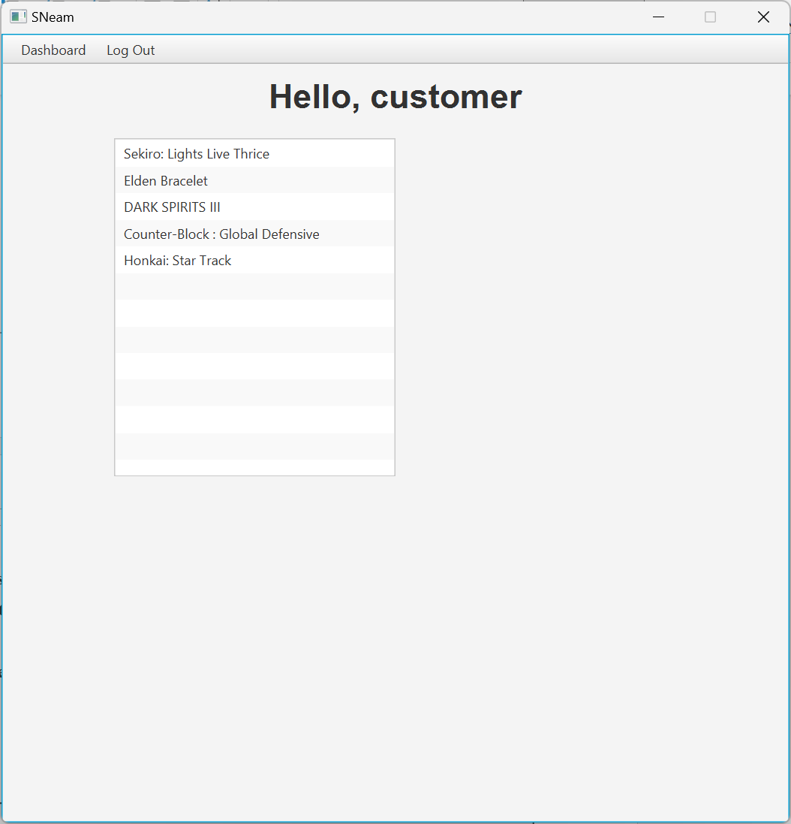

***Figure 7 Home Scene (no selected item)***

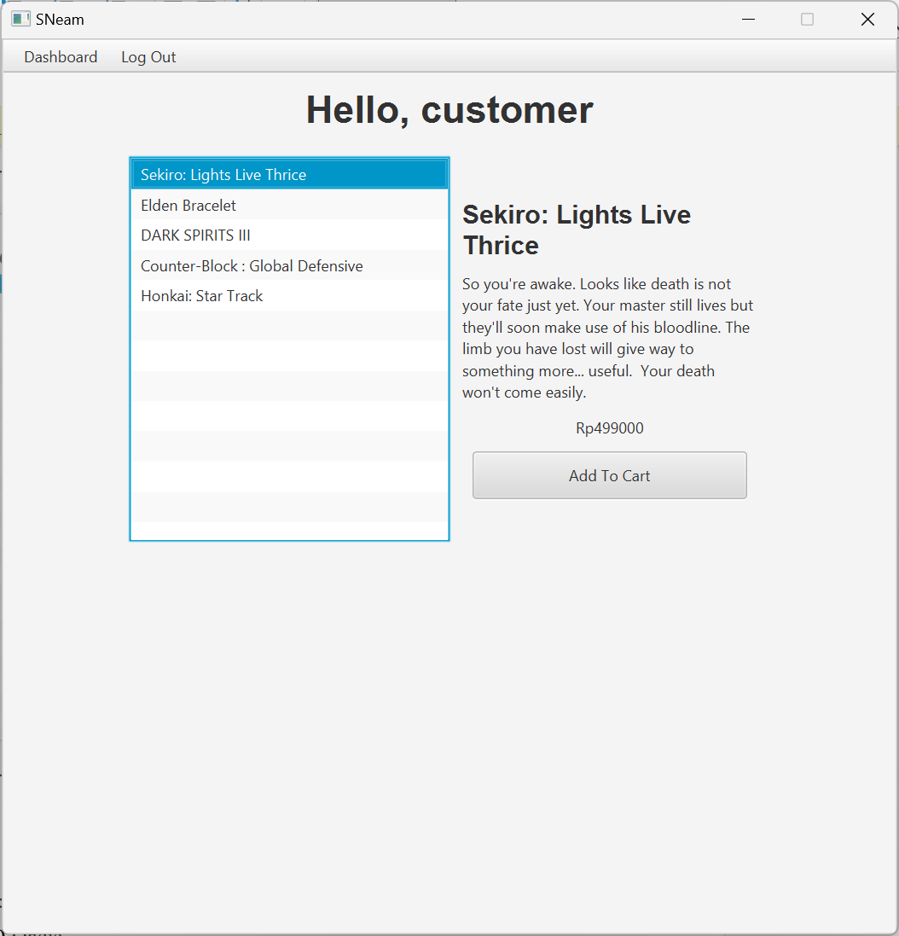

***Figure 8 Home Scene (item selected)***

***Components:***

* **Label** for:
  + Greeting Title
  + Game’s Detail:
    - Game Name
    - Game Description
    - Price
* **ListView** for displaying all games from database.
* **Buttton** for Add to Cart button.
* **Menubar, Menu** for navigation bar
* **MenuItem** for navigation to Cart Scene.
* **MenuItem** for logging out.

**Description:**

* Greeting Title **will always say “Hello, [Current user’s username]”.**
* **Display GameName** value for each of the games in the ListView.
* If the **user clicks a game** from the games list, **update the Home Scene to display details of the selected game.** The details consist of:
  + Game Name
  + Game Description
  + Game Price
  + Add to Cart Button
* If the **user did not select any of the games** from the game list, update the Home Scene to **hide the details of game and also the add to cart button**.
* **Add to Cart** button:
  + **Open a new pop-up add to cart window.**

1. **Add To Cart Scene (Customer)**

**Add To Cart Scene** let users to can **add a new item to their cart**. This scene is a new **pop-up window** that is separated from the main window. **Customer can change the quantity** of order using a spinner.

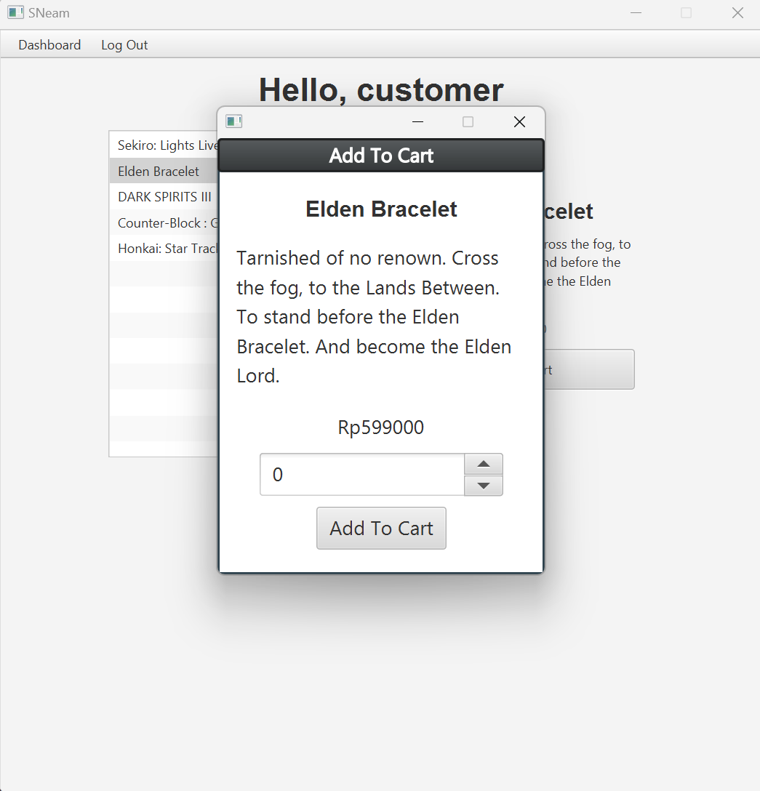

***Figure 9 Customer add new item pop-up***

***Components:***

* **Window** for the pop-up window, with title “Add To Cart”.
* **Label** forGame Name, Game Description, Game Price.
* **Spinner** for quantity.
* **Button** for Add To Cart Button.

**Description:**

* **Display** Game Name, Game Description, Game Price **based on what is selected** on the ListView.
* **If Game is already in the cart, quantity spinner** will be set based on what **quantity** is in **cart.**
* **Spinner quantity** can only be in the range of 0 and 10 .
* **Add To Cart Button:**
  + **If quantity is set to 0 and game is not in cart**, close the pop-up.
  + **If quantity is set to 0 and game is in cart, delete cart.**
  + **If quantity is not 0 and game is in cart**, update quantity in cart.
  + **If quantity is not 0 and game is not in cart**, add new cart.

1. **Cart Scene (Customer)**

**Cart Scene** let’s user to check how many games and it’s price is in the user’s cart. They can also **check out** to finish their transaction.

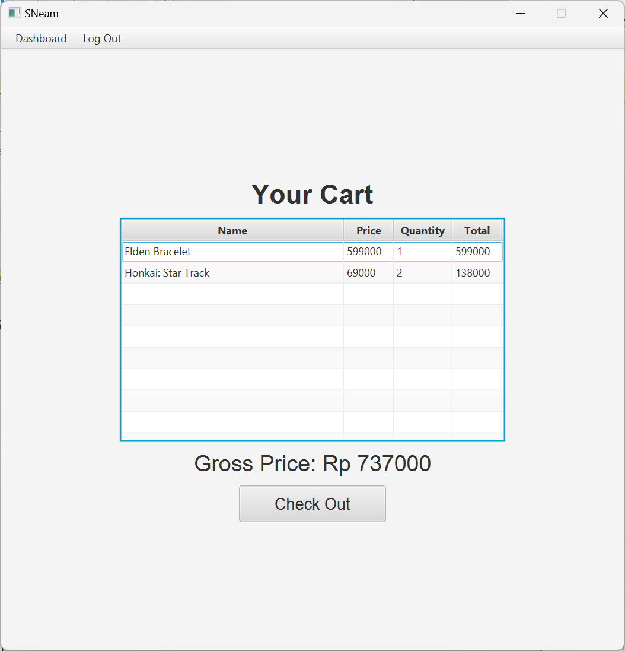

***Figure 10 Cart Scene***

***Components:***

* **Label** for scene title, gross price.
* **TableView** for all of the item in cart.
  + TableColumn for Game Name, Game Price, Quantity, Total.
* **Button** for check out button.
* **Menubar, Menu** for navigation bar
* **MenuItem** for navigation to Home Scene.
* **MenuItem** for logging out.

**Description:**

* **TableColumn Total** came from **quantity * price**.
* **Check Out Button:**
  + **If the cart is empty** display a warning alert.

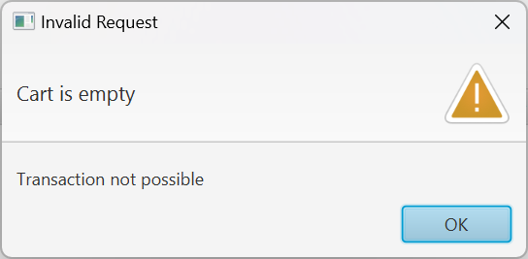

***Figure 11 Empty Cart Warning***

* + **Generate** new **Transaction ID** with **format:**



* + **Add** new transaction to Transaction Header and Transaction Detail.
  + **Remove** all game from customer from cart.

1. **Dashboard Navigation Bar (Customer)**

This navigation bar is **only available on Home Scene and Cart Scene**. It is **used to navigate between Home Scene, Cart Scene and Log Out**.

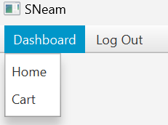

***Figure 12 User Dashboard Menu***

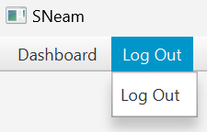

***Figure 13 User Log Out Menu***

***Components:***

* **Menubar, Menu** for showing current scene (Home or Cart)
* **MenuItem** for navigation between Home and Cart Scenes and for logging out.

**Description:**

* **MenuItem Home** will redirect to **Home Scene.**
* **MenuItem Cart** will redirect to **Cart Scene**.
* **MenuItem LogOut** will redirect to **Login Scene** and remove current logged in user.

1. **Home Scene (Admin)**

Home Scene **that’s available for users with “Admin” Role** **can view all games from the database** on a **ListView**. **User** can **click on one of the games** on the list to **show the details of the selected game**. **User** can **add** new games, **update** existing games, and **delete** existing games.

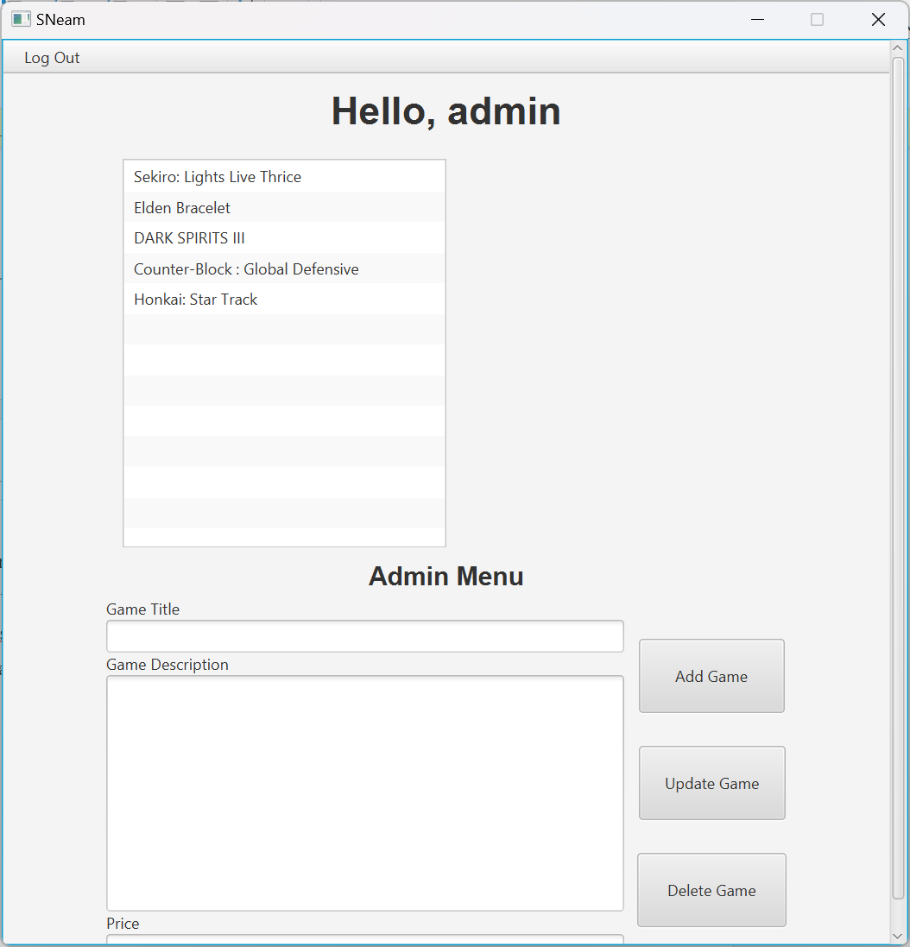

***Figure 14 Admin Home Menu (Not Selected)***

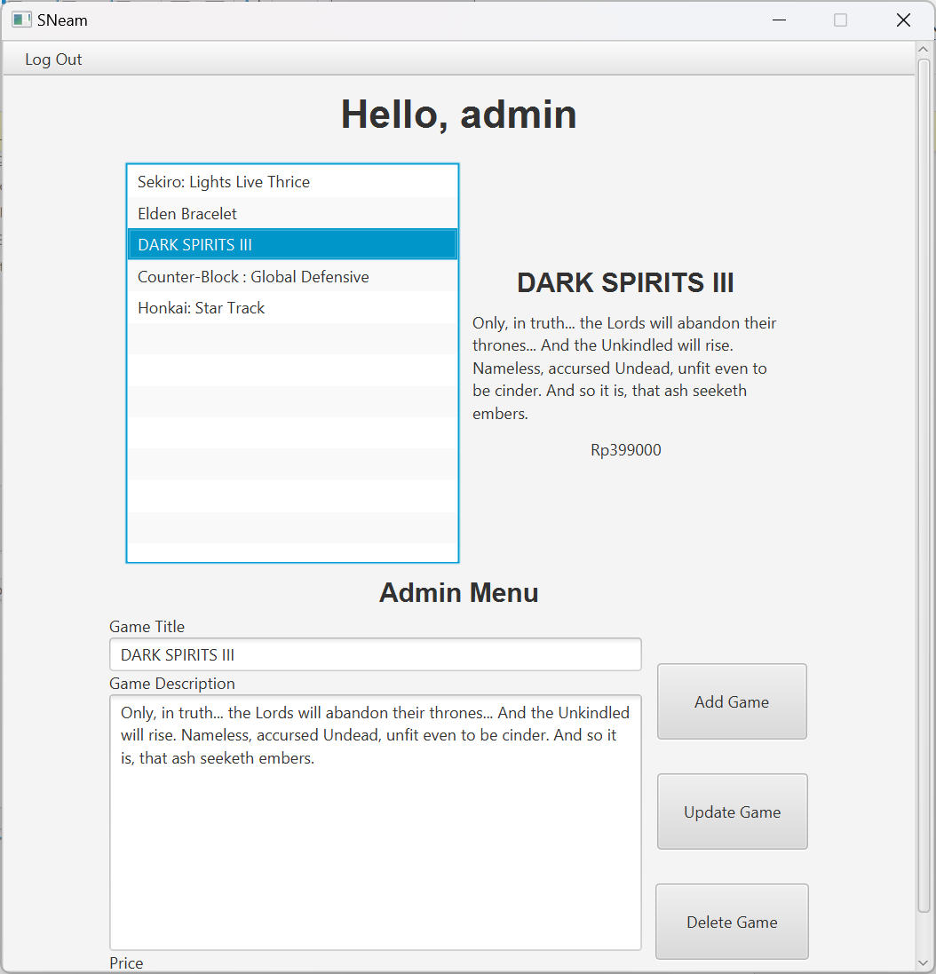

***Figure 15 Admin Home Menu (Selected)***

***Components:***

* **Label** for:
  + Greeting Title
  + Game’s Detail:
    - Game Name
    - Game Description
    - Price
  + Admin’s Menu:
    - Change Game Title
    - Change Game Description
    - Change Price
* **ListView** for displaying all games from database.
* **Buttton** for Add Game, Update Game and Delete Game.
* **Textfield** for Game Name field, Game Price field.
* **TextArea** for Game Description area.
* **Menubar, Menu** for navigation bar
* **MenuItem** for logging out.

**Description:**

* Greeting Title **will always say “Hello, [Current user’s username]”.**
* **Display Game Name** value for each of the games in the ListView.
* If the **user clicks a game** from the games list, **update the Home Scene to display details of the selected game.** The details consist of:
  + Game Name
  + Game Description
  + Game Price
* These details will also be inserted in **Game Name field, Game Price field, and Game Description.**
* If the **user has not selected any of the games** from the game list, update the Home Scene to **hide the details of game.**
* If the **user has not selected any of the games** Game Name field, Game Price field, and Game Description will still be empty.
* **Add Game** button:
  + **Generate** new **Game ID** with **format**:



* + Game Name Field **cannot be empty.**
  + Game Description Area **cannot be empty.**
  + Game Price Field **cannot be empty.**
  + Game Description **cannot exceed 250 characters.**
  + Game Name **cannot exceed 50 characters.**
  + Game Price **must be numeric.**
  + Game Price **cannot exceed 10 characters.**
  + If game **successfully added** refresh **Home Scene (Admin)**.

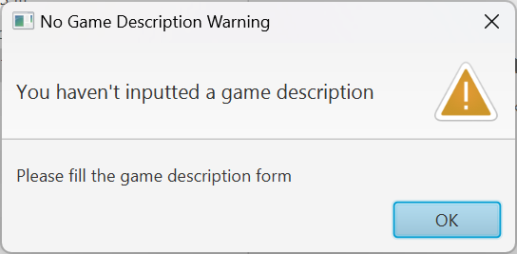

***Figure 16 Game Description Area Is Empty***

* **Update Game** button:
  + If **clicked** **without selecting** any games in ListView show **Warning Alert.**
  + If **Game Name field, Game Price field, and Game Description Area are all empty** show **Warning Alert.**
  + But if **only one or two form is empty (not all)** it **will only update the non-empty form** as long as **it passes the validation below**:
    - Game Description **cannot exceed 250 characters.**
    - Game Name **cannot exceed 50 characters.**
    - Game Price **must be numeric.**
    - Game Price **cannot exceed 10 characters.**
  + If game **successfully updated** refresh **Home Scene (Admin)**.

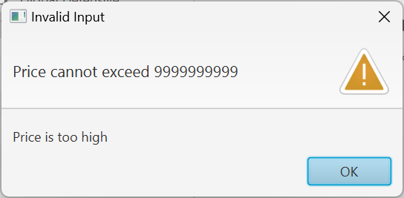

***Figure 17 Price Exceeding 10 Characters***

* **Delete Game** button:
  + If **clicked** **without selecting** any games in ListView show **Warning Alert.**
  + If **clicked when a game is selected show a confirmation alert.**

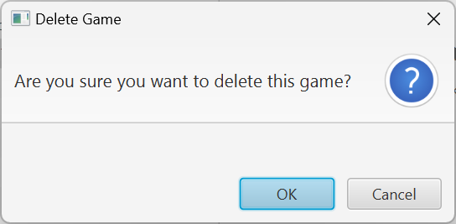

***Figure 18 Delete Game Confirmation***

* + If **OK** is clicked **delete game from database.**
  + if **cancel** is clicked **close alert and don’t delete game.**

1. **Dashboard Navigation Bar (Admin)**

This navigation bar is **only available on Home Scene and Cart Scene**. It is **used to Log Out**.

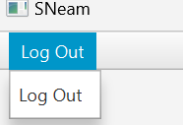

***Figure 19 Admin Log Out Menu***

***Components:***

* **Menubar, Menu** for showing Log Out Menu
* **MenuItem** for logging out.

**Description:**

* **MenuItem LogOut** will redirect to **Login Scene** and remove current logged in user.