测试结果
- 基本测试
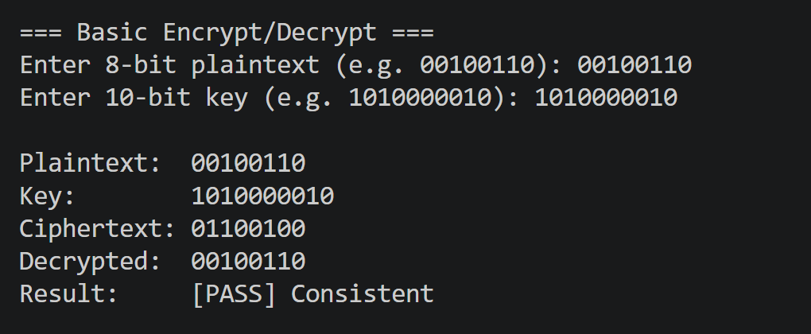
- 交叉测试
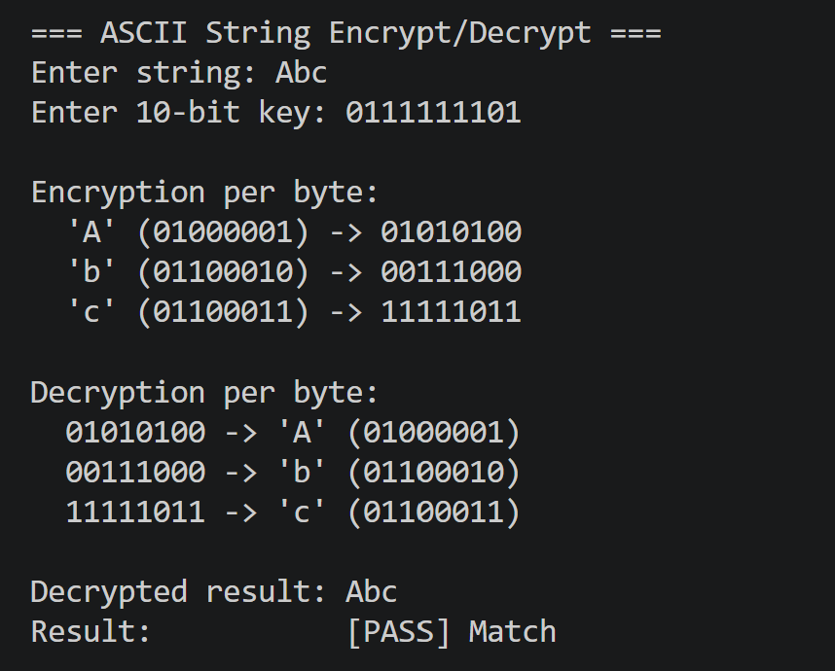
- 扩展测试
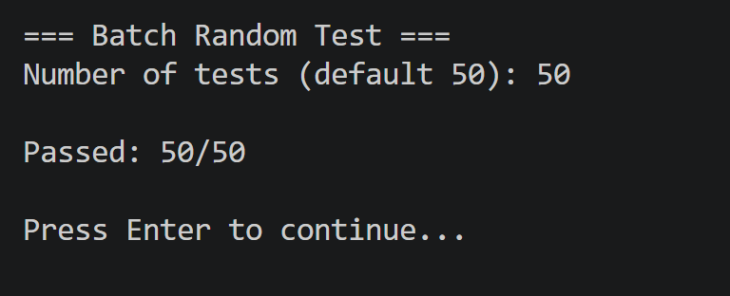
- 暴力破解
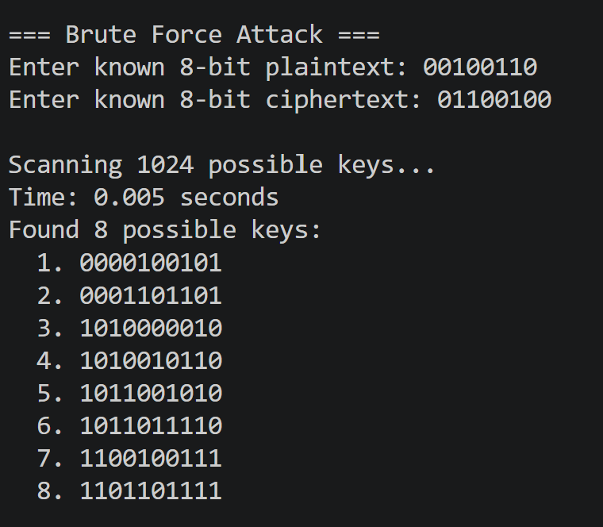
- 封闭测试
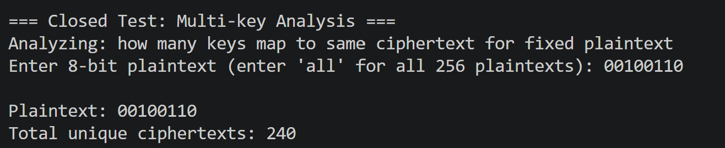
Ciphertexts with multiple keys:
Ciphertext 00000000 <- 8 keys
Ciphertext 00000001 <- 4 keys
Ciphertext 00000010 <- 4 keys
Ciphertext 00000011 <- 4 keys
Ciphertext 00000101 <- 4 keys
Ciphertext 00000110 <- 4 keys
Ciphertext 00000111 <- 4 keys
Ciphertext 00001000 <- 4 keys
Ciphertext 00001001 <- 4 keys
Ciphertext 00001010 <- 4 keys
Ciphertext 00001011 <- 4 keys
Ciphertext 00001100 <- 4 keys
Ciphertext 00001101 <- 4 keys
Ciphertext 00001110 <- 4 keys
Ciphertext 00001111 <- 4 keys
Ciphertext 00010000 <- 6 keys
Ciphertext 00010001 <- 4 keys
Ciphertext 00010010 <- 2 keys
Ciphertext 00010011 <- 4 keys
Ciphertext 00010100 <- 2 keys
Ciphertext 00010101 <- 4 keys
Ciphertext 00010110 <- 6 keys
Ciphertext 00010111 <- 4 keys
Ciphertext 00011000 <- 4 keys
Ciphertext 00011001 <- 4 keys
Ciphertext 00011010 <- 4 keys
Ciphertext 00011011 <- 4 keys
Ciphertext 00011100 <- 4 keys
Ciphertext 00011101 <- 4 keys
Ciphertext 00011110 <- 4 keys
Ciphertext 00011111 <- 4 keys
Ciphertext 00100000 <- 4 keys
Ciphertext 00100001 <- 2 keys
Ciphertext 00100010 <- 8 keys
Ciphertext 00100011 <- 6 keys
Ciphertext 00100100 <- 4 keys
Ciphertext 00100101 <- 6 keys
Ciphertext 00100111 <- 2 keys
Ciphertext 00101000 <- 2 keys
Ciphertext 00101001 <- 2 keys
Ciphertext 00101010 <- 6 keys
Ciphertext 00101011 <- 6 keys
Ciphertext 00101100 <- 6 keys
Ciphertext 00101101 <- 6 keys
Ciphertext 00101110 <- 2 keys
Ciphertext 00101111 <- 2 keys
Ciphertext 00110000 <- 6 keys
Ciphertext 00110001 <- 4 keys
Ciphertext 00110010 <- 2 keys
Ciphertext 00110011 <- 4 keys
Ciphertext 00110100 <- 2 keys
Ciphertext 00110101 <- 4 keys
Ciphertext 00110110 <- 6 keys
Ciphertext 00110111 <- 4 keys
Ciphertext 00111000 <- 4 keys
Ciphertext 00111001 <- 4 keys
Ciphertext 00111010 <- 4 keys
Ciphertext 00111011 <- 4 keys
Ciphertext 00111100 <- 4 keys
Ciphertext 00111101 <- 4 keys
Ciphertext 00111110 <- 4 keys
Ciphertext 00111111 <- 4 keys
Ciphertext 01000000 <- 8 keys
Ciphertext 01000001 <- 8 keys
Ciphertext 01000010 <- 2 keys
Ciphertext 01000011 <- 6 keys
Ciphertext 01000100 <- 4 keys
Ciphertext 01000101 <- 4 keys
Ciphertext 01000110 <- 2 keys
Ciphertext 01000111 <- 6 keys
Ciphertext 01001000 <- 4 keys
Ciphertext 01001010 <- 6 keys
Ciphertext 01001011 <- 2 keys
Ciphertext 01001101 <- 4 keys
Ciphertext 01001110 <- 6 keys
Ciphertext 01001111 <- 2 keys
Ciphertext 01010000 <- 3 keys
Ciphertext 01010001 <- 3 keys
Ciphertext 01010010 <- 5 keys
Ciphertext 01010110 <- 7 keys
Ciphertext 01010111 <- 3 keys
Ciphertext 01011000 <- 7 keys
Ciphertext 01011001 <- 5 keys
Ciphertext 01011010 <- 3 keys
Ciphertext 01011011 <- 5 keys
Ciphertext 01011100 <- 5 keys
Ciphertext 01011101 <- 7 keys
Ciphertext 01011111 <- 7 keys
Ciphertext 01100000 <- 4 keys
Ciphertext 01100001 <- 4 keys
Ciphertext 01100010 <- 2 keys
Ciphertext 01100011 <- 12 keys
Ciphertext 01100100 <- 8 keys
Ciphertext 01100101 <- 8 keys
Ciphertext 01100110 <- 2 keys
Ciphertext 01101000 <- 2 keys
Ciphertext 01101010 <- 8 keys
Ciphertext 01101011 <- 4 keys
Ciphertext 01101100 <- 2 keys
Ciphertext 01101101 <- 4 keys
Ciphertext 01101110 <- 4 keys
Ciphertext 01110000 <- 3 keys
Ciphertext 01110001 <- 3 keys
Ciphertext 01110010 <- 5 keys
Ciphertext 01110110 <- 7 keys
Ciphertext 01110111 <- 3 keys
Ciphertext 01111000 <- 7 keys
Ciphertext 01111001 <- 5 keys
Ciphertext 01111010 <- 3 keys
Ciphertext 01111011 <- 5 keys
Ciphertext 01111100 <- 5 keys
Ciphertext 01111101 <- 7 keys
Ciphertext 01111111 <- 7 keys
Ciphertext 10000000 <- 4 keys
Ciphertext 10000001 <- 8 keys
Ciphertext 10000010 <- 4 keys
Ciphertext 10000011 <- 4 keys
Ciphertext 10000100 <- 4 keys
Ciphertext 10000110 <- 4 keys
Ciphertext 10000111 <- 4 keys
Ciphertext 10001001 <- 8 keys
Ciphertext 10001010 <- 4 keys
Ciphertext 10001011 <- 4 keys
Ciphertext 10001100 <- 8 keys
Ciphertext 10001110 <- 4 keys
Ciphertext 10001111 <- 4 keys
Ciphertext 10010000 <- 4 keys
Ciphertext 10010001 <- 6 keys
Ciphertext 10010010 <- 2 keys
Ciphertext 10010011 <- 4 keys
Ciphertext 10010100 <- 4 keys
Ciphertext 10010101 <- 2 keys
Ciphertext 10010110 <- 6 keys
Ciphertext 10010111 <- 4 keys
Ciphertext 10011000 <- 2 keys
Ciphertext 10011001 <- 6 keys
Ciphertext 10011010 <- 2 keys
Ciphertext 10011011 <- 6 keys
Ciphertext 10011100 <- 6 keys
Ciphertext 10011101 <- 2 keys
Ciphertext 10011110 <- 6 keys
Ciphertext 10011111 <- 2 keys
Ciphertext 10100000 <- 2 keys
Ciphertext 10100001 <- 4 keys
Ciphertext 10100010 <- 8 keys
Ciphertext 10100011 <- 6 keys
Ciphertext 10100100 <- 6 keys
Ciphertext 10100101 <- 4 keys
Ciphertext 10100111 <- 2 keys
Ciphertext 10101001 <- 4 keys
Ciphertext 10101010 <- 8 keys
Ciphertext 10101011 <- 4 keys
Ciphertext 10101100 <- 8 keys
Ciphertext 10101101 <- 4 keys
Ciphertext 10101111 <- 4 keys
Ciphertext 10110000 <- 4 keys
Ciphertext 10110001 <- 6 keys
Ciphertext 10110010 <- 2 keys
Ciphertext 10110011 <- 4 keys
Ciphertext 10110100 <- 4 keys
Ciphertext 10110101 <- 2 keys
Ciphertext 10110110 <- 6 keys
Ciphertext 10110111 <- 4 keys
Ciphertext 10111000 <- 2 keys
Ciphertext 10111001 <- 6 keys
Ciphertext 10111010 <- 2 keys
Ciphertext 10111011 <- 6 keys
Ciphertext 10111100 <- 6 keys
Ciphertext 10111101 <- 2 keys
Ciphertext 10111110 <- 6 keys
Ciphertext 10111111 <- 2 keys
Ciphertext 11000000 <- 4 keys
Ciphertext 11000001 <- 4 keys
Ciphertext 11000010 <- 6 keys
Ciphertext 11000011 <- 2 keys
Ciphertext 11000110 <- 6 keys
Ciphertext 11000111 <- 2 keys
Ciphertext 11001000 <- 8 keys
Ciphertext 11001001 <- 4 keys
Ciphertext 11001010 <- 2 keys
Ciphertext 11001011 <- 6 keys
Ciphertext 11001100 <- 4 keys
Ciphertext 11001101 <- 8 keys
Ciphertext 11001110 <- 2 keys
Ciphertext 11001111 <- 6 keys
Ciphertext 11010000 <- 7 keys
Ciphertext 11010001 <- 7 keys
Ciphertext 11010010 <- 3 keys
Ciphertext 11010011 <- 3 keys
Ciphertext 11010100 <- 5 keys
Ciphertext 11010101 <- 5 keys
Ciphertext 11010111 <- 9 keys
Ciphertext 11011000 <- 3 keys
Ciphertext 11011010 <- 7 keys
Ciphertext 11011101 <- 3 keys
Ciphertext 11011110 <- 5 keys
Ciphertext 11011111 <- 3 keys
Ciphertext 11100000 <- 2 keys
Ciphertext 11100001 <- 2 keys
Ciphertext 11100010 <- 10 keys
Ciphertext 11100011 <- 4 keys
Ciphertext 11100100 <- 2 keys
Ciphertext 11100101 <- 2 keys
Ciphertext 11100110 <- 2 keys
Ciphertext 11101000 <- 4 keys
Ciphertext 11101001 <- 2 keys
Ciphertext 11101010 <- 2 keys
Ciphertext 11101011 <- 10 keys
Ciphertext 11101100 <- 8 keys
Ciphertext 11101101 <- 10 keys
Ciphertext 11101110 <- 2 keys
Ciphertext 11101111 <- 2 keys
Ciphertext 11110000 <- 7 keys
Ciphertext 11110001 <- 7 keys
Ciphertext 11110010 <- 3 keys
Ciphertext 11110011 <- 3 keys
Ciphertext 11110100 <- 5 keys
Ciphertext 11110101 <- 5 keys
Ciphertext 11110111 <- 9 keys
Ciphertext 11111000 <- 3 keys
Ciphertext 11111010 <- 7 keys
Ciphertext 11111101 <- 3 keys
Ciphertext 11111110 <- 5 keys
Ciphertext 11111111 <- 3 keys

Total ciphertexts with multiple keys: 224
Conclusion: Yes, different keys can encrypt same plaintext to same ciphertext.

