**Nama : Dafa Sultan Atalariq**

**NIM : A11.2022.14016**

**Matkul : Pemrograman Sisi Klien**

**Kelompok : A11.4702**

**Ujian Tengah Semester**

**Repository Github :** [**https://github.com/dafasultan/utspemsik.git**](https://github.com/dafasultan/utspemsik.git)

**Code dan Hasil Program :**

**Struktur Folder**

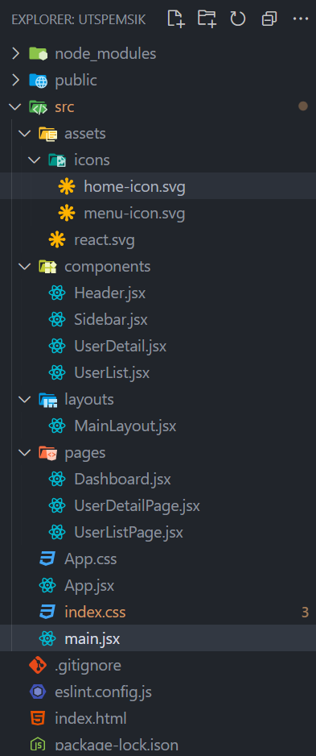

**App.jsx**

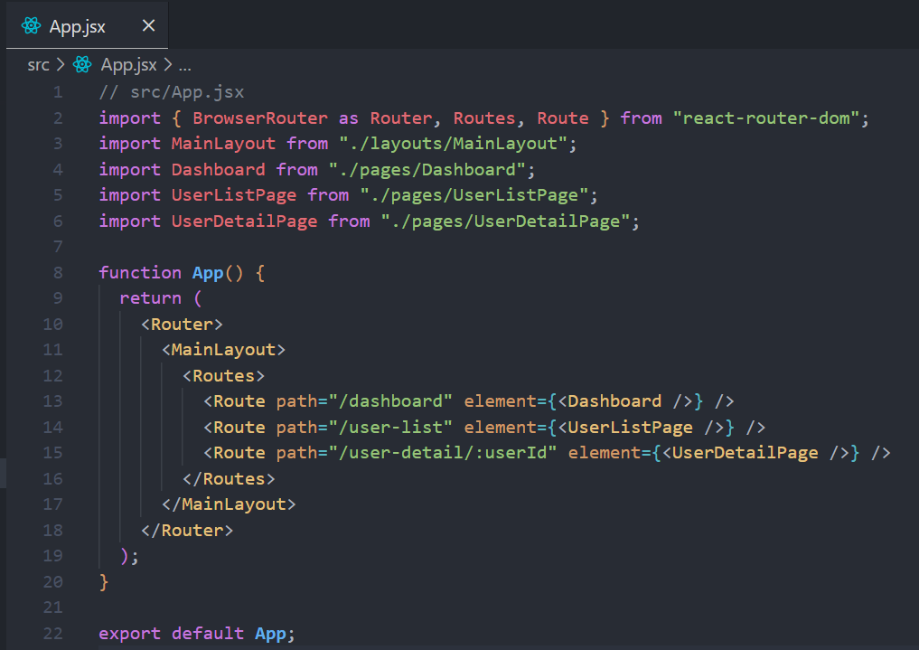

**index.css**

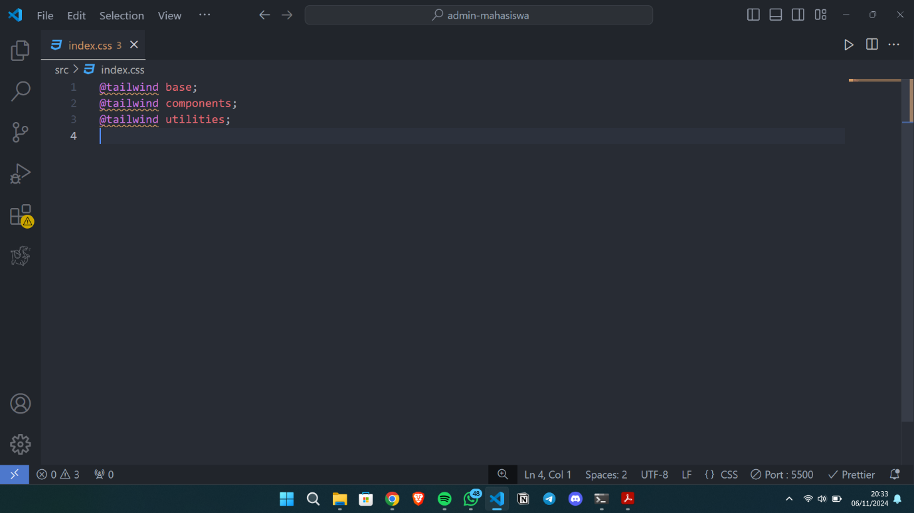

**Pages/Dashboard.jsx**

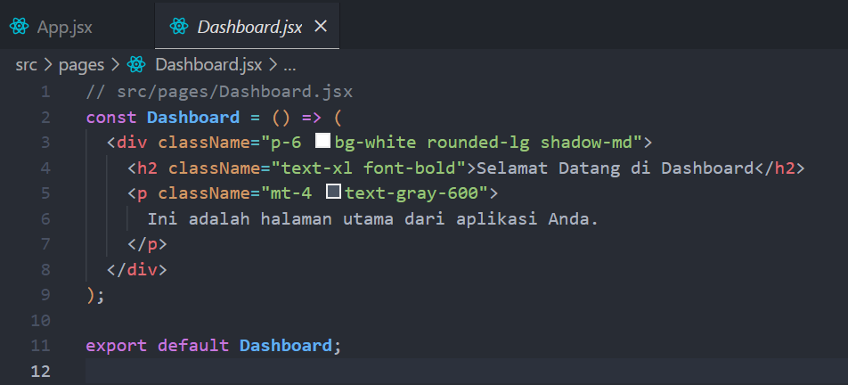

**pages/UserDetailPage.jsx**

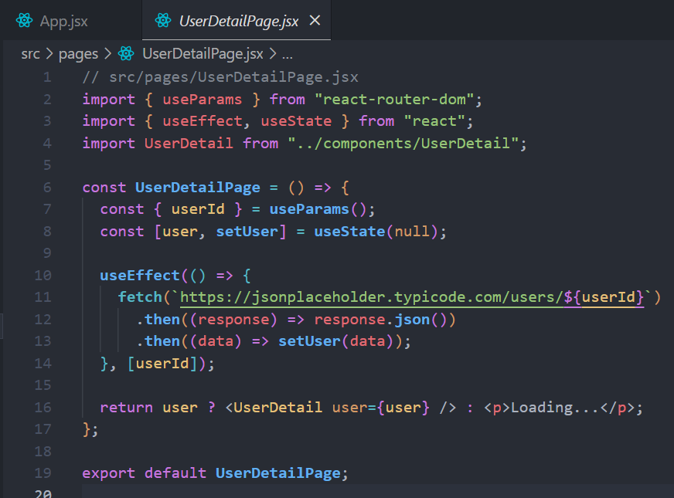

**pages/UserListPage.jsx**

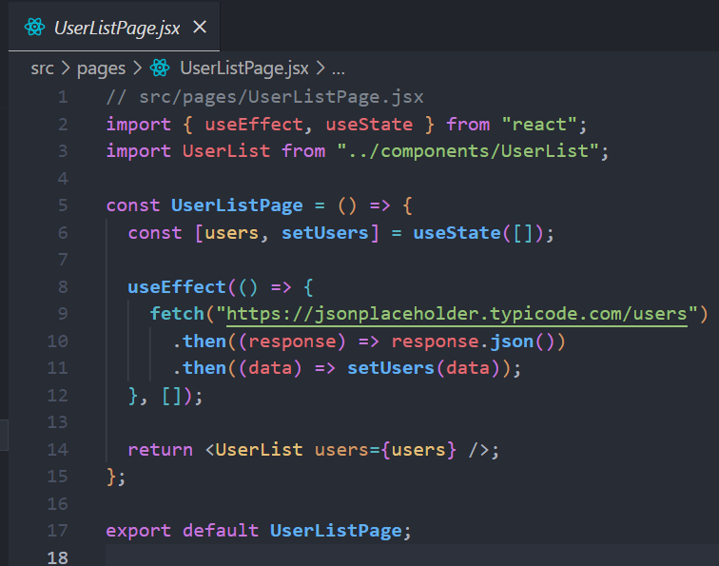

**layouts/MainLayout.jsx**

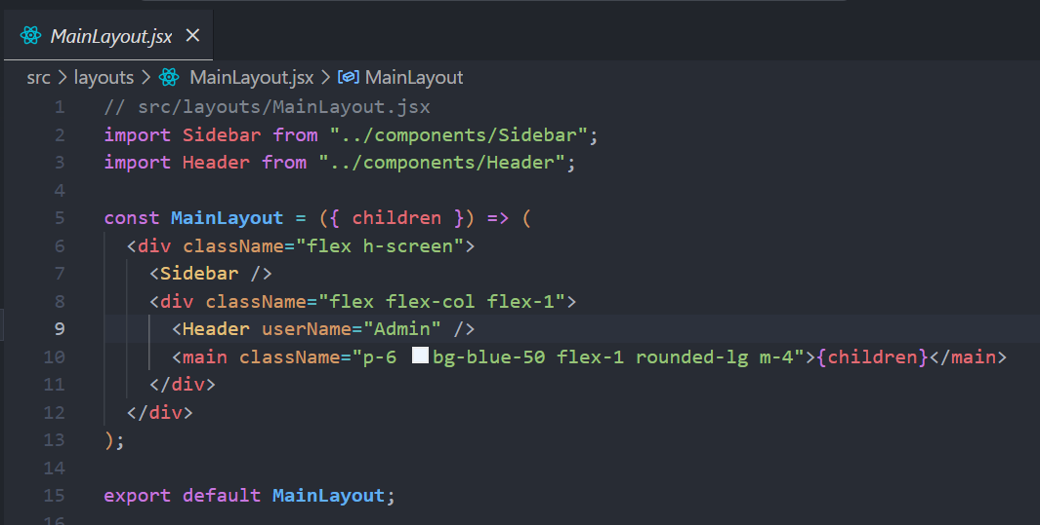

**Components**

**UserList.jsx**

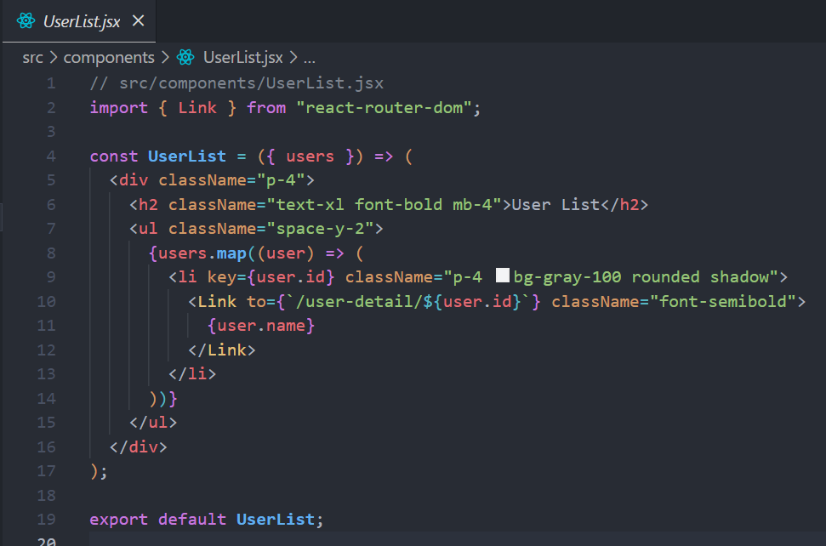

**UserDetail.jsx**

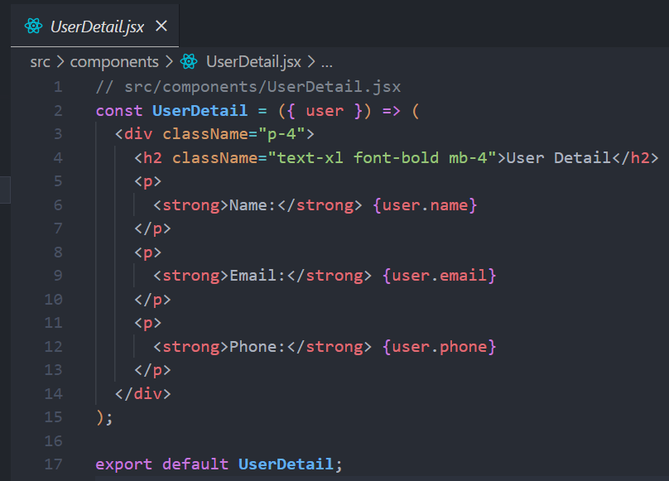

**Sidebar.jsx**

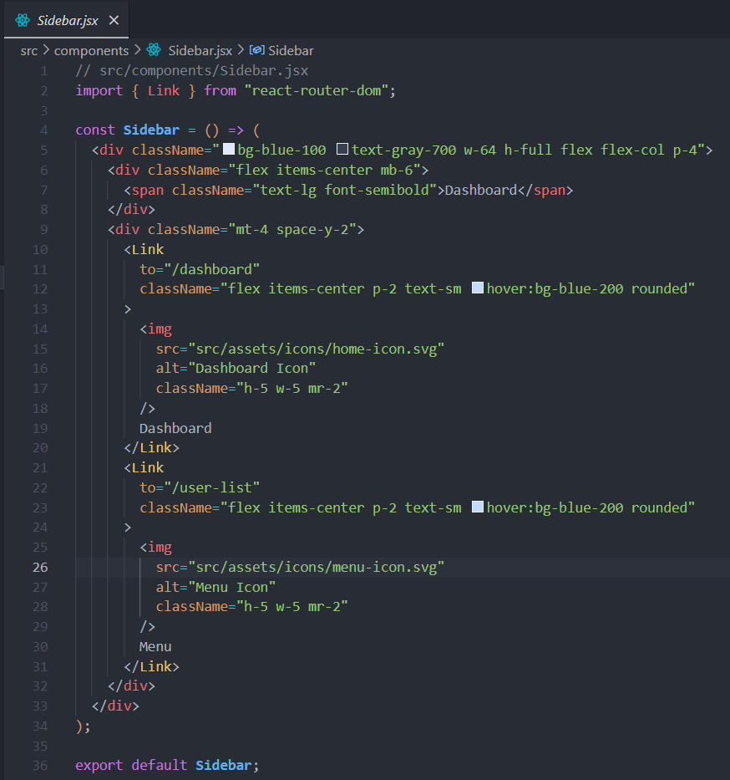

**Header.jsx**

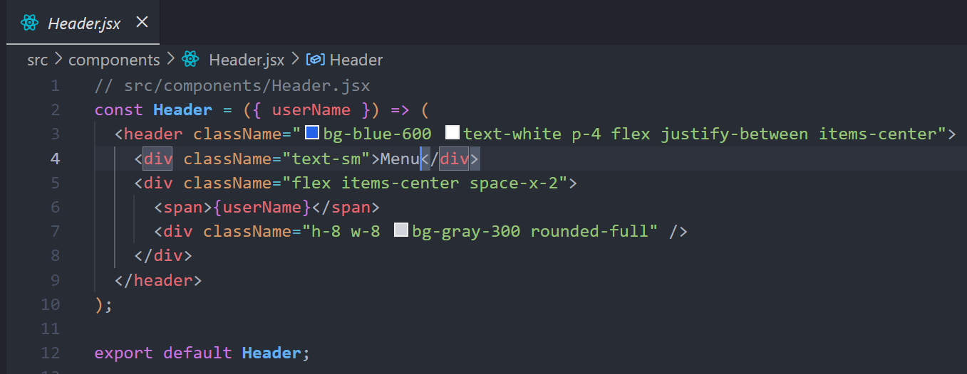

**Hasil**

**Dashboard**

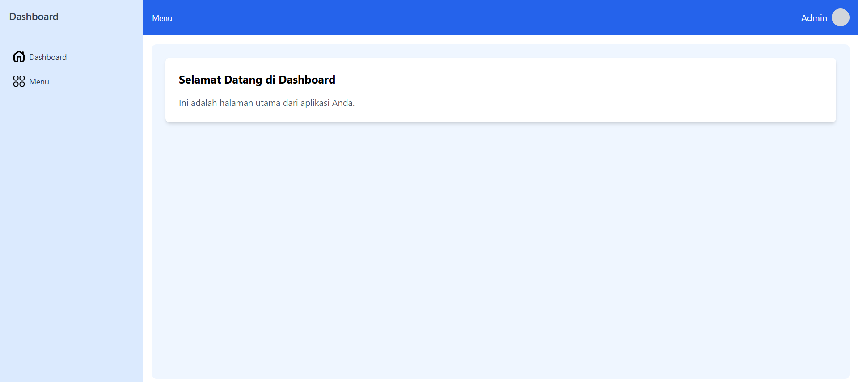

**Menu**

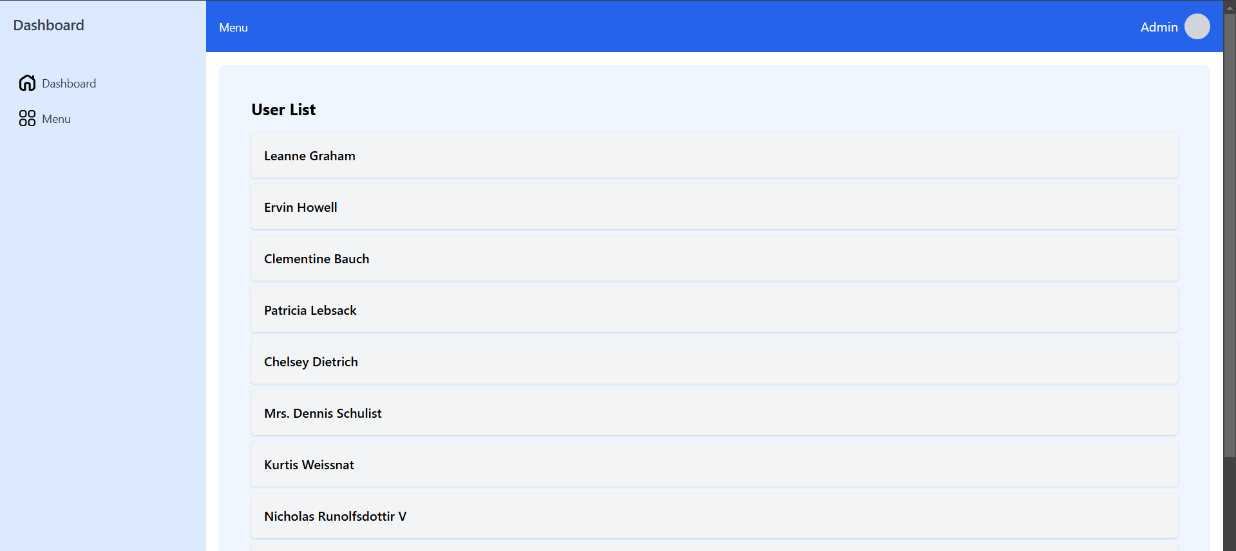

**User Detail Page**

