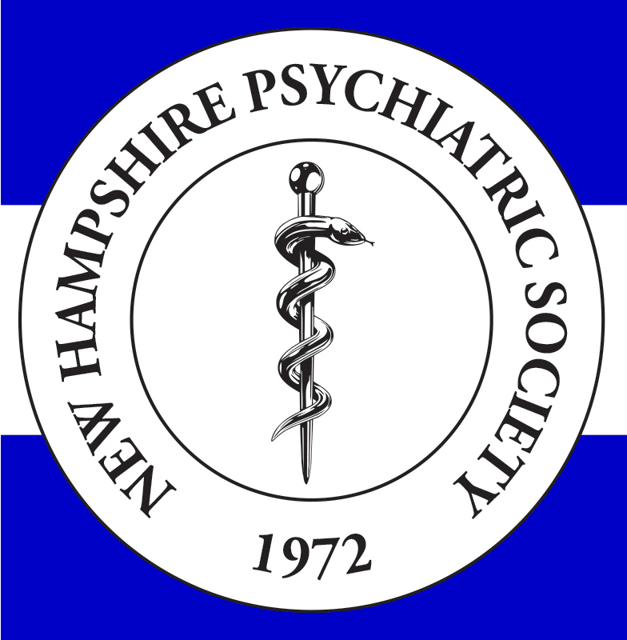 | New Hampshire Psychiatric Society  Newsletter
Fall 2015 | We exist to bring together psychiatrists to work for the benefit  of our patients and our profession.
In This Issue:
- President’s Message
- Legislative Update
- Letter From the Editor
- Firearm Safety
- Resident’s Column

Contact Us:
President: Lisa Mister, MD
lisa.A.Mistler@dartmouth.edu

Editor: Leonard Korn, MD
lenkorn.md@gmail.com

Exec. Director: Catrina Watson
Catrina.watson@nhms.org

President’s Message
Since I don’t tend to write things like this very often, I looked
around on the APA and DB websites for examples of
“President’s Letters.” I couldn’t quite find anything that felt
like my style, so here goes. I certainly did not expect Jeff to
ask me if I would consider being President, but when he
did, it occurred to me that most everyone else around the
Executive Board table had served at least once, and that
many of the Presidents I knew had left or retired. It
seemed like the right time to commit to paying back all of
the hard work that folks before me had put into the job.
I missed the first meeting in July because I had laryngitis, but since then have been trying to learn the ropes from Jeff and Catrina.

One of the key roles NHPS plays is to provide a voice in the legislature, for our patients and for our profession. We will continue to advocate actively at the Statehouse, with Jeff Fetter as our legislative representative. He and I may be reaching out to some of you to testify at crucial legislative hearings during the session, and hope the legislators can hear from as many of you as possible. As Alex deNesnera showed us during the years he was legislative rep, NHPS can make important changes to the NH statutes that affect our lives and our patients’ lives.

I know that previous Presidents had specific issues they concentrated on during their tenure. When I thought about what I wanted to focus on, I realized that I don’t have a sense of what is important to the membership across the state. In order to better serve the membership, the Exec Board will be sending a survey via SurveyMonkey to all of you to please complete. It will be one open-ended question, “What do you want to see NHPS focus on this year and next?” As a small token of our appreciation for your input, we will be sending you a gift card for $5. Please take the time to fill it out. We will collate the results and report them to you in the next Newsletter.

Those of you that know me know I am passionate about the practice of psychiatry. It is from that standpoint that I find the work we do on behalf of our members, patients, and profession very satisfying. I look forward to the next year, working side by side with my wonderful and thoughtful colleagues on the Exec Committee.

Lisa Mistler, MD



Legislative Session Overview
SB 23: Signed into law. The Psychiatric Society supported the bill which provides APRN’s that have received additional training with the ability to admit individuals to NH Hospital.
HB 422: Amended to remove provisions which would have provided similar abilities to physician assistants. It provides PAs with the authority to sign death certificates.
HB 564: Passed by legislature, still before the governor. Requires several reports to the Health and Human Services Oversight Committee relative to the efficacy of the prohibition on prior authorization for certain mental health prescriptions for individuals on Medicaid. Updates from the Department and Community mental health centers are required in July, August, September, and November.
SB 84: Passed by legislature, before the governor as well. It would become effective 60 days after being signed by the Governor with compromise language on controlled substances and telemedicine.
Other legislation of interest which has been passed into law:
HB 271 - relative to possession and administration of an opioid antagonist for opioid-related overdoses. http://www.gencourt.state.nh.us/legislation/2015/HB0271.html
HB 422 - relative to certification of death certificates by physician assistants. http://www.gencourt.state.nh.us/legislation/2015/HB0422.html
SB 22 - relative to certain changes in the law governing the therapeutic use of cannabis. http://www.gencourt.state.nh.us/legislation/2015/SB0022.html
SB 23 - allowing certain advanced practice registered nurses to authorize involuntary commitment and voluntary admission to state institutions. http://www.gencourt.state.nh.us/legislation/2015/SB0023.html
SB 31 - relative to the controlled drug prescription health and safety program. http://www.gencourt.state.nh.us/legislation/2015/SB0031.html
SB 33 - relative to continuing education requirements for mental health practitioners on suicide prevention. http://www.gencourt.state.nh.us/legislation/2015/SB0033.html

HB 128 - authorizing individuals and certain businesses to purchase health insurance from out-of-state companies.
http://www.gencourt.state.nh.us/legislation/2015/HB0128.html

HB 593 - permitting qualifying patients and registered caregivers to cultivate cannabis for therapeutic use.
http://www.gencourt.state.nh.us/legislation/2015/HB0593.html

SB 67 - establishing a commission to study opioid misuse in New Hampshire.
http://www.gencourt.state.nh.us/legislation/2015/SB0067.html

SB 131 - authorizing individuals and certain businesses to purchase health insurance from out-of-state companies.
http://www.gencourt.state.nh.us/legislation/2015/SB0131.html

SB 138 - relative to claims arising from clinical services provided to the department of corrections.
http://www.gencourt.state.nh.us/legislation/2015/SB0138.html

SB 224 - making a capital appropriation for the Valley Regional Hospital in Claremont to construct an involuntary commitment mental health facility.
http://www.gencourt.state.nh.us/legislation/2015/SB0224.html

SB 56 - establishing a commission to study oversight, regulation, and reporting of patient safety and health care quality issues. http://www.gencourt.state.nh.us/legislation/2015/SB0056.html
SB 96 - establishing a commission to study the expansion of rights of defense and indemnification under RSA 99-D to proceedings against state employees before professional licensing boards. http://www.gencourt.state.nh.us/legislation/2015/SB0096.html
SB 114 - enabling a driver’s license applicant to request that his or her license indicate that he or she has a medically recognized disorder. http://www.gencourt.state.nh.us/legislation/2015/SB0114.html
Other Legislation of interest passed by both the House and Senate but not yet acted on by the Governor:
HB 330 - establishing an oversight commission for medical cost transparency. http://www.gencourt.state.nh.us/legislation/2015/HB0330.html
HB 476 - amending the definition of “qualifying medical condition” in the therapeutic cannabis law. http://www.gencourt.state.nh.us/legislation/2015/HB0476.html
HB 483 - relative to the commission on primary care workforce issues. http://www.gencourt.state.nh.us/legislation/2015/HB0483.html
HB 508 – relative to the dissolution of the New Hampshire medical malpractice joint underwriting association and relative to cost-sharing parity for oral anti-cancer therapies. http://www.gencourt.state.nh.us/legislation/2015/HB0508.html
HB 564 - relative to prior authorization for certain prescription drugs. http://www.gencourt.state.nh.us/legislation/2015/HB0564.html
SB 84 - relative to the definition of “telemedicine.” http://www.gencourt.state.nh.us/legislation/2015/SB0084.html
SB 112 - requiring the Medicaid managed care program to cover telemedicine services. http://www.gencourt.state.nh.us/legislation/2015/SB0112.html

Continued on next page

Legislative Session Overview cont.
Legislation which was retained/referred
HB 128 - authorizing individuals and certain businesses to purchase health insurance from out-of-state companies. http://www.gencourt.state.nh.us/legislation/2015/HB0128.html
HB 593 - permitting qualifying patients and registered caregivers to cultivate cannabis for therapeutic use. http://www.gencourt.state.nh.us/legislation/2015/HB0593.html
SB 67 - establishing a commission to study opioid misuse in New Hampshire. http://www.gencourt.state.nh.us/legislation/2015/SB0067.html
SB 131 - authorizing individuals and certain businesses to purchase health insurance from out-of-state companies. http://www.gencourt.state.nh.us/legislation/2015/SB0131.html
SB 138 - relative to claims arising from clinical services provided to the department of corrections. http://www.gencourt.state.nh.us/legislation/2015/SB0138.html
SB 224 - making a capital appropriation for the Valley Regional Hospital in Claremont to construct an involuntary commitment mental health facility. http://www.gencourt.state.nh.us/legislation/2015/SB0224.html

Letter from the Editor
Len Korn, MD
Today really felt like fall with cold, clouds, wind and a little rain. Changes are in the air, whether we like it or not, and that goes for psychiatry and medicine as well for the seasons. Change is not easy for any of us, but we certainly need to adapt to survive.

This NHPS Newsletter is the first with Lisa Mistler, MD as our newly elected President. We also have several relatively new Executive Council members that I’d like to introduce: Osvaldo Evangelista, MD, from Riverbend Community Mental Health Center, Isabel Norian. MD, from Center for Life Management, Rusty Kawatsuji, MD, from New Hampshire Hospital;, and Patrick Ho, MD, Dartmouth Psychiatry Resident.
Since the last Newsletter NHPS has continued to try to facilitate some reasonableness in the prior authorization process. Ken Cohen, Isabel Norian, Jeff Fetter and others are active in this area for all of NH psychiatry.

NHMS is also addressing this issue along with NHPS and other specialty societies. Please consider sharing your thoughts and even your energy with us as we try to change this time-consuming and mostly useless PA process.

On September 26th NHPS is joining with the Maine Association of Psychiatric Physicians for a social evening for residents, board members and guests in the Seacoast (Throwback Brewery at Hobbs Farm in North Hampton). The details are included in a separate notice in this Newsletter. Please consider attending and meeting residents and more seasoned colleagues from both NH and Maine in this first joint venture of our neighboring societies.

We are planning to have a special Resident’s Column for future editions of the NHPS Newsletter, as NHPS tries to facilitate connections between all psychiatrists, young and not-so-young. We are all busy in our lives and practice, but we are stronger when we communicate with each other. Please let us hear from you through email, phone, articles, letters to the editor, book reviews, even poetry.

Continued on next page

Does NHPS have your email address? To keep your membership costs down, we try to utilize electronic communications as much as possible. Please make sure we have your email address.
Catrina.watson@nhms.org

Writers Wanted

The NHPS Newsletter staff welcome content from our readers. Please consider sharing your thoughts and words about psychiatry in 2015 and the future with the New Hampshire community of psychiatrists.

We accept letters to the editor, articles, book reviews or commentaries. Let us hear from you!

Email Len at len.korn.md@gmail.com, Jeff at jfetter@mhn-services.com or Catrina at Catrina.Watson@nhms.org.


Letter from the Editor cont.

At our last board meeting we discussed how best to represent psychiatry in NH for our loyal NHPS members and other NH psychiatrists who haven’t yet joined. We considered a directed questionnaire, asking for your input in many specified areas and topics of interest or concern. However, we thought we would try very simply to just ask an open-ended question and to try to encourage response by giving a five dollar coupon (to Dunkin Donuts?) to all respondents. The survey can be through Survey Monkey or through email lenkorn.md@gmail.com .

The single survey question is as follows: What are the issues that you feel are most important for NHPS to be active in for 2015 through 2016? Thanks for your participation in this survey. We need to hear from you!

One final thought. I have always been in favor of a single-payer system, as far-fetched a dream that may be. I just never quite imagined that it would be Anthem/Cigna! Call your congressman! Help!

Firearm Safety in NH cont.
Cars are even being designed with automatic braking systems, just in case drivers are distracted. Not so with guns, as proposed safety regulations are often defeated with the slogan “just administer the laws we already have.” Those laws however are filled with loopholes that the NRA has promulgated in spite of the vast public support for reasonable gun regulations.

In NH the New Hampshire Medical Society has passed a comprehensive and reasonable first step in safer gun regulations for New Hampshire. This policy position includes promoting universal background checks for all gun purchases, safety locks and other safe storage proposals and the provision of the names of persons involuntarily committed the NHH to the national data bank (NICS). I suspect some or all of these safety provisions will be included in legislation for the next session of the NH legislature. I will provide more specific information when actual legislation is proposed so that organized medical support can provide a balance to the power of the NRA on this important public safety issue.

Firearm Safety in NH
Len Korn, MD
It is hard to have a discussion of firearm safety in our country without some context of the enormity of the problem. Every day in the US there are some 30 murders and 58 suicides by firearm. That is 88 families of victims and perpetrators every day dealing with death by firearms, 88 police departments, 88 communities traumatized by violent death.

In the US we have a firearm homicide rate 20 times higher than the combined rate of 22 countries similar in wealth and population to us. American children die by guns 11 times as often as children from countries similar to ours. Indeed, having a gun in the home is 22 times more likely to be used to kill or injure in a domestic homicide, suicide or unintentional shooting than used in self-defense.

Often, when I bring up the issue of gun violence with colleagues and friends, this issue is often dismissed as being too “political.” Well, it is true that this aspect of public safety has been highly politicized by the NRA, so that our country leads so dramatically in these horrible statistics and safety.

I often contrast firearm safety in our country with automobile safety. Thanks to Ralph Nader and so many others we have a remarkably declining death rate on our roads. Indeed, cars of the future may drive themselves, hopefully even more safety than at present.
The Fishing Bobber
By J.R., MD
Do you know the nature of the fishing bobber?
How the precious vessel glides upon a pond,
With every crest and trough,
Like human bonds,
Floating in daylight?

The scintillating surface is a smaller glove,
For keeping youthful desires warm.
In truly deep water,
Rests real reform.
It’s…alchemical.

Now dragged down by the universal attraction
Resistance creates turbidity
And as water weight builds,
The heart’s proclivity
Writhes beyond daylight.

However, a bobber can reach a place of such depth,
that it slows to a gentle creep,
And thanks to perseverance, it warmly floats again
without a glove in the deep.



ADULT PSYCHIATRIST
Seeking a fulltime or part time, fee for service board certified psychiatrist licensed to practice in New Hampshire to join a busy, well-established mental health practice with over twenty providers and three locations.
Affiliation with managed care organizations and an interest working with adults preferred.

If interested, please send Curriculum Vitae to:

William B. Flynn, Ph.D.
Executive Director
MERRIMACK VALLEY COUNSELING ASSOCIATION
39 Simon Street, Unit #2A
Nashua, NH 03060
Tel. (603) 888-4347
Fax (603) 577-9157
E-mail: flynnwb@franklinpierce.edu

