**Presentation**

**by**

**Timothy E. Wilens, MD**

**“**When Substance Abuse & Juvenile Bipolar Disorder Meet:

An Explosive Combination**”**

**Please join your colleagues at the N.H. Psychiatric Society**

**Annual Spring Meeting, Awards Dinner &**

**Scientific Presentation**

### Thursday, May 23, 2013

**5:30 - 8:30 p.m.**

Lake Sunapee Country Club 100 Country Club Lane

New London, N.H.

**Timothy Edwin Wilens, MD** is a senior staff member in the Pediatric Psychopharmacology Clinic and Research Program and director of the Center for Addiction Medicine at Massachusetts General Hospital in Boston. Widely published, Dr. Wilens has more than 300 original articles, reviews, chapters and editorials to his credit.

Dr. Wilens is a consultant on substance abuse to the National Football League and Major League Baseball and is consistently named one of the “Best Doctors in America” for psychiatry.

In this talk, participants will learn the major symptoms and presentation of bipolar disorder in adolescents, and the relationship of substance abuse in adolescents and young adults with bipolar disorder. Participants will also learn treatment strategies for individuals affected with bipolar disorder and substance use disorders.

**Leadership Award**

The N.H. Psychiatric Society Leadership Award has been established this year to recognize and encourage excellence in advancing the goals of the society.  Recipients may be nominated at any time by any society member, who can write a letter in support of the nomination. Recipients will be chosen by the Executive Council.  The award will be bestowed based on meeting at least one of three criteria: demonstrating leadership by excellent clinical example, advancing the care of the mentally ill in New Hampshire through exemplary public service or outstanding service to the N.H. Psychiatric Society.

Awards this year will be presented to:

**Louis Josephson, PhD and**

**Judge Richard A. Hampe**

**REGISTRATION FORM**:

PLEASE RESERVE _____ PLACE(S) FOR ME AT THE MAY 23, 2013, MEETING

*$25.00 per person\**

*Limited Seating*

*Please register before* ***May 15***

Name: _____________________________

PLEASE PRINT

Indicate if you are a Resident ______

Address: ___________________________

___________________________________

Email address: ___________________________________

Fee enclosed ($25 each):_____________

___ Roasted Chicken

___ Potato Gnocchi w/ Spinach & mushrooms

*Residents will have fee refunded upon attending

*Make checks payable to:*

*N.H. Psychiatric Society*

*7 North State St.*

*Concord, NH 03301*

*Questions?*

*Please call Joy Potter at 603-224-7083*

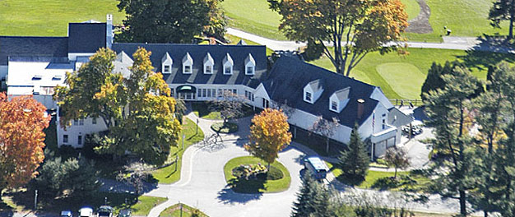

Concord Hospital designates this live activity for a maximum of one (1) *AMA PRA Category 1 Credit*(s)™. Physicians should claim only the credit commensurate with the extent of their participation in the activity.

“This activity has been planned and implemented in accordance with the Essential Areas and policies of the NHMS Council on Education through the joint sponsorship of **Concord Hospital and New Hampshire Medical Society.** Concord Hospital is accredited by the N.H. Medical Society Council on Education to provide continuing medical education for physicians.”

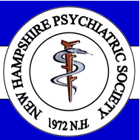

***Annual Spring Meeting, Awards Dinner &***

***Scientific Presentation***

**“**When Substance Abuse & Juvenile Bipolar Disorder Meet: An Explosive Combination**”**

### *May 23, 2013*