miniSQL 文本关系型数据库系统实现

课程:算法设计与分析 导师:宫秀军

2009硕士 李佳麒 2509218031

摘要：本文描述了使用java语言实现一个以文本方式作为存储媒介的关系型数据库系统的实现。支持简单的结构化查询语言(SQL)，即简单的数据库定义语言(DDL)与数据库操纵语言(DML)。SQL语句的解析由正则表达式分析形成语法树，然后进行语法、词法检查，交给执行器执行返回结果集或返回错误报告。

Abstract: This article describe a implemention of text storage RDMS in java language.It’s support simple SQL,DML & DDL .It’s use regular expression to compile the SQL language. Translate into syntax tree then execute or return an error report.

关键词：数据库； 关系型数据库； 文本存储；语法树；正则表达式；DDL；DML；

Keywords: database; RDBMS; text storage; syntax tree; regular expression; DDL; DML;

引言
关系型数据库系统，是当今广泛流行并使用的数据库系统。其身影几乎覆盖了所有行业领域，其重要地位由此可见一斑。

关系型数据库以行和列的形式存储数据，以便于用户理解。这一系列的行和列被称为表，一组表组成了数据库。表与表之间的数据记录有关系。用户用查询(Query)来检索数据库中的数据。一个Query是一个用于指定数据库中行和列的SELECT语句。关系型数据库管理系统中储存与管理数据的基本形式是二维表。

问题描述
此问题原形，来自于北大ACM月赛的一道模拟题(http://acm.pku.edu.cn/JudgeOnline/problem?id=3699)，问题描述如下:

2.1 Description
Joan is taking an internship at a company these days. Every day she is assigned tons of dull statistical jobs such as counting how many products made by the company values more than $100. In order to have more time to chat with the handsome intern nearby, she asks you to program a clever software that helps her get released from the onerous work.
The software should take as input a table of records together with several queries and for each query output all the records respectively.

2.2 Input
The first part of the input is a single line consisting of three integers, m(1 ≤ m ≤ 10), n(1 ≤ n ≤ 10000), k(1 ≤ k ≤ 100) indicating the number of columns in the table, the number of records and the number of queries.
The second part of the input is the description of the table, which consists of m lines. The i-th line of this part consists two strings in the format Column_Name Type which describes the i-th column of the table.
- Column_Name contains only letters(a-zA-Z), digits(0-9) and underline(_).
- Type is either "STR" or "INT" indicating the type of this column.
The third part of the input shows the content of the table which contains n lines. The i-th line of this part shows the i-th record in the table which consists of m items.
- if the type of the i-th column is "INT", the i-th item will be a 32-bit integer.
- if the type of the i-th column is "STR" , the i-th item will be a string containing only letters(a-zA-Z), digits(0-9) and underline(_).
The last part of the input gives the k queries which are similar to SQL select statements. The query is in the format select Column_List where Condition
- Column_List contains a list of column names which are separated by a single comma. All the names occured in the description of the table.
- Condition is in the format Column_Name Op Value
  - Column_Name is one of the column name in the description of the table.
  - if the column's type is "STR", Op is "=". Otherwise it may be "=", "<" or ">".
  - if the column's type is "STR", Value will be a quoted string containing only letters(a-zA-Z), digits(0-9) and underline(_). Otherwise it will be a 32-bit integer.
The size of the input will not exceed 1M bytes.

2.3 Output
For each query output a table and a blank line as Sample Output shows.
Sample Input
3 10 4
SID INT
NAME STR
PRIZE INT
1000 Potion 50
1001 Phoenix_Down 150
1002 Remedy 300
1003 Dagger 320
1004 Rod 260
1005 Flame_Staff 1100
1006 Broad_Sword 330
1007 Fork 1100
1008 Javelin 880
1009 Cats_Claws 4000
select SID,NAME,PRIZE where PRIZE>100
select SID,SID where NAME="Dagger"
select PRIZE where NAME="Rod"
select SID,NAME,PRIZE where NAME="Excalibur"
Sample Output

+-----------------------------+
| SID | NAME | PRIZE |
|------|--------------|-------|
| 1001 | Phoenix_Down | 150 |
| 1002 | Remedy | 300 |
| 1003 | Dagger | 320 |
| 1004 | Rod | 260 |
| 1005 | Flame_Staff | 1100 |
| 1006 | Broad_Sword | 330 |
| 1007 | Fork | 1100 |
| 1008 | Javelin | 880 |
| 1009 | Cats_Claws | 4000 |
+-----------------------------+

+-------------+
| SID | SID |
|------|------|
| 1003 | 1003 |
+-------------+

+-------+
| PRIZE |
|-------|
| 260 |
+-------+

+--------------------+
| SID | NAME | PRIZE |
|-----|------|-------|
+--------------------+

程序实现及分析

代码规模

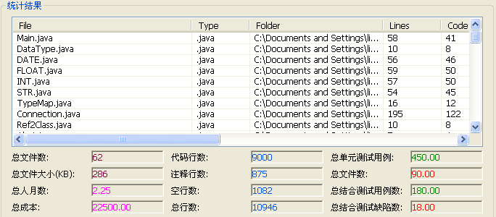
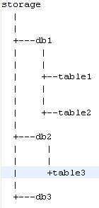
图 1 代码统计

3.2 存储结构
数据库引擎,数据库及数据表均采用目录和文件方式保存,其结构如图
private File databasefile ; //数据库目录
private File storge; //存储引擎目录
private File currenttable; //当前表文件
private static Connection connection; //连接

//单例模式保存数据库连接
public static Connection getInstance() throws InstantiationException, IllegalAccessException, ClassNotFoundException{
if(connection==null){
connection = new Connection();
}
return connection;
}

3.3 支持数据类型
字段类型数据接口:

public interface DataType {
public String getStringValue();
public int getLength();
public Class<?> getType();
public DataType getValue();
public int compare(String r);
}

支持数据类型:
- INT(整型)
- STR(字符型)
- DATE(日期)
- FLOAT(附点数)

3.4命令集
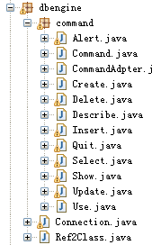
图表 2 命令集

支持具体命令:
- use $db
- create database $name
- show database
- show tables
- create table $name ($filed $type $length , $filed $type $length)
- select * from $table where $field=$cond
- describe $table;
- insert into $table value($value);

程序通过持续监听标准输入,接受命令移交给ParserManager处理,
try{
Command rc = Ref2Class.getCommand(res.toLowerCase().split(" ")[0]);
res = res.substring(0, res.length()-1);
rc.excuse(res);
}catch(Exception e){
System.out.println("unknow command");
}

所有命令均实现Command接口,此处运用了适配器模式,实际所有类均通过集成CommandAdpter类来完成对Command接口的实现.充分运用了多态.
每个命令执行器又通过反射将具体命令完成.

3.5 测试与执行
4 10
SID INT 8
NAME STR 20
SEX STR 2
AGE INT 8
1000 Potion F 22
1001 Phoenix_Down M 34
1002 Remedy M 52
1003 Dagger F 31
1004 Rod M 42
1005 Flame_Staff M 72
1006 Broad_Sword F 47
1007 Fork M 10
1008 Javelin M 85
1009 Cats_Claws F 37
1010 Dafei M 25
1011 Maliwen M 25

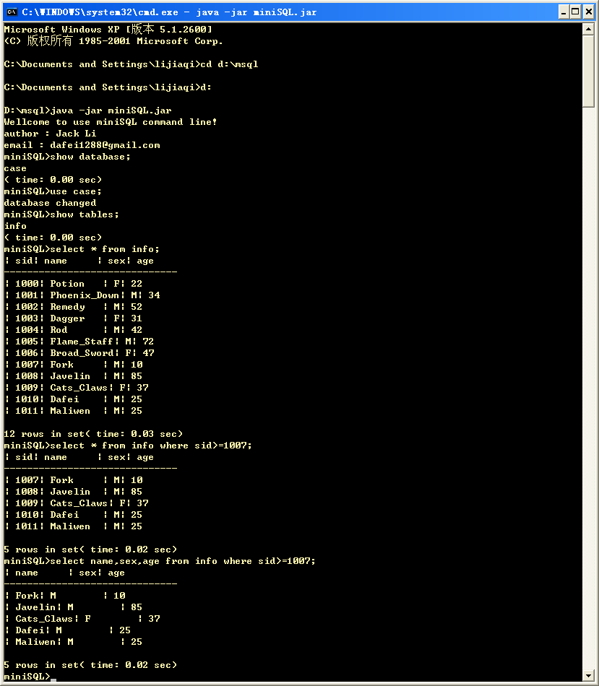

参考文献：
[1]: POJ http://acm.pku.edu.cn/JudgeOnline/problem?id=3699
[2]: Abraham Silberschatz ,<Database System Concepts>, Mc Graw Hill
[3]: Bruce Eckel , <Thinking in JAVA> , Prentice Hall PTR
[4]: Oreilly , < Head First Design Patterns>
[5]: Charles E. Leiserson , < Introduction to Algorithms > ¸ MIT

