**ESP32 Board With**

**16 Channel PWM Board**

# GPIO Definition

* 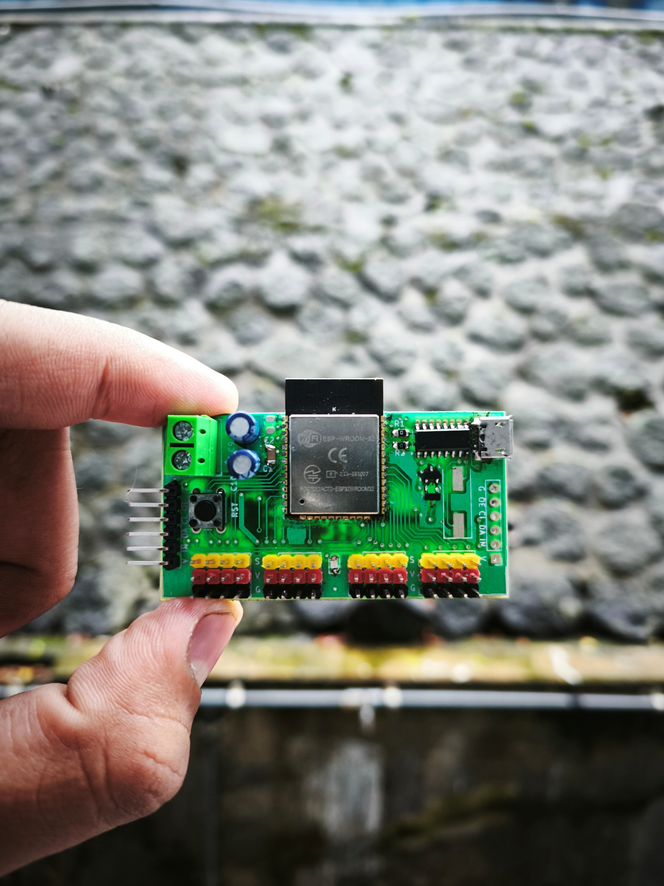Yellow Pin : Output Signal PWM
* Red Pin : Output Voltage Supply
* Black Pin : Ground

Input VCC

**\*Recommendation +5V**

**G** : Ground

**OE** : Output Enable

**CL** : I2C SCL

**DA** : I2C SDA

**IN** : Input Logic

**V** : Input VCC

**PWM1** : GPIO 32

**PWM2** : GPIO 33

**PWM3** : GPIO 25

**PWM4** : GPIO 26

**PWM5** : GPIO 27

**PWM6** : GPIO 14

**PWM7** : GPIO 12

**PWM8** : GPIO 13

**PWM9** : GPIO 2

**PWM10** : GPIO 4

**PWM11** : GPIO 16

**PWM12** : GPIO 17

**PWM13** : GPIO 5

**PWM14** : GPIO 18

**PWM15** : GPIO 19

**PWM16** : GPIO 23

# Spesification

|  |  |  |  |  |  |
| --- | --- | --- | --- | --- | --- |
| **Symbol** | **Parameter** | **Min** | **Typ** | **Max** | **Unit** |
| VCC | Supply Voltage for Output Pin | - | 5 | 5.3 | V |
| IN | Supply Voltage For Logic (Microcontroller) | 3.3 | - | 5.3 | V |
|  | High Level Input Voltage | - | - | 3.3 | V |
|  | Low Level Input Voltage | 0 | - | - | V |
|  | High Level Output Voltage | - | 3.3 | - | V |
|  | Low Level Output Voltage | 0 | - | - | V |
| Freq | Output Frequency Signal | - | - | 40 | Mhz |

# Information

In the red box in the picture there is a jumper pad. connected if the **VCC Input** also activates the logic supply (microcontroller). if not connected then the supply will be connected **independently**.

# Example Code

#define PWM_1 32

#define PWM_2 33

#define FREQUENCY 5000

#define BIT_WIDTH 12

void setup(){

Serial.begin(115200);

ledcAttach(PWM_1, FREQUENCY, BIT_WIDTH);

ledcAttach(PWM_2, FREQUENCY, BIT_WIDTH);

}

void loop(){

ledcFade(PWM_1, 0, 4095, 2000);

ledcFade(PWM_2, 0, 4095, 2000);

delay(1000);

}