NAMA : Daffa Dhiya Ulhaq Hirzillah

NIM : 1301174650

KELAS : IFIK-41-03

package segitigaimpal;

import java.util.Scanner;

public class Segitiga {

public static void main (String [] args) {

Scanner nilai= new Scanner (System.in);

int a, b ,c ;

System.out.print ("sisi1= ");

a = nilai.nextInt ();

System.out.print ("sisi2= ");

b = nilai.nextInt ();

System.out.print ("sisi3= ");

c = nilai.nextInt ();

if ((a == 0) || (b == 0) || (c == 0)) {

System.out.println("Bukan Segitiga");

} else {

if ((a == b) && (c == a))

System.out.println("Segitiga Sama Sisi");

else

if ((a == b) || (a == c) || (b == c))

System.out.println("Segitiga Sama Kaki");

else

System.out.println("Segitiga Sembarang");

}

}

}

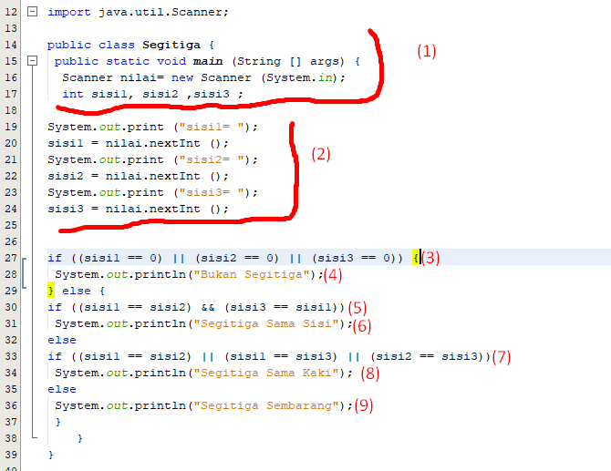

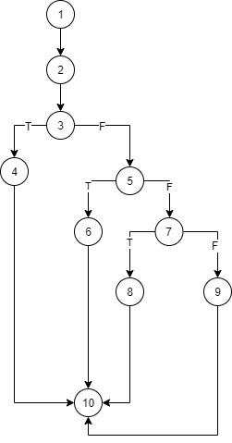

Since V(G) = 4

Path 1 = 1,2,3,4,10

Path 2 = 1,2,3,5,6,10

Path 3 = 1,2,3,4,5,7,8,10

Path 4 = 1,2,3,4,5,7,9,10