LAPORAN PRAKTIKUM 6

ANALISIS ALGORITMA



DISUSUN OLEH:

NAMA : Muhammad Daffa ALfarizqi

NPM : 140810180039

Program Studi S-1 Teknik Informatika

Departemen Ilmu Komputer

Fakultas Matematika dan Ilmu Pengetahuan Alam

Universitas Padjadjaran

2020

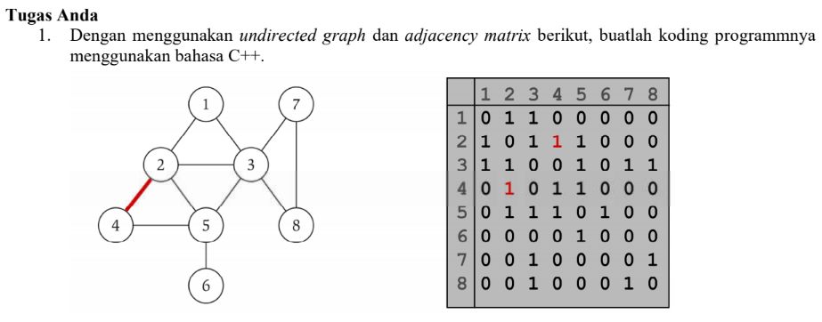

#include <iostream>

#include <cstdlib>

using namespace std;

#define MAX 20

*/\**

*\* Adjacency Matrix Class*

*\*/*

class AdjacencyMatrix

{

private:

int n;

int **adj;

bool *visited;

public:

AdjacencyMatrix(int n)

{

this->n = n;

visited = new bool [n];

adj = new int* [n];

for (int i = 0; i < n; i++)

{

adj[i] = new int [n];

for(int j = 0; j < n; j++)

{

adj[i][j] = 0;

}

}

}

*/\**

*\* Adding Edge to Graph*

*\*/*

void add_edge(int origin, int destin)

{

if( origin > n || destin > n || origin < 0 || destin < 0)

{

cout<<"Invalid edge!\n";

}

else

{

adj[origin - 1][destin - 1] = 1;

}

}

*/\**

*\* Print the graph*

*\*/*

void display()

{

int i,j;

for(i = 0;i < n;i++)

{

for(j = 0; j < n; j++)

cout<<adj[i][j]<<" ";

cout<<endl;

}

}

};

*/\**

*\* Main*

*\*/*

int main()

{

int nodes, max_edges, origin, destin;

cout<<"Enter number of nodes: ";

cin>>nodes;

AdjacencyMatrix am(nodes);

max_edges = nodes * (nodes - 1);

for (int i = 0; i < max_edges; i++)

{

cout<<"Enter edge (-1 -1 to exit): ";

cin>>origin>>destin;

if((origin == -1) && (destin == -1))

break;

am.add_edge(origin, destin);

}

am.display();

return 0;

}

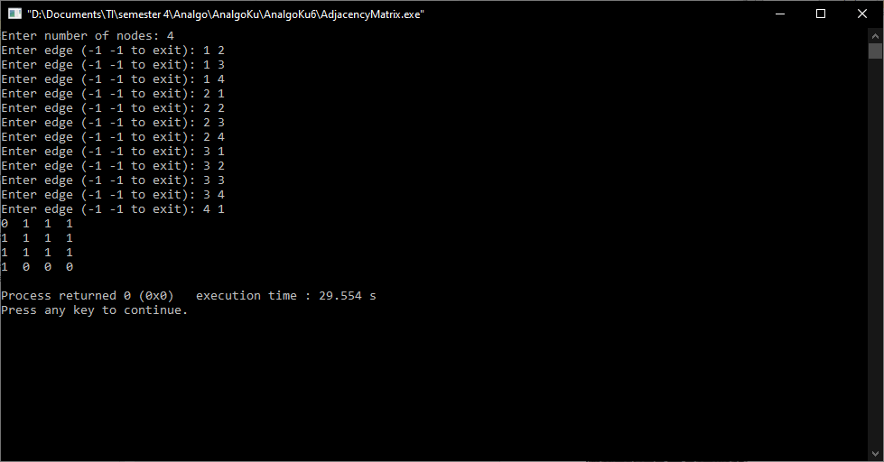

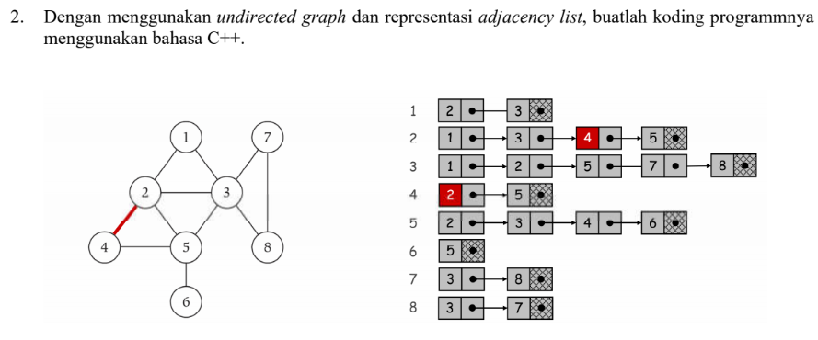

#include <iostream>

#include <cstdlib>

using namespace std;

*/\**

*\* Adjacency List Node*

*\*/*

struct AdjListNode

{

int dest;

struct AdjListNode* next;

};

*/\**

*\* Adjacency List*

*\*/*

struct AdjList

{

struct AdjListNode *head;

};

*/\**

*\* Class Graph*

*\*/*

class Graph

{

private:

int V;

struct AdjList* array;

public:

Graph(int V)

{

this->V = V;

array = new AdjList [V];

for (int i = 0; i < V; ++i)

array[i].head = NULL;

}

*/\**

*\* Creating New Adjacency List Node*

*\*/*

AdjListNode* newAdjListNode(int dest)

{

AdjListNode* newNode = new AdjListNode;

newNode->dest = dest;

newNode->next = NULL;

return newNode;

}

*/\**

*\* Adding Edge to Graph*

*\*/*

void addEdge(int src, int dest)

{

AdjListNode* newNode = newAdjListNode(dest);

newNode->next = array[src].head;

array[src].head = newNode;

newNode = newAdjListNode(src);

newNode->next = array[dest].head;

array[dest].head = newNode;

}

*/\**

*\* Print the graph*

*\*/*

void printGraph()

{

int v;

for (v = 1; v < V; ++v)

{

AdjListNode* pCrawl = array[v].head;

cout<<"\n Adjacency list of vertex "<<v<<"\n head ";

while (pCrawl)

{

cout<<"-> "<<pCrawl->dest;

pCrawl = pCrawl->next;

}

cout<<endl;

}

}

};

*/\**

*\* Main*

*\*/*

int main()

{

Graph gh(8);

gh.addEdge(1, 2);

gh.addEdge(1, 3);

gh.addEdge(2, 4);

gh.addEdge(2, 5);

gh.addEdge(2, 3);

gh.addEdge(3, 7);

gh.addEdge(3, 8);

gh.addEdge(4, 5);

gh.addEdge(5, 3);

gh.addEdge(5, 6);

gh.addEdge(7, 8);

*// print the adjacency list representation of the above graph*

gh.printGraph();

return 0;

}

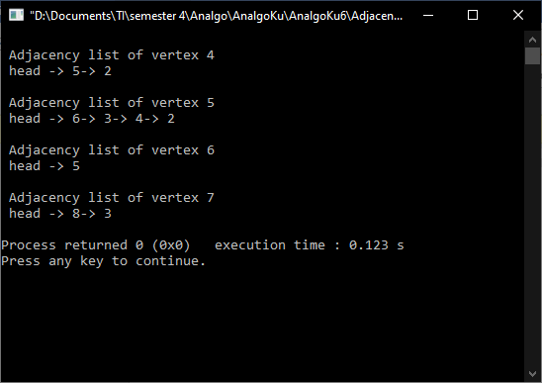

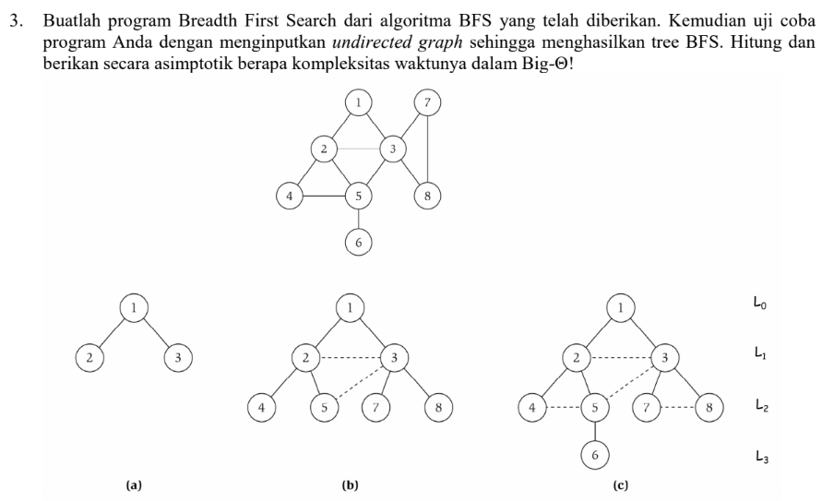

#include<iostream>

using namespace std;

int main(){

int vertexSize = 8;

int adjacency[8][8] = {

{0,1,1,0,0,0,0,0},

{1,0,1,1,1,0,0,0},

{1,1,0,0,1,0,1,1},

{0,1,0,0,1,0,0,0},

{0,1,1,1,0,1,0,0},

{0,0,0,0,1,0,0,0},

{0,0,1,0,0,0,0,1},

{0,0,1,0,0,0,1,0}

};

bool discovered[vertexSize];

for(int i = 0; i < vertexSize; i++){

discovered[i] = false;

}

int output[vertexSize];

*//inisialisasi start*

discovered[0] = true;

output[0] = 1;

int counter = 1;

for(int i = 0; i < vertexSize; i++){

for(int j = 0; j < vertexSize; j++){

if((adjacency[i][j] == 1)&&(discovered[j] == false)){

output[counter] = j+1;

discovered[j] = true;

counter++;

}

}

}

cout<<"BFS : "<<endl;

for(int i = 0; i < vertexSize; i++){

cout<<output[i]<<" ";

}

}

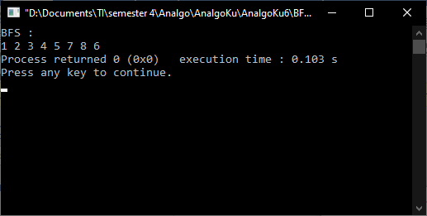

BFS adalah metode pencarian secara melebar, jadi mencari di 1 level dulu dari kiri ke kanan. Kalau sudah dikunjungi semua nodenya maka pencarian dilanjut ke level berikutnya. Worst case BFS harus mempertimbangkan semua jalur (path) untuk semua node yang mungkin, maka nilai kompleksitas waktu dari BFS adalah O( |V| + |E| ). Karena Big-O dari BFS adalah O(V+E) dimana V itu jumlah vertex dan E itu adalah jumlah edges maka Big-O = O(n) dimana n = v+e. Maka dari itu Big-Ө nya adalah Ө(n).

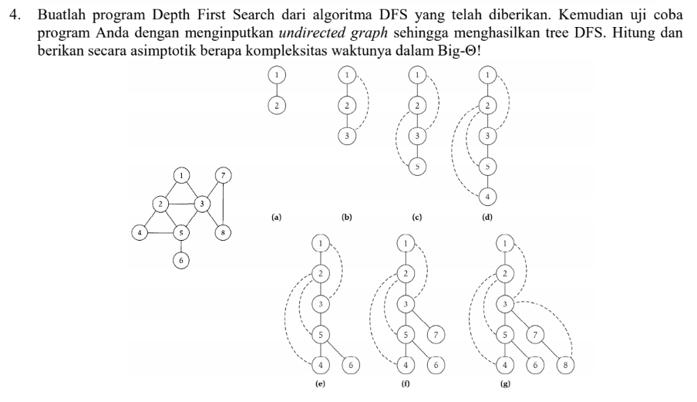

#include <iostream>

#include <list>

using namespace std;

class Graph{

int N;

list<int> *adj;

void DFSUtil(int u, bool visited[]){

visited[u] = true;

cout << u << " ";

list<int>::iterator i;

for(i = adj[u].begin(); i != adj[u].end(); i++){

if(!visited[*i]){

DFSUtil(*i, visited);

}

}

}

public :

Graph(int N){

this->N = N;

adj = new list<int>[N];

}

void addEdge(int u, int v){

adj[u].push_back(v);

}

void DFS(int u){

bool *visited = new bool[N];

for(int i = 0; i < N; i++){

visited[i] = false;

}

DFSUtil(u, visited);

}

};

int main(){

Graph g(8);

g.addEdge(1,2);

g.addEdge(1,3);

g.addEdge(2,3);

g.addEdge(2,4);

g.addEdge(2,5);

g.addEdge(3,7);

g.addEdge(3,8);

g.addEdge(4,5);

g.addEdge(5,3);

g.addEdge(5,6);

g.addEdge(7,8);

cout << "\nDFS Traversal Starts from Node 1" << endl;

g.DFS(1);

return 0;

}

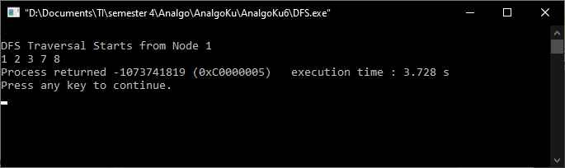

DFS merupakan metode pencarian mendalam, yang mengunjungi semua node dari yang terkiri lalu geser ke kanan hingga semua node dikunjungi. Kompleksitas ruang algoritma DFS adalah O(bm), karena kita hanya hanya perlu menyimpan satu buah lintasan tunggal dari akar sampai daun, ditambah dengan simpulsimpul saudara kandungnya yang belum dikembangkan.