**Laporan**

**“Login Firebase”**

Disusun sebagai

**MATA KULIAH : PBF**

Oleh :

**Daffa Tahta Akbar 1741720152**

**Kelas :**

**3B**



**PROGRAM STUDI D-IV TEKNIK INFORMATIKA**

**JURUSAN TEKNIK INFORMASI**

**POLITEKNIK NEGERI MALANG**

**2020**

1. Enable login email

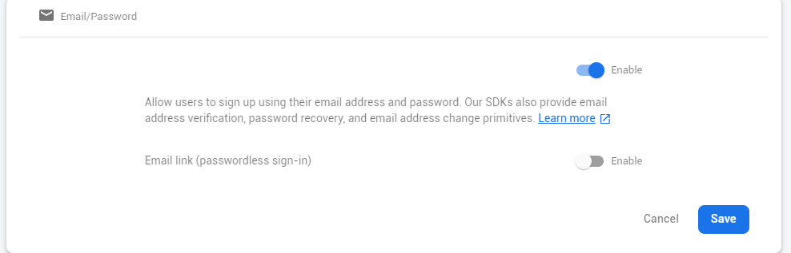

1. Buat database

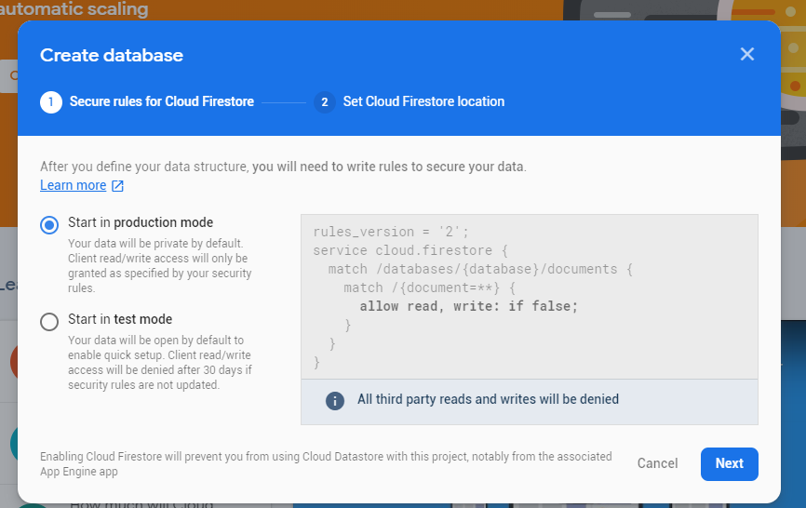

1. Create new react app
2. Install
   1. Npm install -g firebase-tools
   2. Firebase login
   3. Firebase init
3. Setting untuk firebase dan hosting
   1. Pilih build
   2. Lalu pilih overwrite
4. Install redux
   1. React-router-dom
   2. React-redux
   3. Redux-thunk
   4. Npm I firebase
   5. Npm I @material-ui/core
5. Install material icon

Npm I @material-ui-icons

1. Setting firebase config
   1. Pilih project setting
   2. Ke bagian </>
   3. Masukkan app nickname
   4. Centang hosting
   5. Click next lalu masuk ke project setting

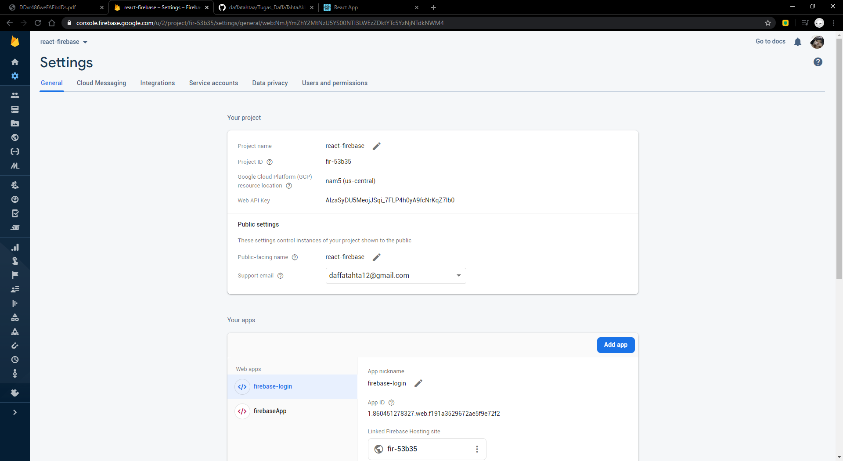

* 1. Masuk ke bagian your apps

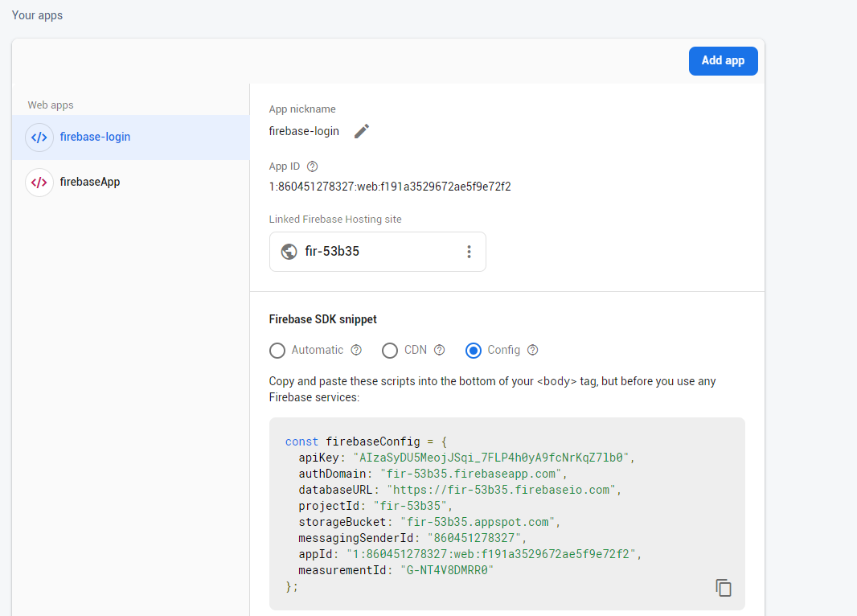

* 1. Ke bagian config
  2. Copy dan paste di firebase.js

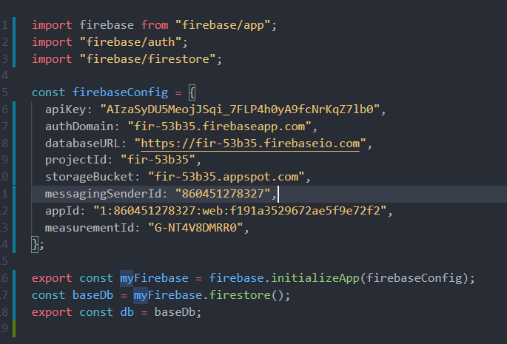

1. Edit file actions/auth.js

import { myFirebase } from "../firebase/firebase";

export const LOGIN_REQUEST = "LOGIN_REQUEST";

export const LOGIN_SUCCESS = "LOGIN_SUCCESS";

export const LOGIN_FAILURE = "LOGIN_FAILURE";

export const LOGOUT_REQUEST = "LOGOUT_REQUEST";

export const LOGOUT_SUCCESS = "LOGOUT_SUCCESS";

export const LOGOUT_FAILURE = "LOGOUT_FAILURE";

export const VERIFY_REQUEST = "VERIFY_REQUEST";

export const VERIFY_SUCCESS = "VERIFY_SUCCESS";

const requestLogin = () => {

return {

type: LOGIN_REQUEST,

};

};

const receiveLogin = (user) => {

return {

type: LOGIN_SUCCESS,

user,

};

};

const loginError = () => {

return {

type: LOGIN_FAILURE,

};

};

const requestLogout = () => {

return {

type: LOGOUT_REQUEST,

};

};

const receiveLogout = () => {

return {

type: LOGOUT_SUCCESS,

};

};

const logoutError = () => {

return {

type: LOGOUT_FAILURE,

};

};

const verifyRequest = () => {

return {

type: VERIFY_REQUEST,

};

};

const verifySuccess = () => {

return {

type: VERIFY_SUCCESS,

};

};

export const loginUser = (email, password) => (dispatch) => {

dispatch(requestLogin());

myFirebase

.auth()

.signInWithEmailAndPassword(email, password)

.then((user) => {

dispatch(receiveLogin(user));

})

.catch((error) => {

//Do something with the error if you want!

dispatch(loginError());

});

};

export const logoutUser = () => (dispatch) => {

dispatch(requestLogout());

myFirebase

.auth()

.signOut()

.then(() => {

dispatch(receiveLogout());

})

.catch((error) => {

//Do something with the error if you want!

dispatch(logoutError());

});

};

export const verifyAuth = () => (dispatch) => {

dispatch(verifyRequest());

myFirebase.auth().onAuthStateChanged((user) => {

if (user !== null) {

dispatch(receiveLogin(user));

}

dispatch(verifySuccess());

});

};

1. Edit reducers/index.js

import {

LOGIN_REQUEST,

LOGIN_SUCCESS,

LOGIN_FAILURE,

LOGOUT_REQUEST,

LOGOUT_SUCCESS,

LOGOUT_FAILURE,

VERIFY_REQUEST,

VERIFY_SUCCESS,

} from "../actions/auth";

export default (

state = {

isLoggingIn: false,

isLoggingOut: false,

isVerifying: false,

loginError: false,

logoutError: false,

isAuthenticated: false,

user: {},

},

action

) => {

switch (action.type) {

case LOGIN_REQUEST:

return { ...state, isLoggingIn: true, loginError: false };

case LOGIN_SUCCESS:

return {

...state,

isLoggingIn: false,

isAuthenticated: true,

user: action.user,

};

case LOGIN_FAILURE:

return {

...state,

isLoggingIn: false,

isAuthenticated: false,

loginError: true,

};

case LOGOUT_REQUEST:

return { ...state, isLoggingOut: true, logoutError: false };

case LOGOUT_SUCCESS:

return {

...state,

isLoggingOut: false,

isAuthenticated: false,

user: {},

};

case LOGOUT_FAILURE:

return { ...state, isLoggingOut: false, logoutError: true };

case VERIFY_REQUEST:

return { ...state, isVerifying: true, verifyingError: false };

case VERIFY_SUCCESS:

return { ...state, isVerifying: false };

default:

return state;

}

};

1. Setting redux plumbing
2. Pilih src folder called configureStore.js

import { applyMiddleware, createStore } from "redux";

import thunkMiddleware from "redux-thunk";

import { verifyAuth } from "./actions/auth";

import rootReducer from "./reducers";

export default function configureStore(persistedState) {

const store = createStore(

rootReducer,

persistedState,

applyMiddleware(thunkMiddleware)

);

store.dispatch(verifyAuth());

return store;

}

1. Pilih dan edit foldersrc dan root

import React from "react";

import { Provider } from "react-redux";

import { BrowserRouter as Router } from "react-router-dom";

import App from "./App";

import configureStore from "./configureStore";

const store = configureStore();

function Root() {

return (

<Provider store={store}>

{" "}

<Router>

{" "}

<App />{" "}

</Router>{" "}

</Provider>

);

}

export default Root;

1. Edit folder src/index.js

import React from "react";

import ReactDOM from "react-dom";

import Root from "./root";

import "./index.css";

import * as serviceWorker from "./serviceWorker";

ReactDOM.render(<Root />, document.getElementById("root"));

// If you want your app to work offline and load faster, you can change

// unregister() to register() below. Note this comes with some pitfalls.

// Learn more about service workers: https://bit.ly/CRA-PWA

serviceWorker.unregister();

1. Buat coding app.js

import React from "react";

import { Route, Switch } from "react-router-dom";

import { connect } from "react-redux";

import ProtectedRoute from "./components/protectedRoute";

import Home from "./components/Home";

import Login from "./components/Login";

function App(props) {

const { isAuthenticated, isVerifying } = props;

return (

<Switch>

<ProtectedRoute exact path="/" component={Home} isAuthenticated={isAuthenticated} isVerifying={isVerifying}/>

<Route path="/login" component={Login} />

</Switch>

);

}

function mapStateToProps(state) {

return {

isAuthenticated: state.auth.isAuthenticated,

isVerifying: state.auth.isVerifying

};

}

export default connect(mapStateToProps)(App);

1. Buatlah file dan simpan component/Login.js

import React, { Component } from "react";

import { connect } from "react-redux";

import { Redirect } from "react-router-dom";

import { loginUser } from "../actions/auth";

import { withStyles } from "@material-ui/styles";

import Avatar from "@material-ui/core/Avatar";

import Button from "@material-ui/core/Button";

import TextField from "@material-ui/core/TextField";

import LockOutlinedIcon from "@material-ui/icons/LockOutlined";

import Typography from "@material-ui/core/Typography";

import Paper from "@material-ui/core/Paper";

import Container from "@material-ui/core/Container";

const styles = () => ({

"@global": {

body: {

backgroundColor: "#fff",

},

},

paper: {

marginTop: 100,

display: "flex",

padding: 20,

flexDirection: "column",

alignItems: "center",

},

avatar: {

marginLeft: "auto",

marginRight: "auto",

backgroundColor: "#f50057",

},

form: {

marginTop: 1,

},

errorText: {

color: "#f50057",

marginBottom: 5,

textAlign: "center",

},

});

class Login extends Component {

state = { email: "", password: "" };

handleEmailChange = ({ target }) => {

this.setState({ email: target.value });

};

handlePasswordChange = ({ target }) => {

this.setState({ password: target.value });

};

handleSubmit = () => {

const { dispatch } = this.props;

const { email, password } = this.state;

dispatch(loginUser(email, password));

};

render() {

const { classes, loginError, isAuthenticated } = this.props;

if (isAuthenticated) {

return <Redirect to="/" />;

} else {

return (

<Container component="main" maxWidth="xs">

<Paper className={classes.paper}>

<Avatar className={classes.avatar}>

<LockOutlinedIcon />

</Avatar>

<Typography component="h1" variant="h5">

Sign in

</Typography>

<TextField

variant="outlined"

margin="normal"

fullWidth

id="email"

label="Email Address"

name="email"

onChange={this.handleEmailChange}

/>

<TextField

variant="outlined"

margin="normal"

fullWidthname="password"

label="Password"

type="password"

id="password"

onChange={this.handlePasswordChange}

/>

{loginError && (

<Typography component="p" className={classes.errorText}>

Incorrect email or password.

</Typography>

)}

<Button

type="button"

fullWidth

variant="contained"

color="primary"

className={classes.submit}

onClick={this.handleSubmit}

>

Sign In

</Button>

</Paper>

</Container>

);

}

}

}

function mapStateToProps(state) {

return {

isLoggingIn: state.auth.isLoggingIn,

loginError: state.auth.loginError,

isAuthenticated: state.auth.isAuthenticated,

};

}

export default withStyles(styles)(connect(mapStateToProps)(Login));

1. Buka component/Home.js

import React, { Component } from "react";

import { connect } from "react-redux";

import { logoutUser } from "../actions/auth";

class Home extends Component {

handleLogout = () => {

const { dispatch } = this.props;

dispatch(logoutUser());

};

render() {

const { isLoggingOut, logoutError } = this.props;

return (

<div>

<h1>This is your app's protected area.</h1>

<p>Any routes here will also be protected</p>

<button onClick={this.handleLogout}>Logout</button>

{isLoggingOut && <p>Logging Out....</p>}

{logoutError && <p>Error logging out</p>}

</div>

);

}

}

function mapStateToProps(state) {

return {

isLoggingOut: state.auth.isLoggingOut,

logoutError: state.auth.logoutError,

};

}

export default connect(mapStateToProps)(Home);

1. Run

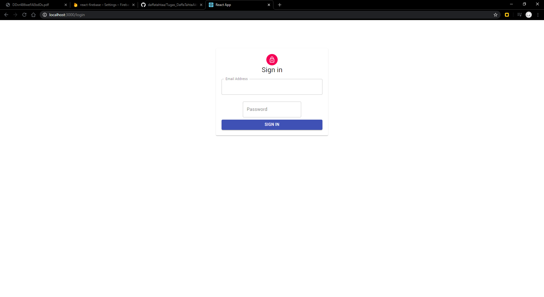

1. Link github: <https://github.com/daffatahtaa/Tugas_DaffaTahtaAkbar_1741720152_PBF/tree/master/LoginFIrebase/login-firebase>