**Laporan Praktikum**

**“React Firebase”**

Disusun sebagai

**MATA KULIAH : PBF**

Oleh :

**Daffa Tahta Akbar 1741720152**

**Kelas :**

**3B**



**PROGRAM STUDI D-IV TEKNIK INFORMATIKA**

**JURUSAN TEKNIK INFORMASI**

**POLITEKNIK NEGERI MALANG**

**2020**

**Praktikum**

1. Ketikkan *create-react-app react-firebase* untuk membuat project react yang baru
2. Di dalam folder src buatlah 6 file baru yaitu :
   1. Index.js
   2. Login.js
   3. Join.js
   4. Header.js
   5. routes.js
   6. styles.css
3. Setelah itu install react-dom dengan *react-router-dom*
4. Setelah terinstall buka file index.js dan ketikkan code berikut

import React, { useState } from "react";

import ReactDOM from "react-dom";

import { Switch, BrowserRouter as Router, Route } from "react-router-dom";

import routes from "./route.js";

import Header from "./Header";

import "./styles.css";

import * as firebase from "firebase";

import firebaseConfig from "./firebase.config";

firebase.initializeApp(firebaseConfig);

export const AuthContext = React.createContext(null);

function App() {

const [isLoggedIn, setLoggedIn] = useState(false);

return (

<AuthContext.Provider value={{ isLoggedIn, setLoggedIn }}>

Is logged in? {JSON.stringify(isLoggedIn)}

<div className="App">

<Router>

<Header />

<Switch>

{routes.map((route) => (

<Route

key={route.path}

path={route.path}

exact={route.exact}

component={route.main}

/>

))}

</Switch>

</Router>

</div>

</AuthContext.Provider>

);

}

const rootElement = document.getElementById("root");

ReactDOM.render(<App />, rootElement);

1. Lalu ke file Login.js dan ketikkan kode berikut

import React, { useState, useContext } from "react";

import { AuthContext } from "./index";

import * as firebase from "firebase";

const Login = () => {

const [email, setEmail] = useState("");

const [password, setPassword] = useState("");

const [error, setError] = useState("");

const Auth = useContext(AuthContext);

const handleForm = (e) => {

e.preventDefault();

firebase

.auth()

.signInWithEmailAndPassword(email, password)

.then((res) => {

if (res.user) Auth.setLoggedIn(true);

})

.catch((e) => {

setError(e.message);

});

};

return (

<div>

<h1>Login</h1>

<form onSubmit={(e) => handleForm(e)}>

<input

value={email}

onChange={(e) => setEmail(e.target.value)}

name="email"

type="email"

placeholder="email"

/>

<input

value={password}

onChange={(e) => setPassword(e.target.value)}

name="password"

type="password"

placeholder="password"

/>

<hr />

<button class="googleBtn" type="button">

<img

src="https://upload.wikimedia.org/wikipedia/commons/5/53/Google_%22G%22_Logo.svg"

alt="logo"

/>

Login With Google

</button>

<button type="submit">Login</button>

<span>{error}</span>

</form>

</div>

);

};

export default Login;

1. Edit file Join.js

import React, { useState, useContext } from "react";

import { AuthContext } from "./index";

import * as firebase from "firebase";

const Join = () => {

const [email, setEmail] = useState("");

const [password, setPassword] = useState("");

const [error, setError] = useState("");

const Auth = useContext(AuthContext);

const handleForm = (e) => {

e.preventDefault();

firebase

.auth()

.createUserWithEmailAndPassword(email, password)

.then((res) => {

if (res.user) Auth.setLoggedIn(true);

})

.catch((e) => {

setError(e.message);

});

};

return (

<div>

<h1>Join</h1>

<form onSubmit={(e) => handleForm(e)}>

<input

value={email}

onChange={(e) => setEmail(e.target.value)}

name="email"

type="email"

placeholder="email"

/>

<input

value={password}

onChange={(e) => setPassword(e.target.value)}

name="password"

type="password"

placeholder="password"

/>

<hr />

<button class="googleBtn" type="button">

<img

src="https://upload.wikimedia.org/wikipedia/commons/5/53/Google_%22G%22_Logo.svg"

alt="logo"

/>

Join With Google

</button>

<button type="submit">Join</button>

<span>{error}</span>

</form>

</div>

);

};

export default Join;

1. Edit Header.js

import React from "react";

import routes from "./route";

import { Link } from "react-router-dom";

const Header = () => (

<ul className="nav">

{routes.map((route, i) => (

<li key={i}>

<Link to={route.path}>{route.name}</Link>

</li>

))}

</ul>

);

export default Header;

1. Edit route.js

import React from "react";

import Login from "./Login";

import Join from "./Join";

const routes = [

{ name: "Join", path: "/", exact: true, main: () => <Join /> },

{ name: "Login", path: "/login", exact: true, main: () => <Login /> },

];

export default routes;

1. Edit style.css

.App {

font-family: sans-serif;

padding: 50px;

}

h1 {

margin: 0 0 25px 0;

text-align: left;

}

form {

display: flex;

flex-direction: column;

}

input {

max-width: 450px;

width: auto;

border: none;

margin: 0 0 25px 0;

box-shadow: 0 1px 3px rgba(0, e, 0, 0.12), e 1px 2px rgba(0, e, 0, 0.24);

transition: all 0.3s cubic-bezier(0.25, 0.8, 0.25, 1);

padding: 10px;

}

button {

width: 125px;

box-shadow: e 1px 3px rgba(0, e, 0, 0.12), 0 1px 2px rgba(e, 0, e, 0.24);

border: none;

padding: 7px;

text-align: center;

cursor: pointer;

}

button[type="submit"] {

background-color: #4c566a;

color: white;

font-size: 14px;

font-weight: 900;

border-radius: 5px;

text-transform: uppercase;

padding: 15p;

}

.googleBtn {

width: 225px;

margin: 0 0 50px 0;

display: flex;

justify-content: center;

font-size: 16px;

}

.googleBtn img {

width: 16px;

height: 16px;

padding: 0;

margin: 0 5px;

vertical-align: middle;

}

.nav {

display: flex;

text-decoration: none;

list-style-type: none;

justify-content: flex-start;

margin: 0 0 50px;

padding: 0;

}

.nav li {

margin: 0 10px;

}

1. Kemudian buika console firebase dan buat projectbaru

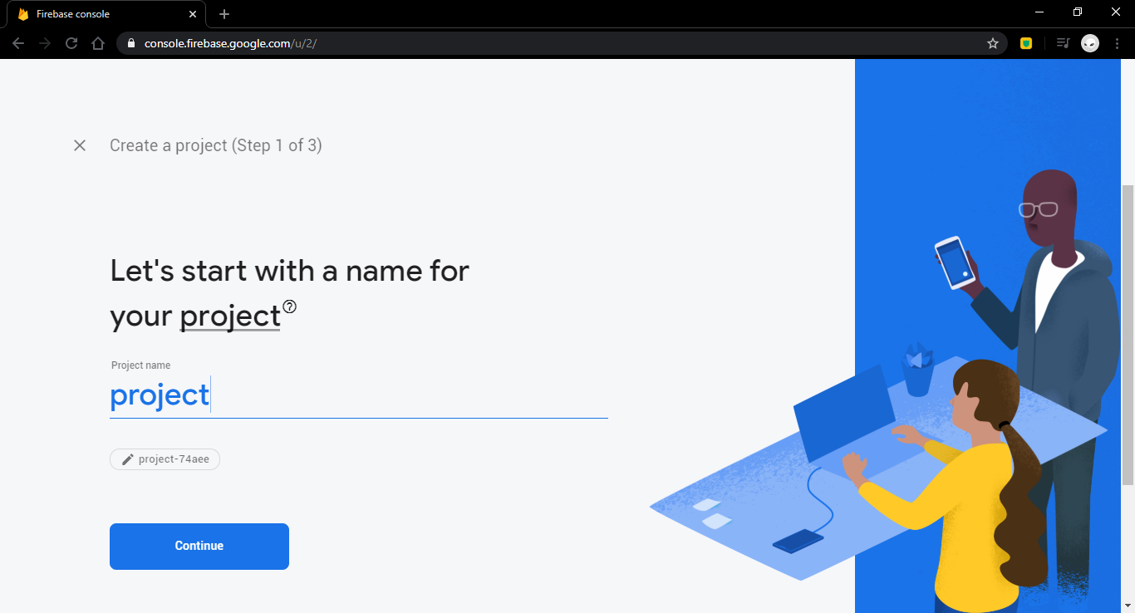

1. Lalu install firebase di react dengan cara *npm i –save firebase*
2. Setelah firebase selesai di buat pilih bagianyang web supaya bisa terhubung

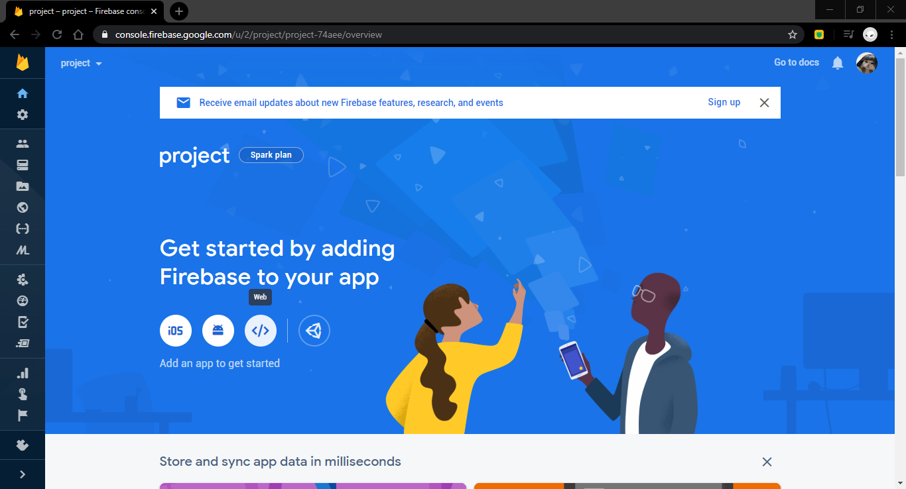

1. Pada **Firebase SDK Snippet** pilih bagian Config lalu copy

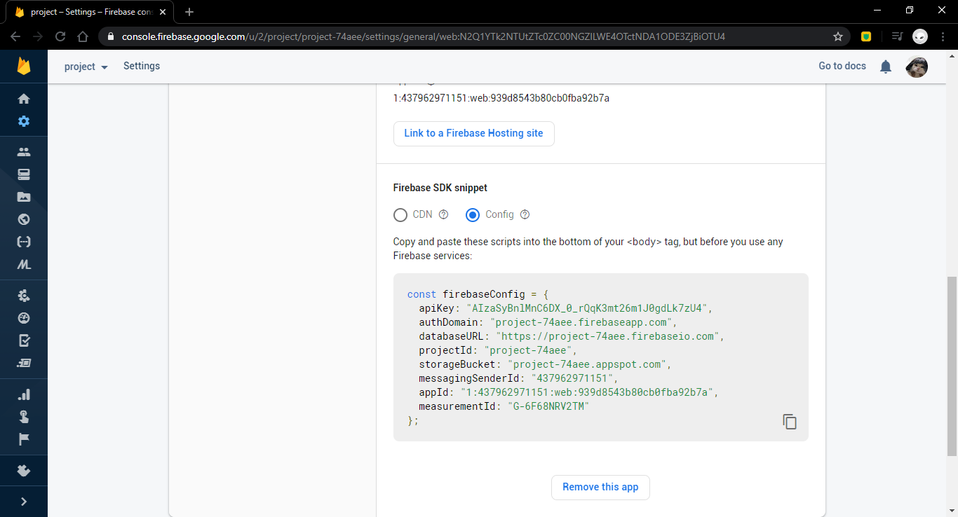

1. Buat file baru dengan nama firebase.config.js
2. Paste code yang telah di copy tersebut
3. Tambahkan line code ini di index.js

import * as firebase from "firebase";

import firebaseConfig from "./firebase.config";

firebase.initializeApp(firebaseConfig);

1. Tambah dan rubah Join.js

import * as firebase from “firebase”;

di method auth :

const handleForm = (e) => {

e.preventDefault();

firebase

.auth()

.createUserWithEmailAndPassword(email, password)

.then((res) => {

if (res.user) Auth.setLoggedIn(true);

})

.catch((e) => {

setError(e.message);

});

};

1. Tambah dan rubah Login.js

import * as firebase from “firebase”;

di method auth

const handleForm = (e) => {

e.preventDefault();

firebase

.auth()

.signInWithEmailAndPassword(email, password)

.then((res) => {

if (res.user) Auth.setLoggedIn(true);

})

.catch((e) => {

setError(e.message);

});

};

1. Buka firebase dan aktifkan authentication email dan google

